@prefix : <http://www.ontogrid.net/StickyNote#> .

@prefix xsd: <http://www.w3.org/2001/XMLSchema#> .

:event3 :eventDate "2006-05-15"^^xsd:date;

:involves :CaroleGoble,

:PinarAlper .

:event4 :eventDate "2006-05-16"^^xsd:date;

:involves :OscarCorcho .

:event5 :eventDate "2006-05-15"^^xsd:date;

:involves :CaroleGoble .

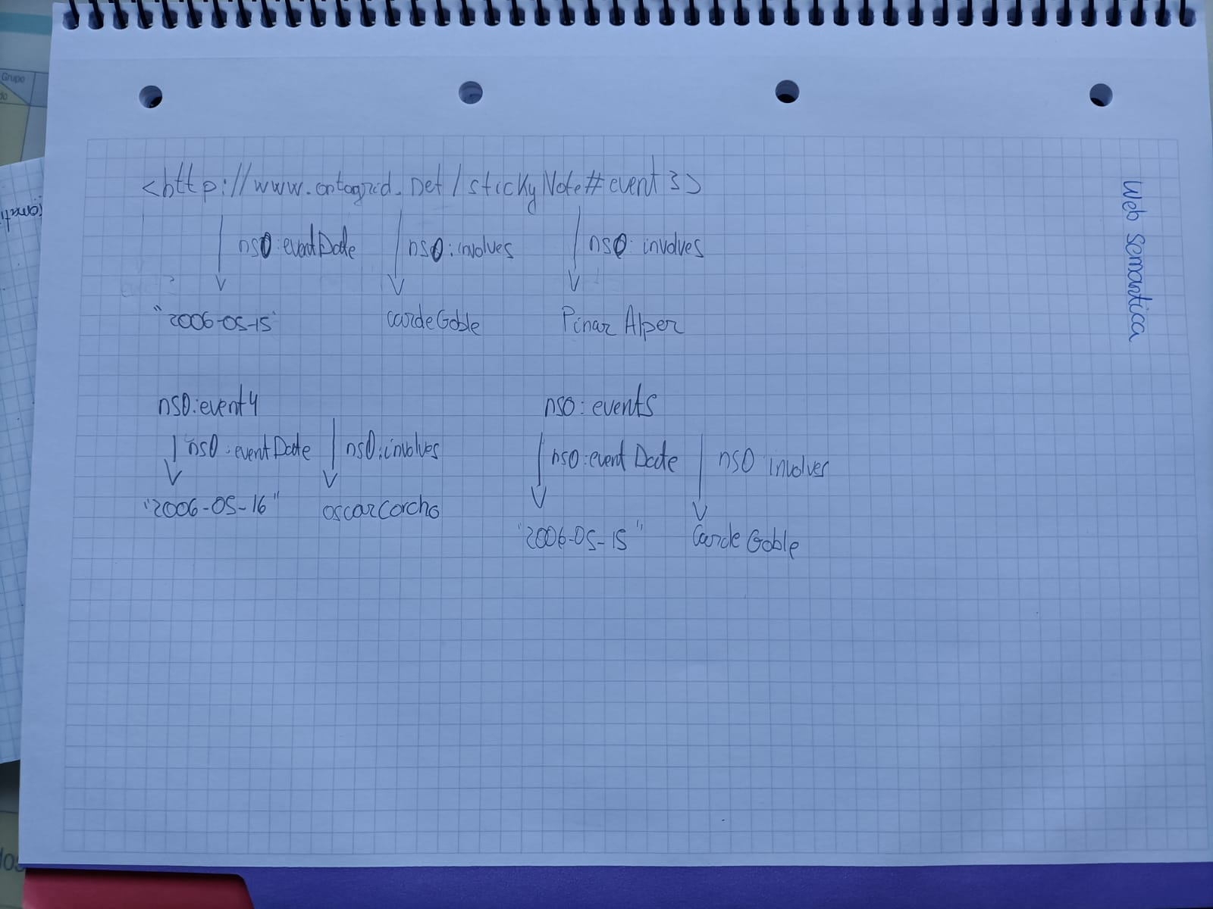

:Class01 :includes :Sensor029,

:computer101.

:Sensor029 : has Measurements : Measurement8401.

:Computer101: hasowner :User10A.

:Measurement 8401: has Temperature “29”;

:AtTime “2010-06-12T 12:00:12”.

User10A: hasName “Pedro”.