Design and construction of a prototype transmitter and receiver of acoustic waves in the underwater environment

1st Alejandro Andrés Valle Recarte  
Universidad Tecnológica Centroamericana  
UNITEC, Honduras  
alejandro_valle99@unitec.edu  
2nd Luis Gustavo Romero Palma  
Universidad Tecnológica Centroamericana  
Unitec, Honduras  
romero.luisg@unitec.edu

3nd Alicia María Reyes Duke   
Universidad Tecnológica Centroamericana  
Unitec, Honduras  
alicia.reyes@unitec.edu.hn

*Abstract*— In this research, an incremental methodology was  
used for the design and development of a communication system  
for the transmission of data in the underwater environment  
using acoustic waves. This communication system consists of  
PIC microcontrollers, XR-2206 modulator circuit and XR-2211  
demodulator circuit, signal conditioning circuits, piezoelectric  
transducer and a hydrophone. The transmitter and receiver  
electronic boards were built, and successful results were obtained in controlled environments, with no signal loss. Final results in a swimming pool showed that the communication system was highly sensitive to the artificial noise from the pool filters, resulting in inefficient communication

Keywords— XR-2206, XR-2211, electronic boards, PIC

# Introduction

Technologically, the whole world is intercommunicated thanks to telecommunications. With great ease, two or more people can communicate with each other regardless of the distance between them. This ease of communication is a product of technological advances in multiple areas of information technology, specifically telecommunications. These types of communications are easily employed in the terrestrial environment, either wired or wireless, but would these types of communications work efficiently in the underwater environment? Wired communications are widely used in the underwater environment. There are two types of underwater cables: cables for electrical power transmission and cables for data transmission [1]. As a result of the above mentioned it can be said that, although the underwater environment does not have the same wireless transmission facility as the terrestrial environment, it is possible to implement wireless communication, but with limitations regarding the distance; based on this it can be assumed that it is feasible to send information over a short distance without the use of submarine cables. This and other unknowns will be analyzed and answered throughout the project with respect to underwater wireless communication, specifically acoustics. Acoustics will be used over radiofrequency and optical due to major difficulties of implementation of these, e.g., excessive signal attenuation. This research is intended to serve as an initial step in the development and implementation of underwater communications networks in Honduras. By means of an incremental methodology, the development of a transmitter and receiver for data transmission and reception using acoustic waves is proposed, implementing the FSK modulation and demodulation technique.

# Context

## Underwater communication channels

All three types of communications have their advantages and disadvantages in the underwater environment, which are limited by their effective communication range, information transfer, high costs, etc [2] . In this case, the objective is communication with significant distance, low cost, and effective information transfer. This is possible with acoustic communication.

The major advantage of acoustic communication over radio frequency and optical wave communication is its low attenuation and long-distance communication capability. This is at the expense of reduced bandwidth and low transfer speed. Other negative factors to consider are the Doppler effect caused by the very nature of the sea and the fact that the transmitter and receiver are unlikely to be completely fixed. The latency times increase the signal processing difficulties, limited bandwidth, and mainly, the inter-symbol interference. However, all these disadvantages are solved by high computational resources, which can equally be considered a disadvantage. Despite all of the above acoustic waves propagate more efficiently in water than radiofrequency and optical, which is why it is the most widely used underwater communication system [3].

## Piezoelectric transducer

A piezoelectric transducer is a ferroelectric material that converts electrical energy into mechanical energy and vice versa. For example, when a 15kHz sine voltage is applied to the electrodes of the transducer, it will mechanically vibrate at 15kHz, behaving like a speaker. Conversely, if it receives a 15kHz pressure wave, it will generate a 15kHz electric current behaving like a microphone. [3]

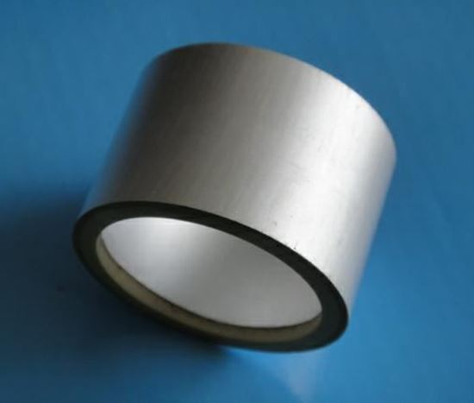

The piezoelectric transducer used can be seen in figure 1. It has a resonant frequency of 30 kHz, measurements of 36x31x20mm and radial resonance. The measurements will be important later.

## XR2206 and XR2211

The XR-2206 is a monolithic integrated circuit function generator capable of producing sine waves, pulse trains, triangles, etc., with high stability and accuracy. The operating frequency is externally selectable from 0.01 Hz to over 1 MHz. This integrated circuit is made for communications, instrumentation, and sine function generator, AM, FM and FSK generation applications.

Since the XR2206 was chosen to be the system modulator, its counterpart from the same company, the XR-2211 integrated circuit, was used. The XR-2211 is a monolithic integrated circuit specifically designed for data communication applications. It is particularly used for FSK applications. It operates over a frequency range from 0.01Hz to 300kHz. The circuit has features such as input signal tracking over an externally set range, carrier detection and, most importantly, FSK demodulation.

## Hydrophone

A hydrophone is a piezoelectric transducer that transforms an acoustic signal into an electrical signal for use in water or other liquid, like the operation of a conventional microphone [5]. A hydrophone was purchased from the U.S. company Aquarian Hydrophones. The purchased hydrophone which can be seen on figure 2 has a 3.5mm male jack connector and a 3-meter-long cable. The hydrophone has a built-in preamplifier.

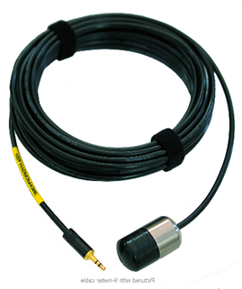

## Softwares

Various types of software were used for the development of this research. Multisim was used for electronical simulations. Solidworks was used on the mold design for the piezoelectric transducer. And Proteus Professional was used for PCB design.

# Methodology

The incremental methodology oriented to evolutionary delivery was implemented, which allows developing the project in iterations or increments, in which each increment is a functional product adding important features in each subsequent increment.

“The incremental methodology starts from an initial design with basic features, known as a description sketch and then as the development progresses, increasingly more complete versions of the system are made, until a final version is reached that completely satisfies the user's needs and meets all the information and management requirements of this” [6].

The model on figure 3 was made based on Pressman´s model on software development. Each increment consists of four stages and are presented as follows: Analysis and planning, design, construction, and implementation and evaluation.

The increments are:

1. Wired modulation and demodulation
2. Sending temperature sensor data via wired connection
3. Signal conditioning
4. Final integration

# Results

## Increment 1: Wired modulation and demodulation

For this increment, the main objective is testing of the integrated circuits XR2206 and XR2211. In this increment an important parameter for the communication system was defined, the baud rate.

At this stage, a reading of the XR-2206 and XR-2211 integrated circuits datasheet is carried out for the correct understanding of the integrated circuits operation and the necessary calculations for the components in the final circuitry. Such calculations and schematics can be found on both devices’ datasheet. These calculations require the mark and space frequency, which were fixed on 10kHz for bit 0 and 15 kHz for bit 1.

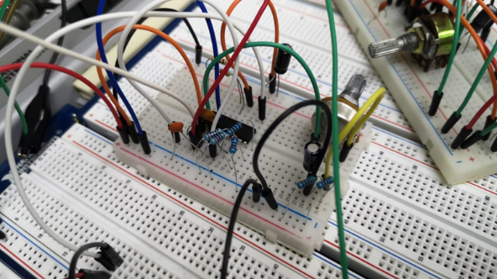

**Both modulator and demodulator were mounted on protoboard as seen on figure 4 and figure 5 and were keep on these until the final increment. The tests were successful, we were able to modulate and demodulate a pulse train from a function generator efficiently as seen on figure 6.

The input signal is the yellow pulse train, and the demodulator output signal is the blue pulse train. Also, the signal modulation can be seen, in which different frequencies are visibly observed in logic state 1 and 0. The output signal is slightly out of phase with respect to the input signal, which is normal in this type of modulation.

On initial tests, the system was not working. After thorough analysis of all components, the capacitance which establish the baud rate was set for a baud rate of around 3000. Through literature, it was found that in some cases the system failed even on 1200 baud rate. The baud rate is inversely proportional to the capacitance as seen on equation 1, so changing the baud rate, increases or decreases both the circuitry and necessary components. Due to budget and circuitry issues, the baud rate was tested only from 600 and below, proving successful on all of them. Of course, the highest baud rate, 600, was chosen.

## Increment 2. Sending temperature sensor data via wired connection

The main objective on this increment is read the DS18B20 digital temperature sensor using the PIC18F2550 microcontroller and send the reading as a pulse train to the modulator circuit. After that, it is necessary to demodulate the same signal and that the microcontroller of the receiver can display the data and print them on an LCD screen for comparison between the sent and received signal. Sending data from a real sensor was chosen just to give the system a more realistic approach, since temperature readings are common in aquatic environments.

The great advantage of the DS18B20 sensor is that it uses only one cable to send data, thanks to its One-wire operation protocol, which helps to reduce circuitry. MikroC software already has a One-wire library, which was used for the programming.

The sending of data as a pulse train is thanks to the USART protocol (*Universal Synchronous/Asynchronous Receiver Transmitter)*. For the configuration of the USART protocol it is necessary to manipulate different registers. These registers are: TXSTA, RCSTA and BAUDCON. Both microcontrollers were programmed to work with this protocol and baud rate was set to 600 for both.

The system worked when combined with the modulator and demodulator as seen on figure 8.

## Increment 3. Signal conditioning

With the modulation and demodulation system transmitting data by wire, signal amplifiers and filters were developed so that the signal containing the message could be sent underwater.

It was necessary to encapsulate the piezoelectric transducer to make it submersible. The space that must be between the encapsulant and the transducer is ¼ of the wavelength of the wave with the highest frequency. The magnitude of the wavelength was calculated using maximum frequency of 25 KHz as shown in equation 2 obtaining as a result λ=6 cm, giving as a result the separation distance of 1.5 cm.

The mold design has an internal diameter of 72.6 mm and a depth of 55 mm so that the transducer allows waves smaller than 25 KHz to pass through, as shown in Figure 9.

Epoxy resin was used to encapsulate the transducer in the fabricated mold as shown in Figure 10.

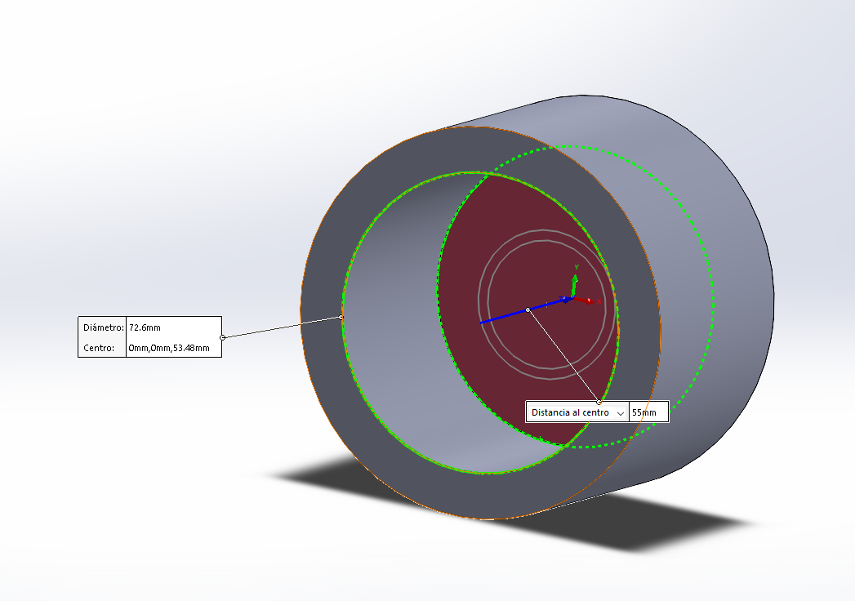

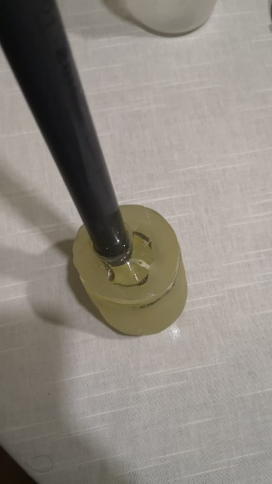

A power amplifier was used so that it could amplify the voltage and transmitted power to send it underwater. The TDA2030A amplifier with variable gain between 1 and 10 was used to modify the signal strength. The design of this circuit is shown in Figure 11.

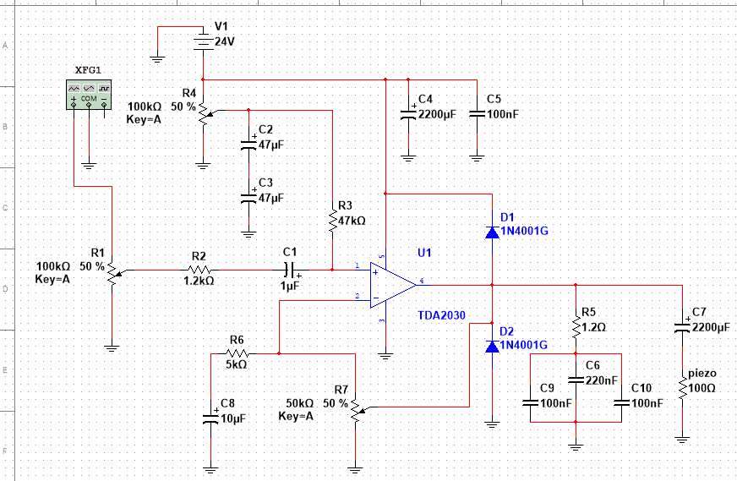

In the data reception stage, a signal filter was designed using an LM324 low power amplifier to be used as an active filter to eliminate unwanted frequencies and at the same time amplify the attenuated signal after the filtering stage. The design was made with a single integrated circuit since it contains several amplifiers in one as shown in Figure 12.

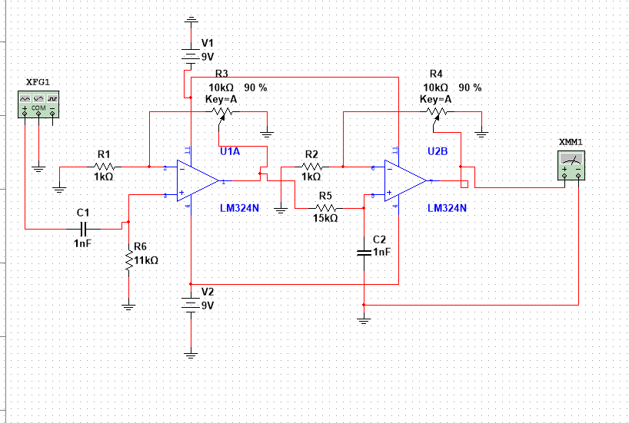

## D. Increment 4. Final integration

Once the functionality of the whole system was verified, the electronic boards of the transmitter and receiver were built. Once the boards were ready, final tests were carried out in controlled environments and, finally, in a swimming pool.

Low cost and fast implementation ways for the development of the boards were evaluated. Therefore, the electronic boards were made using the acetone technique, in which it is not necessary to use an iron. First, print the circuit on photographic paper and, using acetone, transfer the tracks to the bakelite. Subsequently, they are subjected to a mixture of muriatic acid and hydrogen peroxide, in this way, only the tracks with copper remain.

The result of each PCB are as follows:

### First test

The first test performed was in a plastic container with the following measurements 50x15x15cm. It is a small, low-volume container shown in Figure 15. As well, the potted piezoelectric transducer and hydrophone can be seen.

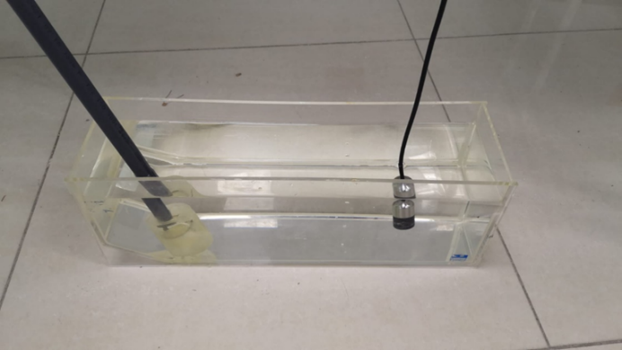

The system was fully efficient once the gain of the receiver operational amplifier was adjusted. It did not suffer any data loss. The data loss is basically if the receiver prints on the LCD a different value than the one sent by the transmitter. The transmitter sends a reading every 520 ms, and a test time of 1 minute was taken, which equals approximately 115 data successfully sent and received.

In figures 16 and 17 both transmitter and receiver can be seen on the exact moment that it was sending 24 degrees Celsius.

### Second test

The second test was somewhat similar in the aspect that it was always tested in a controlled environment, the only difference being that it was a larger vessel of greater volume. The second vessel used is shown in Figure 18. The distance that the transducer and hydrophone were placed is approximately 1.5 meters. Such vessel can be seen in figure 18.

In this second test, as in the first, positive results were obtained. The same procedure was followed as in the first test of 115 samples and at no time was there an erroneous reception in the receiver. It is always necessary to perform the gain adjustment on the receiver, which takes a few seconds to make.

### Third test

The third and final test was conducted in a swimming pool. The last test consists of evaluating the performance of the devices in an uncontrolled environment. The swimming pool has several filters and cleaning systems, adding noise to the transmission medium. In addition, it has a much larger volume than the first and second test vessels. Figure 19 shows the configuration that was tested in the pool. The box framed in red is the transducer and the box framed in yellow is the hydrophone.

The last test was unsuccessful because the receiver printed random values on the LCD. For example, the transmitter sent 34 degrees Celsius, and the receiver displayed 148 and so on for each data sent. In multiple position configurations between transmitter and receiver, the random values were received. The boards were checked with oscilloscopes, and everything was working correctly. Another test was done in the pool, but this time, the vessel from the first test was taken to the pool. The system worked correctly in the vessel, but not in the pool. Despite placing them at a similar distance in the pool as if they were in the vessel, it was not successful.

The following hypotheses were formulated for the non-functioning of the system:

* Despite implementing in the receiver an active filter between the range of 9kHz and 16 kHz, the system is very sensitive to noise caused by the pool filters and in other uncontrolled environments.
* The chosen power amplifier is not efficient enough to obtain a nominal signal-to-noise ratio.

# Conclusions

##### The transmitter and receiver prototypes were developed for data transmission in the underwater environment. The system can send and receive data effectively in controlled environments; however, it was not successful in uncontrolled environments. A total of 115 samples of sent and received data were tested. The first two tests showed 100% efficiency; however, the third and final test resulted in 4% efficiency. More efficient power amplifiers and filters are recommended for future work.

##### References

[1] T. Davenport, «Submarine Communications Cables and Law of the Sea: Problems in Law and Practice», *Ocean Development & International Law*, vol. 43, n.o 3, pp. 201-242, jul. 2012, doi: 10.1080/00908320.2012.698922.

[2] L. Lanbo, Z. Shengli, y C. Jun-Hong, «Prospects and problems of wireless communication for underwater sensor networks», *Wirel. Commun. Mob. Comput.*, vol. 8, n.o 8, pp. 977-994, oct. 2008, doi: 10.1002/wcm.654.

[3] M. Lanzagorta, «Underwater Communications», *Synthesis Lectures on Communications*, vol. 5, n.o 2, pp. 1-129, oct. 2012, doi: 10.2200/S00409ED1V01Y201203COM006.

[4] C. Xia, «A low-cost modular underwater acoustic communication system», Thesis, Massachusetts Institute of Technology, 2020. Accedido: 25 de enero de 2022. [En línea]. Disponible en: https://dspace.mit.edu/handle/1721.1/130598

[5] A. F. Uribe Gómez y J. A. Vélez Hurtado, «Diseño e implementación de un sistema de comunicación subacuática basado en la emisión y recepción de señales en el rango de frecuencias de ultrasonido», *Biblioteca USB Medellín (San Benito) CD-4458t*, 2017, Accedido: 25 de enero de 2022. [En línea]. Disponible en: http://bibliotecadigital.usb.edu.co/handle/10819/7033

[6] A. R. L. Yacelga, J. L. A. Espinoza, y R. A. D. Vásquez, «Aplicación de la metodología incremental en el desarrollo de sistemas de información», *Universidad y Sociedad*, vol. 13, n.o 5, Art. n.o 5, sep. 2021.

