Using Databases Final Project Report

Part A – Database Creation
For this part, I created all the tables needed for our restaurant and delivery system. This included tables for employees, roles, customers, addresses, categories, menu items, inventory, orders, order items, deliveries, and the order status history.
Each table was designed with the proper primary keys, foreign keys, and data types so they work together correctly. This structure allows the system to handle everything from adding menu items to placing orders and assigning delivery drivers.
Short Explanation:
The main goal of this section was to build the foundation of the database. All tables were created without cascading rules (since this requirement was removed) and were set up to support the rest of the project’s features.

Part C – Authorization and User Permissions
For this part, I created three MySQL users that match real roles in a restaurant:
- cashier_user – Can view and add orders and customer information, but cannot delete anything.
- cook_user – Can see orders and update the order status when preparing food.
- manager_user – Has full control and can do everything in the database.
To verify that the permissions were set up properly, I used SHOW GRANTS for each user and then tried running commands they shouldn’t be allowed to use. If the permissions were correct, MySQL showed an error message.

C.1 – SHOW GRANTS
Below are the screenshots showing the permissions for each user:
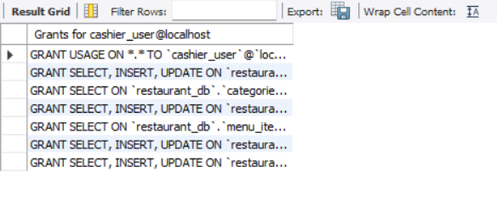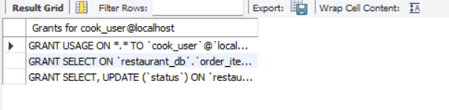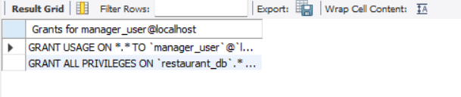

C.2 – Permission Testing
To test the restrictions:
- I logged in as cashier_user and tried deleting an order. This should fail.
- I logged in as cook_user and tried updating something they are not allowed to change. This should also fail.
Both attempts resulted in MySQL errors, which confirms the permissions were applied correctly.
Short Explanation:
This part shows that each user can only do what their job role allows. The system properly blocks unauthorized actions, which helps protect the data and prevent mistakes.

Part D: Stored Procedures and Automated Operations:
The following code is to calculate the total of an Order and a test code under: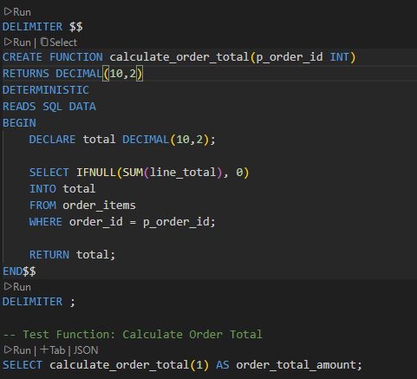
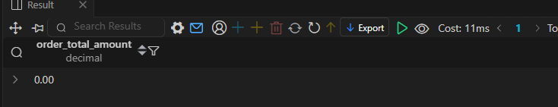
The Following code is to assign a driver automatically and its test code
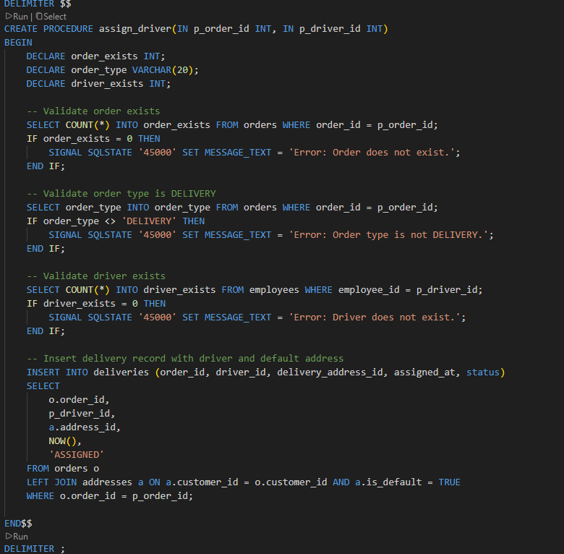
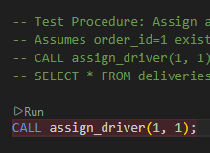

Part E – Triggers
I created three triggers that automate important actions in the database:

1. Order Status History Trigger
This trigger automatically records every time an order’s status changes. It adds a new entry to the order_status_history table showing the old status, the new status, and when the change happened.
Test Case:
UPDATE orders SET status = 'PREPARING' WHERE order_id = 1;
SELECT * FROM order_status_history WHERE order_id = 1;
This confirms that the trigger activates whenever the status changes.

2. Prevent Deleting Menu Items Used in Orders
This trigger stops anyone from deleting a menu item if it was already used in an order. This protects the order history and keeps the data consistent.
Test Case:
DELETE FROM menu_items WHERE name = 'Margherita';
If the item is linked to past orders, MySQL will show an error and won’t delete it.

3. Inventory Reduction Trigger
This trigger updates inventory levels automatically whenever a menu item is added to an order. This helps simulate how ingredients are used in real restaurants.
Test Case:
SELECT * FROM inventory_items;

INSERT INTO order_items (order_id, menu_item_id, quantity, unit_price, line_total)
VALUES (1, 1, 2, 14.99, 29.98);

SELECT * FROM inventory_items;
You can see the ingredient amounts decrease after adding the order item.

Short Explanation:
These triggers help automate the system and reduce mistakes. They keep track of order changes, protect important data, and keep inventory levels accurate without needing manual updates.

Part F: Backup and Restore:
Commands Used:
Mysqldump -u root – p restaurant_db > restaurant_db_backup.sql
Mysql -u root -p < restaurant_db_backup.sql

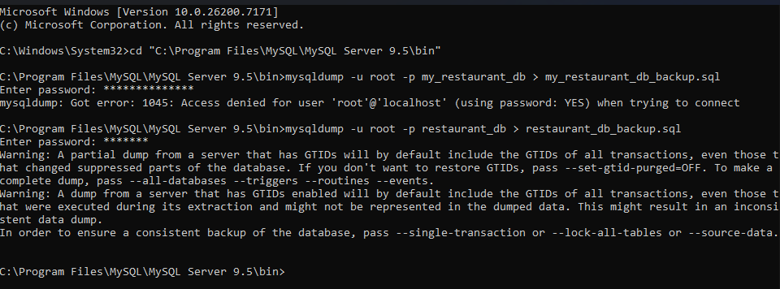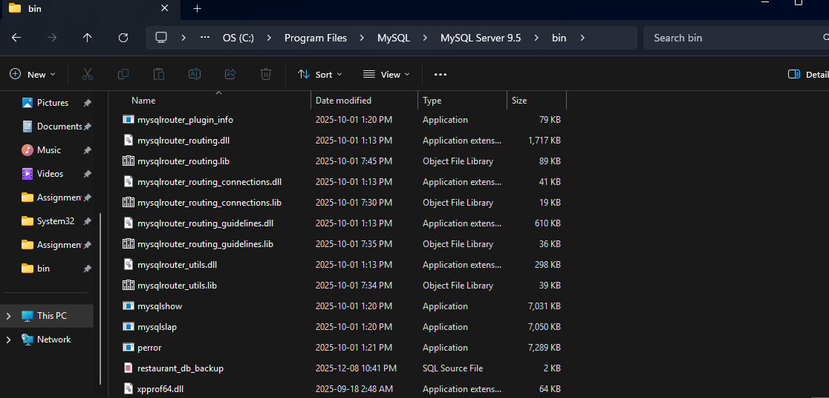
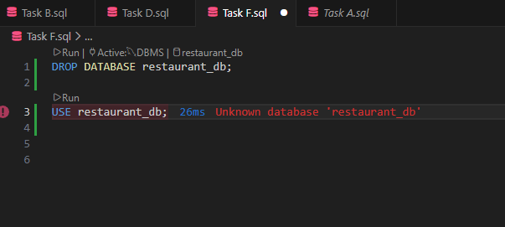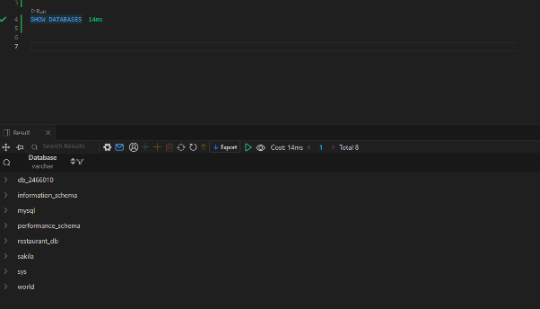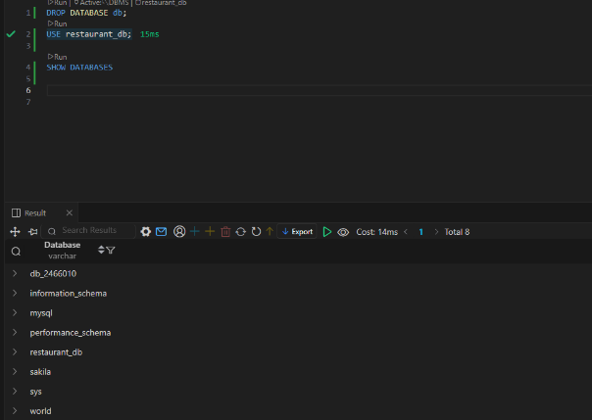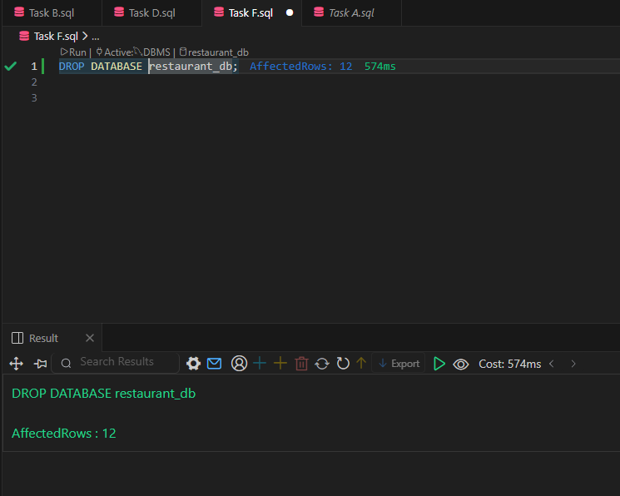
First 30 Lines of backup code:
-- MySQL dump 10.13 Distrib 9.5.0, for Win64 (x86_64)
--
-- Host: localhost Database: restaurant_db
-- ------------------------------------------------------
-- Server version 9.5.0

/*!40101 SET @OLD_CHARACTER_SET_CLIENT=@@CHARACTER_SET_CLIENT */;
/*!40101 SET @OLD_CHARACTER_SET_RESULTS=@@CHARACTER_SET_RESULTS */;
/*!40101 SET @OLD_COLLATION_CONNECTION=@@COLLATION_CONNECTION */;
/*!50503 SET NAMES utf8mb4 */;
/*!40103 SET @OLD_TIME_ZONE=@@TIME_ZONE */;
/*!40103 SET TIME_ZONE='+00:00' */;
/*!40014 SET @OLD_UNIQUE_CHECKS=@@UNIQUE_CHECKS, UNIQUE_CHECKS=0 */;
/*!40014 SET @OLD_FOREIGN_KEY_CHECKS=@@FOREIGN_KEY_CHECKS, FOREIGN_KEY_CHECKS=0 */;
/*!40101 SET @OLD_SQL_MODE=@@SQL_MODE, SQL_MODE='NO_AUTO_VALUE_ON_ZERO' */;
/*!40111 SET @OLD_SQL_NOTES=@@SQL_NOTES, SQL_NOTES=0 */;
SET @MYSQLDUMP_TEMP_LOG_BIN = @@SESSION.SQL_LOG_BIN;
SET @@SESSION.SQL_LOG_BIN= 0;

[everything from your dump remains unchanged]

SET @@SESSION.SQL_LOG_BIN = @MYSQLDUMP_TEMP_LOG_BIN;
/*!40103 SET TIME_ZONE=@OLD_TIME_ZONE */;

/*!40101 SET SQL_MODE=@OLD_SQL_MODE */;
/*!40014 SET FOREIGN_KEY_CHECKS=@OLD_FOREIGN_KEY_CHECKS */;
/*!40014 SET UNIQUE_CHECKS=@OLD_UNIQUE_CHECKS */;
/*!40101 SET CHARACTER_SET_CLIENT=@OLD_CHARACTER_SET_CLIENT */;
/*!40101 SET CHARACTER_SET_RESULTS=@OLD_CHARACTER_SET_RESULTS */;
/*!40101 SET COLLATION_CONNECTION=@OLD_COLLATION_CONNECTION */;

