Supplementary Materials for
Genome re-sequencing and genome-wide polymorphisms in mosquito vectors Aedes aegypti and Aedes albopictus from south India.

Preeti Acharya^{1,2}, Upasana Shyamsunder Singh³, Veeramanoharan Rajamannar⁴, Mayilsamy Muniaraj⁴, Binata Nayak^{1*}, Aparup Das^{2*}

*Correspondence: binatanayak@suniv.ac.in (B.N.); aparupdas@nirth.res.in (A.D.)

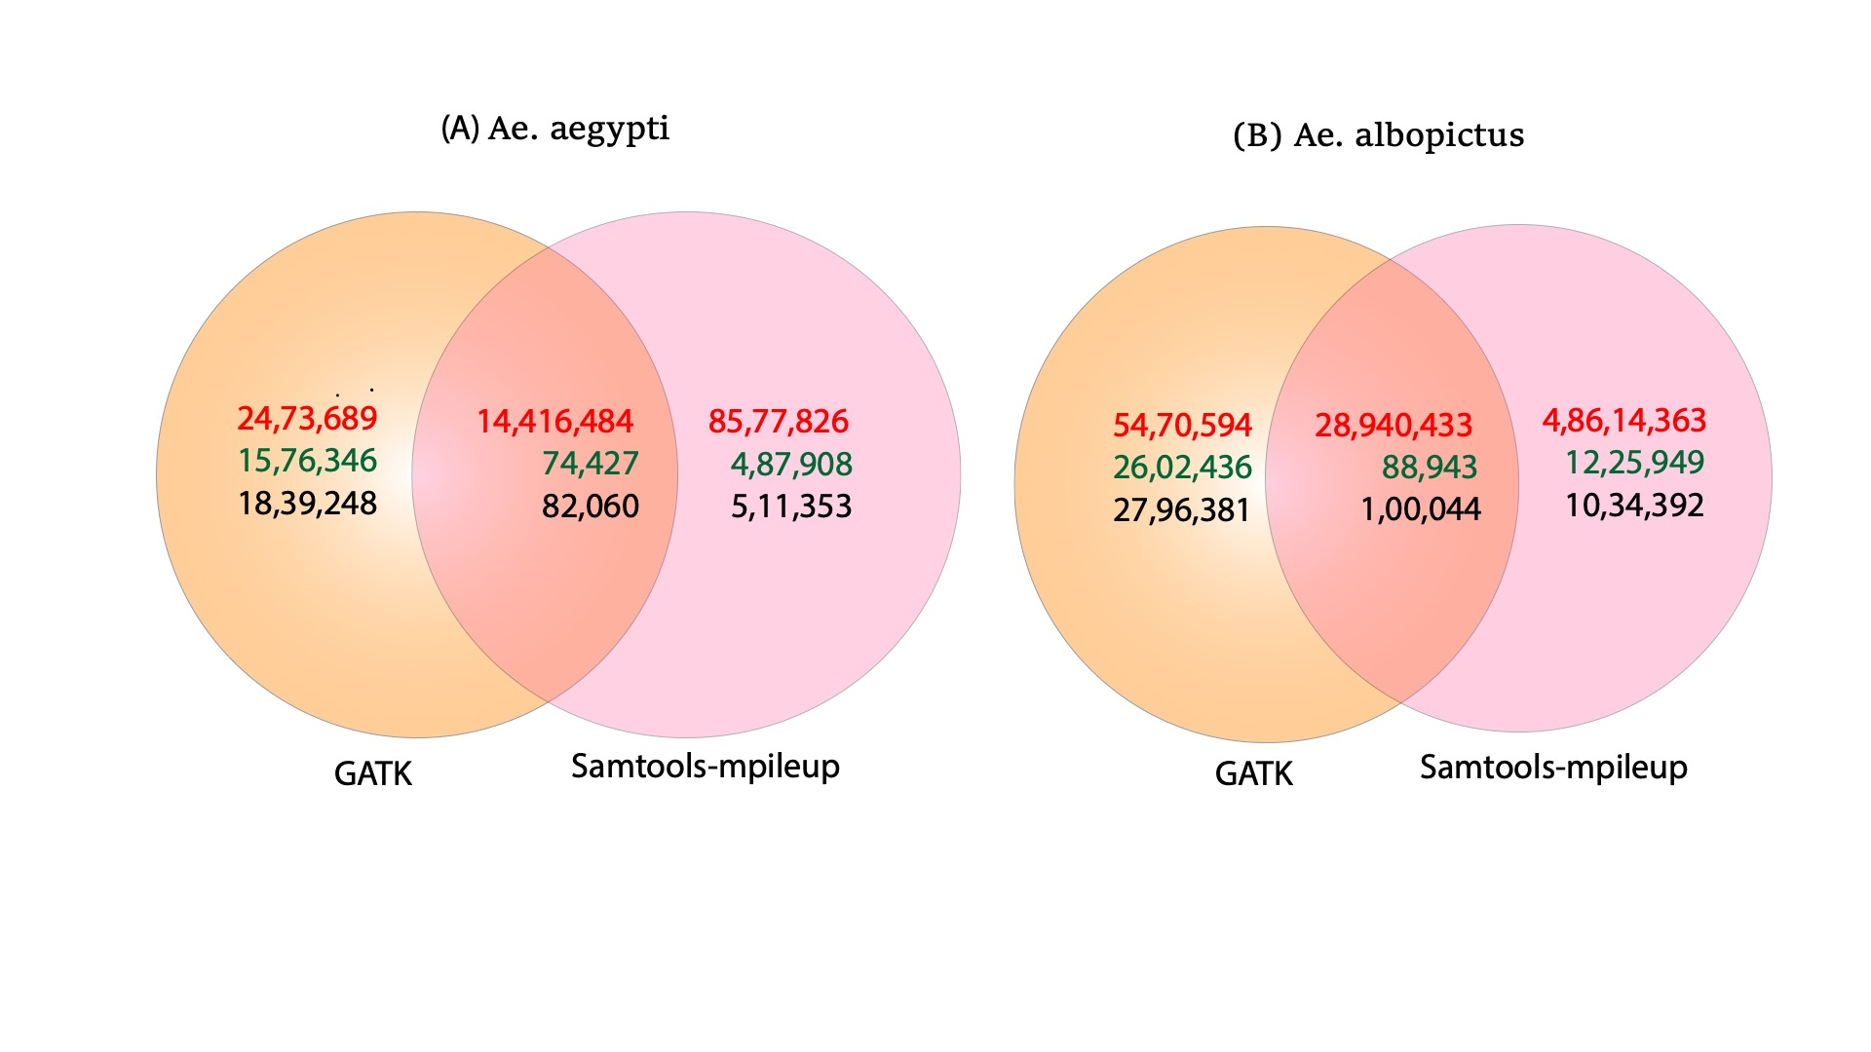
FigureS1 Venn diagram showing common and unique Variants identified by GATK and Samtools-mpileup. (A) Variants identified in Ae. Aegypti and (B) Ae. albopictus. The red colour represents number of SNPs, purple represent number of insertions and black represents number of deletions.

Commands used for data analysis

Note: The commands shown below is for reads obtained from Aedes albopictus; Same commands were used for Aedes aegypti sample.
Reads name :
SO_6885_CRME_AB_S_R1.fastq.gz
SO_6885_CRME_AB_S_R2.fastq.gz

- Qaultity check for raw reads

- fastp (adapter removing and low quality base removing) and fastqc commands
##fastp
fastp -h SO_6885_CRME_AB_S.html -j SO_6885_CRME_AB_S.json -i SO_6885_CRME_AB_S_R1.fastq.gz -I SO_6885_CRME_AB_S_R2.fastq.gz -o SO_6885_CRME_AB_S_R1.clean.fastq.gz -O SO_6885_CRME_AB_S_R2.clean.fastq.gz -z 9 -w 10 --detect_adapter_for_pe -l 50
- ##fastqc
fastqc *.clean.fastq.gz
- Indexing
bwa index GCF_006496715.1_Aalbo_primary.1_genomic.fna

samtools faidx GCF_006496715.1_Aalbo_primary.1_genomic.fna

- Create dictionary files
picard-tools-1.48/CreateSequenceDictionary.jar R=GCF_006496715.1_Aalbo_primary.1_genomic.fna O=GCF_006496715.1_Aalbo_primary.1_genomic.dict

- Mapping
bwa mem -t 30 -M -R '@RG\tID:AB\tSM:AB\tPL:Illumina' GCF_006496715.1_Aalbo_primary.1_genomic.fna Cleaned_data/SO_6885_CRME_AB_S_R1.clean.fastq.gz Cleaned_data/SO_6885_CRME_AB_S_R2.clean.fastq.gz > AB.sam

samtools-0.1.19/samtools view -bS -@30 AB.sam > AB.bam

- create mapping stats files
samtools-0.1.19/samtools flagstat AB.bam > AB.mapping_stats.txt

- sort and mark duplicates

picard-tools-1.48/SortSam.jar I=AB.bam O=AB.sorted.bam SO=coordinate TMP_DIR=tmp VALIDATION_STRINGENCY=LENIENT CREATE_INDEX=FALSE

java -jar /data1/softwares/picard-tools-1.48/MarkDuplicates.jar I=AB.sorted.bam O=AB.sorted.rmdup.bam REMOVE_DUPLICATES=true ASSUME_SORTED=true METRICS_FILE=GATK_snps/AB.metric.file

java -jar /data1/Softwares/picard-tools-1.48/BuildBamIndex.jar I=AB.sorted.rmdup.bam O=AB.sorted.rmdup.bam.bai

- variants calling using GATK

gatk --java-options "-Xmx80G" HaplotypeCaller --tmp-dir tmp -I AB.sorted.rmdup.bam -R GCF_006496715.1_Aalbo_primary.1_genomic.fna -O AB.variants.vcf

- gatk filtering

gatk -T VariantFiltration -R GCF_006496715.1_Aalbo_primary.1_genomic.fna -V AB.variants.vcf --filterName FAIL --filterExpression "QD < 2.0 || FS > 60.0 || MQ < 40.0 || DP < 10 || MQRankSum < -12.5 || ReadPosRankSum < -8.0" -o AB_filt_10x.vcf

bcftools view AB_filt_10x.vcf --threads 12 -Oz -o AB.filt_10x.vcf.gz

- bcftools mpipelup to call variants

bcftools mpileup --threads 16 -f GCF_006496715.1_Aalbo_primary.1_genomic.fna AB.sorted.bam | bcftools call --threads 8 -mv -Ob -o AB.bcf
- convert bcf to vcf
bcftools convert AB.bcf --threads 12 -o AB.samtool.vcf
bcftools view AB.samtool.vcf --threads 12 -Oz -o AB.samtool.vcf.gz

- find common variants between filtered GATK and samtoools mpipelup

bcftools isec -p AB_GTAK_sampileup/ -n=2 -w1 AB.variants1_filt10x.vcf.gz AB.samtool.vcf.gz

Note:
AB_GTAK_sampileup/ folder contains three files output files (output file 0002.vcf is one of them which has common Variants).

File was rename using below command:

mv 0002.vcf AB_GATK_10xsampileup.vcf

- SNP annotation
Note: before running annotation custom databases for AB and AE samples were build as per SnpEff instructions (AB and AE names were given to them)

java -jar /data1/softwares/snpEff/snpEff.jar AB -c /data1/softwares/snpEff/snpEff.config AB_GATK_10xsampileup.vcf > AB_GATK_10xsampileup_annotated.vcf

