Predicting Electricity Price Spikes in Alberta (2020-2025)
JorgeFolder project deliverable
University of Calgary style academic report draft

Abstract
This project develops a full machine learning pipeline to predict two-hour-ahead electricity price spikes in Alberta using hourly AESO market and generation data from 2020-01-03 through 2025-07-01 23:00:00. Three neural-network families were implemented and compared: a multilayer perceptron (MLP), a 1D convolutional neural network (CNN), and a long short-term memory network (LSTM). The target was defined as a binary indicator for pool prices above $200/MWh at time t+2, while explanatory variables were measured at time t. Using a strict time-based split and five-fold TimeSeriesSplit tuning within the train/validation horizon, the best model on the untouched test set was the CNN with F1=0.475, precision=0.462, recall=0.489, and ROC-AUC=0.941. The results indicate that system tightness, lagged price behavior, and renewable variability are informative predictors of spike risk.

Introduction and Motivation
Alberta's electricity market is highly sensitive to short-run system conditions because supply and demand must balance in real time. Under an energy-only market design, scarcity, renewable variability, intertie limitations, and demand pressure can all contribute to sharp price spikes.

Literature Review
The report framework draws on official AESO market documentation and on prior electricity-price forecasting studies. Stathakis et al. (2021) frame spike prediction as a classification problem. Ugurlu et al. (2018) show the relevance of recurrent neural networks, and Kuo and Huang (2018) motivate CNN/LSTM-style architectures for structured temporal inputs.

Data and Methodology
The final modeling sample used hourly AESO data from 2020-01-03 through 2025-07-01 23:00:00 on a fixed MPT axis. Train covered 2020-01-03 to 2023-11-05 23:00:00, validation covered 2023-11-06 to 2024-12-11 23:00:00, and test covered 2024-12-12 to 2025-07-01 23:00:00. The target was spike_lead_2, defined as two-hour-ahead pool price above $200/MWh.
split | rows | start | end | spike_rate_lead_2
train | 33672 | 2020-01-03 | 2023-11-05 23:00:00 | 0.1238
validation | 9648 | 2023-11-06 | 2024-12-11 23:00:00 | 0.0615
test | 4848 | 2024-12-12 | 2025-07-01 23:00:00 | 0.0182

Exploratory Data Analysis
The EDA highlights non-normal price behavior, strong calendar structure, and distinct system conditions during spike hours.
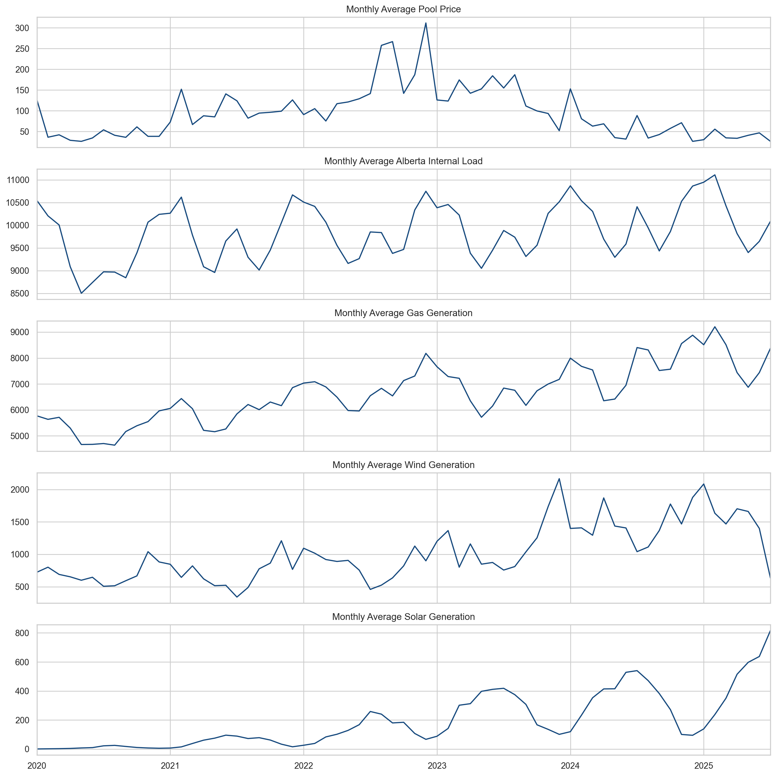
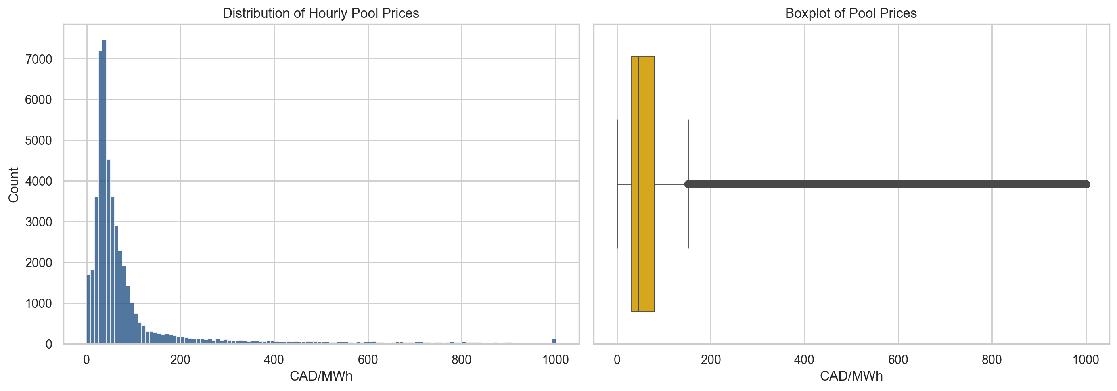
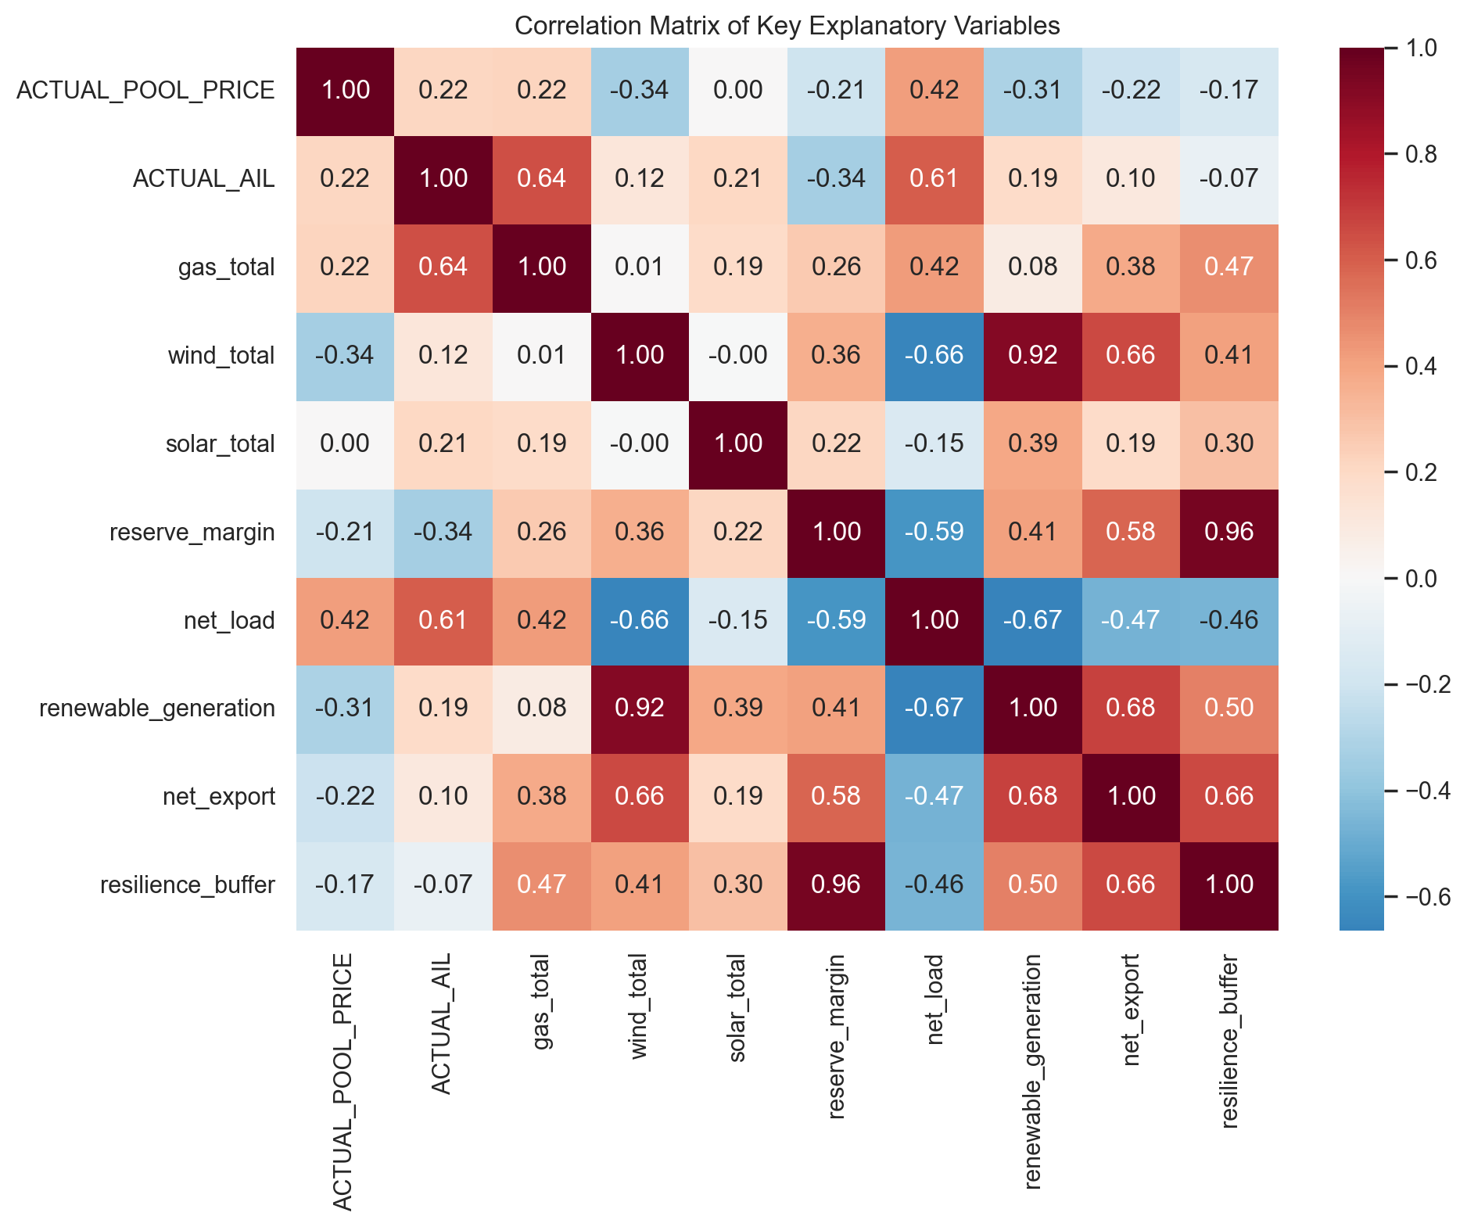
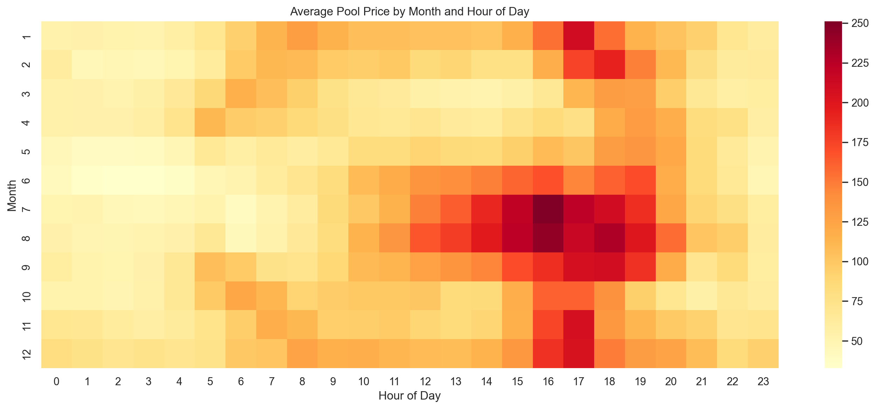
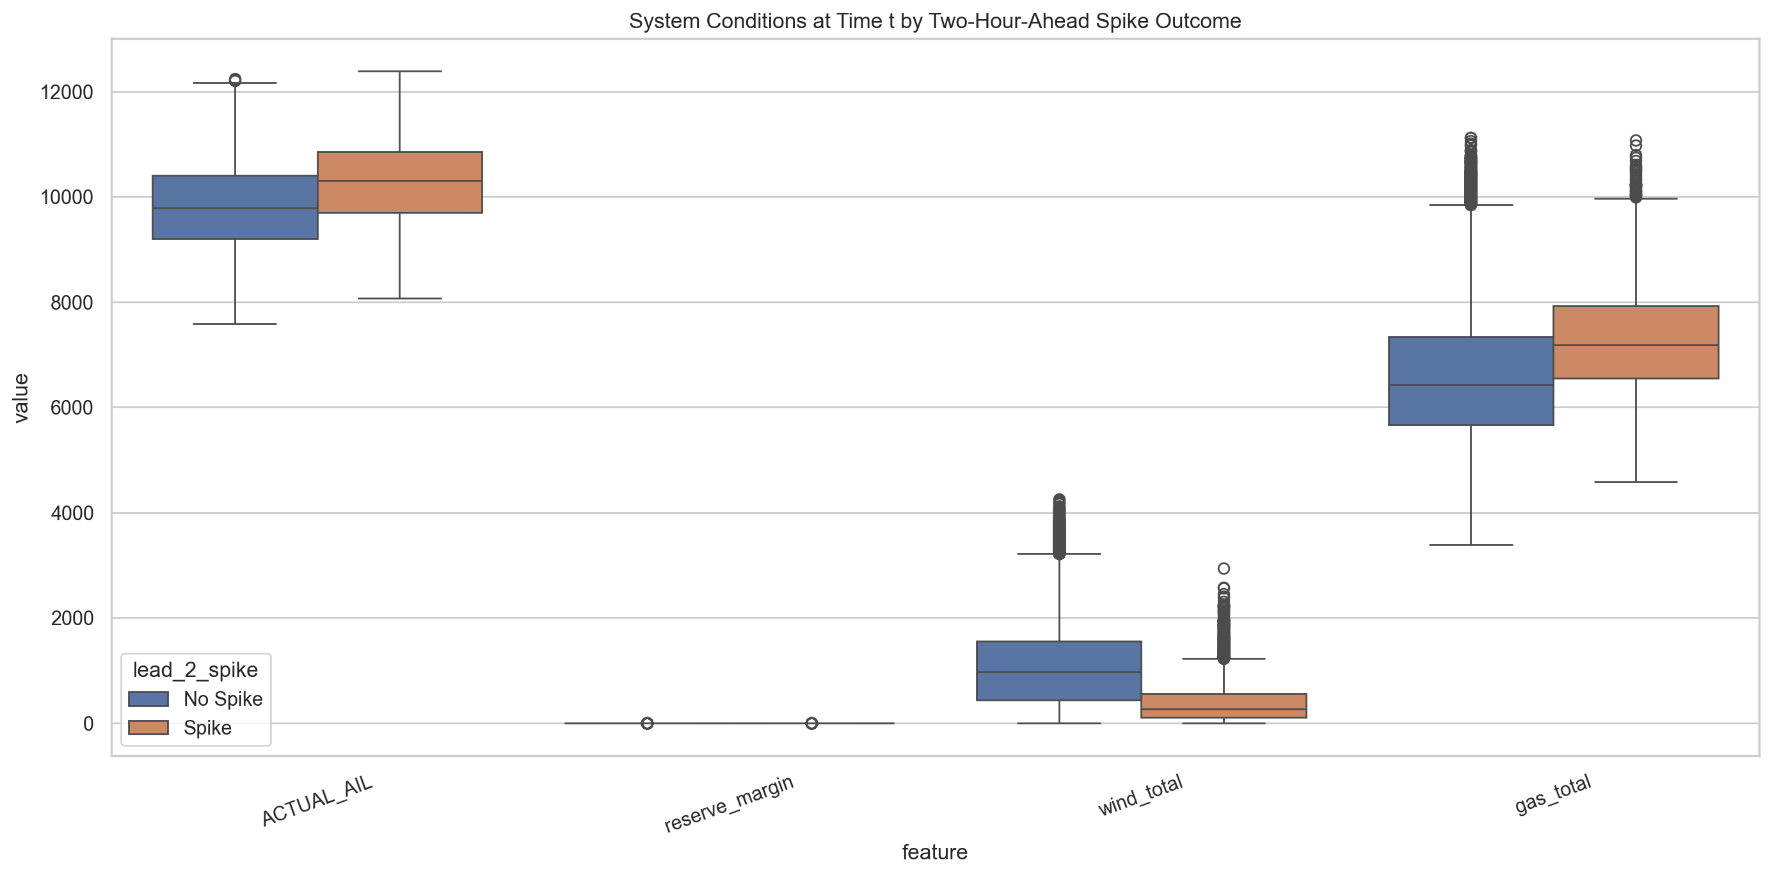
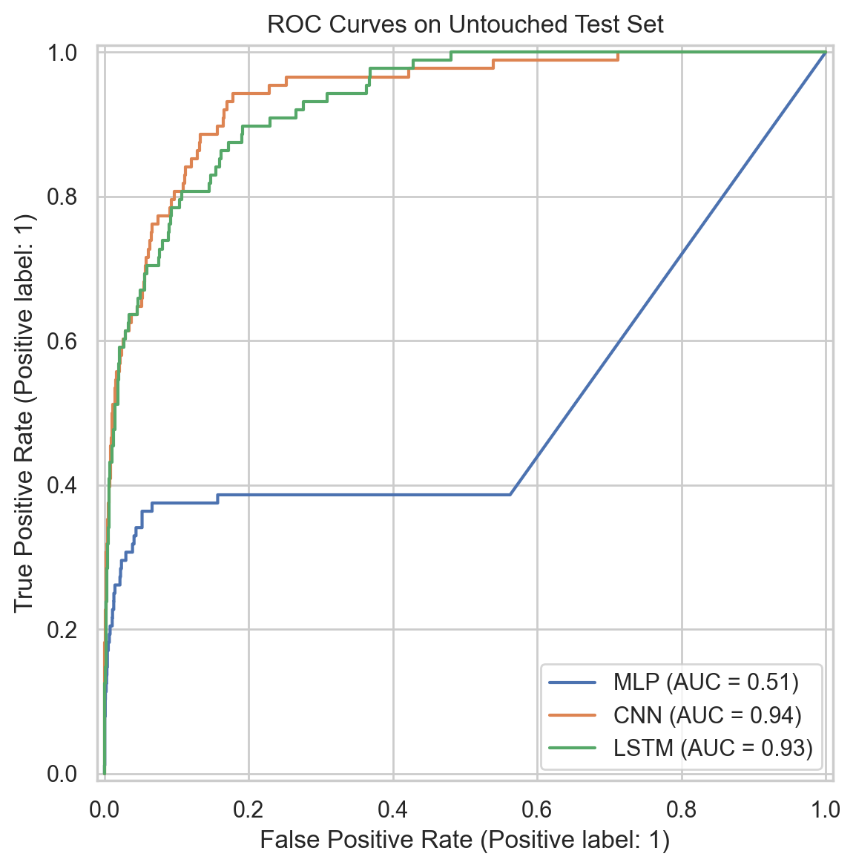

Results and Model Comparison
The CNN achieved the strongest F1-score on the untouched test set. Because spike forecasting is an imbalanced classification problem, F1-score was treated as the primary selection metric.
model | cv_best_f1 | validation_f1 | validation_precision | validation_recall | validation_roc_auc | test_f1 | test_precision | test_recall | test_roc_auc | threshold
cnn | 0.5504 | 0.5818 | 0.648 | 0.5278 | 0.9209 | 0.4751 | 0.4624 | 0.4886 | 0.9406 | 0.9
lstm | 0.591 | 0.5936 | 0.6078 | 0.5801 | 0.9153 | 0.4111 | 0.3152 | 0.5909 | 0.932 | 0.9
mlp | 0.4739 | 0.5479 | 0.4567 | 0.6847 | 0.931 | 0.2085 | 0.1579 | 0.3068 | 0.5132 | 0.9

Discussion
False negatives for the best model were associated with mean reserve margin 1.168, mean wind generation 665.5 MW, and mean two-hour-ahead price 459.21 CAD/MWh.
False positives for the best model were associated with mean reserve margin 1.126, mean wind generation 320.8 MW, and mean two-hour-ahead price 90.07 CAD/MWh.
The main practical implication is that scarcity conditions can often be detected from contemporaneous load, reserves, generation mix, and recent price behavior, but some spike events remain difficult because they are triggered by abrupt market changes that are not fully captured by the current feature set.

Conclusion and Future Work
This project delivered a complete reproducible pipeline for two-hour-ahead spike prediction in Alberta. Future improvements should incorporate weather, outages, and probabilistic calibration, and should test economic decision rules under asymmetric loss functions.

References
Alberta Electric System Operator. (2021). 2020 annual market statistics. https://www.aeso.ca/assets/Uploads/2020-Annual-Market-Stats-Final.pdf
Alberta Electric System Operator. (n.d.). Daily average pool price report. https://ets.aeso.ca/ets_web/ip/Market/Reports/DailyAveragePoolPriceReportServlet
Stathakis, E., Papadimitriou, T., & Gogas, P. (2021). Forecasting price spikes in electricity markets. Review of Economic Analysis, 13, 65-87. https://openjournals.uwaterloo.ca/index.php/rofea/article/download/1822/2096/5445
Ugurlu, U., Oksuz, I., & Tas, O. (2018). Electricity price forecasting using recurrent neural networks. Energies, 11(5), 1255. https://res.mdpi.com/d_attachment/energies/energies-11-01255/article_deploy/energies-11-01255.pdf
Kuo, P.-H., & Huang, C.-J. (2018). An electricity price forecasting model by hybrid structured deep neural networks. Sustainability, 10(4), 1280. https://www.mdpi.com/2071-1050/10/4/1280
Christensen, T., Hurn, A. S., & Lindsay, K. A. (2012). Forecasting spikes in electricity prices. International Journal of Forecasting, 28(2), 400-411. https://doi.org/10.1016/j.ijforecast.2011.02.019

