TÉCNICAS NUMÉRICAS PARA APROXIMAR LA(S) RAÍZ(CES) DE UNA ECUACIÓN

$$x^{2}-5x-1=0→ecuación cuadrática$$
$$e^{3x}=\frac{\sqrt[6]{x^{9}}}{ln\left(x\right)}, log_{2}\left(\sqrt{x}\right)=tan\left(\frac{1}{x}\right)→técnicas numéricas$$

Método de la Secante
- Iterativo
- No siempre hay convergencia.
- Requiere de dos aproximaciones - valores iniciales: $a, b$
- Unir la recta secante que pasa por las coordenadas de las aproximaciones iniciales.
$$Secante→\left\{\begin{aligned}a→x_{0} \\ b→x_{1} \\ x_{i}=x_{i-1}-\frac{f(x_{i-1})(x_{i-1}-x_{i-2})}{f\left(x_{i-1}\right)-f(x_{i-2})}\end{aligned}\right.$$
Ejercicio 1:
$$f\left(x\right)=4x^{2}-7x-10→\left\{\begin{aligned}x_{0}=1 \\ x_{1}=6\end{aligned}\right.$$
$$It.$$ | $$x_{i-2}$$ | $$f\left(x_{i-2}\right)$$ | $$x_{i-1}$$ | $$f\left(x_{i-1}\right)$$ | $$Raíz→x_{i}$$ | $$f\left(x_{i}\right)$$ | $$e_{r}$$
1 | $$x_{0}=1$$ | $$f\left(x_{0}\right)=-13$$ | $$x_{1}=6$$ | $$f\left(x_{1}\right)=92$$ | $$x_{2}=x_{1}-\frac{f\left(x_{1}\right)\left(x_{1}-x_{0}\right)}{f\left(x_{1}\right)-f\left(x_{0}\right)}=6-\frac{92\left(6-1\right)}{92-\left(-13\right)}=1.62$$ | $$f\left(x_{2} \right)=-10.84$$
$$2$$ | $$x_{1}=6$$ | $$f\left(x_{1}\right)=92$$ | $$x_{2}=1.62$$ | $$f\left(x_{2} \right)=-10.84$$ | $$x_{3}=x_{2}-\frac{f\left(x_{2}\right)\left(x_{2}-x_{1}\right)}{f\left(x_{2}\right)-f\left(x_{1}\right)}=1.62-\frac{-10.84\left(1.62-6\right)}{-10.84-92}=2.08$$ | $$f\left(x_{3}\right)=-7.24$$ | $$0.22$$
3 | $$x_{2}=1.62$$ | $$f\left(x_{2} \right)=-10.84$$ | $$x_{3}=2.08$$ | $$f\left(x_{3}\right)=-7.24$$ | $$x_{4}=x_{3}-\frac{f\left(x_{3}\right)\left(x_{3}-x_{2}\right)}{f\left(x_{3}\right)-f\left(x_{2}\right)}=2.08-\frac{-7.24\left(2.08-1.62\right)}{-7.24-\left(-10.84\right)}=3.01$$ | $$f\left(x_{4}\right)=5.16$$ | $$0.31$$
4 | $$x_{3}=2.08$$ | $$f\left(x_{3}\right)=-7.24$$ | $$x_{4}=3.01$$ | $$f\left(x_{4}\right)=5.16$$ | $$x_{5}=2.62$$ | $$f\left(x_{5}\right)=-0.84$$ | $$0.14$$

Iteración 0 – aproximaciones iniciales:  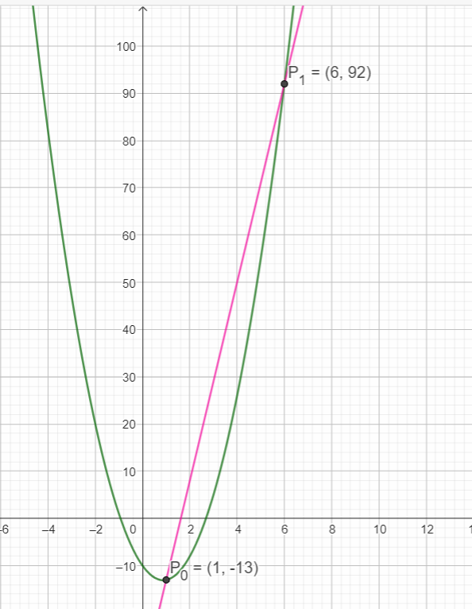 | Iteración 1:  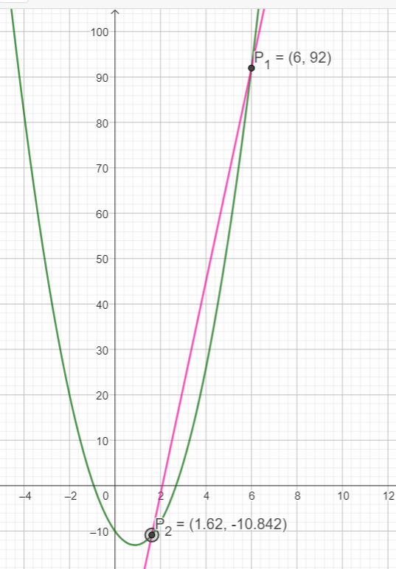 | Iteración 2:  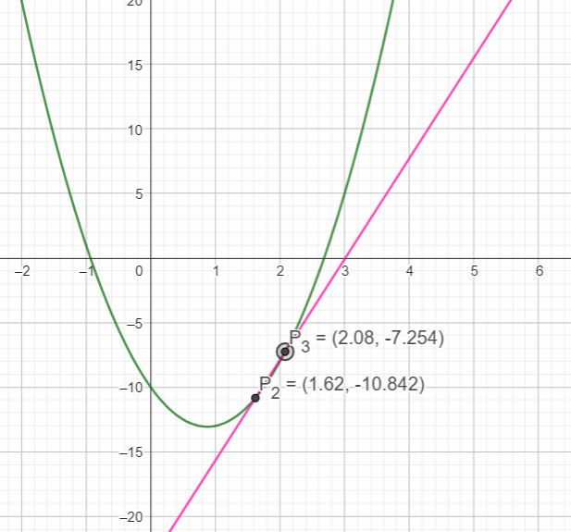
Iteración 3:
