**Task manager:**

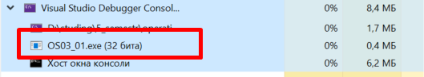

**Tasklist in cmd:**

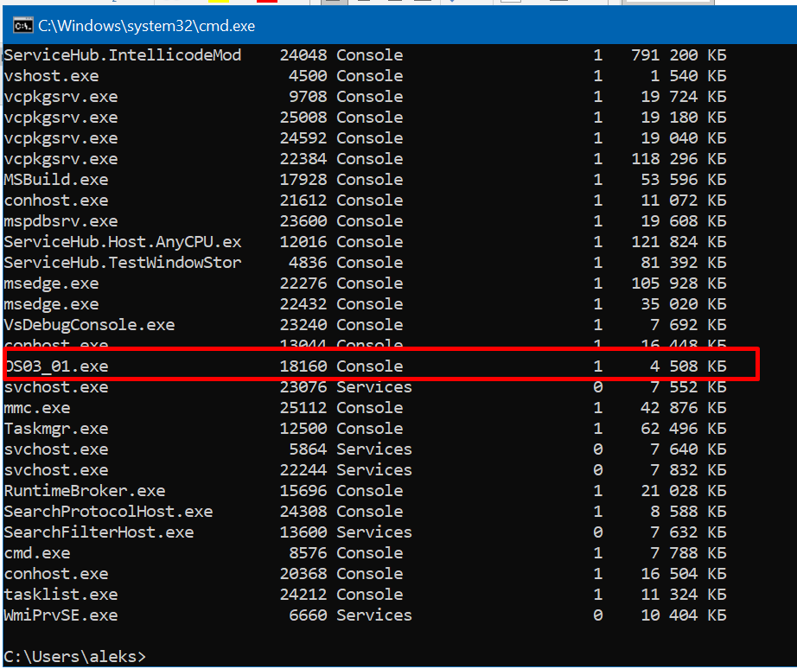

**Performance Monitor:**

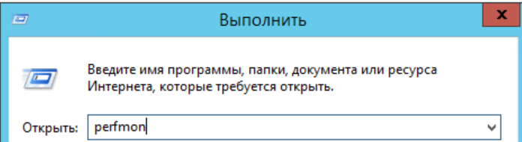

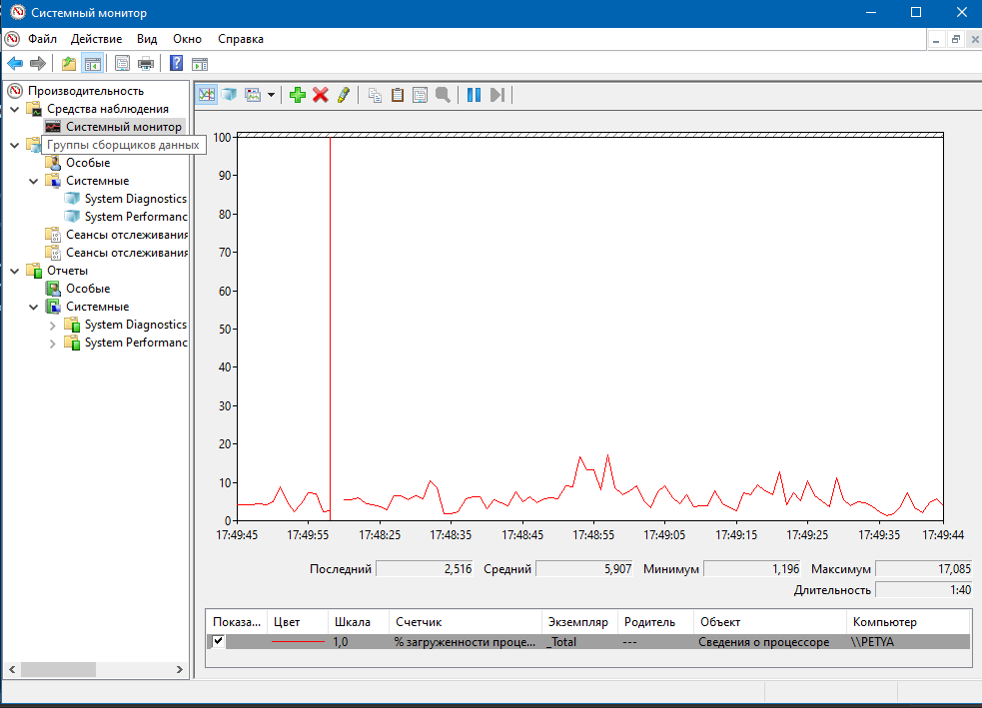

**PowerShell ISE(**powershell_ise**):**

