

**SINGAPORE POLYTECHNIC**

**School of Computing**

Diploma in Infocomm Security Management

**Programming in C and Python**

**ST2411**

**C Assignment 1**

**Report**

Alek Kwek

1804247

DISM/FT/1A/23

Year of Study: 2018

**Report**

My task for this assignment is to create a program to calculate the sales of store outlet in the United States of America using C. This report will outline what I did and what did I learnt from this amazing assignment.

Firstly, I was initially struck at the assignment as I had trouble using C. The biggest problem I have faced in this assignment can be described using two beautiful words: Segmentation fault. Segmentation fault occurs when the program accesses a memory that is not supposed to be accessed by the program. Debugging it is difficult as the code appears to be error free. This fault is like having a girlfriend, she will always express her problems to me. However, when I asked where the root of the problem is, she does not want to tell me. As a result, I had to spend many days to find the problem for her and slowly fix it. One thing I learnt from this experience is that I should not give up even when I could not the fix the problem. The key is to be resilient and grind your teeth in finding the problem. The culprit for segmentation fault is char *, strcmp, strtok and many more. I got the error as this is the first time I use C and did not know how to use them properly at first.

Secondly, I learnt a lot of things in this assignment. I learnt to be grateful when I use other programming languages like Java where I do not have to deal with the memory. In C, I had to be careful when I dealt with memory. If I access some parts of memory that I’m not supposed to access, I would get segmentation fault. This fault helped me to learn more memory than what Computer Architecture and Operating Systems did taught in the last semester. I learnt that there are many types of components in the memory, the heap, the stack and data segments. Furthermore, I learnt how to access the heap using malloc and learn that heap is where dynamic memory allocation takes place. Different memory has different functions and not just one big RAM. This taught me to program better and made me a better programmer in the process of the assignment. In addition, my debugging skills improved as I had to print trace to fix all the issues. Lastly, I used version control to help store my C files and to revert to older versions when the current file has a problem. This benefited me greatly as less time is spend on creating the C files all over again. I used git and GitHub to keep track of my files. I have learnt new bash commands like git add, git commit, and git push as I did the assignment

Overall, I learnt not to give up when even the assignment seems impossible. Like having a relationship. When things are difficult, you don’t just break up and find another girlfriend. You need to sit down and think of a solution to fix the problem. The whole process is not just about struggling with the assignment, it is the perseverance of going through dozens of Stack overflow, C lecture slides and asking my tutor for help. Additionally, going the solution that matters.

All in all, C is one of the most difficult language to master. But with the courage to learn, mastering C is possible.

What I thought memory was before programming in C

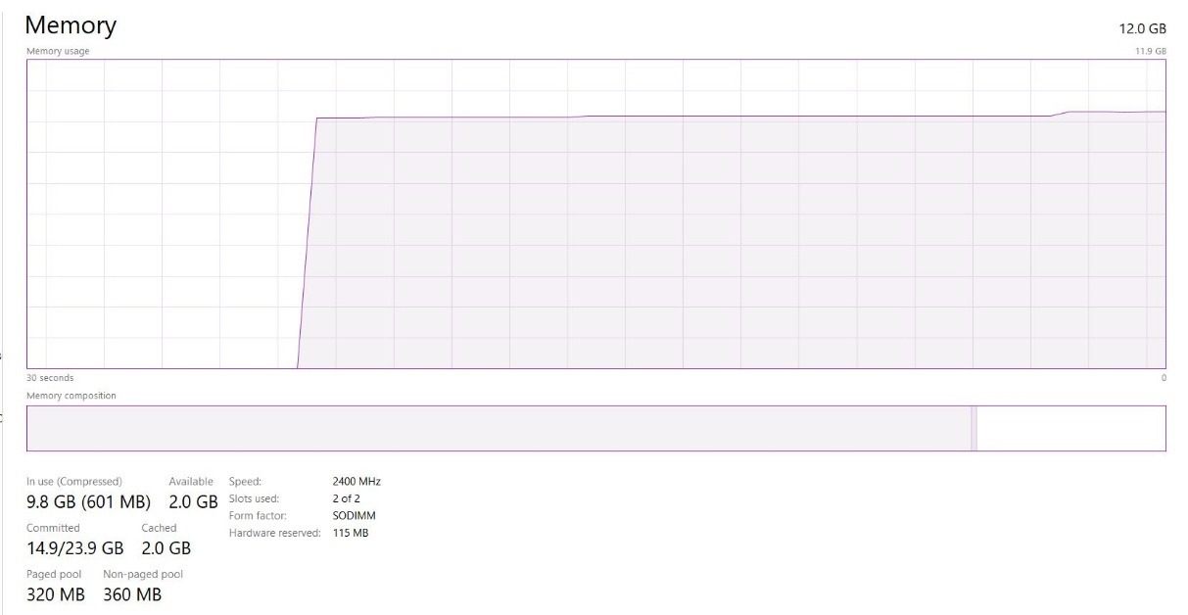

Memory seems to be like just a simple block with application and processes stacking on top of it.

What memory is after programming in C

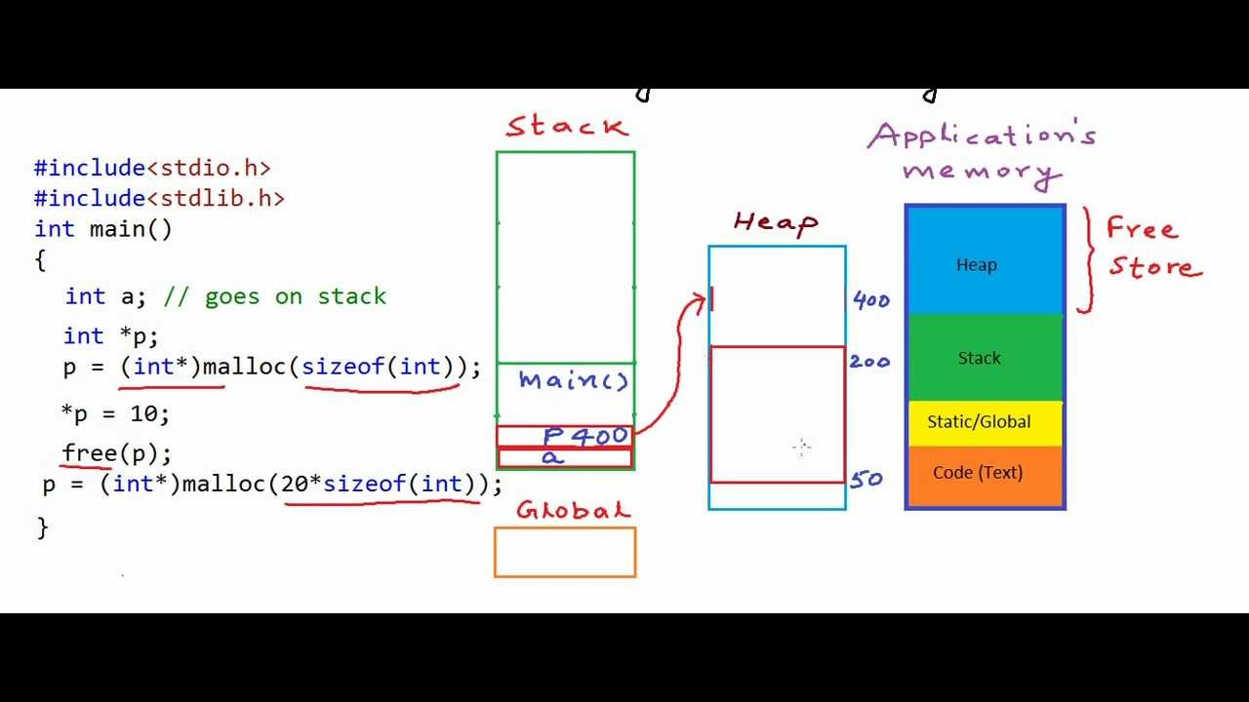

There is heap, stack, global in RAM

Details of the assignment

Limitations

* Maximum array size is 1000. In other words, the maximum number of cities is 999.

Screenshot

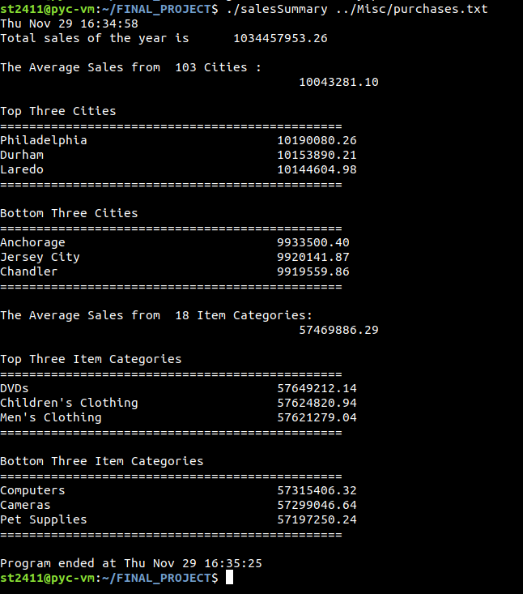

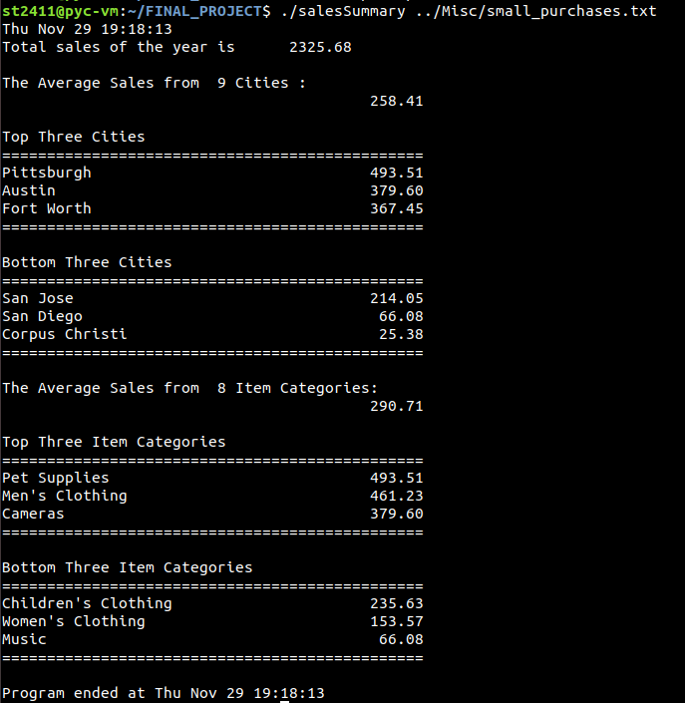

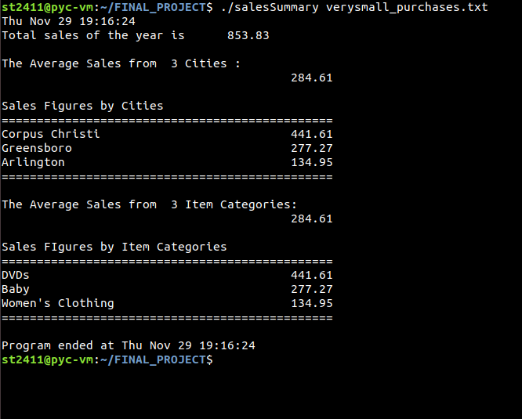

File output

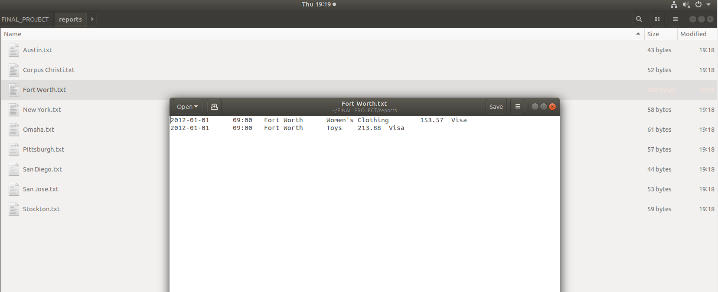

**References**

YouTube. (2013). *Pointers and dynamic memory - stack vs heap*. [online] Available at: https://www.youtube.com/watch?v=_8-ht2AKyH4 [Accessed 29 Nov. 2018].