ASSIGNMENT-15
H NO: 2403A52134

Task 1 – Student Records API
Task:
Use AI to build a RESTful API for managing student records.
Instructions:
- Endpoints required:
  - GET /students → List all students
  - POST /students → Add a new student
  - PUT /students/{id} → Update student details
  - DELETE /students/{id} → Delete a student record
- Use an in-memory data structure (list or dictionary) to store records.
- Ensure API responses are in JSON format.
Expected Output:
- Working API with CRUD functionality for student records.

CODE AND OUTPUT
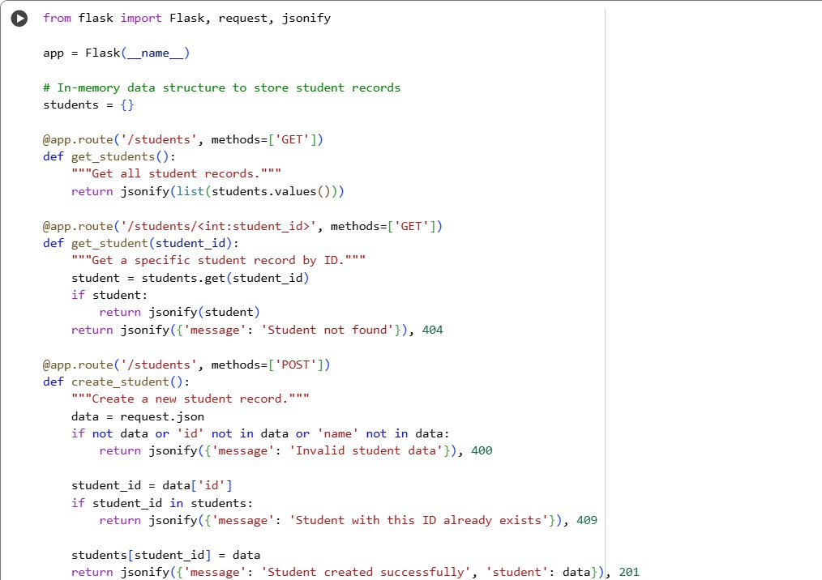
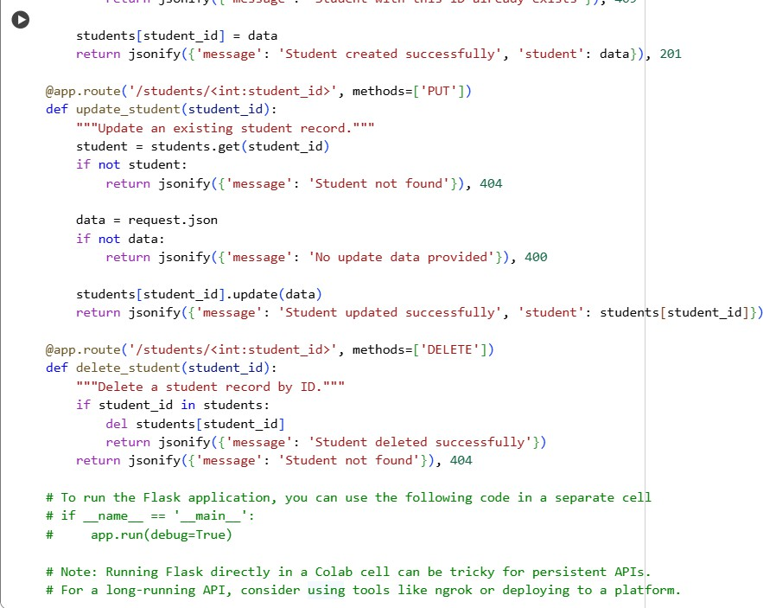
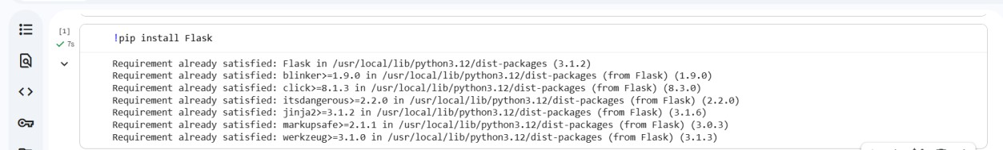

EXPLANATION
- from flask import Flask, request, jsonify: This line imports necessary components from the Flask library.
  - Flask: The main class for creating your web application.
  - request: An object that provides access to incoming request data (like JSON payloads).
  - jsonify: A helper function to return JSON responses from your API endpoints.
- app = Flask( name ): This creates an instance of the Flask application.
- students = {}: This initializes an empty Python dictionary named students. This dictionary serves as the in-memory data structure to store the student records. The keys of the dictionary will be the student IDs, and the values will be the student data (also likely dictionaries).
- @app.route('/students', methods=['GET']): This is a decorator that defines an endpoint for handling GET requests to the /students URL.
  - def get_students():: This function is executed when a GET request is made to /students. It returns a JSON array containing all student records stored in the students dictionary.
- @app.route('/students/<int:student_id>', methods=['GET']): This defines an endpoint for GET requests to /students/<student_id>, where <student_id> is expected to be an integer
  - def get_student(student_id):: This function retrieves a specific student record based on the provided student_id. If the student is found, it returns the student data as JSON; otherwise, it returns a "Student not found" message with a 404 status code.
- @app.route('/students', methods=['POST']): This defines an endpoint for handling POST requests to the /students URL.
  - def create_student():: This function handles the creation of a new student record. It expects the student data in JSON format in the request body. It checks for valid data (including an id and name), ensures the student ID doesn't already exist, adds the new student to the students dictionary, and returns a success message with the created student data and a 201 status code. It returns error messages with 400 or 409 status codes for invalid or duplicate data.
- @app.route('/students/<int:student_id>', methods=['PUT']): This defines an endpoint for handling PUT requests to /students/<student_id>.
  - def update_student(student_id):: This function updates an existing student record based on the student_id. It retrieves the student, updates their record with the data provided in the request body, and returns the updated student data. It returns a 404 if the student is not found.
- @app.route('/students/<int:student_id>', methods=['DELETE']): This defines an endpoint for handling DELETE requests to /students/<student_id>.
  - def delete_student(student_id):: This function deletes a student record based on the student_id. If the student is found and deleted, it returns a success message; otherwise, it returns a 404.
In essence, this code sets up a simple API with endpoints to perform the basic CRUD (Create, Read, Update, Delete) operations on student data stored temporarily in the students dictionary while the Flask application is running.
Task 2:– Library Book Management API
Task:Develop a RESTful API to handle library books.
Instructions:
- Endpoints required:
  - GET /books → Retrieve all books
  - POST /books → Add a new book
  - GET /books/{id} → Get details of a specific book
  - PATCH /books/{id} → Update partial book details (e.g., availability)
  - DELETE /books/{id} → Remove a book
- Implement error handling for invalid requests.
Expected Output:
- Functional API with CRUD + partial updates.
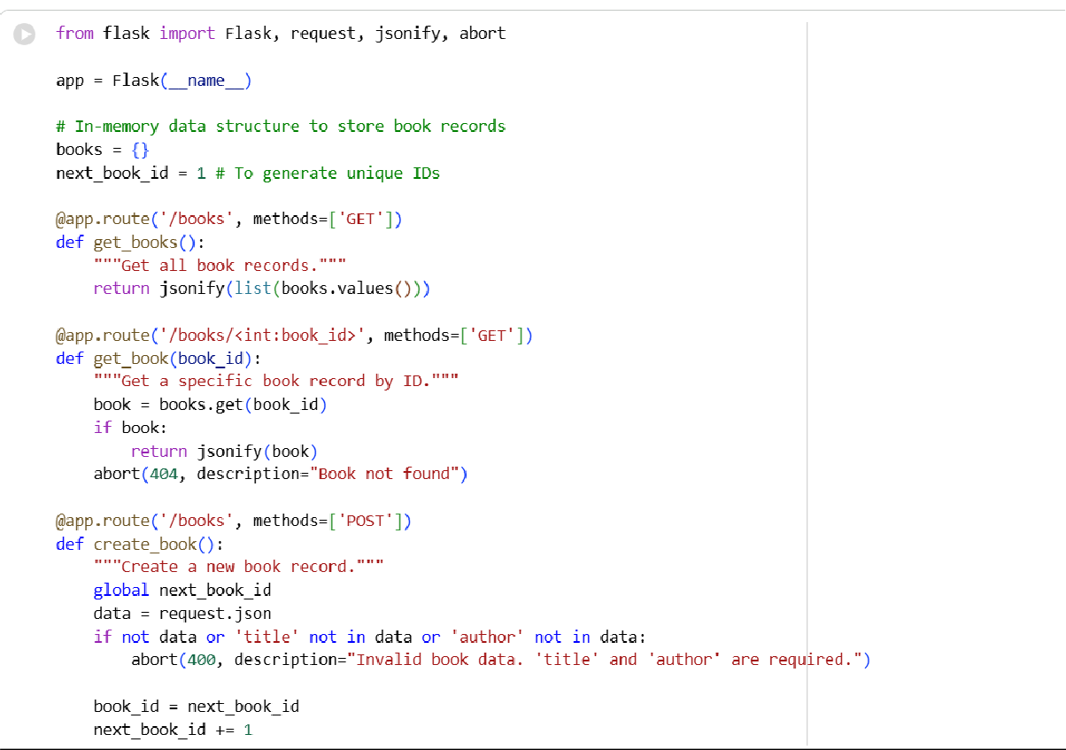
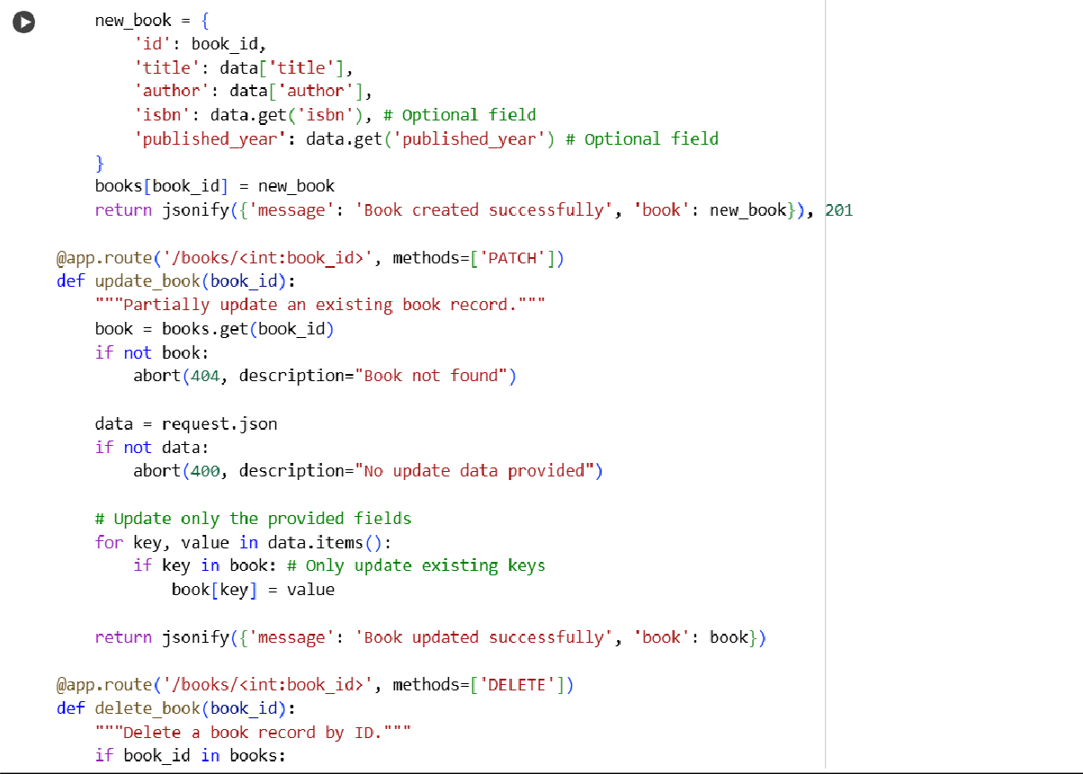

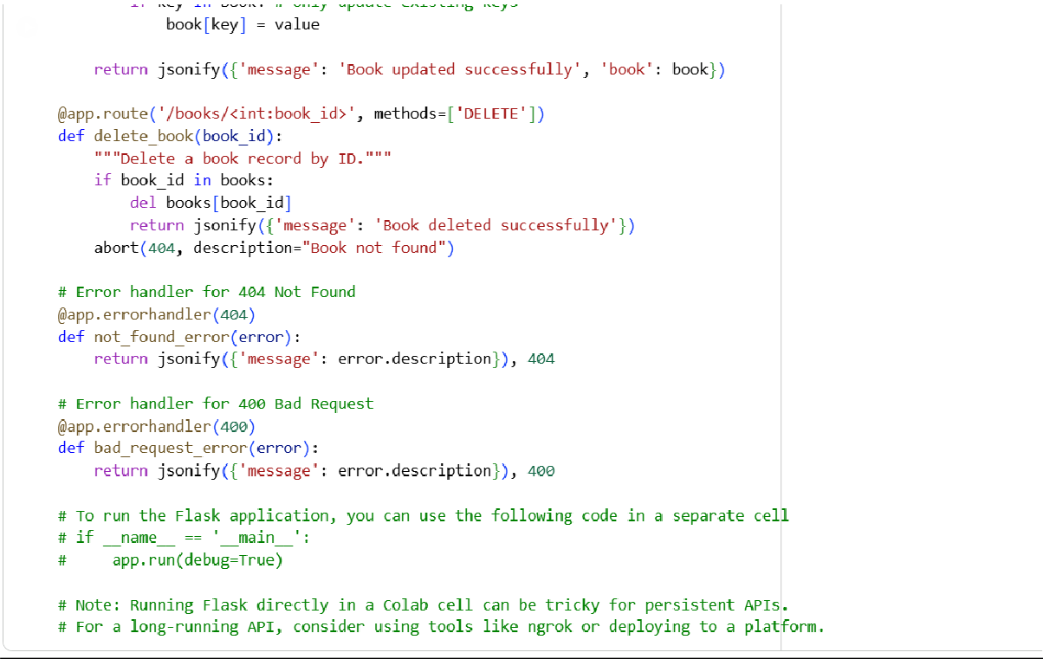

Explanation:
Of course! The code in cell 7f9167f5 defines a Flask-based RESTful API for managing library book records. Here's a breakdown:
- from flask import Flask, request, jsonify, abort: This line imports necessary components from Flask.
  - Flask: The core class for the web application.
  - request: Accesses incoming request data.
  - jsonify: Helps in returning JSON responses.
  - abort: A function to immediately stop the request with a specific HTTP status code and an optional description (used here for error handling).
- app = Flask( name ): Creates an instance of the Flask application.
- books = {}: An in-memory Python dictionary to store book records. Keys will be the book IDs, and values will be the book data.
- next_book_id = 1: An integer variable to keep track of the next available unique ID for new books.
- @app.route('/books', methods=['GET']): Defines the endpoint for GET requests to /books.
  - def get_books():: Returns a JSON list of all book records in the books dictionary
- @app.route('/books/<int:book_id>', methods=['GET']): Defines the endpoint for GET requests to /books/<book_id>.
  - def get_book(book_id):: Retrieves a specific book by its integer ID. If found, returns the book data as JSON. If not found, it uses abort(404, description="Book not found") to return a 404 Not Found error with a custom message.
- @app.route('/books', methods=['POST']): Defines the endpoint for POST requests to /books.
  - def create_book():: Handles the creation of a new book. It expects JSON data with 'title' and 'author'. It uses abort(400, ...) if required fields are missing. It generates a unique ID using next_book_id, creates a new book dictionary (including optional 'isbn' and 'published_year' fields), adds it to
the books dictionary, increments next_book_id, and returns the new book data with a 201 Created status code.
- @app.route('/books/<int:book_id>', methods=['PATCH']): Defines the endpoint for PATCH requests to /books/<book_id>.
  - def update_book(book_id):: Partially updates an existing book record. It retrieves the book by ID (aborting with 404 if not found). It then iterates through the JSON data provided in the request and updates only the fields that already exist in the book record. It aborts with 400 if no update data is provided.
- @app.route('/books/<int:book_id>', methods=['DELETE']): Defines the endpoint for DELETE requests to /books/<book_id>.
  - def delete_book(book_id):: Deletes a book record by its ID. If the ID exists, the book is removed from the dictionary, and a success message is returned. If not found, it aborts with a 404.
- @app.errorhandler(404) and @app.errorhandler(400): These are error handlers. They catch specific HTTP errors (404 Not Found and 400 Bad Request) that were raised using abort() within the route functions and return a consistent JSON response format containing the error's description.
This code provides a functional, albeit simple, API for managing book data in memory, demonstrating how to handle different HTTP methods and implement basic error responses using Flask.

Task 3 – Employee Payroll API
Task:Create an API for managing employees and their salaries.
Instructions:
- Endpoints required:
  - GET /employees → List all employees
  - POST /employees → Add a new employee with salary details
  - PUT /employees/{id}/salary → Update salary of an employee
  - DELETE /employees/{id} → Remove employee from system
- Use AI to:
  - Suggest data model structure.
  - Add comments/docstrings for all endpoints.
Expected Output:
- API supporting salary management with clear documentation.

CODE AND OUTPUT
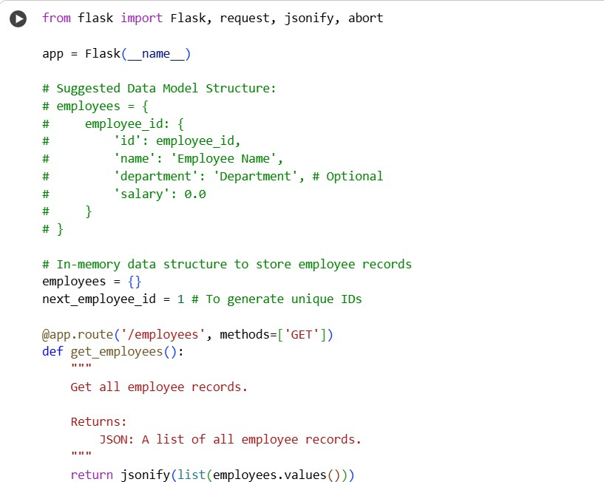
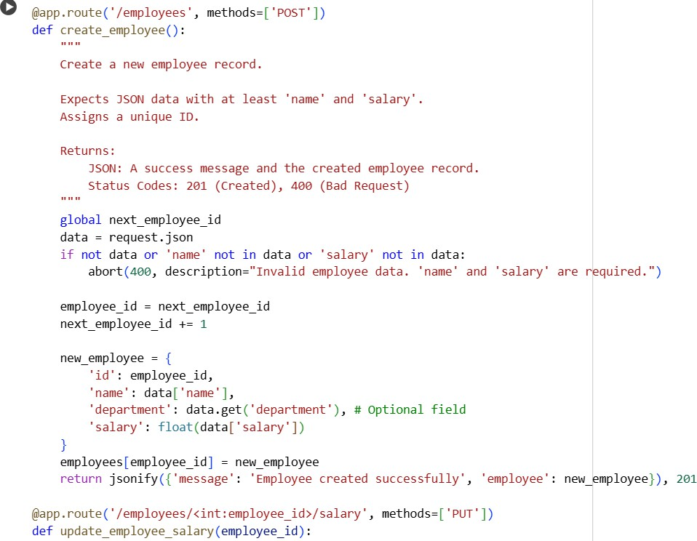
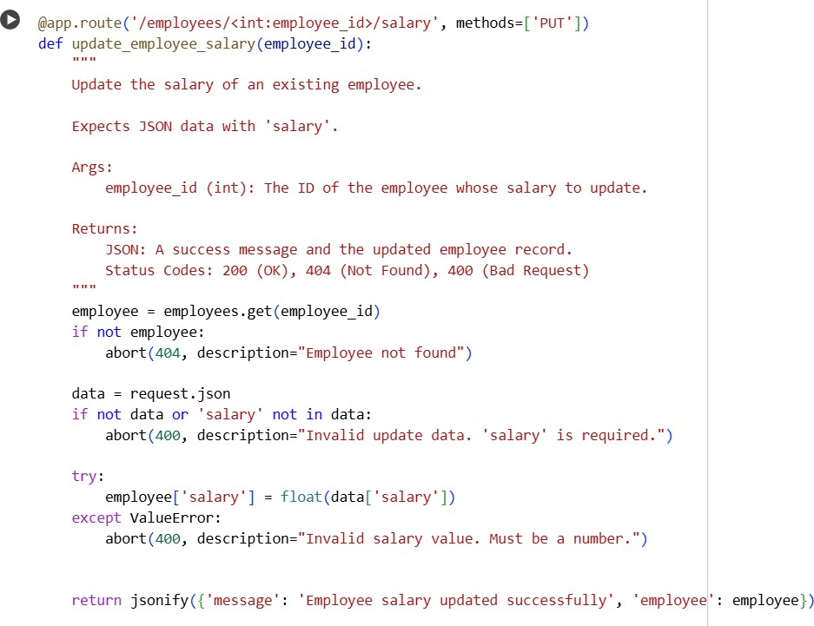
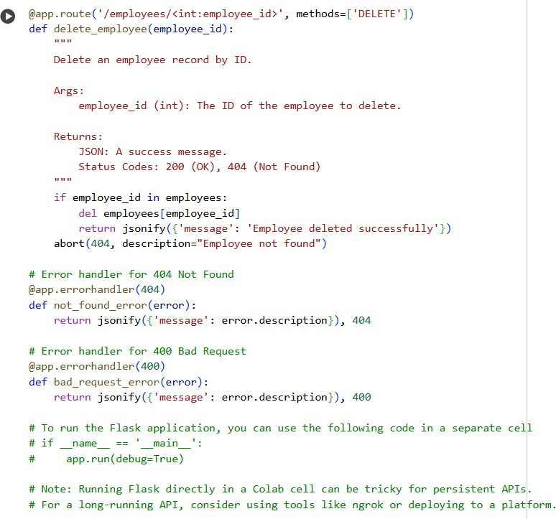
Explanation:
Absolutely! The code in cell ea88f049 sets up a RESTful API using Flask to manage employee records, including their salaries. Here's a breakdown:
- from flask import Flask, request, jsonify, abort: Imports necessary Flask components.
  - Flask: To create the web application.
  - request: To access incoming request data (like JSON).
  - jsonify: To format responses as JSON.
  - abort: To easily return standard HTTP error responses.
- app = Flask( name ): Initializes the Flask application.
- # Suggested Data Model Structure:: This is a comment section suggesting a dictionary structure for storing employee data, including id, name, department (optional),
and salary.
- employees = {}: An in-memory dictionary to hold the employee records. The key will be the employee ID, and the value will be the dictionary representing the employee's data.
- next_employee_id = 1: An integer used to assign unique IDs to new employees.
- @app.route('/employees', methods=['GET']): Defines the endpoint for GET requests to /employees.
  - def get_employees():: This function retrieves and returns a JSON list of all employee records stored in the employees dictionary.
- @app.route('/employees', methods=['POST']): Defines the endpoint for POST requests to /employees.
  - def create_employee():: This function handles adding a new employee. It expects JSON data containing at least 'name' and 'salary'. It uses abort(400, ...) if these required fields are missing. It assigns a unique ID
using next_employee_id, creates the employee dictionary, adds it to
the employees dictionary, and returns the new employee data with a 201 Created status code.
- @app.route('/employees/<int:employee_id>/salary', methods=['PUT']): This is a specific endpoint for PUT requests to /employees/<employee_id>/salary, designed only for updating an employee's salary.
  - def update_employee_salary(employee_id):: This function updates the salary of a specific employee identified by employee_id. It checks if the employee exists (abort(404, ...) if not) and expects JSON data with a 'salary' field (abort(400,
...) if missing or not a valid number). If successful, it updates the employee's salary and returns the updated record.
- @app.route('/employees/<int:employee_id>', methods=['DELETE']): Defines the endpoint for DELETE requests to /employees/<employee_id>.
  - def delete_employee(employee_id):: This function removes an employee record based on the employee_id. If the employee is found and deleted, it returns a success message. If not found, it uses abort(404, ...) to return a 404 error.
- @app.errorhandler(404) and @app.errorhandler(400): These are error handlers that catch 404 Not Found and 400 Bad Request errors raised by the abort() function, returning a consistent JSON response format.

Task 4 – Real-Time Application: Online Food Ordering API
Scenario:
Design a simple API for an online food ordering system.
Requirements:
- Endpoints required:
  - GET /menu → List available dishes
  - POST /order → Place a new order
  - GET /order/{id} → Track order status
  - PUT /order/{id} → Update an existing order (e.g., change items)
  - DELETE /order/{id} → Cancel an order
- AI should generate:
  - REST API code
  - Suggested improvements (like authentication, pagination)
Expected Output:
- Fully working API simulating a food ordering backend.

CODE AND OUTPUT
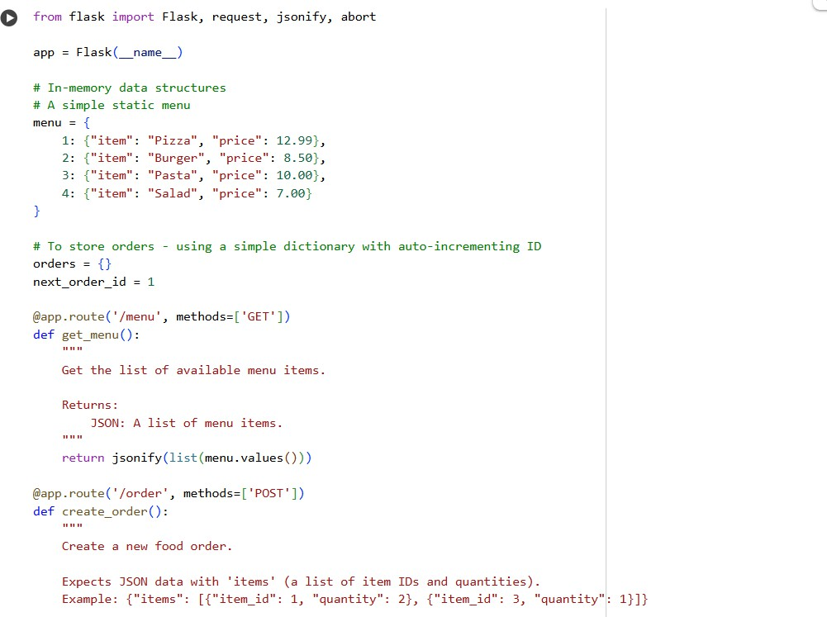

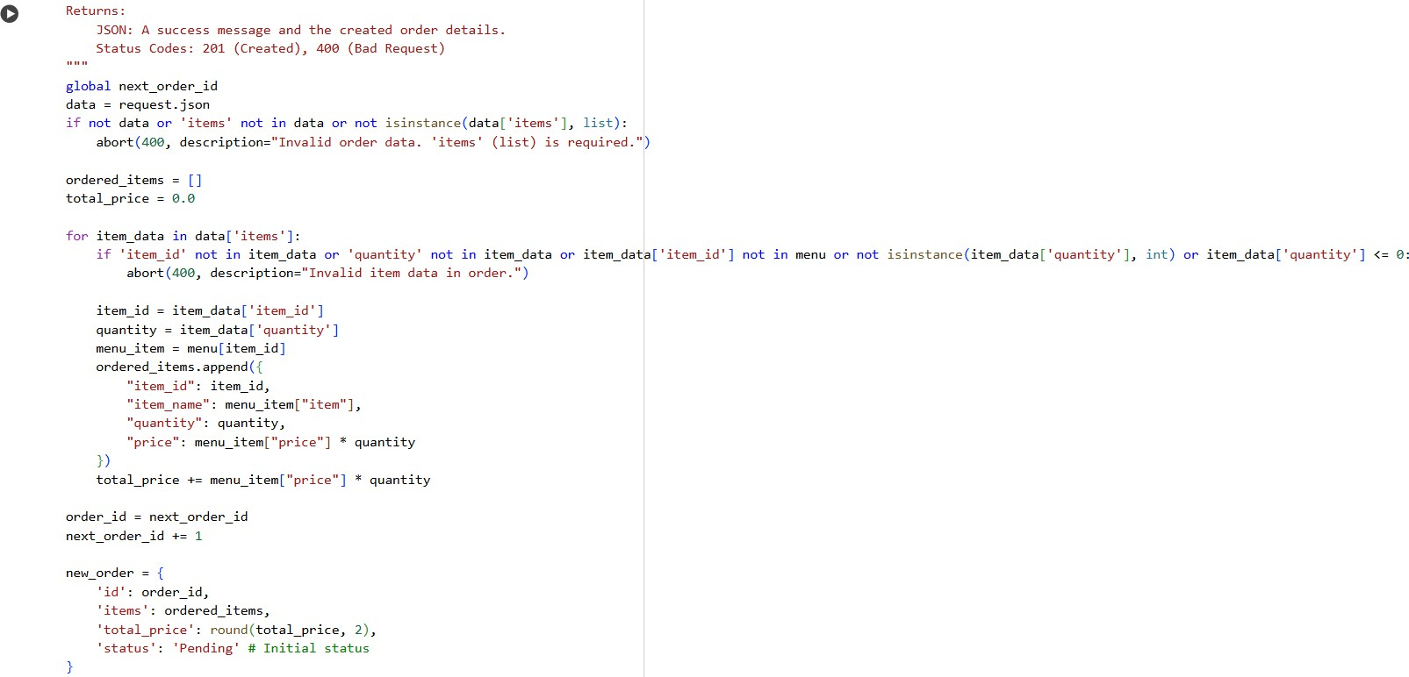

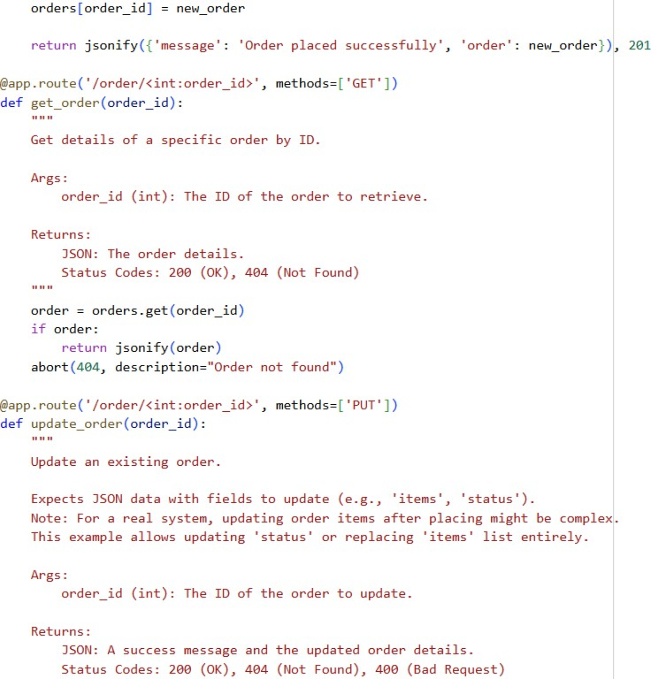

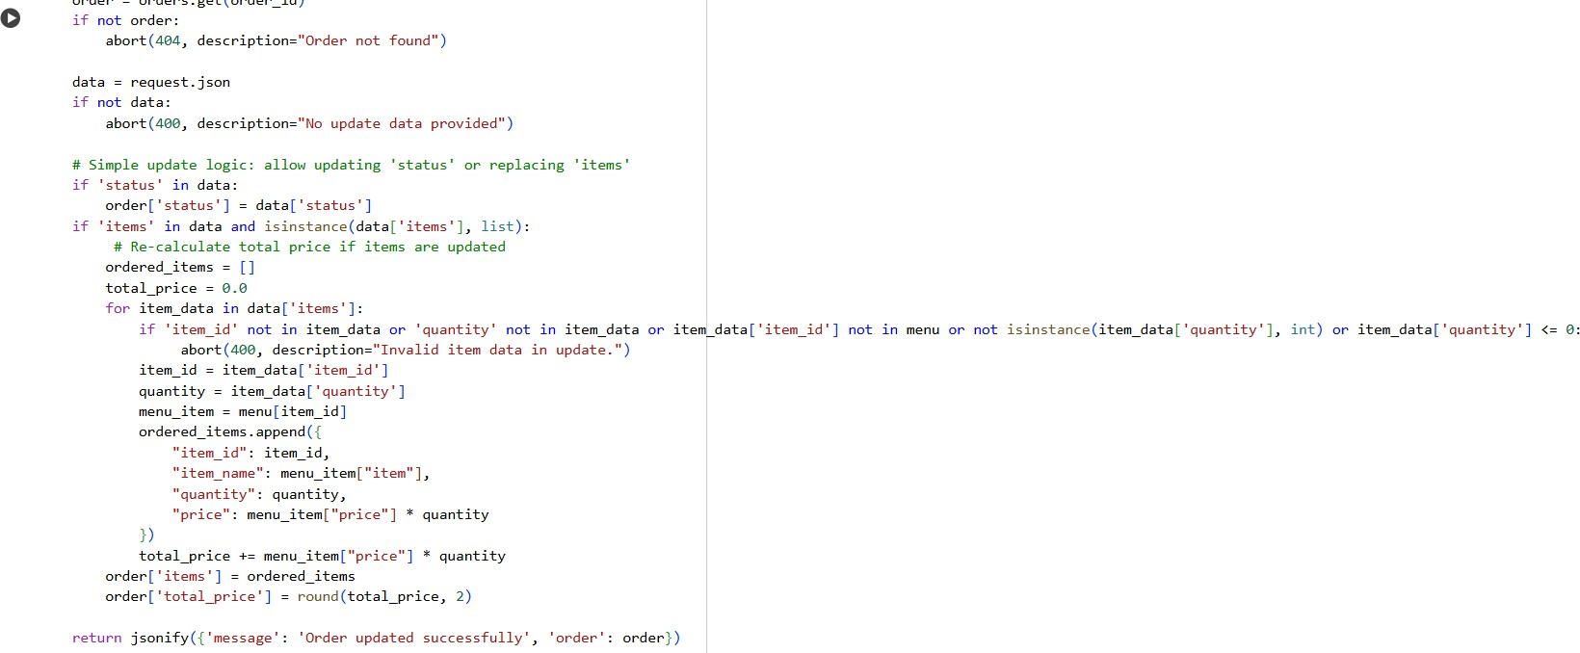
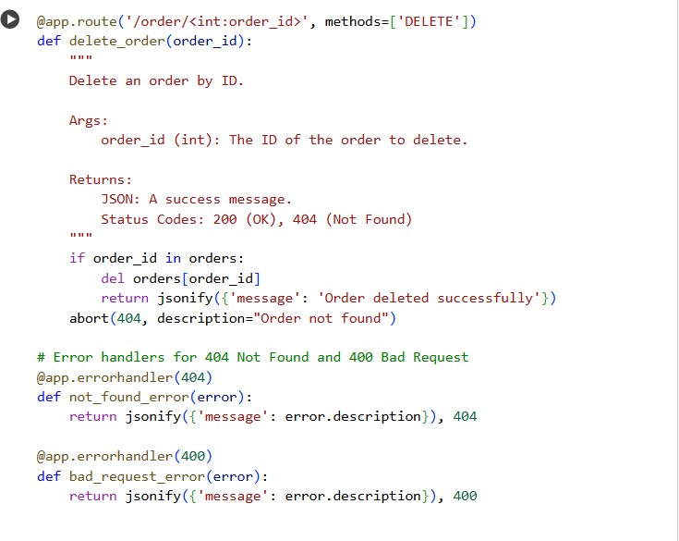
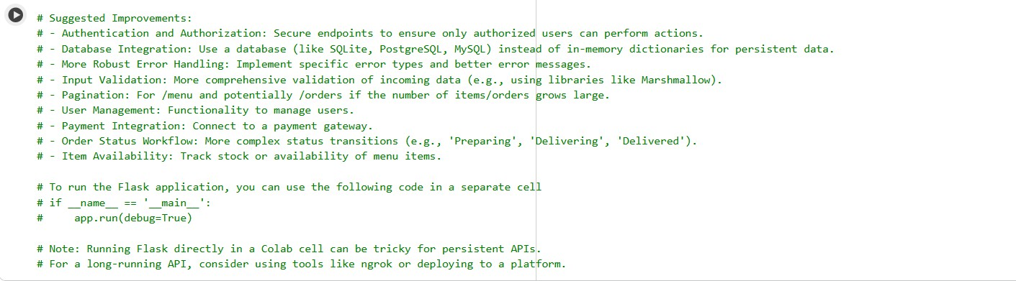

Explanation:
Certainly! The code in cell ec995a46 defines a basic RESTful API for an online food ordering system using the Flask framework. Here's a breakdown of its components:
- from flask import Flask, request, jsonify, abort: Imports necessary classes and functions from Flask, including abort for error handling.
- app = Flask( name ): Initializes the Flask application instance.
- menu = {...}: This dictionary holds the static menu data. Each key is an item ID, and the value is another dictionary containing the item's item name and price.
- orders = {}: This dictionary will store the order records in memory. The key will be the order ID, and the value will be a dictionary representing the order details.
- next_order_id = 1: An integer to generate unique IDs for new orders.
- @app.route('/menu', methods=['GET']): Defines the endpoint for GET requests to /menu.
  - def get_menu():: Returns a JSON list of all items available in the menu dictionary.
- @app.route('/order', methods=['POST']): Defines the endpoint for POST requests to /order.
  - def create_order():: This function handles placing a new order. It expects JSON data with an 'items' key, which should be a list of dictionaries containing 'item_id' and 'quantity'. It validates the input data, calculates the total price based on the menu, assigns a unique order_id, stores the order in
the orders dictionary, and returns the order details with a 201 Created status code. It uses abort(400, ...) for various invalid input scenarios.
- @app.route('/order/<int:order_id>', methods=['GET']): Defines the endpoint for GET requests to /order/<order_id>.
  - def get_order(order_id):: Retrieves and returns the details of a specific order by its integer ID. If the order is not found, it uses abort(404, ...) to return a 404 Not Found error.
- @app.route('/order/<int:order_id>', methods=['PUT']): Defines the endpoint for PUT requests to /order/<order_id>.
  - def update_order(order_id):: This function allows updating an existing order. It checks if the order exists (abort(404, ...) if not). It expects JSON data to update fields like 'status' or replace the 'items' list. If the 'items' list is updated, it recalculates the total price. It uses abort(400, ...) for invalid update data.
- @app.route('/order/<int:order_id>', methods=['DELETE']): Defines the endpoint for DELETE requests to /order/<order_id>.

  - def delete_order(order_id):: Deletes an order by its ID. If the order is found, it is removed from the orders dictionary, and a success message is returned. If not found, it uses abort(404, ...) to return a 404 error.
- @app.errorhandler(404) and @app.errorhandler(400): These are custom error handlers that catch 404 and 400 errors raised by abort() and return a consistent JSON response format with the error description.
- # Suggested Improvements:: This is a comment block listing potential areas for improvement in a real-world system, such as authentication, database integration, more robust error handling, and other features.
This code provides a functional blueprint for a simple food ordering API, demonstrating how to handle different request types, process order data, and implement basic error handling within a Flask application.

