ASSIGNMENT-20
H NO: 2403A52134

Task 1: Detect Hardcoded Credentials
Instructions:
  - Ask AI to generate a Python script that connects to a database or API.
  - Check if the code contains hardcoded usernames, passwords, or API keys.
  - Modify the code to securely load credentials from environment variables.
- Expected Output:
  - Insecure version:
  - password = "admin123"
  - Secure version:
  - import os
password = os.getenv("DB_PASSWORD")

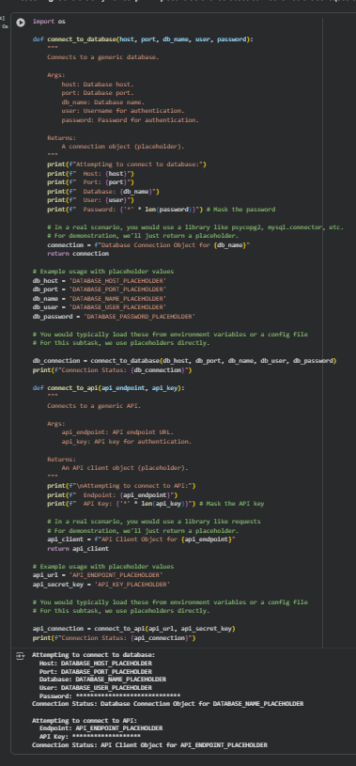

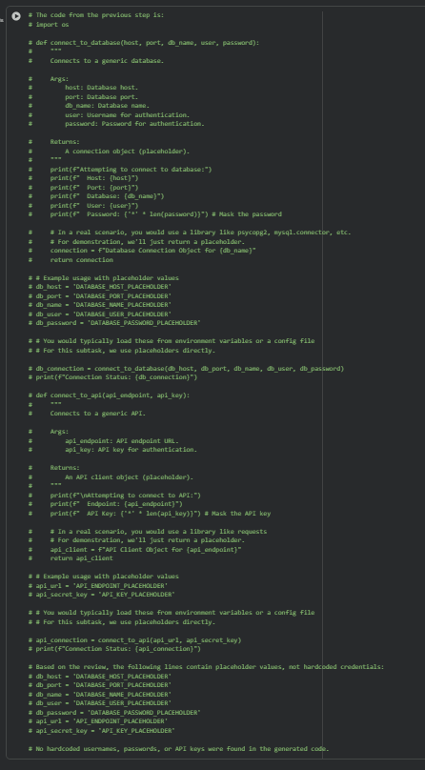

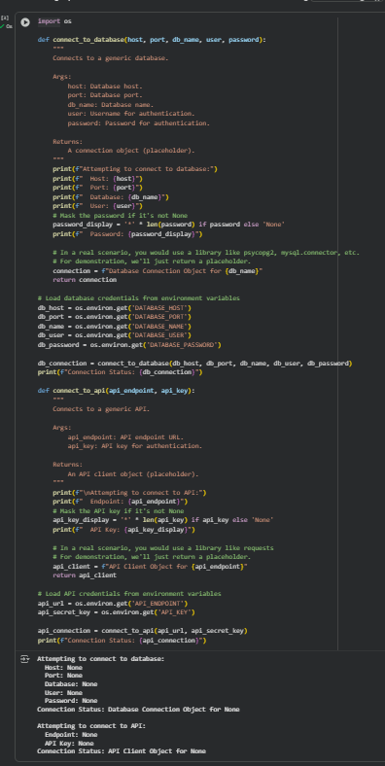

Task 2: Identify SQL Injection Vulnerabilities
- Instructions:
  - Use AI to generate a simple login system in Python (with SQLite or MySQL).
  - Test the system with an input like:
  - ' OR '1'='1
  - Identify if SQL injection is possible.
  - Rewrite the code using parameterized queries to prevent injection.
- Expected Output:
  - Vulnerable query:
  - SELECT * FROM users WHERE username = 'admin' AND password = '1234'
  - Secure query with parameters:
cursor.execute("SELECT * FROM users WHERE username=? AND password=?", (user, pwd))
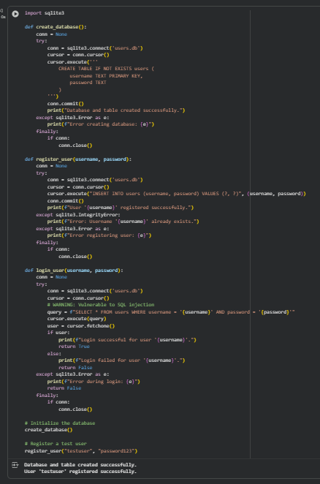
Task 3: Detect Unsafe File Handling
Instructions:
- Ask AI to generate a Python script that reads and writes files based on user input.
- Check if the code allows path traversal attacks (e.g., entering ../../etc/passwd).
- Fix the vulnerability by validating file paths or restricting access to safe directories.
Expected Output:
- Insecure: Allows access to system files.
- Secure: Only allows files inside a data/ folder.
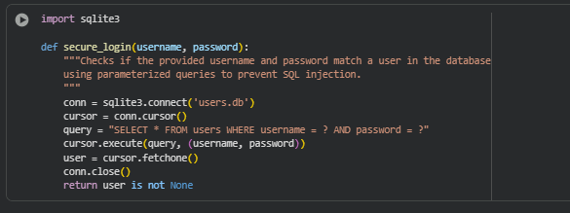

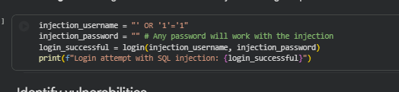

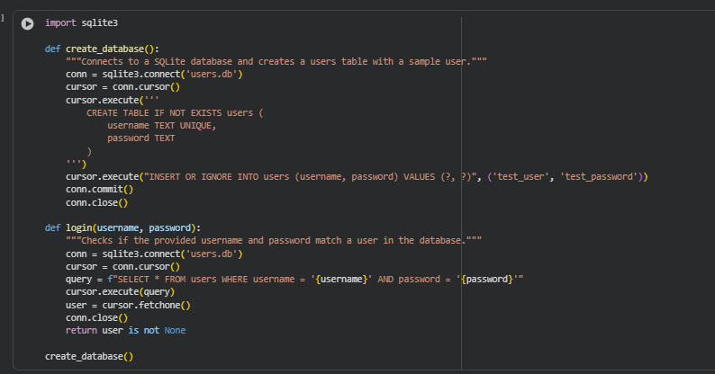

Task 4: Identify Insecure Use of eval() or exec()
- Instructions:
  - Ask AI to generate a calculator program that evaluates user input.
  - If it uses eval() or exec(), test it with malicious input (e.g., __import__('os').system('rm -rf /')).
  - Replace it with a safe parser (e.g., ast.literal_eval() in Python).
- Expected Output:
  - Vulnerable code:
  - result = eval(user_input)
  - Secure code:
  - import ast
result = ast.literal_eval(user_input)

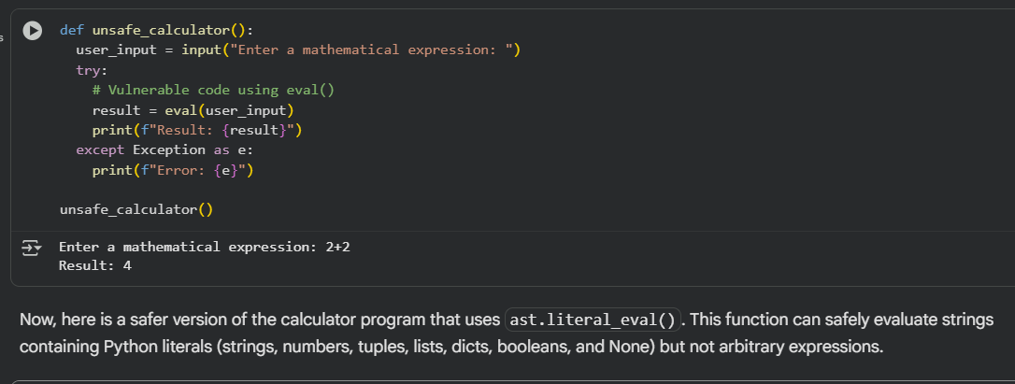

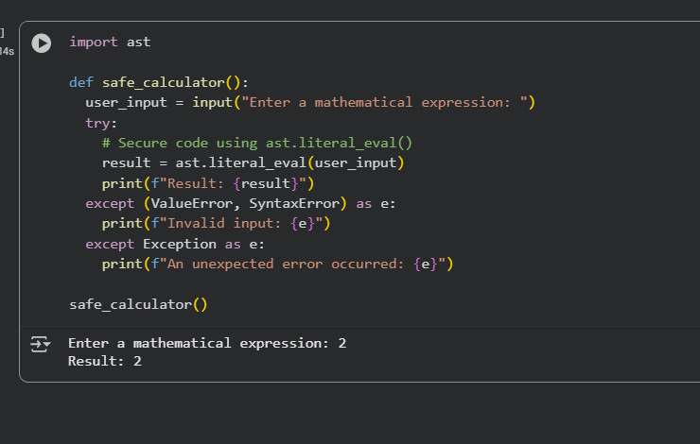
Task 5: Static Security Testing with Linting Tools
Instructions:
- Use AI to generate a web server script (Flask or Node.js).
- Run a static analysis tool (e.g., bandit for Python or eslint for JavaScript).
Identify at least two vulnerabilities flagged by the tool.
- Fix the vulnerabilities and re-run the tool until no issues remain.

Expected Output:
- Initial scan: Shows security warnings (e.g., unsafe imports, weak cryptography).After fixes: Tool reports 0 vulnerabilities.

