Lab Assingment-14
Task 1: Create a Responsive Web Page Layout
Instructions:
- Design a basic web page layout with a header, main content area, and footer using HTML and CSS.
- Use AI to assist in generating responsive CSS for different screen sizes.
- Ensure the layout is clean and visually organized.
Expected Output:
- A responsive web page with:
  - Header with navigation links
  - Main section with placeholder text/images
  - Footer with copyright or contact info
- Layout adapts correctly to desktop, tablet, and mobile screen sizes.

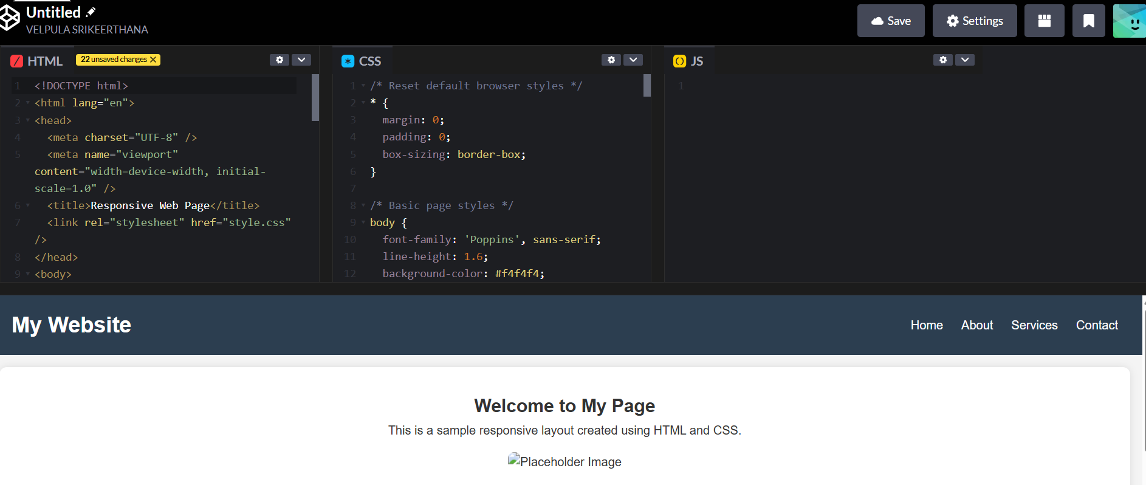
Task 2: Interactive Button with JavaScript
Instructions:
- Create a button on a web page.
- Use AI to generate JavaScript code that displays an alert message when the button is clicked.
- Ensure the code is clean and well-commented.
Expected Output:
- A web page with a button.
- Clicking the button shows a pop-up alert message, e.g., “Button clicked!”.

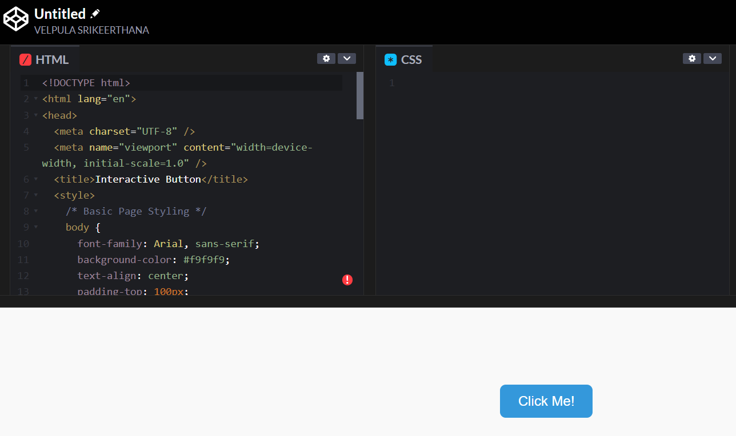
Task 3: Form with Validation
Instructions:
- Design a contact form with fields: Name, Email, Message.
- Use AI to generate JavaScript code for form validation (e.g., non-empty fields, valid email format).
- Add inline error messages if input is invalid.
Expected Output:
- A functional contact form where:
  - Submitting with empty fields shows error messages.
  - Submitting with valid input displays a “Form submitted successfully” message.
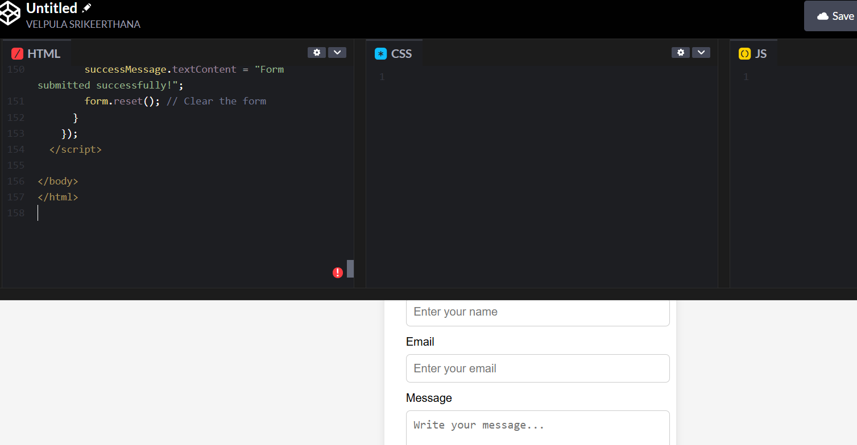
Task 4: Dynamic Content Generation
Instructions:
- Create a list of items (e.g., product names) using HTML.
- Use AI-generated JavaScript to dynamically add or remove items from the list when a button is clicked.
Expected Output:
- A web page with a list and buttons:
  - “Add Item” adds a new item to the list dynamically.
  - “Remove Item” deletes the last item.
- Updates occur without reloading the page.
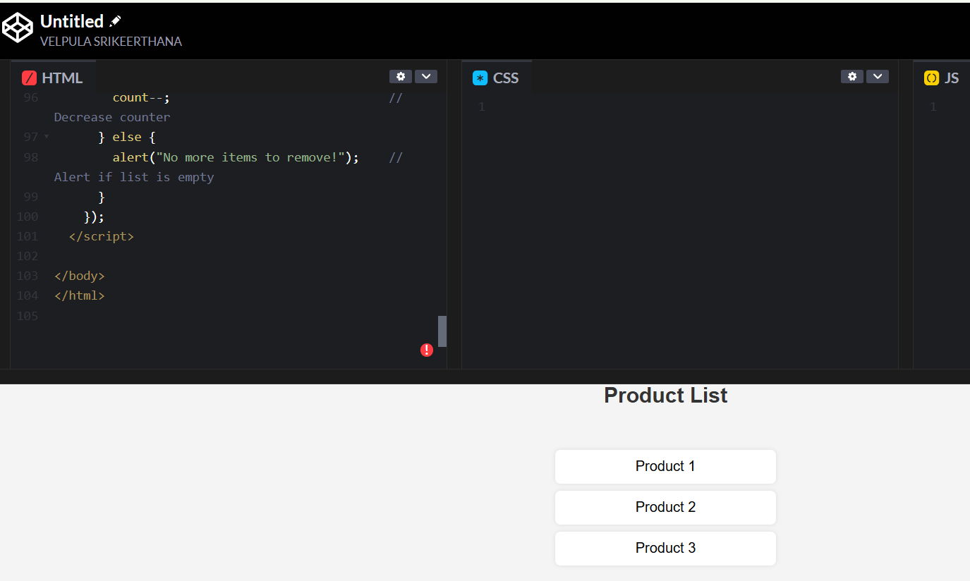
Task 5: Styled Modal Popup
Instructions:
- Use AI to generate a modal popup that opens when a button is clicked.
- Style the modal using CSS with a semi-transparent overlay.
- Include a close button that hides the modal.
Expected Output:
- A web page with a button labeled “Open Modal”.
- Clicking the button displays the modal popup with content.
- Modal can be closed by clicking the “X” button or overlay area.
