ASSIGNMENT - 17

Use AI to generate a Python script for cleaning an employee dataset. Instructions:
- Handle missing values in columns (salary, department, joining_date).
- Convert the "joining_date" column into proper datetime format.
- Standardize department names (e.g., "HR", "hr", "Human Resources" → "HR").
- Encode categorical variables (department, job_role).

Expected Output:
- A cleaned Pandas DataFrame with consistent departments, proper dates, and encoded features.

Expected code :

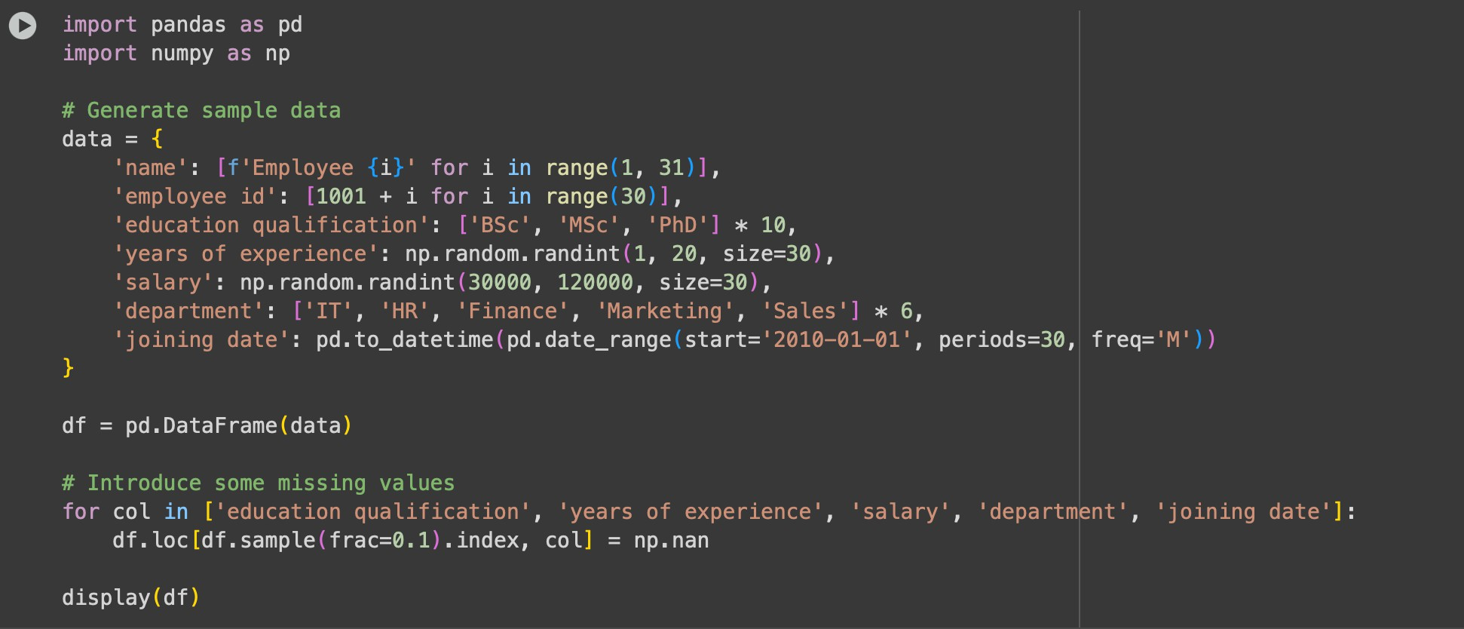

Dataset:

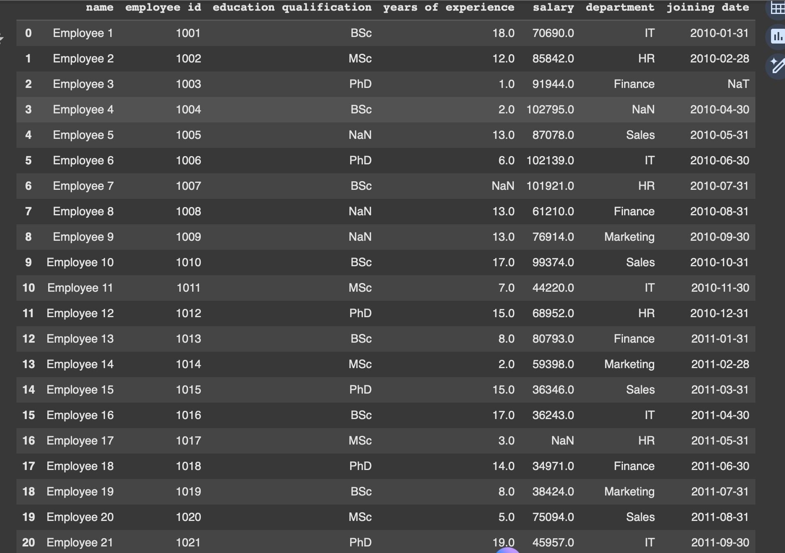

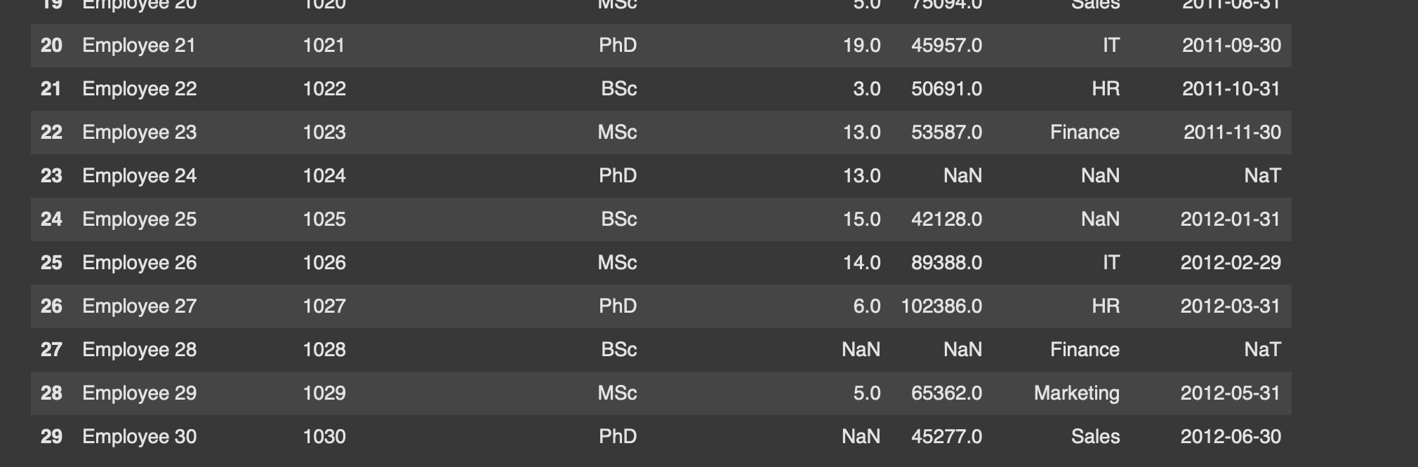

Identifying and handling missing values:

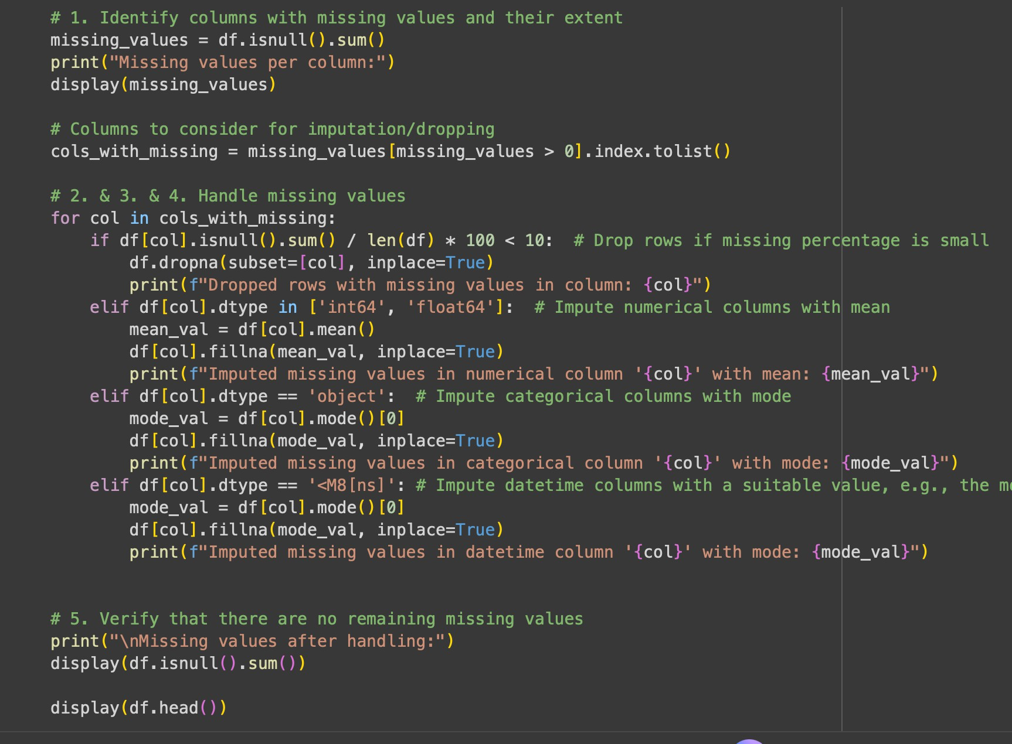

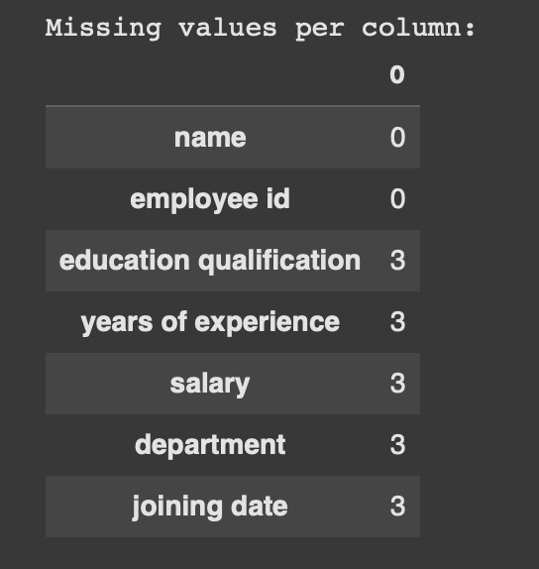
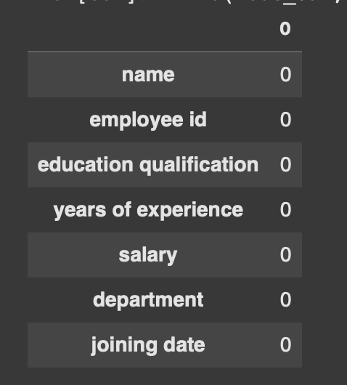

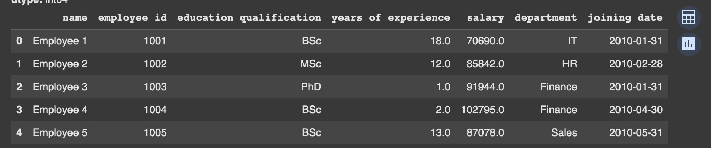

Converting joining date to proper date format:

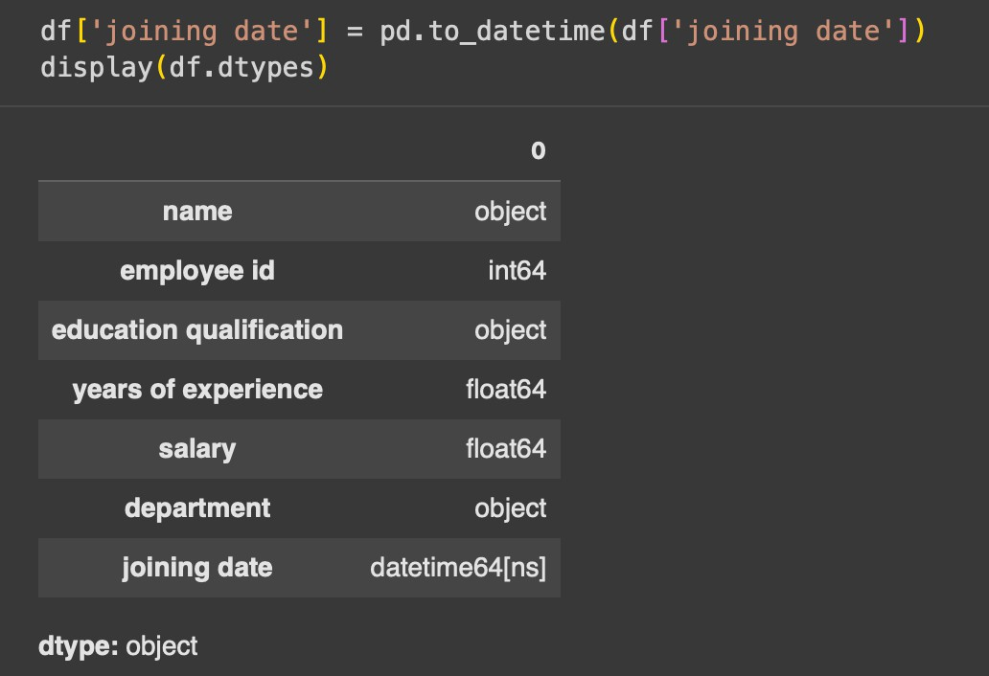

Standardize department names :

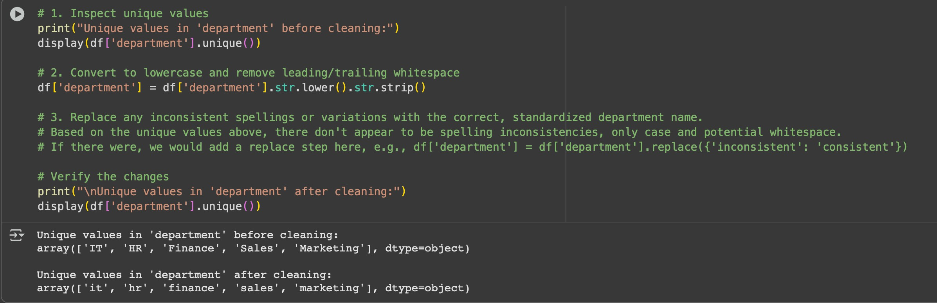

Encoding data:

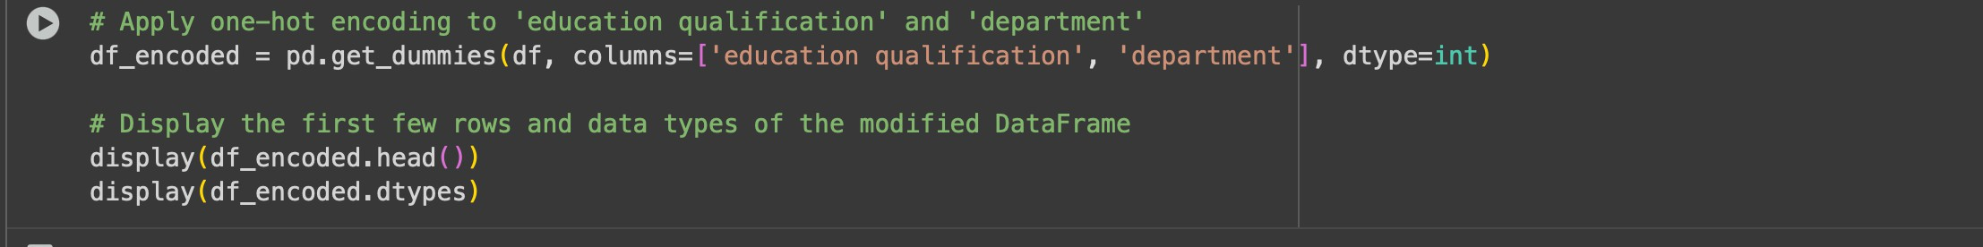

Expected output :

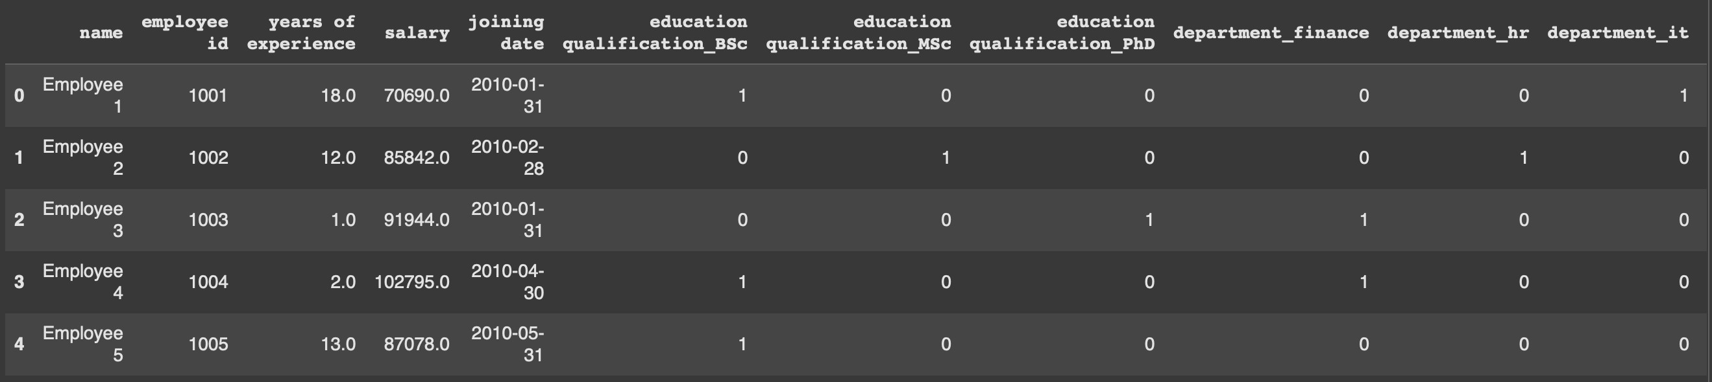

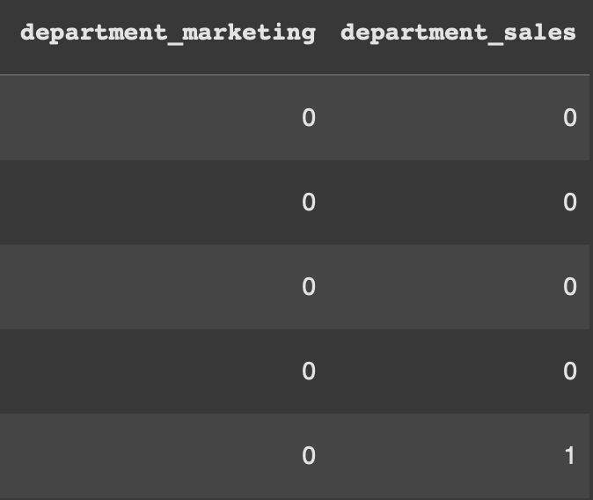
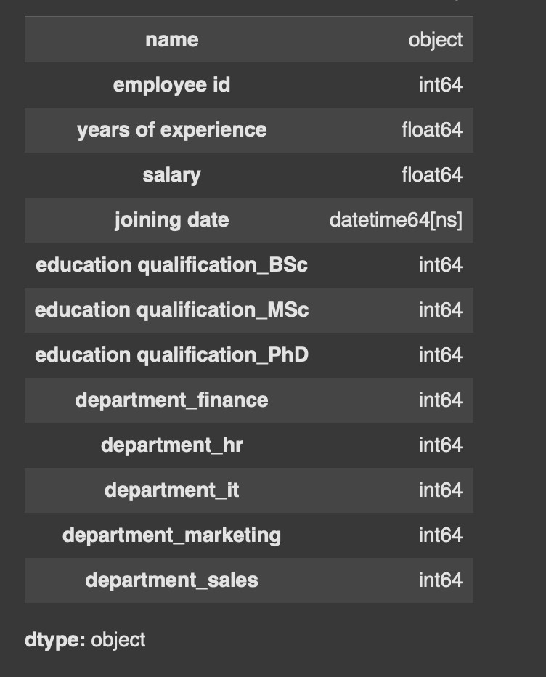

TASK 2:
Use AI to generate a script for preprocessing a sales transaction dataset.
Instructions:
- Convert transaction dates to proper date-time format.
- Create a new column for “Month-Year” from the transaction date.
- Remove rows with negative or zero transaction amounts.
- Normalize the "transaction_amount" column using Min-Max scaling.
Expected Output:
- A preprocessed DataFrame with valid dates, normalized amounts, and no invalid records.

Expected code and sample dataset :
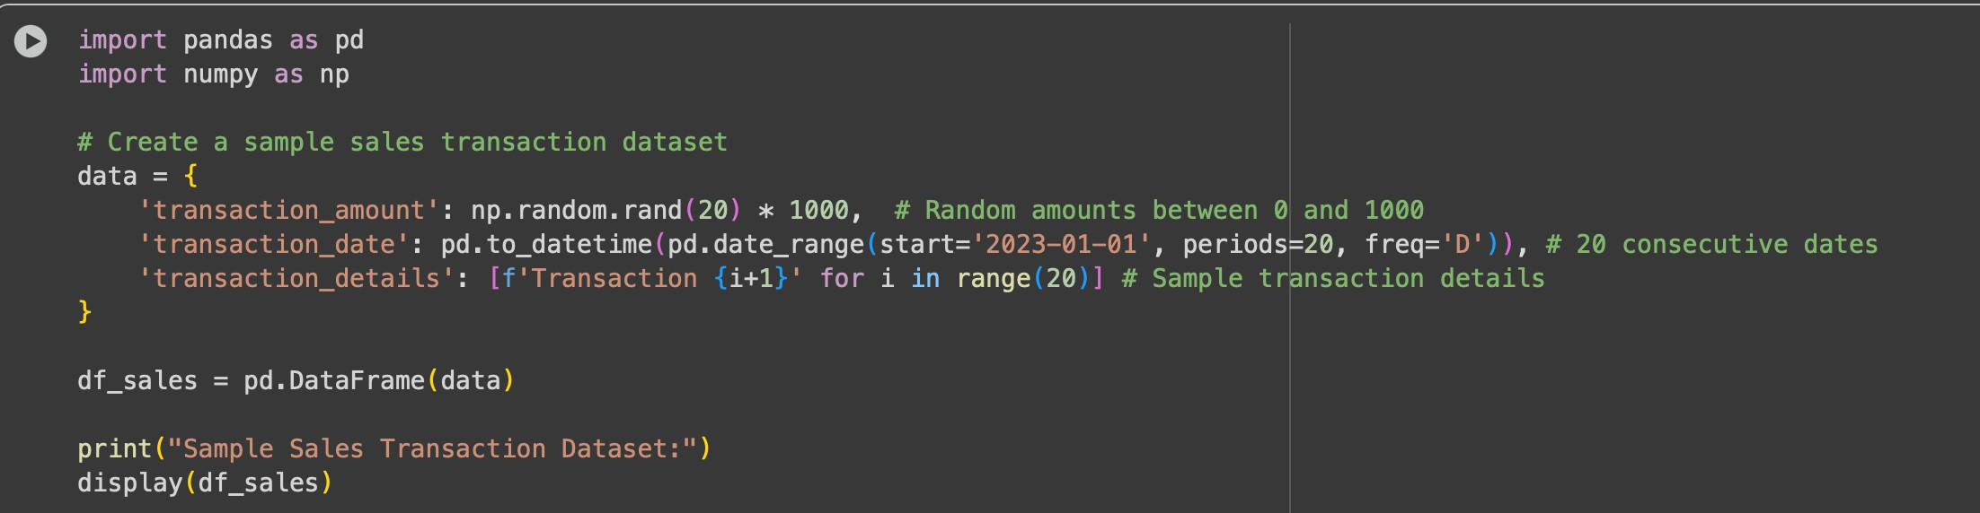

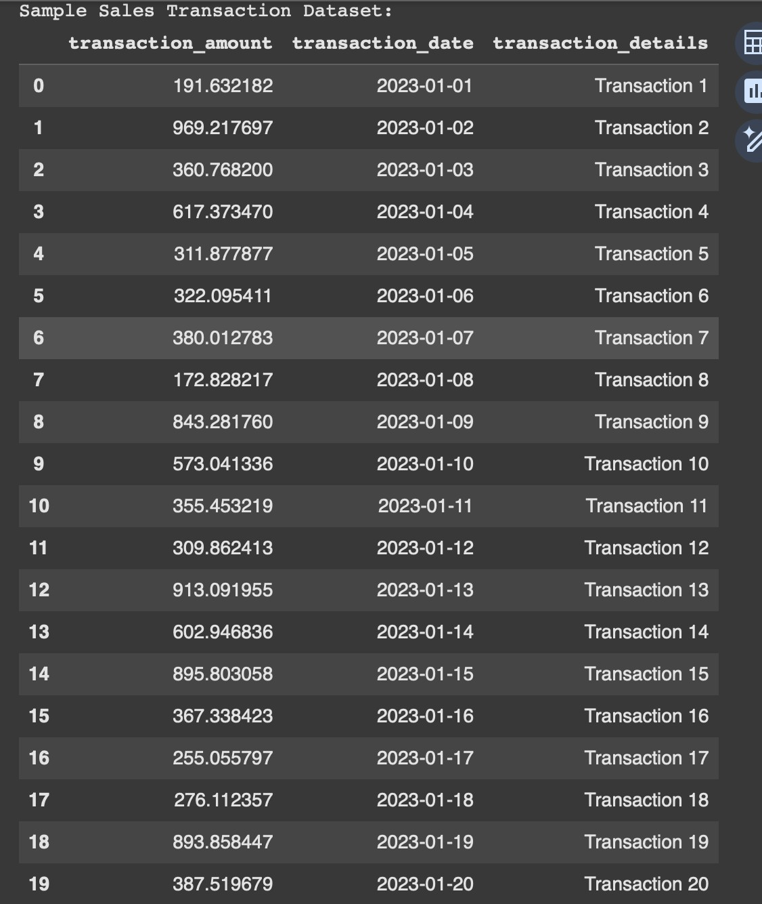

Converting date format and removing irrelevant columns :
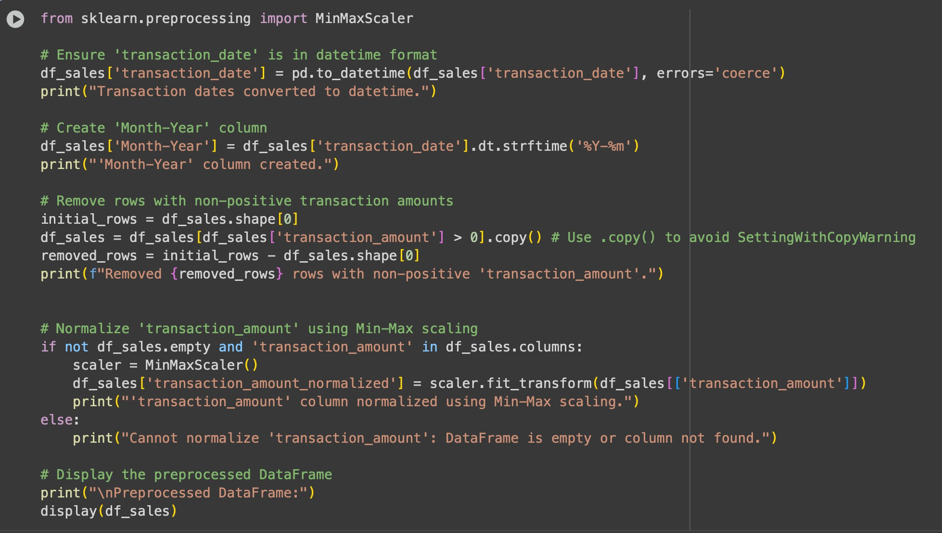

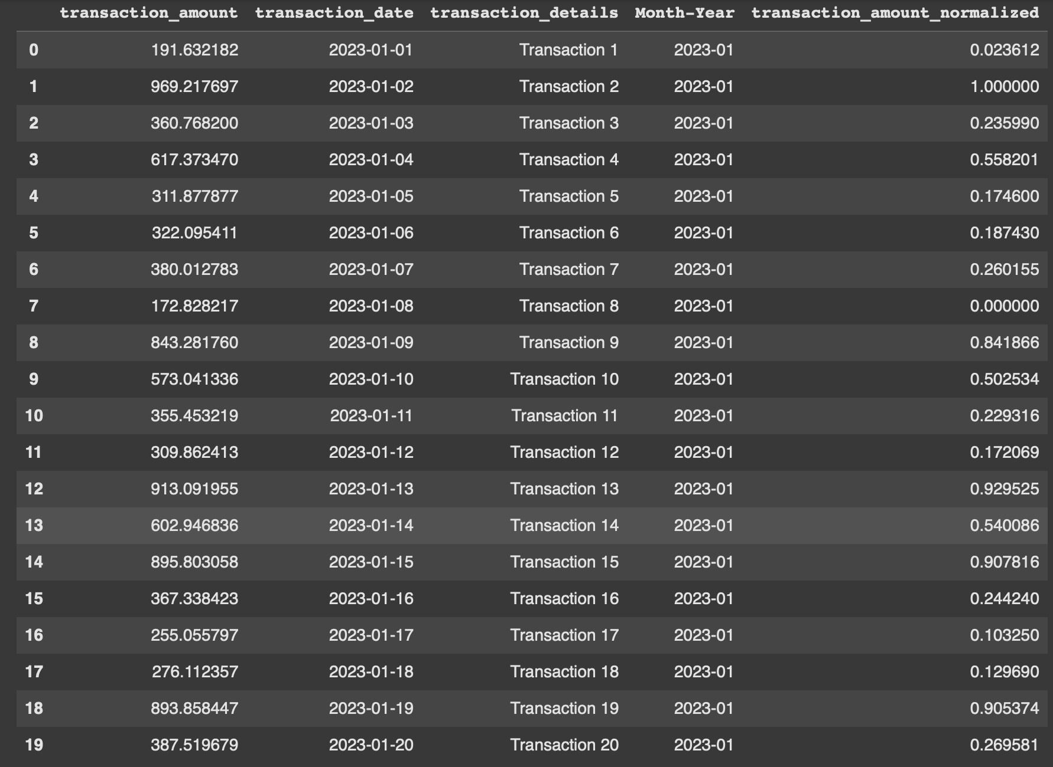

TASK 3:
Use AI to generate a script for cleaning healthcare patient records. Instructions:
- Fill missing values in numeric columns (e.g., blood_pressure, heart_rate) with column mean.
- Standardize units (convert height from cm to meters).
- Correct inconsistent categorical labels (e.g., "M", "Male", "male" → "Male").
- Drop irrelevant columns such as patient_id after cleaning.
Expected Output:
- A cleaned healthcare dataset suitable for ML model training

Expected and sample dataset :
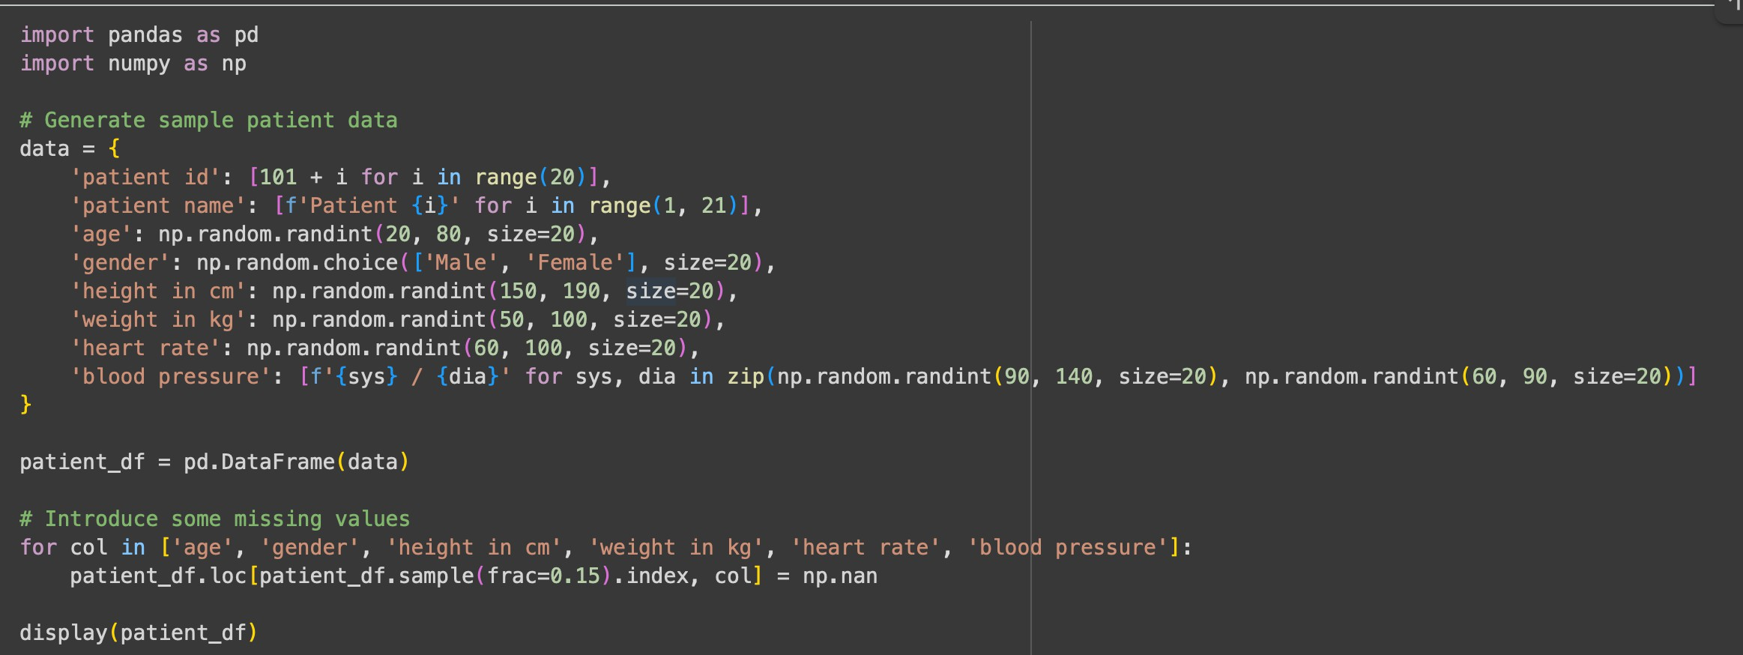
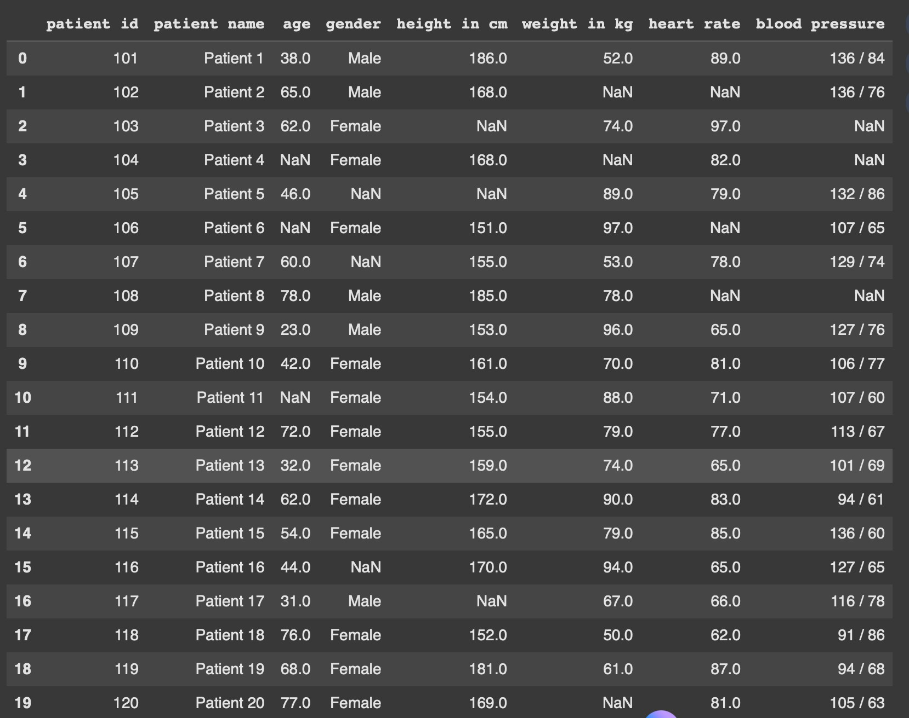

Handling and correcting missing values:
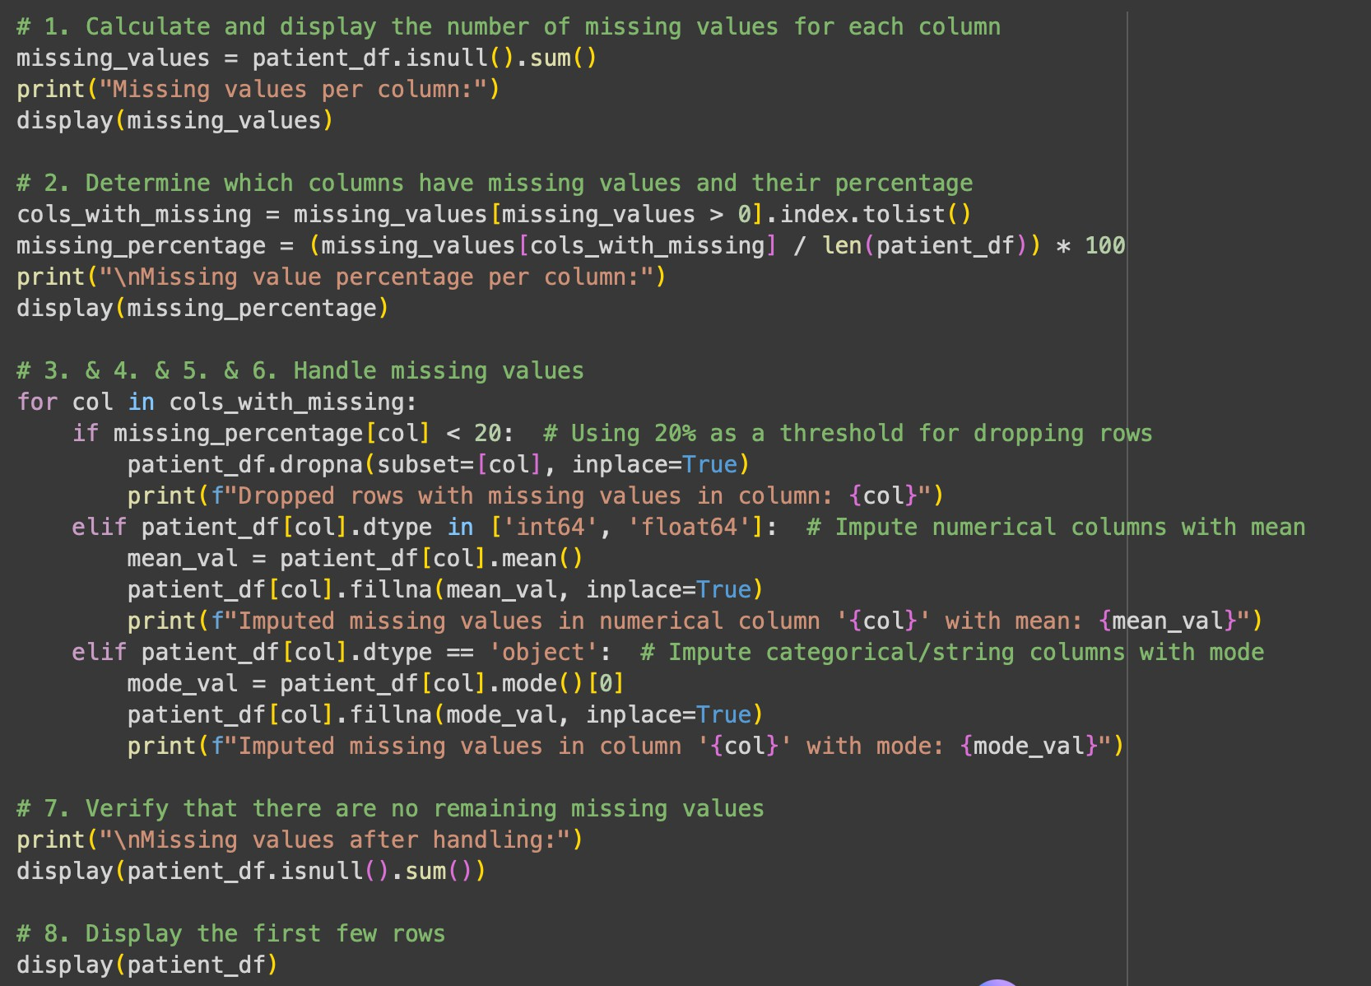

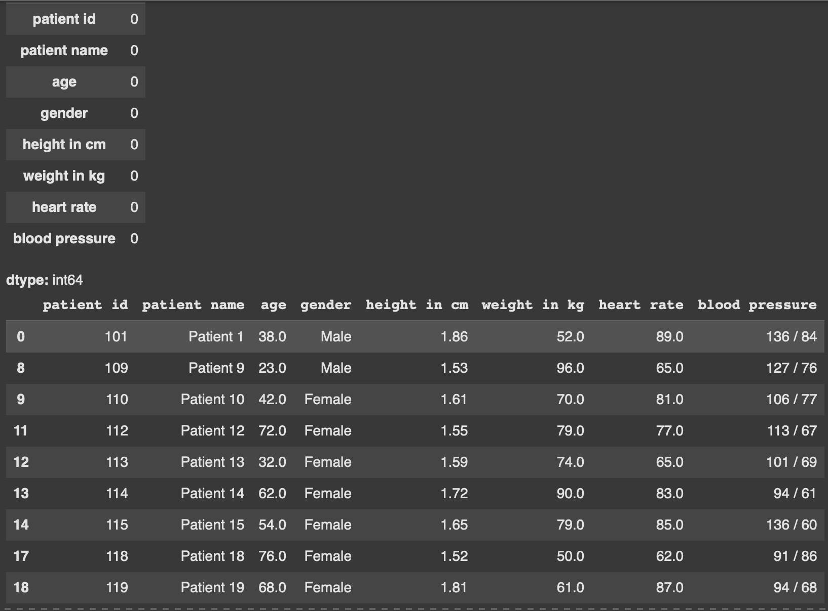

Converting patient height to meters and standardise gender values :
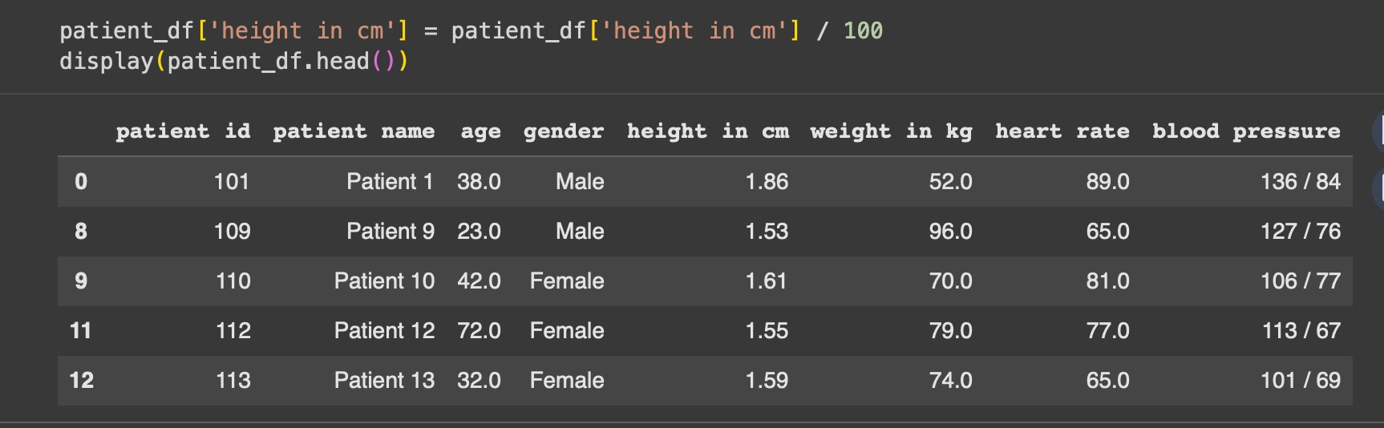

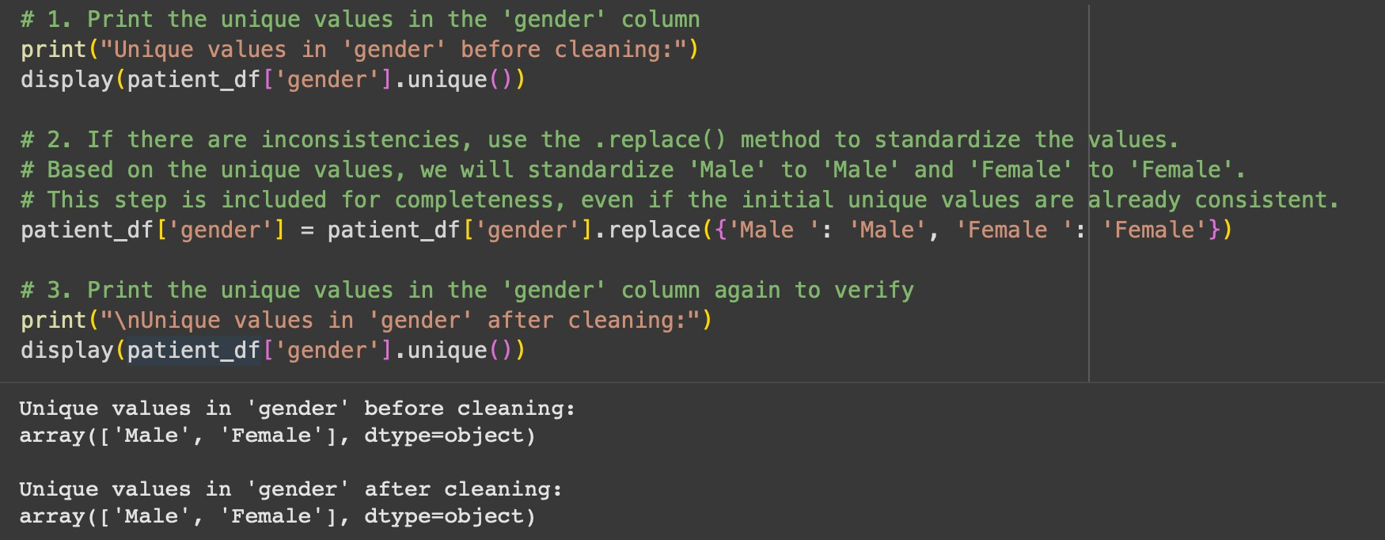

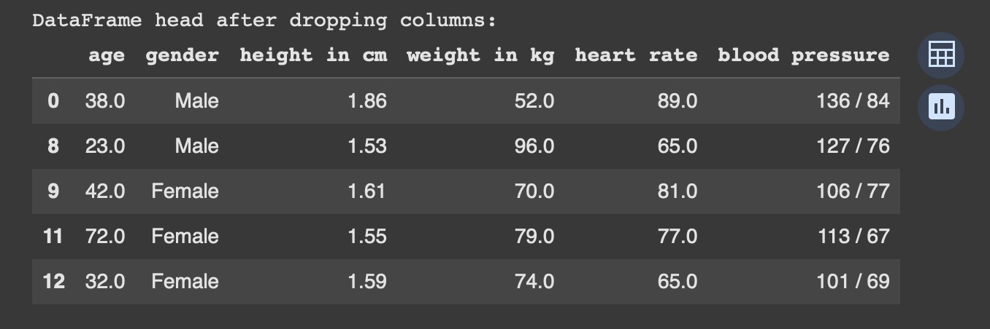

TASK 4 :
Use AI to write a script to preprocess a social media text dataset.
Instructions:
- Remove special characters, URLs, and emojis from text.
- Convert all text to lowercase.
- Tokenize and remove stopwords.
- Apply lemmatization for standardizing words.
Expected Output:
- A processed dataset with clean text, ready for NLP sentiment analysis.

Expected code :

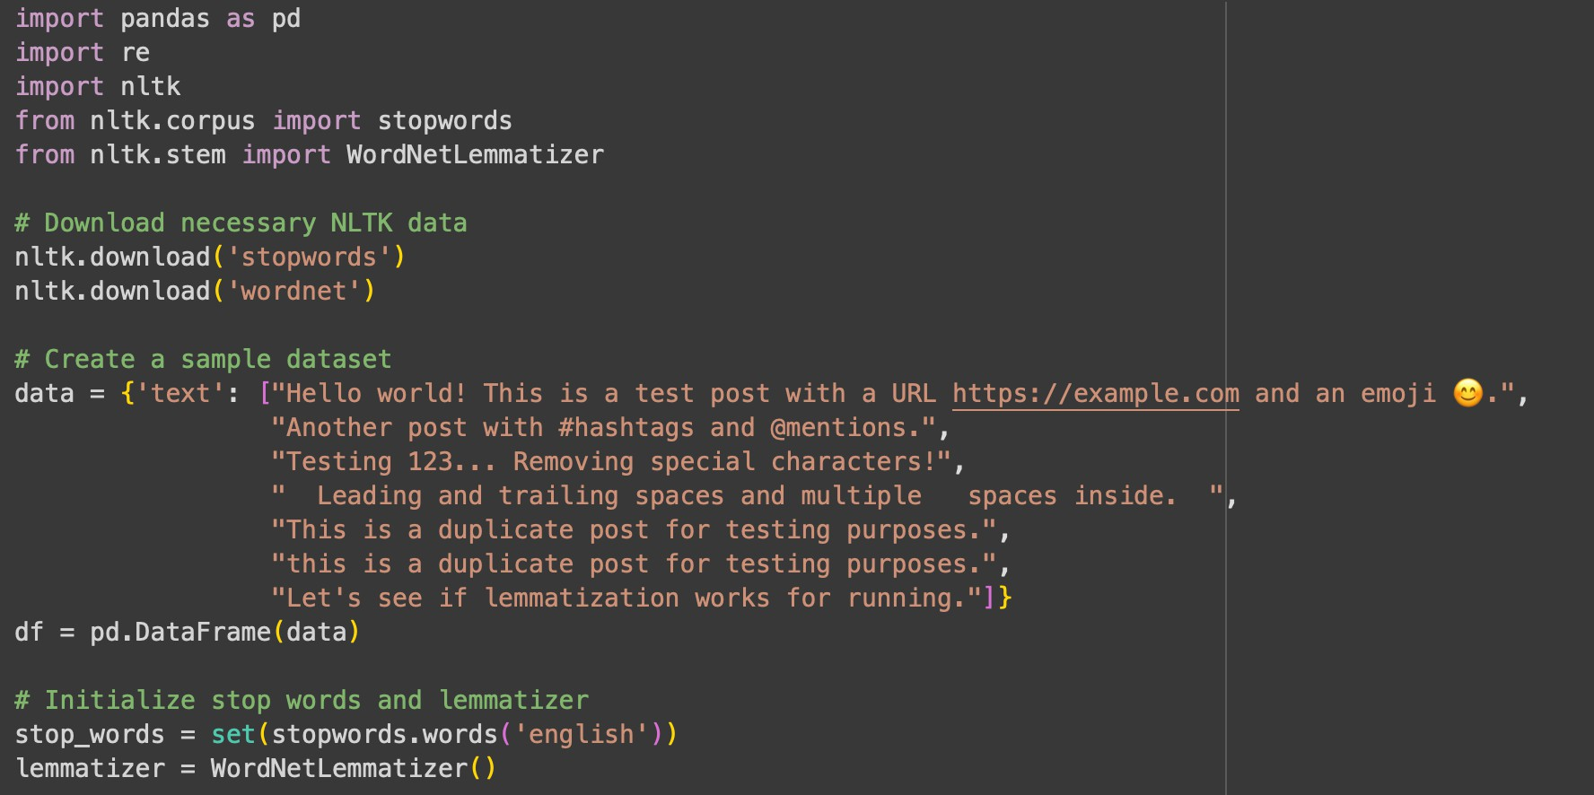

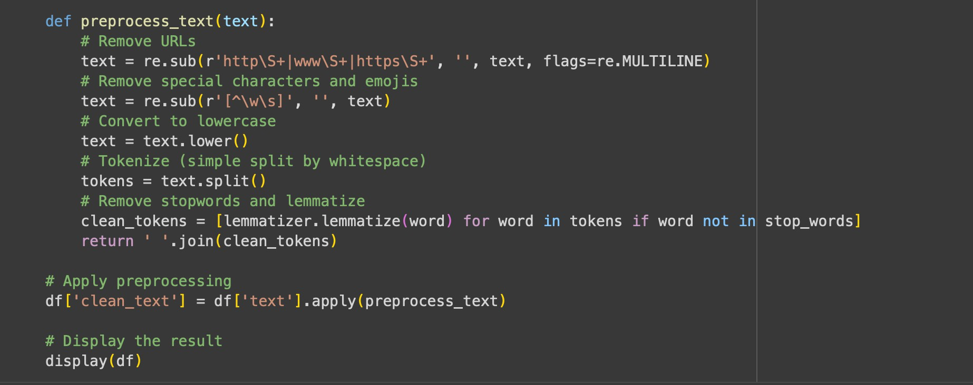

Preprocessed data :

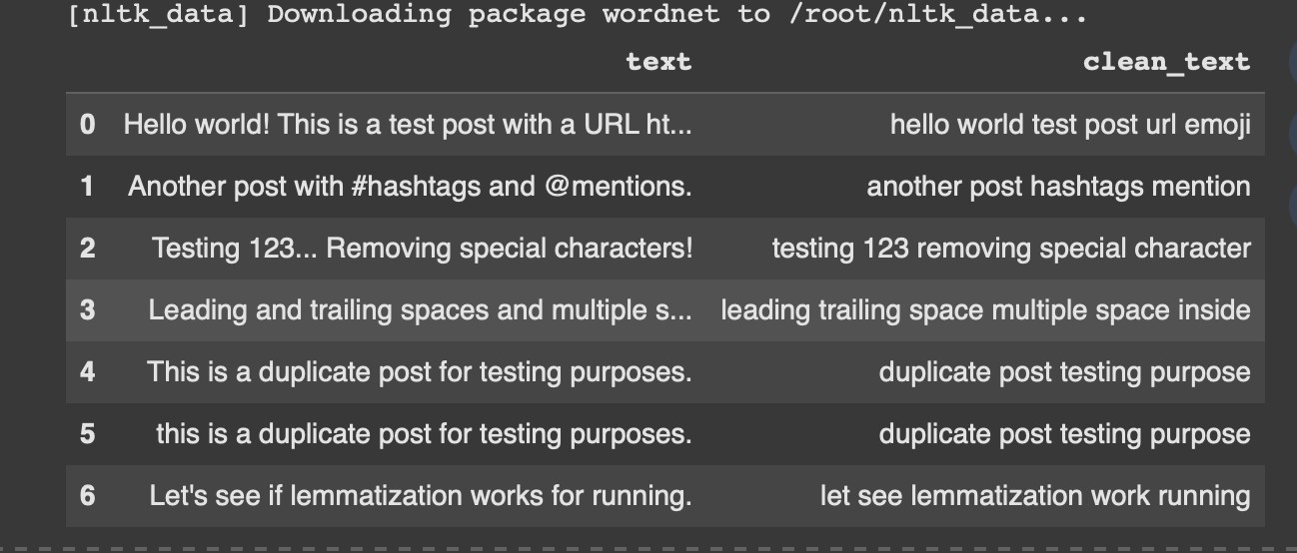

TASK 5 :
Use AI to create a preprocessing script for a financial dataset.
Instructions:
- Handle missing values in stock price and volume.
- Create new features such as moving average (7-day, 30-day).
- Normalize continuous variables using StandardScaler.
- Encode categorical columns (sector, company_name).
Expected Output:
- A feature-engineered DataFrame with new indicators and normalized values for ML tasks.

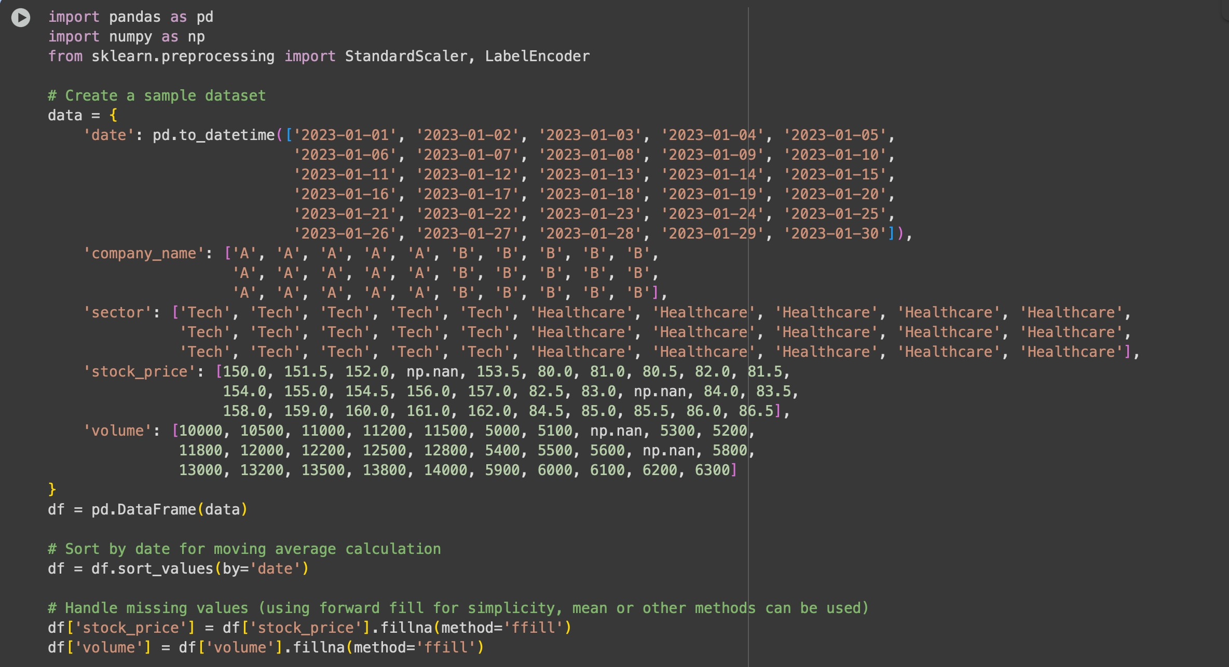

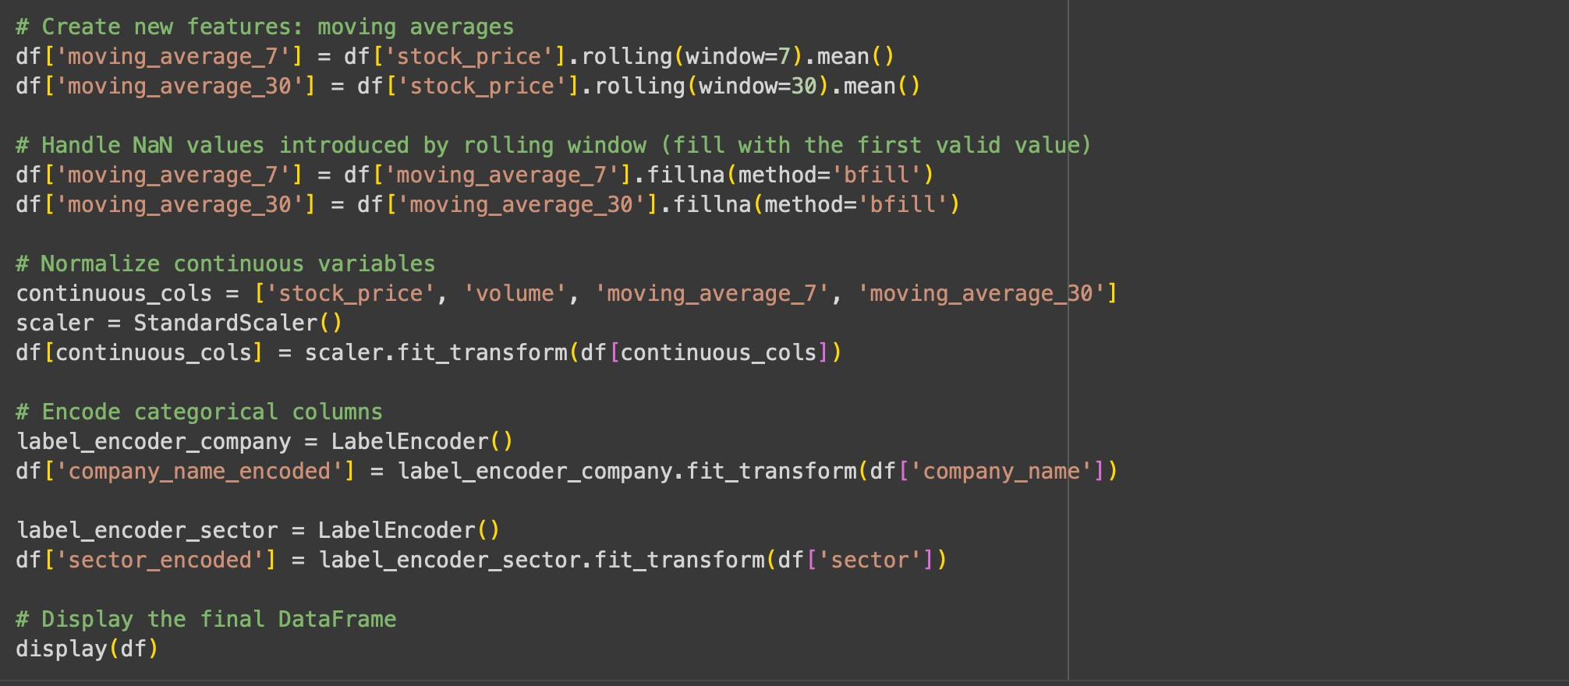

Sample dataset with handling missing values and normalise continuous variables:

