- Create three folders first backupproject (to store config and backup script), backupfolder( to store the backupfiles), backups(it will compress the backup files and store for log retention) (backupfolder and backups must be inside backupproject)
- Create a config.yml and backupscript files in backupproject directory. The reason for creating 2 scripts is yaml script can be used to change the destination without making anything changes in the bash script
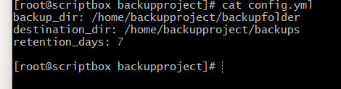
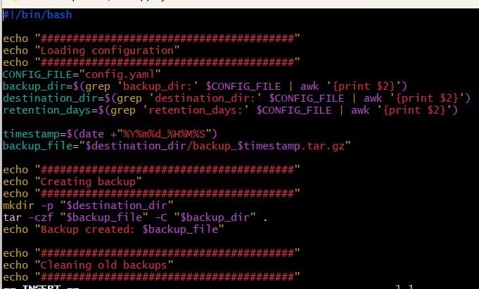
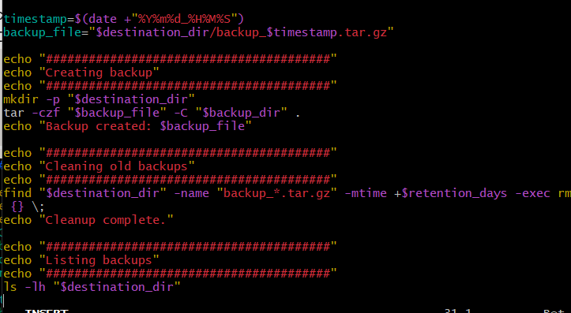
- Run the backupscript to see the latest backupfile in backups folder ( make sure backupscript is executable)
