- Create an EC2 machine and add the script in user data to install docker by default or launch an EC2 machine and use the script to install docker. You can find script in official docker website in documentation.
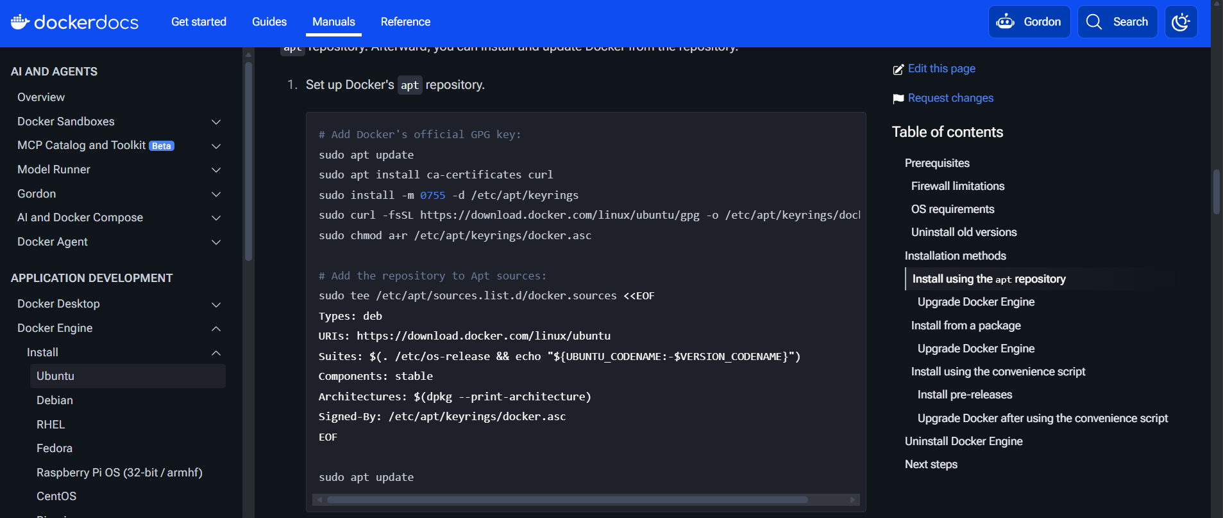

- Check docker service is running or not by entering “systemctl status docker”
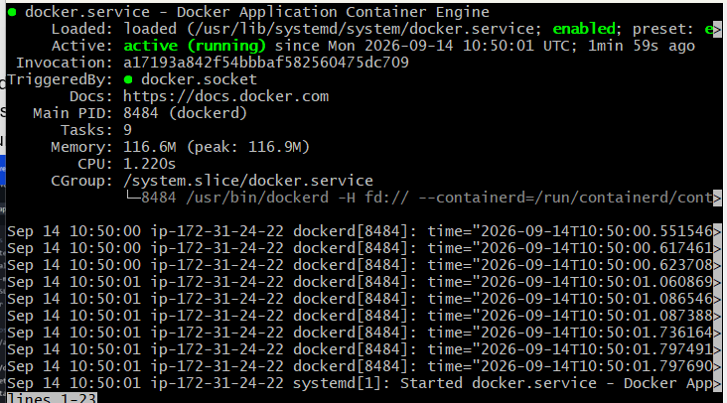
- By default, the user will not have permission to access the docker images only the root user has it, so add the user into docker group
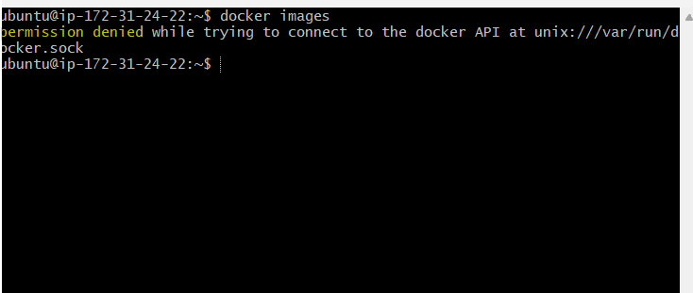
After adding ubuntu in docker group

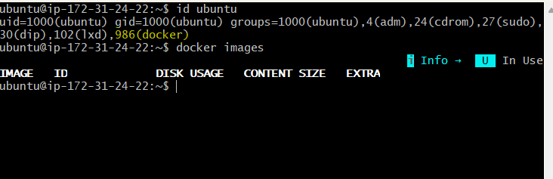
- Running Ngnix (any prod application or service can be running on the container) in the docker.
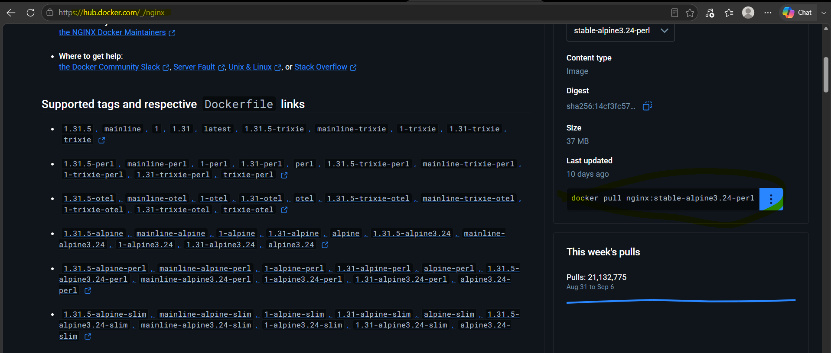

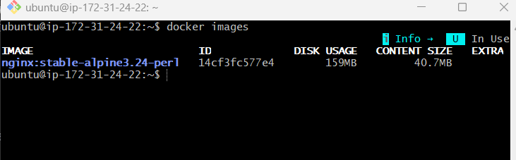
- Docker runs in a private network so to access the service or application running on docker from web, we need to forward the docker port to the service port like "8080:80" here 8080 is a port forwarding to 80 (ngnix)
- Make sure the security group has rules to access 80 or any port.
Before forward porting
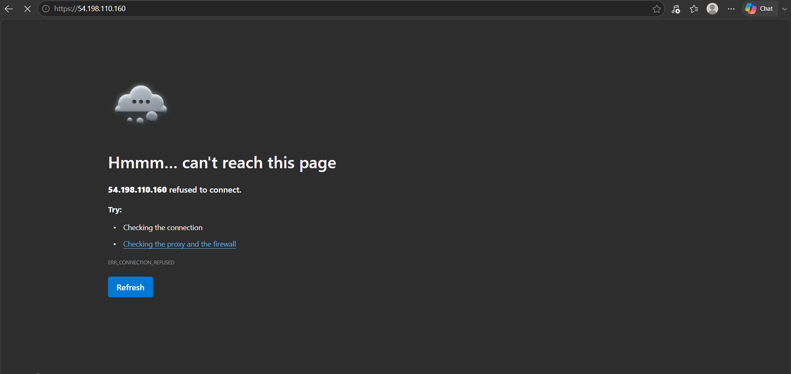

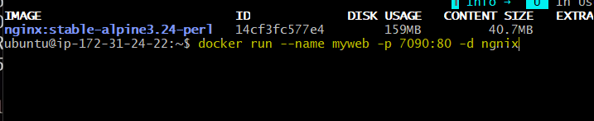
After forwarding the port, don’t forget to add the port number to public ip

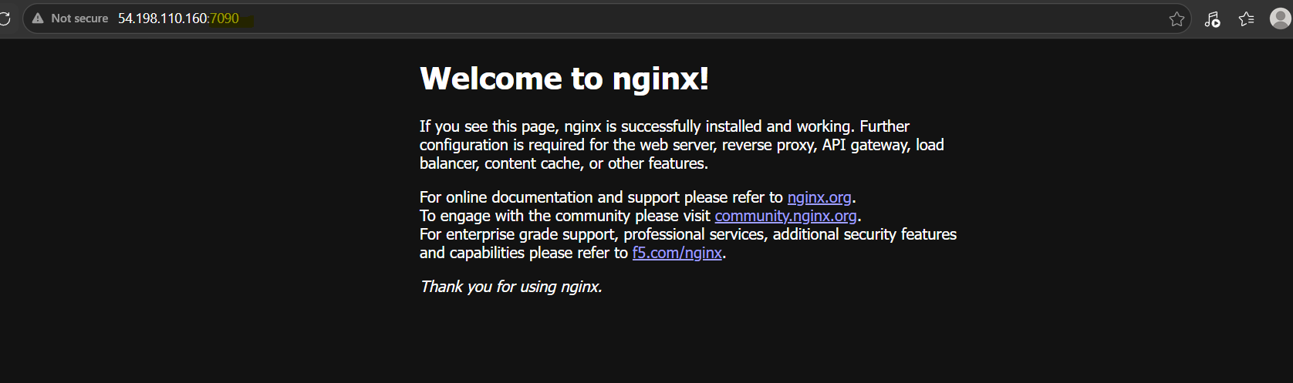
- If you want to remove any image you need to first stop the docker container, then remove that docker container and then remove the image
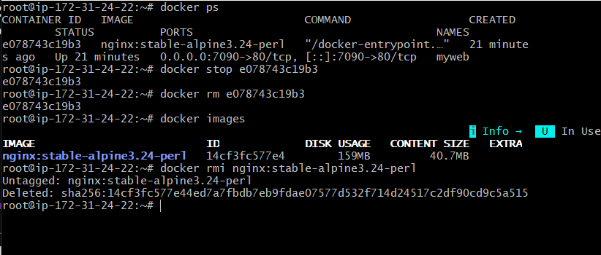
- We can check the logs in docker using command docker logs
