- Create images of app, web and database and upload in docker hub repository and keep them handy
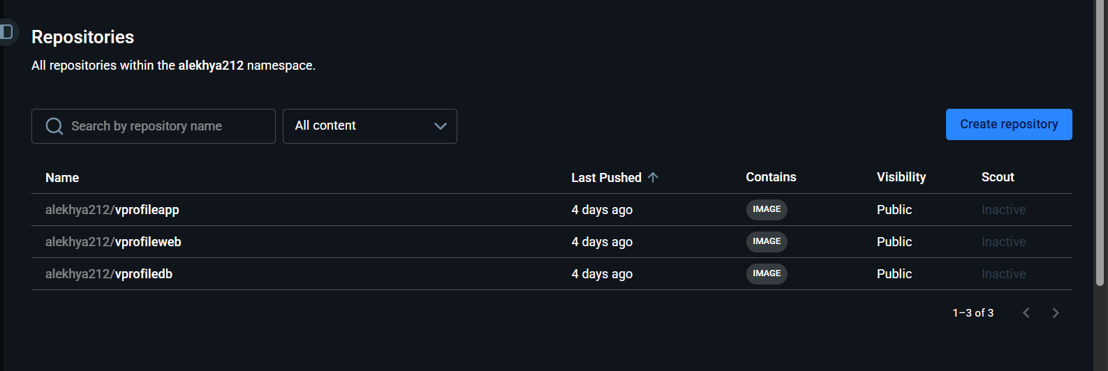

hkhcoder/vprofile-project

- Create an EC2 instance to access all the AWS services. For the EC2 instance to talk to the AWS services we need to get Access key and also install AWS CLI in the EC2 instance.
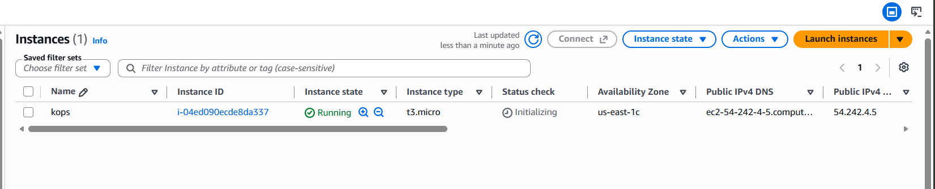
- Create an IAM user to install AWS CLI and run services from this machine. Since the ECS performs many admin activities attach administrator policy to the IAM user
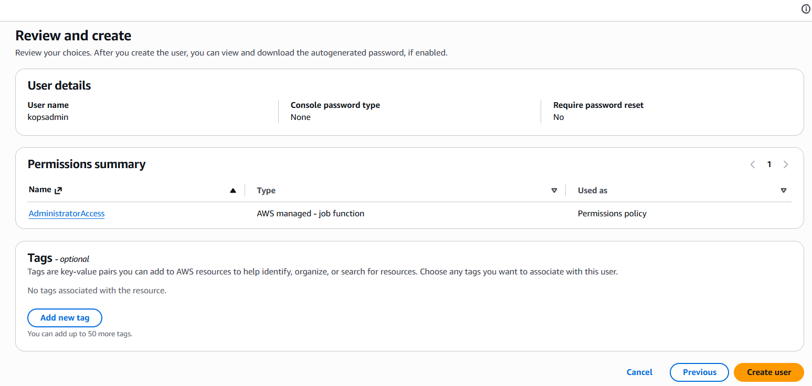

- Create access key to the user
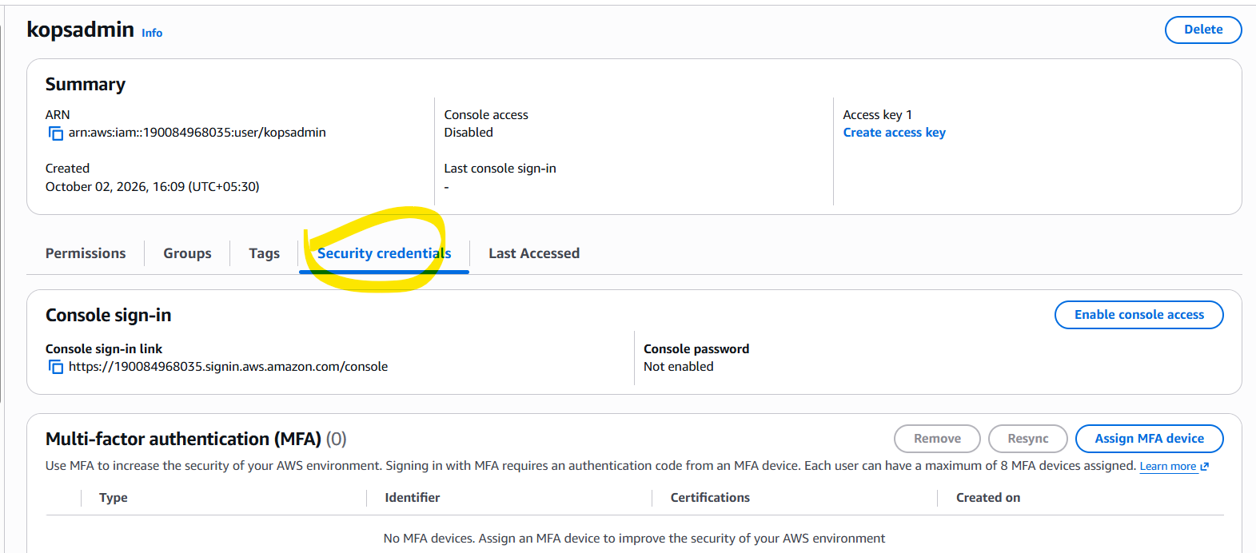
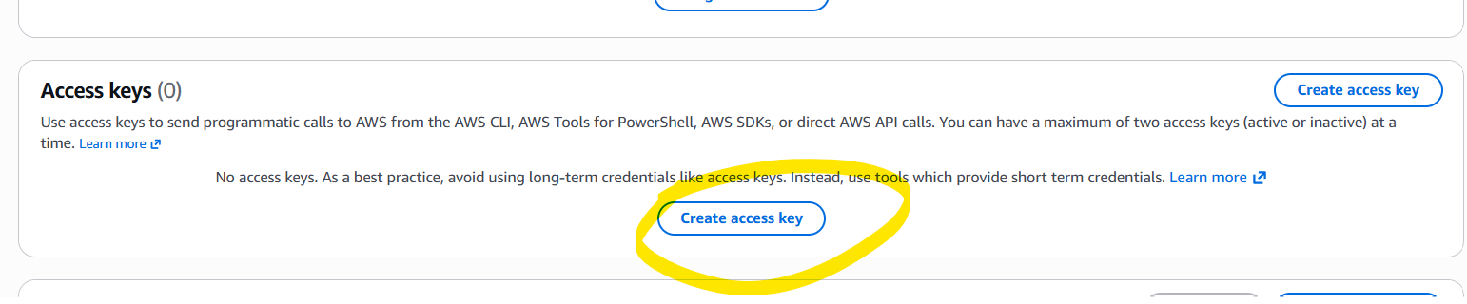
- SSH into the EC2 instance (KOPS) and install AWS CLI
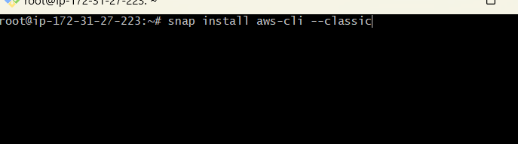
- Store the AWS access key in the EC2 to access the AWS services from the machine
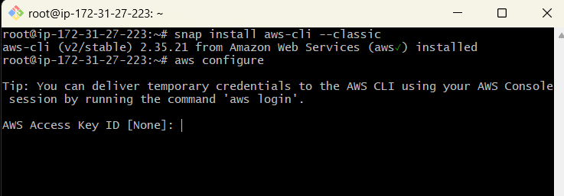
- Install kops in the EC2 machine
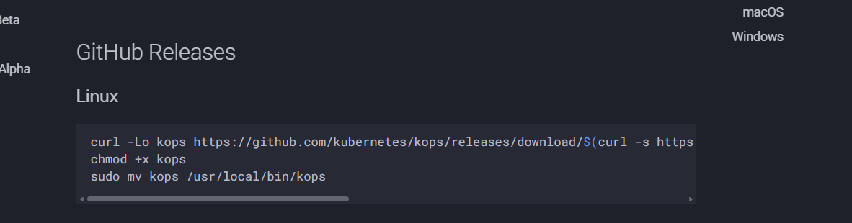
- Install kubctl also in the EC2 machine to manage the Kubernetes clusters from the EC2
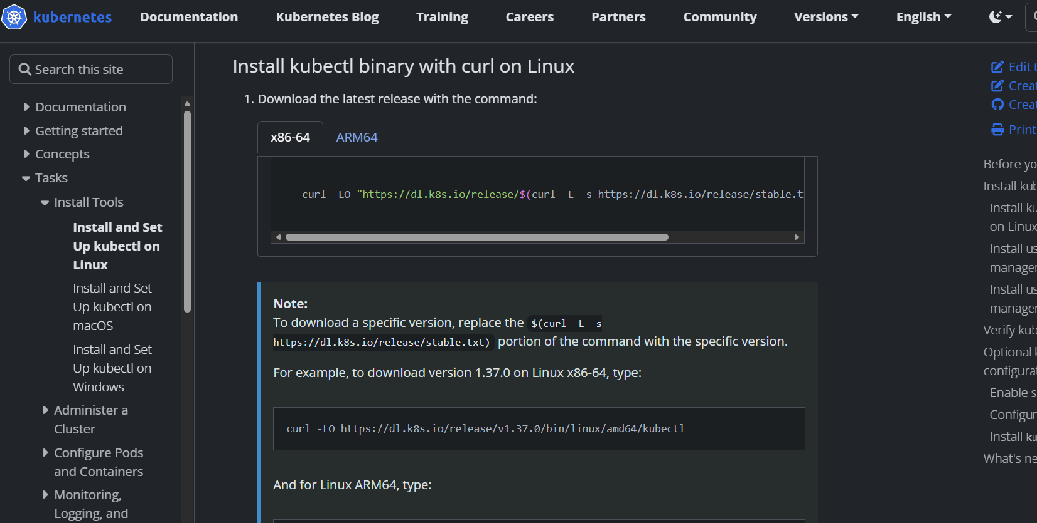
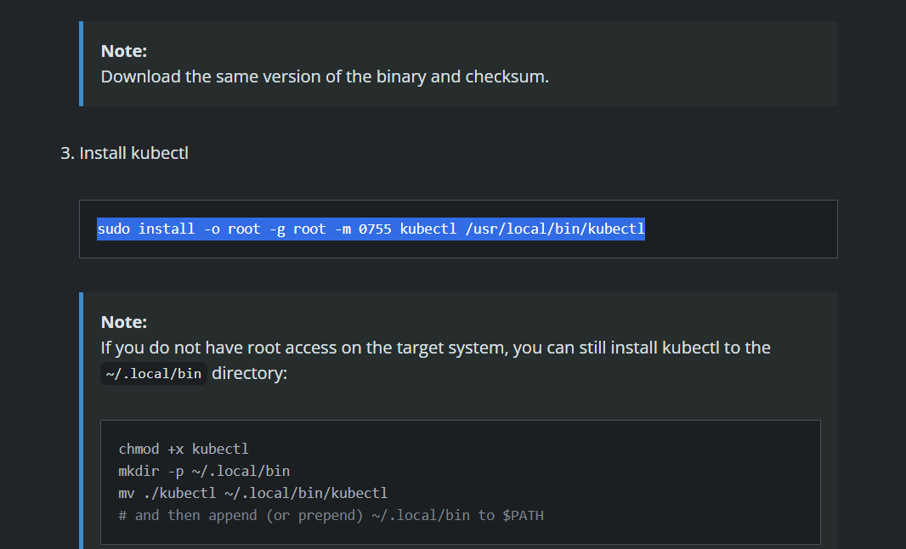
- Create an S3 bucket to host the cluster and store the cluster and app information.
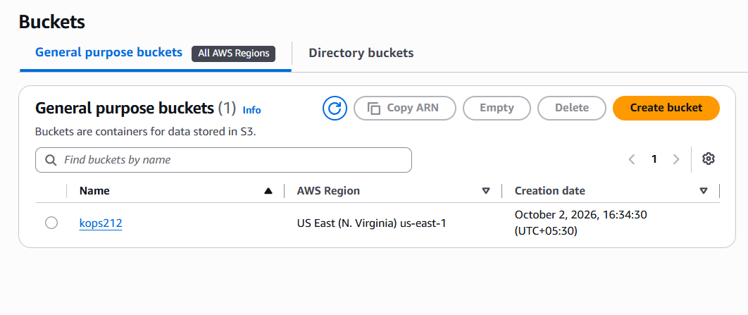
- Create a hosted zone in route 53 ( to create a hosted zone we need to have a domain)
Hostedzone name followed by your domain name (hostedzonename.domainname)
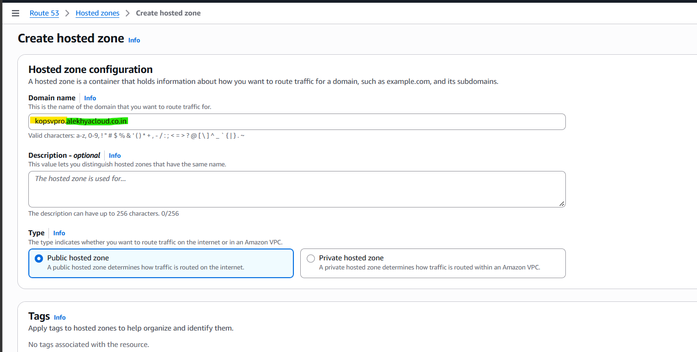
- Add the NS record on the created hosted zone (Route53) in godaddy
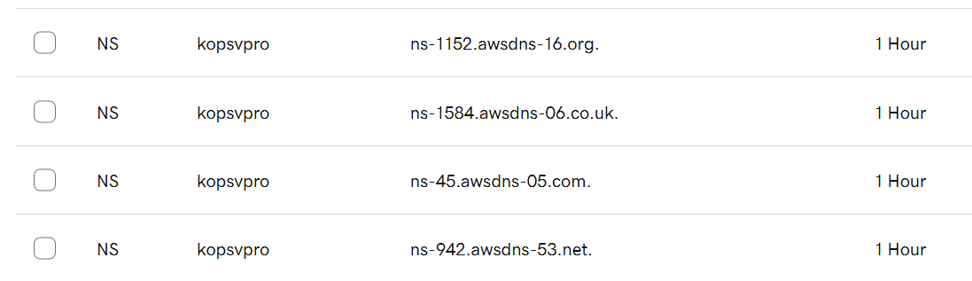
- Use the below script to create the Kubernetes cluster. Make sure the dns record name, zones and the s3 bucket names are accurate. The create command will create the cluster and update will update everything in the S3 bucket

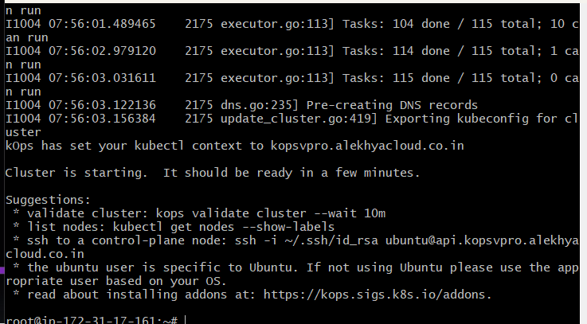

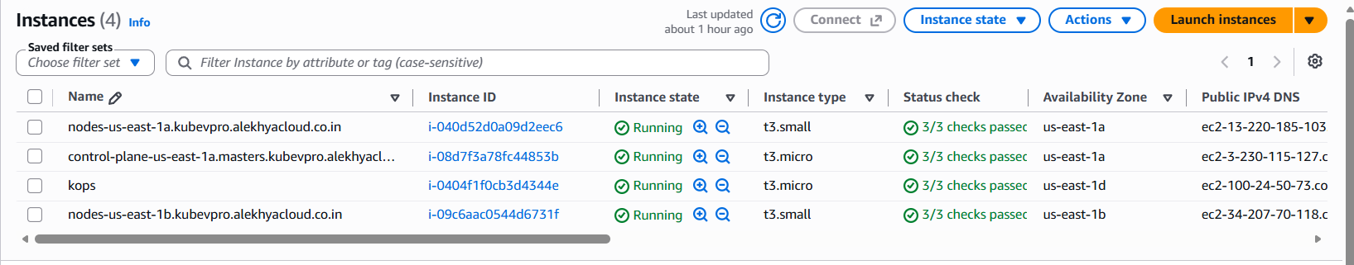

- Go to this path and copy the sourcecode of kubedefs
https://github.com/Alekhya-212/vprokube.git
https://github.com/Alekhya-212/vprokube.git
- Make sure you upload the files in github and clone it in the EC2 kops instance
- Use the below ingress controller command to act as a load balancer between the apps and services within the cluster
kubectl apply -f https://raw.githubusercontent.com/kubernetes/ingress-nginx/controller-v1.1.3/deploy/static/provider/aws/deploy.yaml
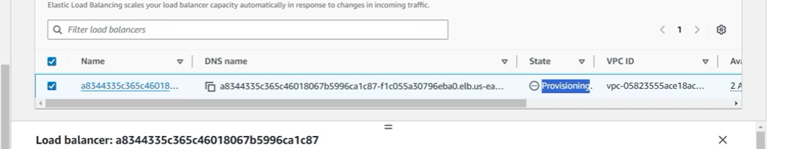
- Also the persistent volumes have been created
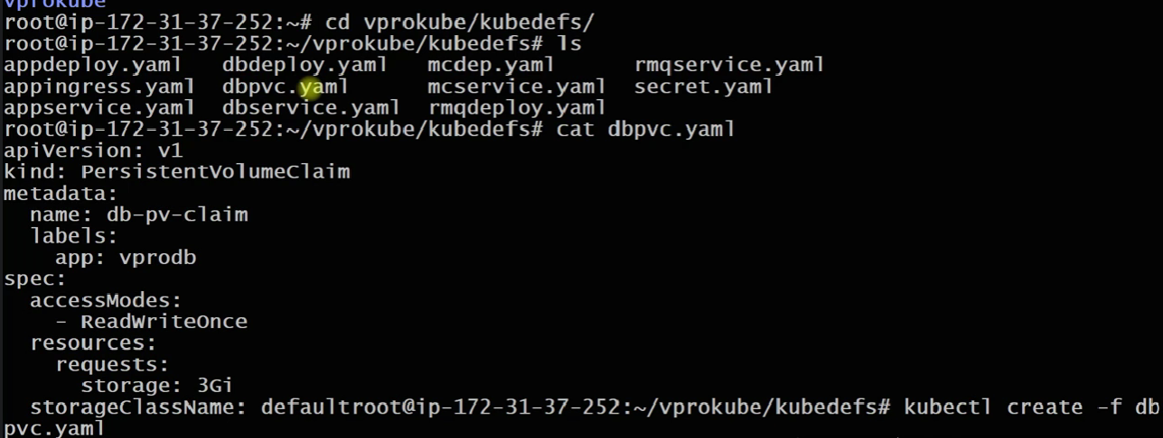
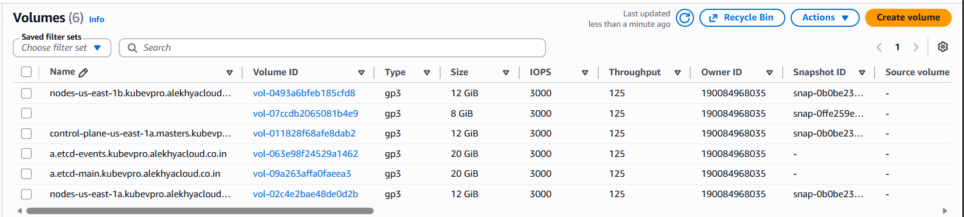
- Once the persistent volumes are created run the command “kubectl create -f .” It will create the application and dependencies and also communication using ingress
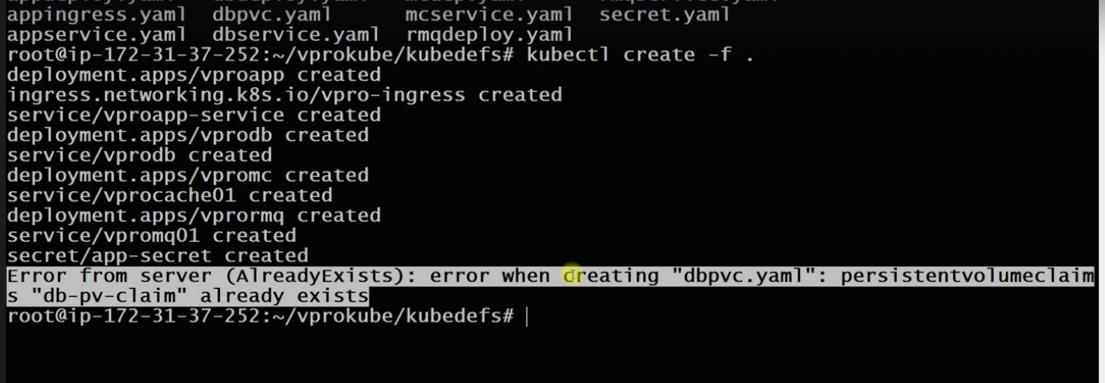
18. The CName will map to the endpoint, we need to add the endpoint to the DNS record in the DNS hosted service
19. Now you will be able to see the application
