- Setup a Linux machine using vagrant or manually according to your requirement and knowledge
- Login into the machine
- Create a directory to store all the details of the website like html files, pngs, css etc
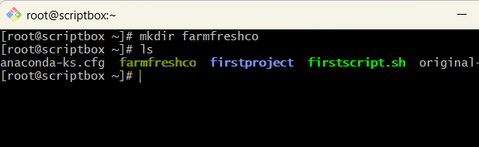
- Add all the files in that directory. I have three files, so I have added three files in my directory
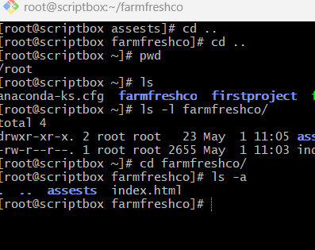
- Now create a script for hosting website in the server with .sh and make sure its executable and run the script
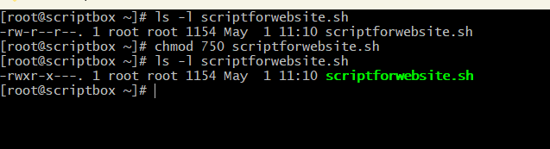
- After running the script check the server ip and search in browser
