100 YEARS THAT CHANGED THE WORLD

Introduction

A lot of things have happened in the last century. A couple of world wars accompanied by the cold war, landing on the moon, the invention of the Internet, the increase in the human life expectancy, the formation of new nations and the changes in the types of government are the key highlights of the 20th century.

The way the world operates and the way people live today is quite different than the way it used to be 100 years ago.

I am illustrating a story here of how things looked way back in the 1900s and how things are today. When you see the changes took place in the entire story gives you a platform to launch multiple scenarios of what could have had happened.

I will help to visualize a dataset of 10 columns which has 80k rows. This dataset has the data of the last 100 years for each country that mainly includes its population, its GDP and average life expectancy.

The increase in the population of the world had its impact on the entire world in the last 100 years.

Dataset

Selection/Source of Dataset

- The dataset used here is provided by gapmider:https://www.gapminder.org/

- The CSV file is crafted to obtain the features (columns) from multiple dataset-CSV files.

- This is done in order to visualize the GDP per capita vs. average life expectancy against the population of the countries.

- Additionally other features like Regions, Governments are included in a single CSV sheet to address the purpose of this visualization.
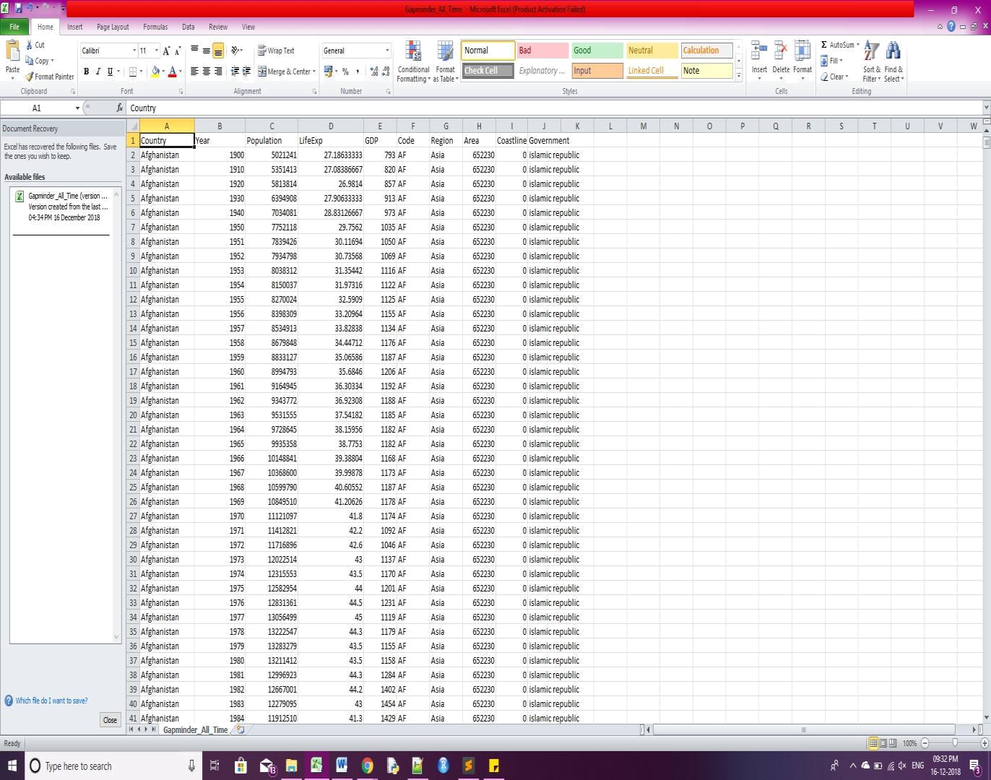

Design

D3.js

- I am using D3.js for this assignment as visualizations can be easily manipulated with it.

- D3 helps you bring data to life using HTML, SVG, and CSS

- It lets you build the data visualization framework that you want

- D3.js is written in JavaScript and uses a functional style which means you can reuse code and add specific functions to your content. Which means it is as powerful as you want to make it.

This chart has 1 bubble chart and 2 bar charts

The bubble chart is interactive and dynamic
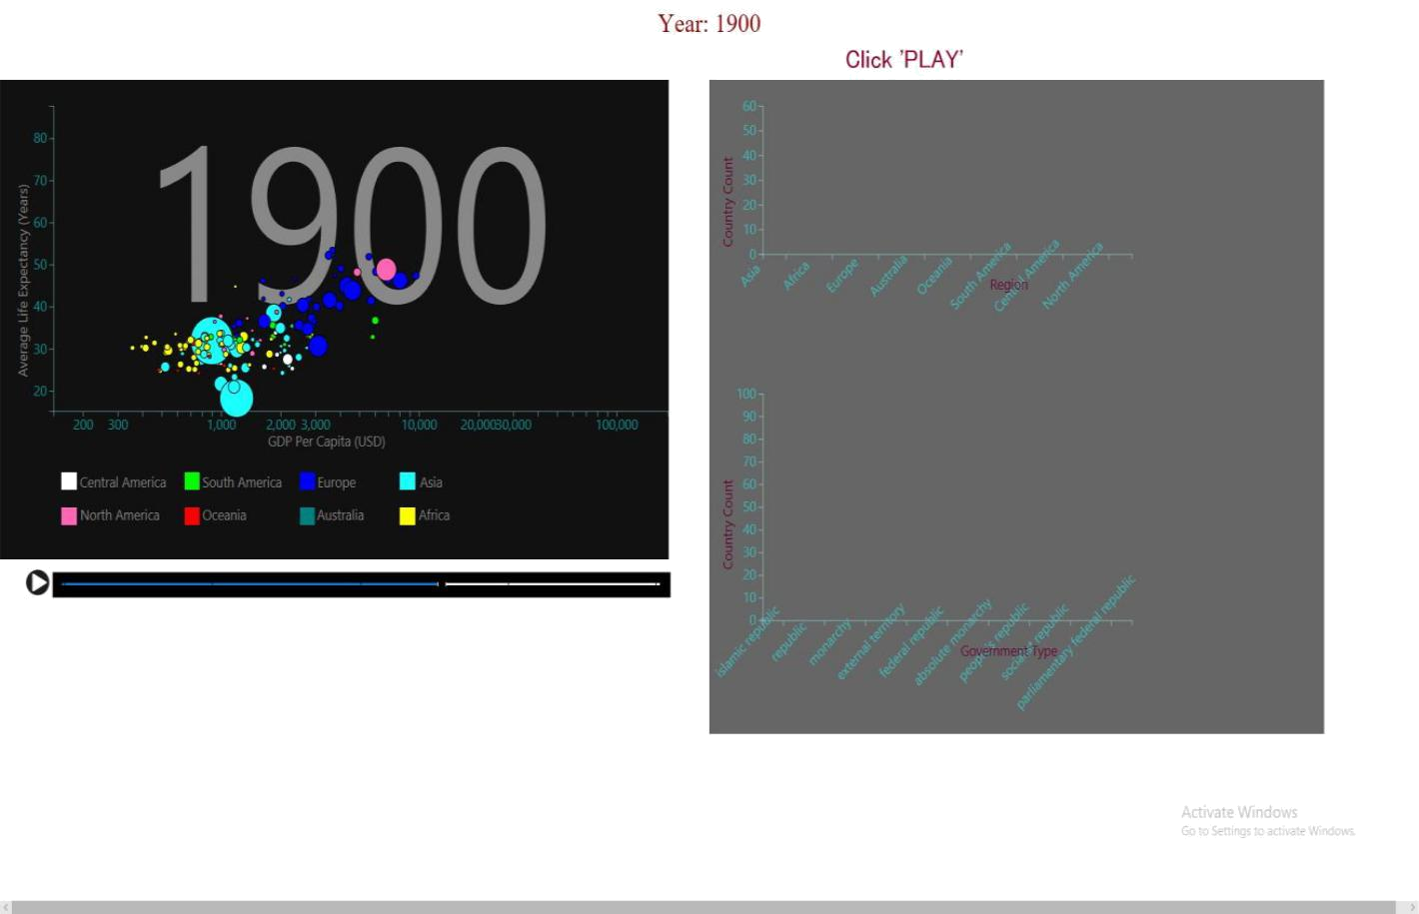
Bubble chart

Bubble charts or bubble graphs are extremely useful graphs for comparing the relationships between data objects in 3 numeric-data dimensions: the X-axis data, the Y-axis data, and data represented by the bubble size. Essentially, bubble charts are like XY scatter graphs except that each point on the scatter graph has an additional data value associated with it that is represented by the size of a circle or “bubble” centered around the XY point.

I found this chart most useful here as I had plot GDP per capita on my X-axis, Average Life Expectancy on Y-axis and being an individual bubble on my bubble chart, each of them represent a country and its size (radius/diameter) being the population of that country(bubble/circle).

Data Proportional to Radius or Area?

Bubble charts can be misleading if care isn’t taken to understand the relationship between bubble size and the data the size represents. If the data is proportional to the bubble radius, the data will be skewed because the bubble area grows exponentially as the square of the radius (Area=π*r^2). For a proportionally accurate representation of the data, bubble data should be represented directly by the area using the circumference of the circle, which grows the bubble area linearly in relation to the diameter (circumference=π*diameter)

You could see that the world didn't change much until the Second World War. After the Second World War most countries started to improve. It is a natural fact that high rate of income implies better access to housing, education, health services and other needs of living which leads to better health, lower rates of mortality and higher life expectancy.
Bar charts

Bar charts explanation,

Top Bar chart - 1

X-axis: Country Count

Y-axis: Region

Functionality:

As you click the play button and interact with the bubble chart -

The change in the number of countries for every region is displayed here in the

“Dynamic Bar Chart -1”.

Bottom Bar chart -2

X-axis: Country Count

Y-axis: Government Type

Functionality:

As you click the play button and interact with the bubble chart - The change in the government type is shown here in the “Dynamic Bar Chart -2”.

- The idea here is to observe the relationship between the information we obtain from the scatter plot dynamically.

- With more data feature and a more accurate and abundant dataset can lead to more successful visualizations.

Colour Scheme

In a scatter or bubble chart, you can specify that data points or bubbles appear in different colours based on an additional measure or fact. The colour of the points or bubbles helps you to see relationships in large amounts of data.

A careful colour scheme has been adopted here which will help to hover over the legend of the bubble chart which is adjusted according to the continent/region. When you hover on one particular continent/region, you will see only the countries belonging to that continent only. For example, you are interested to view European countries only - all you have to do is hover over Europe in the legend.

Transparency of the bubbles is also taken into consideration so as to view the overlapping countries.

You can see this in the video.
Animation and Interaction

The bubble charts don't disappear instantaneously when you select one region. They will disappear and re-appear as per the “mouseover “and “mouseout” functions.

Conclusion:

With the right choice of toolsets and a little imagination, insightful visualizations can be created which was nearly impossible 20 years ago (at this scale), this era with data visualization can create an era of enlightenment about the past.

