**Assignment-1**

**1.Write a java program to find the area of rectangle.**

import java.util.Scanner;

public class Program

{

public static void main(String[] args) {

Scanner sc=new Scanner(System.in);

int b=sc.nextInt();

int h=sc.nextInt();

System.out.print("Area of rectangle is "+b*h);

}

}

Input :

5

7

Output:

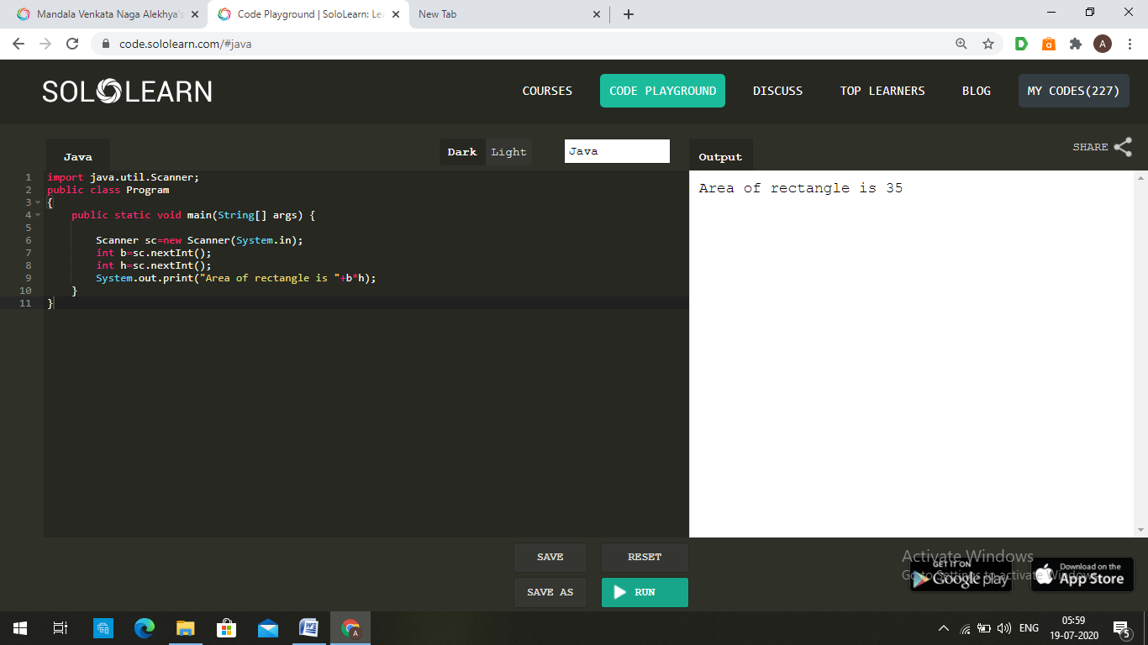

**2.Write a java program to check given no is Armstrong or not.**

import java.util.Scanner;

public class Program

{

public static void main(String[] args) {

Scanner sc=new Scanner(System.in);

int n=sc.nextInt();

int x=n,s=0;

String p=Integer.toString(n);

int r=p.length();

while(n>0)

{

s=s+(int)Math.pow(n%10,r);

n=n/10;

}

if(s==x)

System.out.print(x+" is Armstrong number");

else

System.out.print(x+" is not Armstrong number");

}

}

Input:

153

Output:

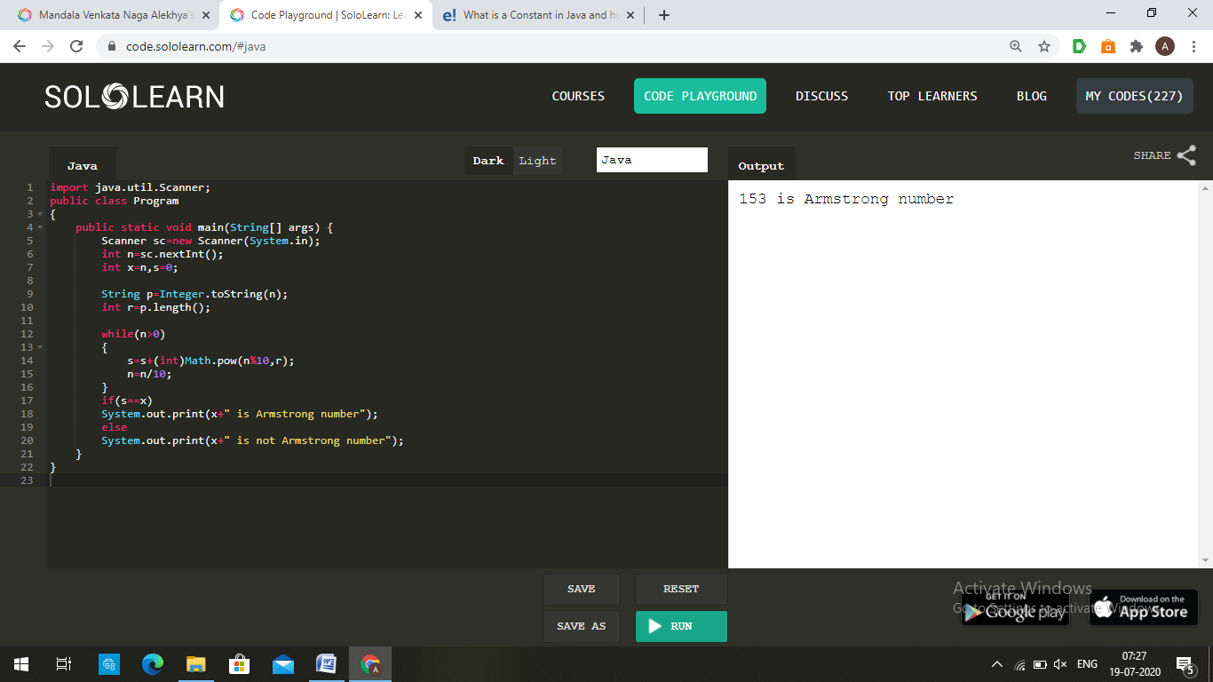

Input:

235

Output:

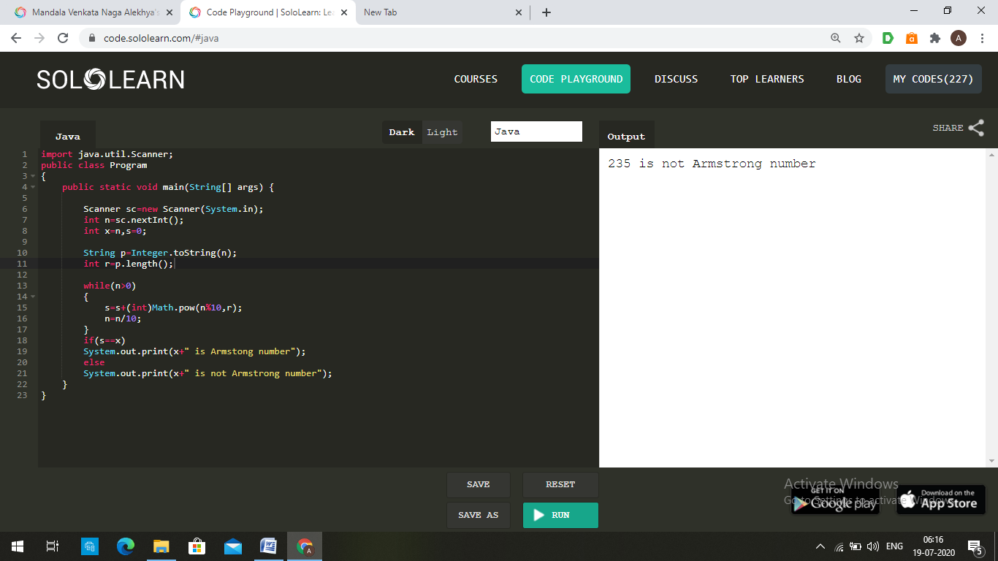

**3.Write a java program to check given no is palindrome or not.**

import java.util.Scanner;

public class Program

{

public static void main(String[] args) {

Scanner sc=new Scanner(System.in);

int n=sc.nextInt();

int x=n,s=0;

while(n>0)

{

s=s*10+(n%10);

n=n/10;

}

if(s==x)

System.out.print(x+" is palindrome number");

else

System.out.print(x+" is not palindrome number");

}

}

Input:

1221

Output:

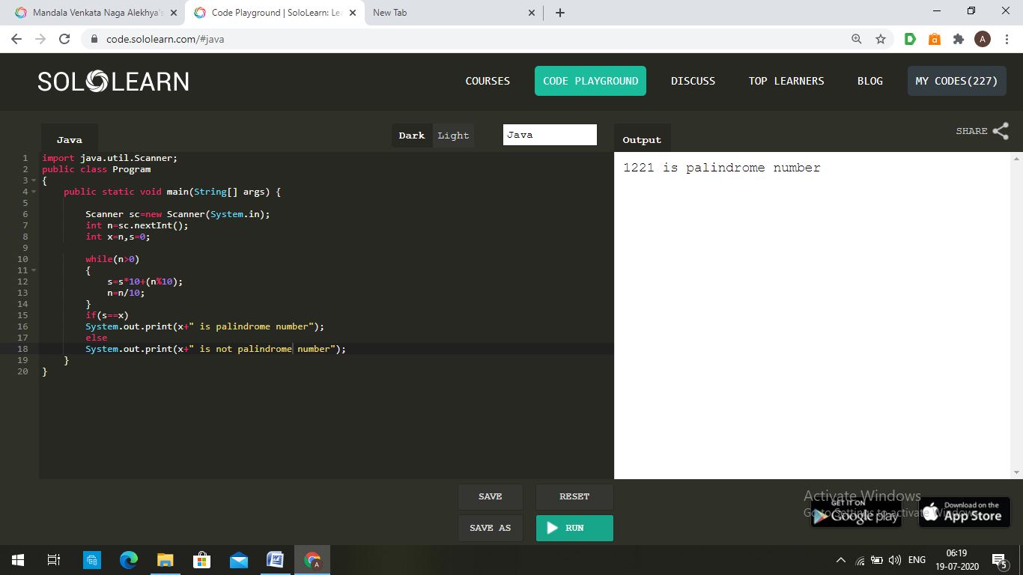

Input:

123

Output:

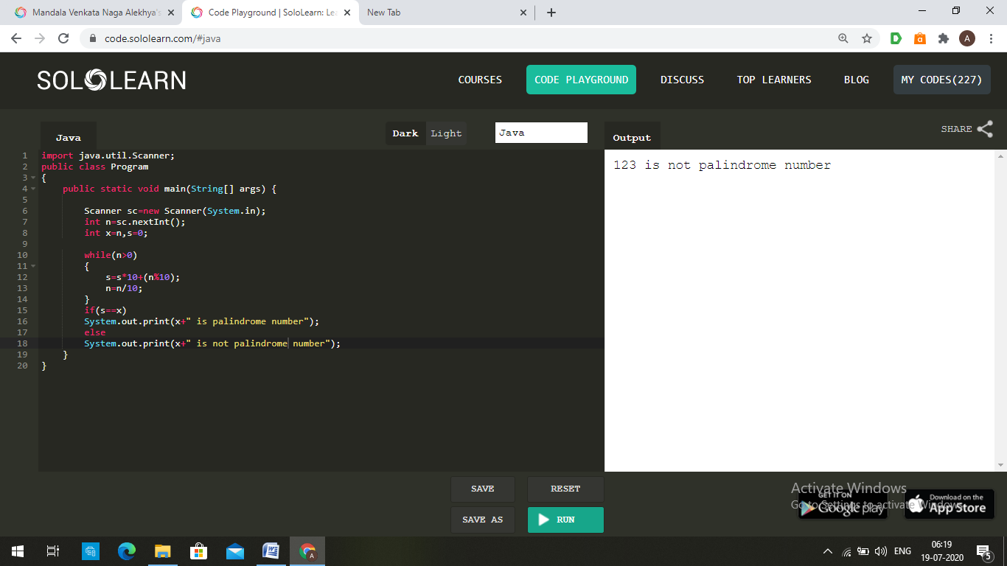

**4.Write a java program to generate first N prime numbers.**

import java.util.Scanner;

public class Program

{

public static void main(String[] args) {

Scanner sc=new Scanner(System.in);

int n=sc.nextInt();

if(n==1)

System.out.print(2);

else

{

System.out.print(2+" ");

int c=1,i,j,x=3;

while(true)

{

if(c==n)

break;

j=1;

for(i=2;i<=x/2;i++)

{

if(x%i==0)

{

j=0;

break;

}

}

if(j==1)

{

System.out.print(x+" ");

c+=1;

}

x+=1;

}

}

}

}

Input:

10

Output:

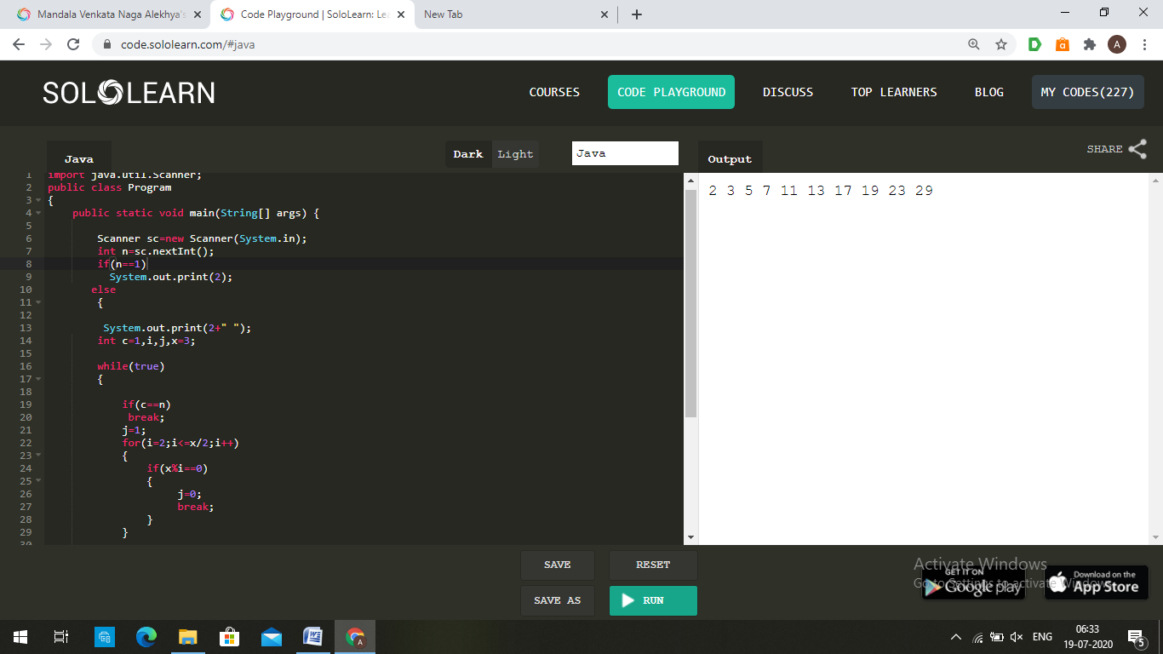

**5.Write a java program to print even numbers in between given two numbers.**

import java.util.Scanner;

public class Program

{

public static void main(String[] args) {

Scanner sc=new Scanner(System.in);

int a=sc.nextInt();

int b=sc.nextInt();

int i;

for(i=a;i<=b;i++)

{

if(i%2==0)

System.out.print(i+" ");

}

}

}

Input:

1

11

Output:

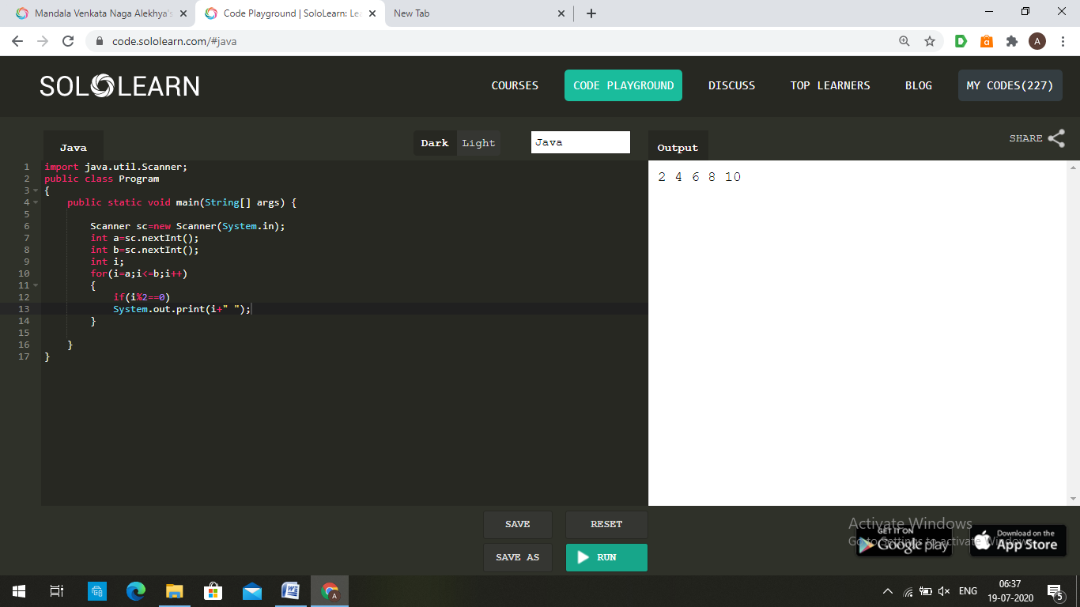

**1.What is abstraction?**

Abstraction is a process of hiding the implementation details and showing only functionality to the user. Another way, it shows only essential things to the user and hides the internal details, for example, sending SMS where you type the text and send the message. You don't know the internal processing about the message delivery. Abstraction lets you focus on what the object does instead of how it does it.

There are two ways to achieve abstraction in java:

1. Abstract class

2. Interface

**2.What is encapsulation?**

Encapsulation in Java is a mechanism of wrapping the data (variables) and code acting on the data (methods) together as a single unit. For example, Declare the variables of a class as private. Provide public setter and getter methods to modify and view the variables values.

**3.What is JDK?**

The Java Development Kit (JDK) is a software development environment that offers a collection of tools and libraries necessary for developing Java applications.

**4.What is JVM?**

A Java virtual machine (JVM) is a virtual machine that enables a computer to run Java programs as well as programs written in other languages that are also compiled to Java bytecode. The JVM reference implementation is developed by the OpenJDK project as open source code and includes a JIT compiler called HotSpot.

**5.Define inheritance**

Inheritance can be defined as the process where one class acquires the properties (methods and fields) of another. The class which inherits the properties of other is known as subclass (derived class, child class) and the class whose properties are inherited is known as superclass (base class, parent class).

**6.How java achieved platform independence?**

Since every Java program runs on Java virtual machine, same byte code can be run on any platform. key is byte code is not machine instruction they are platform independent instruction to JVM. In summary combination of byte code and JVM makes Java program platform independent.

**7.write syntax of main function.**

public static void main(String[] args)

Java main method is the entry point of any java program. Its syntax is always public static void main(String[] args) . You can only change the name of String array argument, for example you can change args to myarg

**8.what is conditional operator?**

Conditional Operators in Java are also known as ternary operators. Conditional operators are simply a condensed form of the if-else statement which also returns a value.

This operator consists of three operands and is used to evaluate Boolean expressions. The goal of the operator is to decide; which value should be assigned to the variable. The operator is written as:

variable x = (expression)? value if true: value if false

**Example:**

public class Test {

public static void main(String args[]) {

int a, b;

a = 10;

b = (a == 1) ? 20: 30;

System.out.println("Value of b is: " + b);

}

}

Output:

Value of b is: 30

**9.How many data types in java?**

There are eight primitive data types. They are:

byte , short, int , long, float, double, boolean , and char. The java. lang. String class represents character strings.

**10.what is constant? how it is declared?**

A constant is a variable whose value cannot change once it has been assigned. Java doesn't have built-in support for constants, but the variable modifiers static and final can be used to effectively create one. Constants can make your program more easily read and understood by others.

The final modifier means that the variable's value cannot change. Once the value is assigned, it cannot be reassigned. The static modifier causes the variable to be available without an instance of it’s defining class being loaded

Example for a constant declaration: static final int MIN_AGE = 18;

Here we declare the ‘MIN_AGE’ identifier as a constant integer with value 18.