**SQL Server Installation steps**

This is the Installation process for SQL Server 2017, even if u are downloading latest version 2019 then also you must follow same process.

**How to download SQL Server Setup:**

**Step 1**: Go and hit this URL from the browser.

<https://www.microsoft.com/en-in/sql-server/sql-server-downloads>

**Step 2**: Click on "Download now" as shown below.

[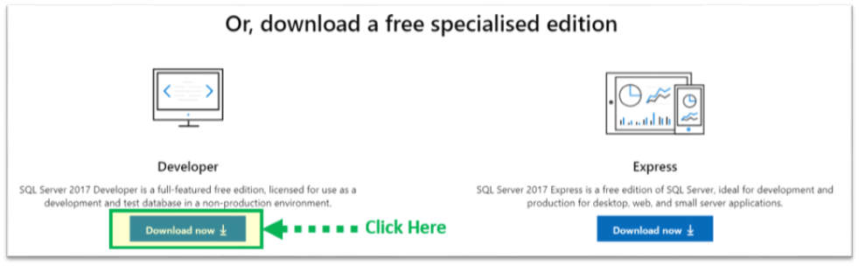](https://www.guru99.com/images/1/030119_0948_HowtoDownlo1.png)

We will get set up as 'SQLServer2017-SSEI-Dev.exe'.[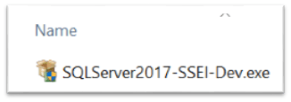](https://www.guru99.com/images/1/030119_0948_HowtoDownlo2.png)

**Steps to install SQL Server**:

**Step 3**: Double click on "SQLServer2017-SSEI-Dev.exe". Below screen will appear with three options: Basic, Custom and Download files.

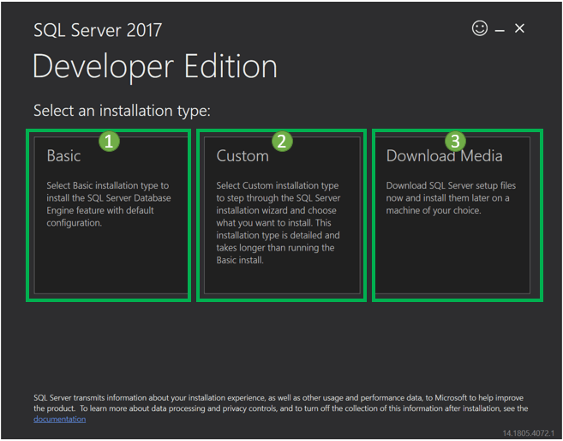

**Step 4**: Choose the basic version by clicking on the 'Basic' option, as it has all default configuration required to learn MS SQL.

[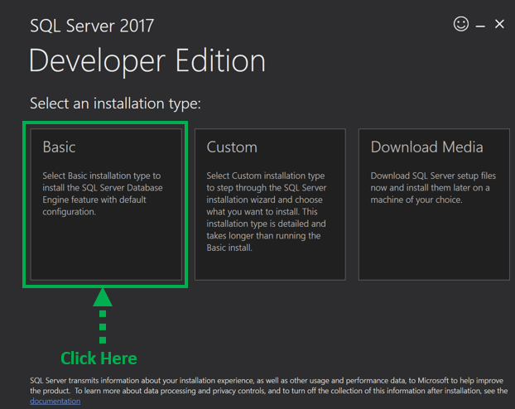](https://www.guru99.com/images/1/030119_0948_HowtoDownlo4.png)

**Step 5**: 'Microsoft Server License Terms' screen will appear. Read the License Terms and then click on 'Accept.'[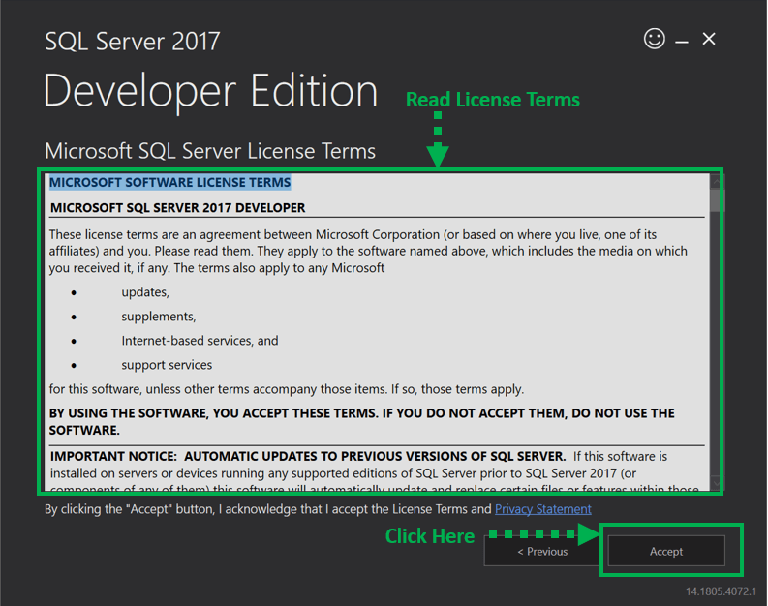](https://www.guru99.com/images/1/030119_0948_HowtoDownlo5.png)

**Step 6**: Below 'SQL server install location' window will appear.

1. The Default location is C:\Program Files\Microsoft SQL Server.
2. Optionally, we can also change the installation location by clicking on Browse.
3. Once the location is selected, click the 'Install' button.

[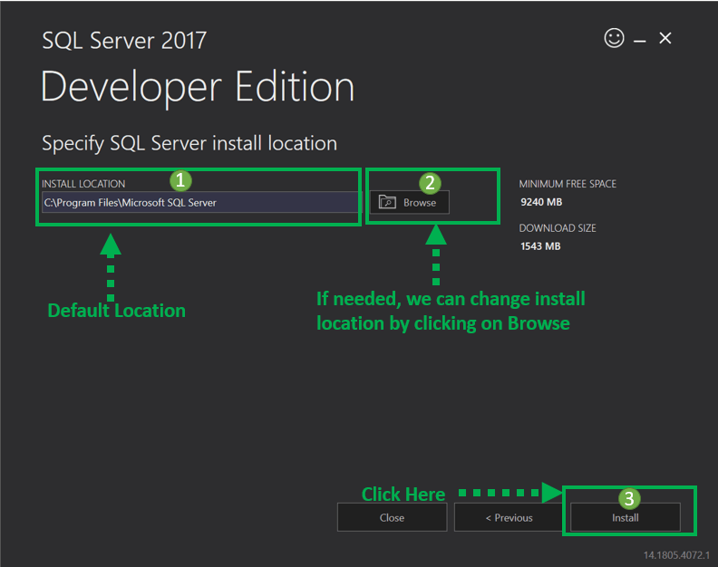](https://www.guru99.com/images/1/030119_0948_HowtoDownlo6.png)

Below 'Downloading install package' progress screen will be displayed. Wait until the download is complete.[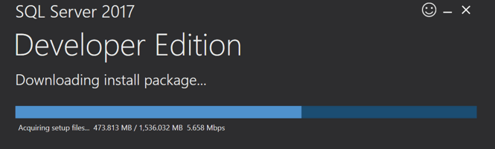](https://www.guru99.com/images/1/030119_0948_HowtoDownlo7.png)

Once, the download is complete, the system will initiate installing developer edition.

[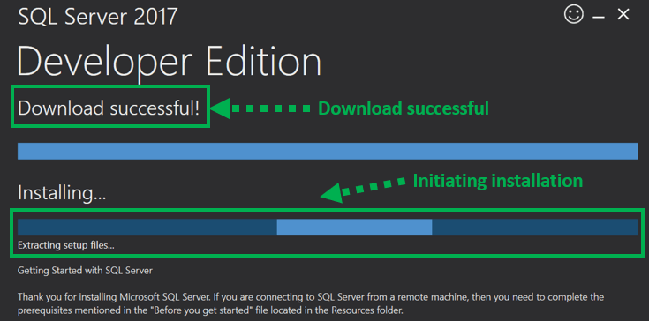](https://www.guru99.com/images/1/030119_0948_HowtoDownlo8.png)

Below screen show installation progress.

[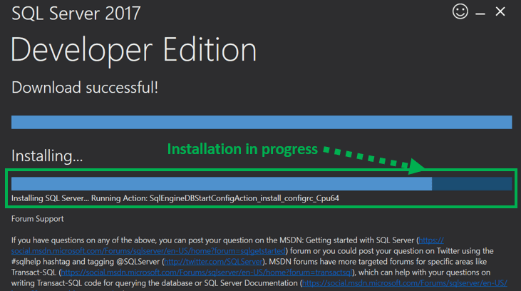](https://www.guru99.com/images/1/030119_0948_HowtoDownlo9.png)

**Step 7**: Once installation is completed successfully, below screen will appear.

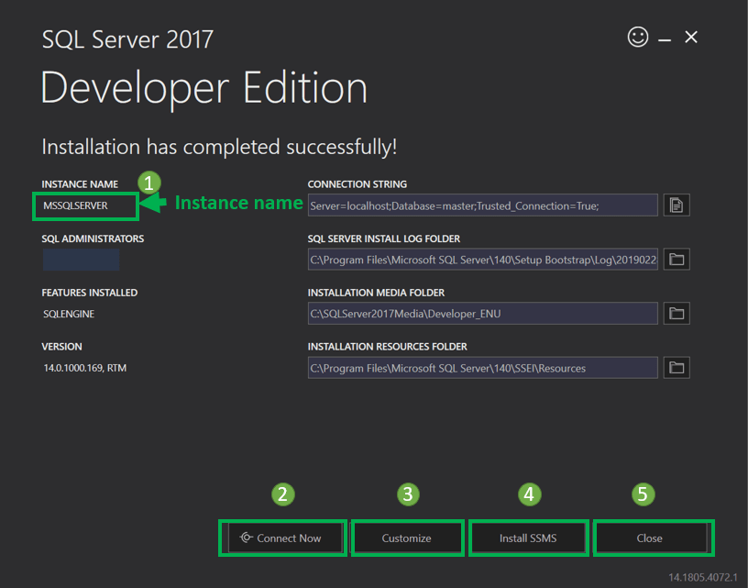

This setup is **sufficient for proceeding further** with learning SQL server, and we can 'Close' this window.

However, below is a summary of the label and button of above diagram.

1. **Instance name:** This is by default labeled as MSSQLSERVER.
2. **Connect now:** This will open a separate command line window for connection testing of what we have just installed.

The system will run by default **'select @@Version'**statement to confirm that we can connect to new MSSQLSERVER instance successfully.

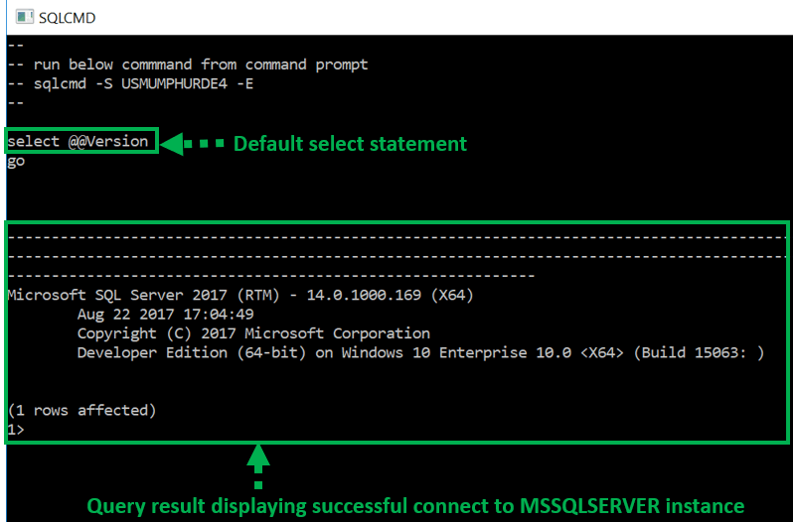

1. **Customize:** This will open the **SQL Installation center** to customize further and add feature other than which are there asd a part of the BASIC installation.
2. **Install SSMS:** This is IDE which will take us to Microsoft SSMS download link. We will cover SSMS in detail in our SSMS tutorial.
3. **Close:** This will close this window. The user is now ready to install SSMS IDE as instructed in SSMS tutorial.

**After Clicking Install SSMS, It will open directly in a browser, then download SSMS**

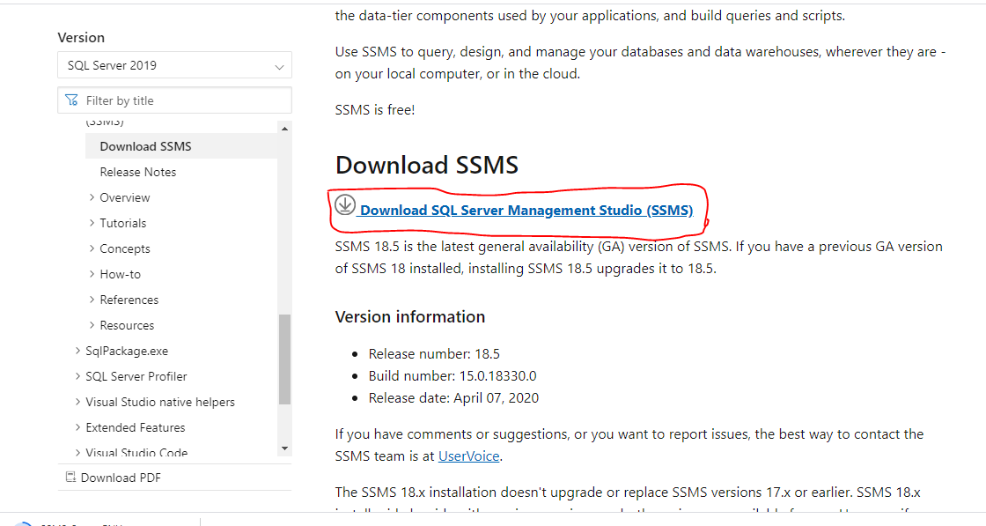

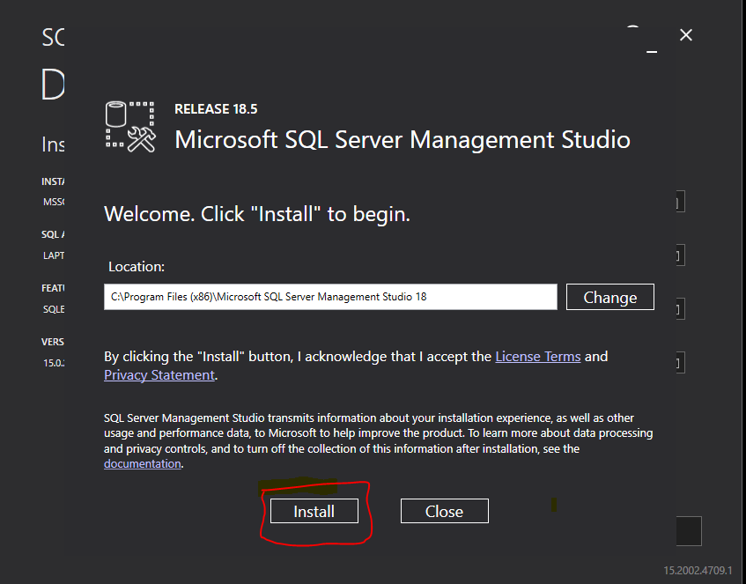

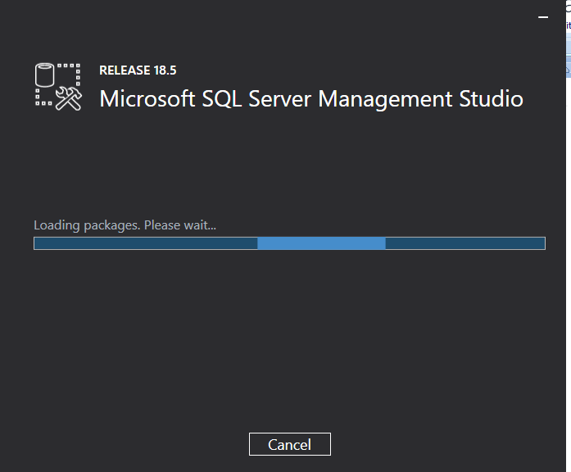

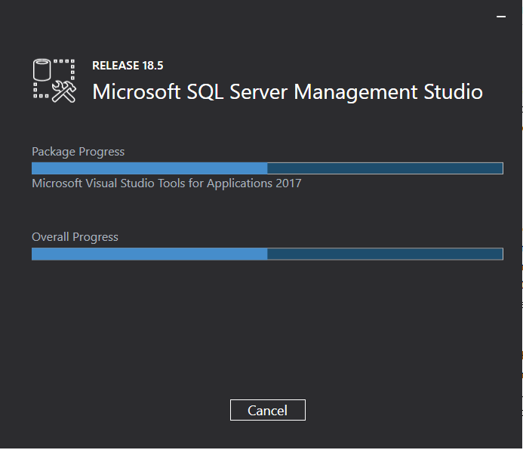

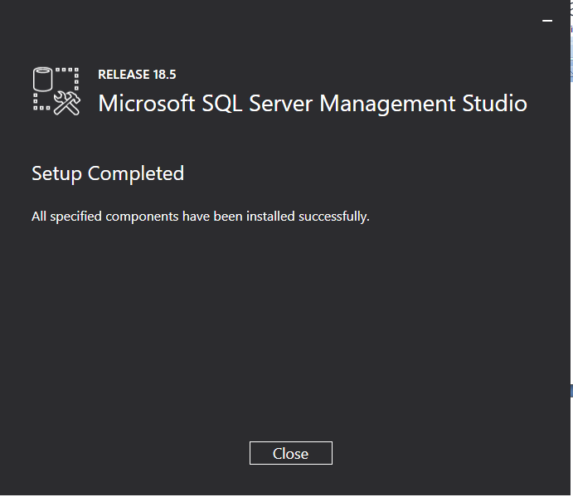

After Installation process , if you open SQL server studio we will see like below.

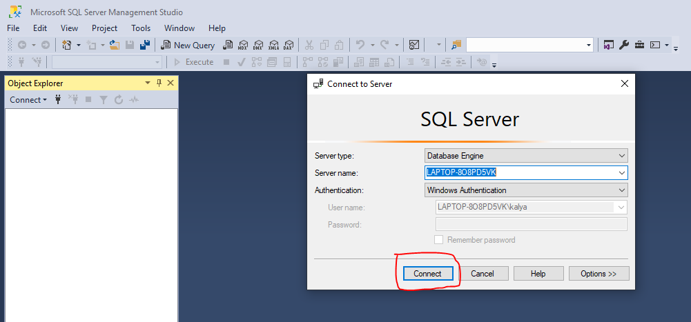

After this click on connect, as highlighted. Then we will get the screen as below and we are ready to use the studio.

