Uber Ride Data Analysis for Revenue Optimization
Alekhya Gangopadhyay
library(ggplot2)
library(dplyr)
# Load dataset
uber <- read.csv("D:/Downloads/ncr_ride_bookings.csv")
# Remove NA
uber <- na.omit(uber)
names(uber) <- make.names(names(uber))
uber$datetime <- as.POSIXct(
paste(uber$Date, uber$Time),
format="%Y-%m-%d %H:%M:%S"
)
# Extract features
uber$hour <- factor(format(uber$datetime, "%H"))
uber$day <- factor(
format(uber$datetime, "%A"),
levels = c("Monday","Tuesday","Wednesday","Thursday","Friday","Saturday","Sunday")
)
uber$Booking.Value <- as.numeric(gsub("[^0-9.]", "", uber$Booking.Value))
# Rides by hour
ggplot(uber, aes(x=hour)) +
geom_bar(fill="blue") +
ggtitle("Rides by Hour")
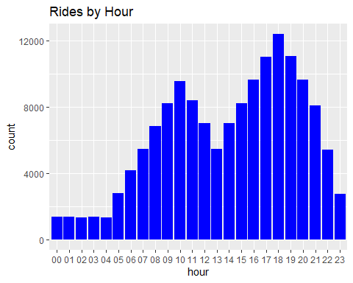
# Rides by day
ggplot(uber, aes(x=day)) +
geom_bar(fill="green") +
ggtitle("Rides by Day")
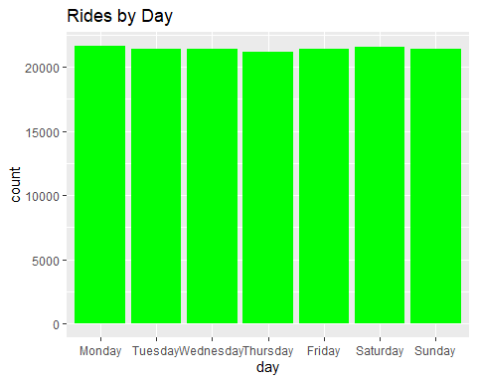
# Revenue analysis
hourly_rev <- uber %>%
group_by(hour) %>%
summarise(
trips = n(),
revenue = sum(Booking.Value, na.rm = TRUE)
)
hourly_rev
## # A tibble: 24 × 3
## hour trips revenue
## <fct> <int> <dbl>
## 1 00 1373 477304
## 2 01 1360 467167
## 3 02 1339 475840
## 4 03 1383 469813
## 5 04 1321 454992
## 6 05 2786 930721
## 7 06 4160 1471059
## 8 07 5450 1851902
## 9 08 6861 2394391
## 10 09 8234 2891944
## # ℹ 14 more rows
# Revenue trend
ggplot(hourly_rev, aes(x=hour, y=revenue, group=1)) +
geom_line(color="red") +
geom_point() +
ggtitle("Revenue by Hour")
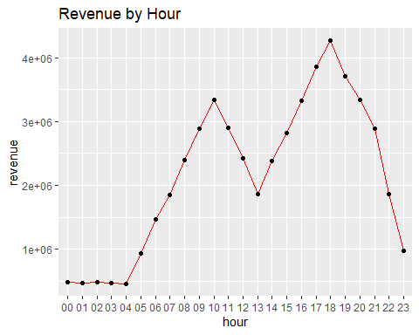
# Payment method analysis
if("Payment.Method" %in% names(uber)){
ggplot(uber, aes(x=Payment.Method)) +
geom_bar(fill="purple") +
ggtitle("Payment Methods")
}
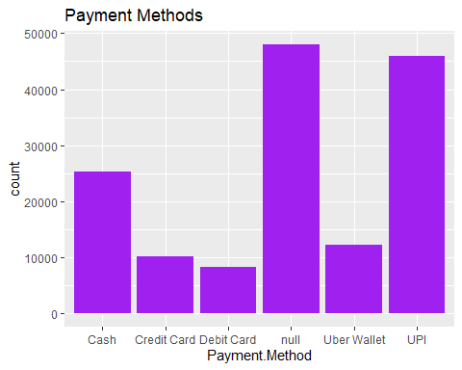
# Booking status analysis
if("Booking.Status" %in% names(uber)){
ggplot(uber, aes(x=Booking.Status)) +
geom_bar(fill="orange") +
ggtitle("Booking Status")
}
