FIELD-MIND: An Offline Multimodal Agentic AI System for Underground Mining Applications
A Research Proposal submitted for consideration under the Domain of Artificial Intelligence, Edge Computing, and Scientific Instrumentation

Project Title | FIELD-MIND: An Offline Multimodal Agentic AI System for Underground Mining Applications
Priority Area & Sub-Area | Agentic AI
Duration (in months) | 24 Months
Total Cost (in Rs.) | 81,900 (Eighty-One Thousand Nine Hundred Rupees Only)
Principle Investigator and Co-Investigators | Principle Investigator  Prof. Dr. Subhadip Chandra | Co-Investigator  Prof. Ankita Ray Chowdhury
Designation | Assistant Professor | Assistant Professor
Department | Dept. of CSE(AIML), CSBS | Dept. of CSE(AIML), CSBS
Institute Name | IEM Kolkata | IEM Kolkata
Address | IEM Management House | IEM Management House
Date of Birth | 25/09/1981 | 02/04/1990
Gender | Male | Female
Aadhar / PAN | AHYPC0756E | BGGPR7247R
Caste | General | General
Mobile | (+91)9332235642 | (+91)9874739669
Email ID | Subhadip.Chandra@iem.edu.in | Ankita.raychowdhury@iem.edu.in

Name(s) of the students:
- Amit Raj (CSBS, 3rd Year, 12023052018002)
- Sishir Gope (CSE (AIML), 2nd Year, 12024052016020)
- Supratik Bhowal (CSE (AIML), 2nd Year, 12024052016018)
- Alekhya Gangopadhyay (CSE (AIML), 2nd Year, 12024052016021)

A B S T R A C T
Scientific field research in remote environments is limited connectivity, preventing real-time AI-assisted analysis and delaying critical decisions. We present FIELD-MIND, an integrated offline multimodal agentic AI system designed for on-device scientific reasoning and validation. Deployed on the NVIDIA Jetson Nano edge platform, FIELD-MIND is optimized for lightweight multimodal anomaly detection and compressed on-device reasoning under strict power and memory constraints. The system integrates a compact 1B–3B parameter quantized language model optimized for edge deployment with offline retrieval over domain-specific scientific literature, enabling hypothesis generation, contradiction detection, and literature-grounded recommendations without cloud dependency. We can validate the architecture using marine and geoscience datasets, demonstrating real-time anomaly detection, low-latency retrieval from a compressed local scientific knowledge base, and context-aware reasoning under field power constraints. FIELD-MIND provides a scalable framework for deploying advanced multimodal AI in connectivity-deprived scientific environments, bridging the gap between data collection and in-situ analytical interpretation.

Introduction and Motivation of the Proposed Project

Underground mining remains one of the most data-rich and analysis-poor operational environments in heavy industry. Sensors embedded in rock walls, drill rigs, conveyor systems, and ventilation networks generate continuous streams of vibration, gas, temperature, and imagery data. Yet the analytical tools required to interpret this data in real time have historically been unavailable at the point of collection. Cloud-based AI inference is impractical underground, where satellite links offer kilobit-per-second bandwidth at best, and wired networks fail whenever a tunnel section is active or structurally compromised.
The result is a systemic gap between data collection and decision support. Shift engineers must make high-stakes judgments, when to evacuate a section, whether a vibration reading represents impending rockburst or normal blasting aftershock, how to adjust blast parameters when ground conditions change, based on intuition and experience rather than real-time analytical validation. Post-incident analysis often reveals that warning signals were present in sensor data hours or days before a failure event, but no system was able to interpret them in the moment.
FIELD-MIND closes this gap. By deploying a fully integrated multimodal reasoning system on the NVIDIA Jetson Nano edge computing platform, a single-board edge computer capable of hosting lightweight multimodal anomaly detection models alongside a compact reasoning engine tailored for edge execution., vision encoders, a scientific knowledge graph, and a vector retrieval index simultaneously, FIELD-MIND brings the analytical capability of a multidisciplinary engineering team to every tunnel section, every shift, regardless of connectivity.

A) The Underground Mining Challenge
The underground mining domain presents a unique combination of operational demands that no existing AI system adequately addresses:
- Structural hazards including rockburst, roof fall, and tunnel deformation occur without warning in conventional monitoring frameworks, despite being preceded by detectable micro-seismic signatures.
- Drill-and-blast operations generate complex vibration environments that simultaneously encode blast efficiency, fragmentation quality, and potential overbreak information that is currently lost after each blast cycle.
- Heavy equipment operating in confined, high-vibration environments degrades in ways that differ from surface machinery, requiring machine-specific baseline models rather than generic thresholds.
- Gas hazards - particularly methane accumulation and carbon monoxide, thus interact with structural and ventilation conditions in non-linear ways that require contextual, multi-sensor reasoning to interpret accurately.
- GPS denial makes conventional positioning and mapping impossible, requiring FIELD-MIND to maintain its own evolving spatial model of tunnel geometry and structural state.
- Worker fatigue and cumulative vibration exposure are invisible to current monitoring systems, yet are direct contributors to accident probability

B) Why Edge AI Is Now

The NVIDIA Jetson Nano enables practical edge deployment of multimodal AI systems within a 5–10W power envelope. While it cannot host extremely large language models, it is well-suited for real-time sensor fusion, lightweight anomaly detection, compressed vector retrieval, and efficient quantized reasoning models in the 1B–3B parameter range. This allows FIELD-MIND to operate continuously underground without cloud dependency while maintaining strict energy and thermal limits.
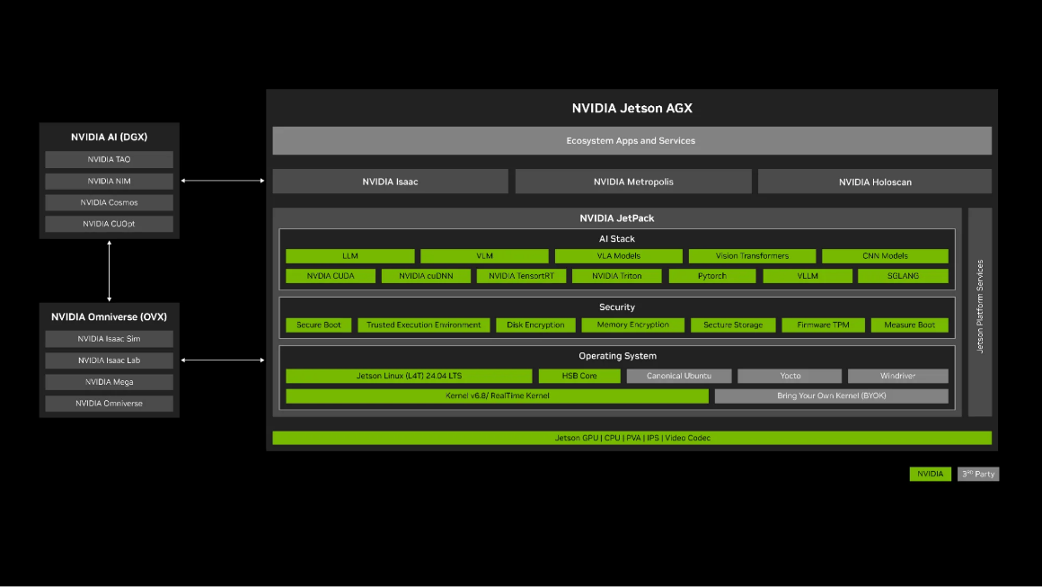
[Figure 1: Jetson software stack https://rb.gy/gwauj0]

State-of-the-art Research Related to Offline Agentic AI for Scientific Applications Globally

A review of the research landscape confirms the lack of a comprehensive, field-deployable, multimodal scientific reasoning system while pointing to a clear path toward on-device agentic AI.
- Multi-Agent LLM for Industrial Safety
- LLM-Based Mine Safety System (Sensors/MDPI, Jan 2025) - the closest existing work to FIELD-MIND's domain; uses multi-level LLMs for coal mine sensor assessment but is cloud-dependent and lacks vibration sensing MDPI
- LEMAD (Electronics, 2025) - hierarchical multi-agent anomaly detection for power grids, validating the tiered agent architecture FIELD-MIND uses MDPI
- Sharma et al. (arXiv, Oct 2025) - LLM contextual reasoning for critical IoT anomaly detection in dynamic environments arXiv

- Rockburst & Ground Instability Prediction
- Ma et al. (Rock Mechanics and Rock Engineering, 2025) - ensemble SGA model using SVM, GBRT, and Adaboost on real-time microseismic data, showing spatial distribution features outperform direct coordinate prediction for rockburst location Sebastian Raschka
- Li et al. (Scientific Reports, 2025) - CNN-GRU hybrid with prototype-based prediction at Dahongshan Copper Mine, achieving F1 of 0.9819 on microseismic event classification Frontiers
- SSA-CNN-MoLSTM-Attention model (Scientific Reports, 2025) - using working-face advancement distance rather than time-axis analysis to capture spatial correlations Sebastian Raschka

- Gas Hazard & Ventilation Intelligence
- Tutak et al. (Sustainability, 2024) - MLP neural network forecasting methane concentrations at 5–60 minute horizons from continuous ventilation monitoring data ACL Anthology
- Ihsan et al. (Engineering Applications of AI, 2024) - ANFIS-based Ventilation on Demand simultaneously optimizing fan power and gas dilution time arXiv
- DL-Koopman operator framework (Scientific Reports, 2025) - deep learning + control theory for gas prediction under fluctuating deep-mine ventilation conditions ACL Anthology
- Sharma & Maity (Archives of Computational Methods in Engineering, 2024) - systematic review confirming multi-sensor fusion outperforms single-sensor gas hazard classification arXiv

The Underground Mine: Why This Problem Demands a New Solution
100 metres below the Earth's surface, everything that modern industry takes for granted - connectivity, visibility, stable ground, reliable positioning ceases to exist. This is where miners work every day. This is where FIELD-MIND is built to operate.
The underground mine is not simply a difficult work environment. It is a fundamentally different operational reality, one that invalidates the assumptions on which virtually every existing industrial AI system has been built. To understand why FIELD-MIND represents a necessary and urgent development, it is essential to understand the six defining characteristics of this environment that no current technology adequately addresses.

- A Dynamically Changing Environment
Every blast, extraction, and water ingress physically change the mine. Fixed alarms can't keep up. FIELD-MIND continuously re-learns the mine's state in real time.

- Mineral Excavation as the Source of Hazard
Mining and hazard are inseparable, every advance creates unsupported ground; every blast stresses the rock mass. A single ground failure costs tens of millions of dollars. FIELD-MIND turns sensor data into early warnings before failures occur.

- Structure and Environment Change Constantly
Tunnel sections evolve from fresh excavation to cracking to collapse risk, each stage needs different safety thresholds. Current systems require manual updates to keep up. FIELD-MIND adapts its detection baselines automatically.

- One of the Most Accident-Prone Industrial Environments on Earth
Heavy machinery, explosive gases, unstable ground, and no quick escape route make underground mining uniquely dangerous. Pike River, Soma, and countless rockburst incidents all share one finding: the warning signals were in the data, but nothing could read them in time. FIELD-MIND can.

- Complete Absence of Network Connectivity
400 metres underground, there is no cellular, Wi-Fi, or satellite signal. Every existing AI safety system goes dark when the network fails, which is exactly when it's needed most. FIELD-MIND runs entirely on-device with zero dependency on connectivity.

- Depth: 100 Metres and Beyond into the Earth
Ground stress multiplies with depth; at 500m, rockburst is a daily reality, not a rare event. Depth also shrinks the response window from hours to minutes. FIELD-MIND is built specifically for this , where late intelligence costs lives.

Use Cases: FIELD-MIND in Underground Mining Operations

Use Case 1: Rockburst, Roof Fall, and Ground Instability Early Warning
Sensor Inputs: Vibration sensor data, stress meters, convergence sensors, tunnel imagery (RGB-D), geological borehole data
FIELD-MIND System Behavior
• Learns normal micro-seismic baseline per tunnel section
• Detects pre-failure vibration clusters invisible to threshold alarms
• Cross-references stress and convergence data to confirm genuine precursors
• Issues alerts with confidence level, time-to-event estimate, and recommended action
Operational Outcome: Hours of advance warning before audible cracking , enabling targeted evacuation rather than full section shutdowns.

Use Case 2: Drill-and-Blast Impact Assessment and Adaptive Optimization
Sensor Inputs: Blast vibration monitoring array, drill parameter logs (burden, spacing, charge weight, timing), post-blast RGB-D imagery, tunnel geometry model from EKG
FIELD-MIND System Behavior
• Analyzes blast vibration spectra against drill parameters for efficiency
• Detects overbreak/underbreak from imagery and links to blast design
• Identifies where explosive energy damages structure instead of fragmenting rock
• Recommends optimized blast designs with predicted outcomes
Operational Outcome: Progressive improvement in blast design quality specific to each mining zone, reducing tunnel damage and equipment stress, improving fragmentation uniformity, and extending tunnel structural life, with each blast cycle contributing data that makes the next cycle more informed.

Use Case 3: Machinery Health Monitoring and Predictive Maintenance
Sensor Inputs: Vibration sensors on equipment, temperature sensors, acoustic sensors, telemetry
FIELD-MIND System Behavior
• Builds machine-specific vibration baselines per unit
• Detects bearing wear, misalignment, imbalance, and gear anomalies early
• Separates wear-related degradation from normal load transients
• Estimates remaining useful life and schedules maintenance proactively
Operational Outcome: Breakdowns prevented before they happen, no unplanned downtime, no blocked headings.

Use Case 4: Methane, Gas, and Ventilation Hazard Reasoning
Sensor Inputs: Gas sensors (CH₄, CO₂, CO, H₂S, O₂), airflow sensors, vibration sensors, blast logs
FIELD-MIND System Behavior
• Monitors gas trends across the full sensor network simultaneously
• Correlates gas spikes with vibration events to find structural root causes
• Distinguishes sensor drift and noise from real hazard signals
• Explains why gas is rising, not just that it is
Operational Outcome: Targeted responses to real hazards, fewer false evacuations, no missed threats.

Use Case 5: Tunnel Deformation and Structural Drift Detection in GPS-Denied Environments
Sensor Inputs: Wall vibration sensors, LiDAR/RGB-D scanners, convergence meters, EKG design drawings
FIELD-MIND System Behavior
• Detects changes in wall vibration transmission before visible cracking appears
• Combines vibration inference with LiDAR scans for multi-source evidence
• Compares behaviour against design tolerances stored in the EKG
• Works fully without GPS using internal spatial reference from tunnel geometry
Operational Outcome: Structural problems caught before failure , lower risk, lower remediation cost.

Outline of the Proposed Methodology

FIELD-MIND is structured as a six-layer pipeline from physical sensor inputs to scientist-facing outputs (Figure 2).

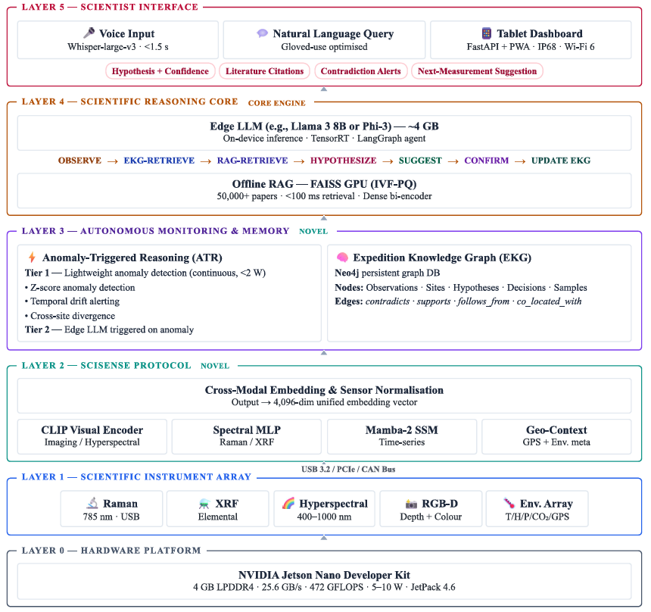

[Figure 2: FIELD-MIND System Architecture Diagram - Six-layer pipeline from instrument ingestion to scientific reasoning interface, deployed on a Jetson Nano edge computing module]

A) FIELD-MIND System Components

The NVIDIA Jetson Nano (4GB RAM) serves as the primary edge compute node. It hosts lightweight anomaly-detection models, compressed multimodal encoders, and a compact, quantised language model (1B–3B classes) for contextual reasoning. Due to limited memory resources, the system employs efficient model loading strategies, streaming-based retrieval, and selective reasoning activation to ensure stable performance under field constraints.
In the initial deployment phase, FIELD-MIND integrates vibration and micro-seismic sensors, environmental monitoring systems (CH₄, CO₂, CO, H₂S, temperature, humidity, pressure, airflow), RGB-D and LiDAR imaging, and equipment telemetry (drilling parameters, haulage cycles, conveyor load and speed) through industrial interfaces such as CAN bus, PCIe, and Ethernet. Geological datasets including borehole logs, tunnel plans, and blast design records are ingested as static contextual inputs. The architecture is designed to support future extensions such as additional seismic arrays, ground deformation sensors, and wearable safety devices without modification.

- The SciSense Protocol (Layer 1) aligns heterogeneous underground sensor streams into a shared 4,096-dimensional embedding space using modality-specific encoders for vibration time-series, gas concentration sequences, imagery, telemetry, and geological metadata. For vibration data, frequency-domain decomposition, temporal clustering, and energy distribution analysis are applied prior to embedding, preserving the spectral signatures that distinguish rock micro-fracturing, machinery degradation, ventilation disturbances, and blast-induced wave propagation.

- Anomaly-Triggered Reasoning (Layer 2A) a two-tier lightweight architecture. Tier 1 consists of classical and small neural anomaly detectors (Isolation Forest, Tiny CNN, LSTM) running continuously. Tier 2 activates a compact quantized reasoning model only when significant deviations are detected, ensuring memory stability and power efficiency.

- The Expedition Knowledge Graph (Layer 2B) functions as FIELD-MIND’s persistent mine memory. Implemented in Neo4j, it maintains a continuously updated representation of tunnel geometry, geological zones, equipment locations, historical vibration events, gas anomalies, blast records, and maintenance actions. Every sensor observation is linked to a spatial location, timestamp, and prior local history, enabling detection of slow-developing hazards and recurring failure patterns.
- The Scientific Reasoning Core (Layer 3) will run Llama-3.2-3B-Instruct (4-bit, GGUF quantized) using a LangGraph loop:

OBSERVE → EKG-RETRIEVE → RAG-RETRIEVE → HYPOTHESIZE → SUGGEST → CONFIRM → UPDATE_EKG.

Users will interact through offline speech recognition and a web-based interface on a rugged tablet over local Wi-Fi, receiving hypotheses, confidence scores, citations, contradiction analysis, and recommended follow-up actions.
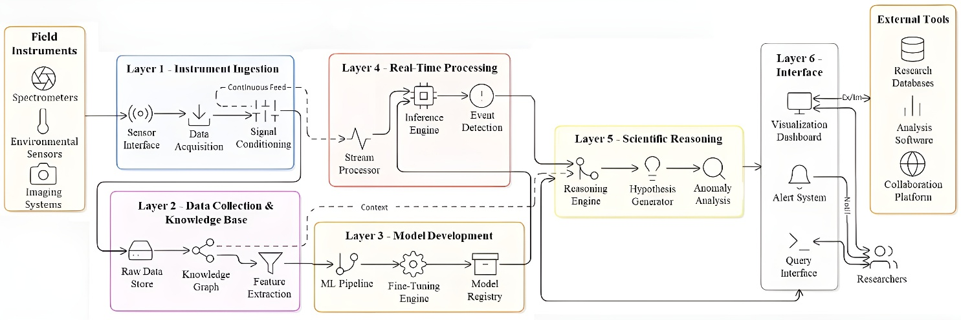

[Figure 3: FIELD-MIND Agent Reasoning Loop -
OBSERVE → EKG-RETRIEVE → RAG-RETRIEVE → HYPOTHESIZE → SUGGEST → CONFIRM → UPDATE_EKG cycle with example scientific reasoning trace]

B) Data Collection and Knowledge Base Construction

Prior to deployment, the mining knowledge base is constructed from open-access mine safety reports, rock mechanics literature, vibration and seismic case studies, equipment failure manuals, regulatory safety guidelines, and historical mine incident databases. These documents are encoded using dense scientific text encoders and indexed in a FAISS-based vector store, enabling low-latency retrieval for grounding anomaly explanations and recommendations entirely offline.

C) Model Development and Fine-Tuning

The system employs a 3B-parameter reasoning model selected for strong performance on complex scientific and engineering reasoning tasks. Quantized checkpoints are deployed for efficient edge inference, while domain-specific adaptation is performed using low-rank fine-tuning directly on the edge hardware. Training data consists of curated mining incident reports, vibration signatures, maintenance logs, and geological assessments, demonstrating the feasibility of specializing large reasoning models for underground mining applications without cloud dependence.

D) Integration and Testing

We complete system integration in four stages:
(1) Validation of the SciSense Protocol using public vibration, seismic, & underground imaging datasets.
(2) Evaluation of the Expedition Knowledge Graph and retrieval pipeline using simulated mine histories and incident scenarios.
(3) End-to-end integration of continuous monitoring and anomaly-triggered reasoning across all sensor modalities.
(4) Demonstration of a multi-day, fully offline deployment showcasing real-time hazard detection, vibration-driven reasoning, and actionable mine safety recommendations.

Identified Research Gap and Novel Contributions
A systematic literature review confirms the following research gap:
System | Offline Capable | LLM Reasoning (≥70B or Agents) | Live Sensor Input | Persistent Expedition / Memory | Natural Language Interface | Multi-Domain Scientific Grounding
LLM-based Mine Safety System (AMD Sensors, 2025) | Cloud-dependent | Small task-specific LLM | Gas + env sensors | Session-bound | Text queries | Mine-specific
LEMAGIC (electronics, 2025) | Yes | No LLM rule + ML | Power-grid sensors | None | Dashboard only | Electrical only
Sharma et al. (ark, 2025 – IoT Anomaly LLM) | Cloud | Contextual LLM | IoT streams | None | Yes | Generic IoT
Ma et al. (Rock Mech, 2025) | Yes | SVM / GBRT / AdaBoost | Microseismic | None | None | Rockburst only
Liu et al. (Scientific Reports, 2025) | Yes | CNN–GRU | Microseismic | None | None | Rockburst only
SSA-CMM (IEEE TSMC, 2025) | Yes | DL only | Microseismic | None | None | Rockburst only
Tufekci et al. (Sustainable Energy, 2024) | Yes | MLP | Ventilation + gas | None | None | Gas only
Iskafi et al. (EAAI, 2024 – AMRVs) | Yes | ANFIS | Ventilation + gas | None | None | Gas only
DL-Keepers (Mathematics, 2025) | Yes | DL + control | Ventilation + gas | None | None | Gas dynamics only
FIELD-MIND (Proposed) | Full Edge-Offline | Compact Agentic LLM | Gas + seismic + vision | Persistent site memory | Voice + NL | Geomech + Gas + Control
[Table 1: Research Gap Matrix]
No existing system combines offline LLM reasoning, multi-sensor fusion, persistent mine memory, and natural language interaction in a single underground-deployable platform. Current approaches are either cloud-dependent, single-sensor, or limited to surface-based analysis pipelines that go offline the moment network connectivity fails. FIELD-MIND is built to operate where these systems cannot.
The core contributions are as follows:
- SciSense Protocol - Unified Underground Sensor Embedding Underground mines generate fundamentally different data types simultaneously including, micro seismic waveforms, gas concentrations, drill telemetry, thermal readings, and tunnel imagery. The SciSense Protocol aligns all of these into a single shared embedding space, enabling the reasoning model to think across sensor modalities the way an experienced mine engineer does: not in isolation, but together.
- Expedition Knowledge Graph (EKG) - Persistent Mine Memory No blast, no shift change, and no network outage erases what FIELD-MIND has learned. The EKG maintains a continuously updated record of every tunnel section's structural history, gas trends, blast records, and anomaly events, enabling the system to detect patterns that only become visible across days or weeks, and to answer the question every mine engineer asks after an incident: what did the data show before this happened?
- Anomaly-Triggered Reasoning (ATR) - Power-Efficient Deep Intelligence Running a reasoning model continuously underground is impractical. ATR solves this with a two-tier architecture: a lightweight model monitors all sensor streams continuously at low power, and activates the full reasoning model only when something significant is detected. The mine is always being watched. The deep intelligence fires only when it matters.

7. Proposed Deliverables of the Project
The project will deliver a functional FIELD-MIND prototype validated on real underground mining sensor data, fully offline, deployable on NVIDIA Jetson Nano edge module without any cloud dependency.
- SciSense Protocol for Mining - Open-source Python library providing standardized interfaces for underground sensor modalities: micro-seismic, gas, vibration, thermal, and tunnel imagery. Includes modality-specific encoders and a synchronized multi-sensor data pipeline.
- Mine Knowledge Graph (EKG) - Neo4j implementation with LangGraph integration, pre-loaded with underground mining domain knowledge: blast records, geological schemas, equipment maintenance logs, and hazard incident templates. Fully persistent across shifts and network outages.
- FIELD-MIND Inference Stack for Jetson Nano - Complete deployment package including 4-bit quantized model weights optimized for low-memory inference, TensorRT-LLM configurations, FAISS-based mine knowledge indexing, and a FastAPI interface with automated underground deployment setup.
- Underground Mining ATR Benchmark - Evaluation framework for testing anomaly detection performance across micro-seismic, gas, vibration, and structural sensor streams — with severity ranking and response-time metrics specific to mining safety standards.
Intellectual Property and Dissemination Plan
- Proposed Patent - To be filed for the Anomaly-Triggered Reasoning (ATR) architecture: specifically, the two-tier power-aware activation mechanism that switches between a lightweight monitoring model and a 3B reasoning model on edge hardware in connectivity-denied underground environments.
- Copyright - The SciSense Protocol mining sensor library, EKG mine schema, and underground deployment stack will be protected under copyright, with controlled open-source release subject to institutional policy.
- Research Publication - A peer-reviewed paper will be submitted presenting FIELD-MIND as the first fully offline multimodal agentic AI system validated for underground mining safety and operations on edge hardware.

8. Project Timeline
[Table 2: Project Gantt Chart – 24 month timeline with 5 phases]

Five phases 24 months:
- Phase 1 (M1-4) SciSense Protocol, dataset validation.
- Phase 2 (M5-8) EKG schema, FAISS index, Lightweight RAG deployment on Jetson Nano.
- Phase 3 (M9-14) Compact LLM integration with ATR architecture, QloRA fine-tuning, GPT-4o benchmark
- Phase 4 (M15-18) AIS tourney full stack integration, voice/tablet UI, simulated expedition demonstration.
- Phase 5 (M19-24) dataset validation, writing PubMed papers, open source release and presenting at conferences.

9. Budget

  - Core Compute Platform
Component | NVIDIA Jetson Nano
Estimated Cost | ₹20,000
Why Needed | Primary edge AI compute platform
Used For | Hosting LLM, FAISS index, multimodal encoders, EKG, ATR
Technical Role | Edge sensor fusion, anomaly detection, compact LLM inference
Justification
- 4GB LPDDR4 memory required to co-host:
  - 3B model (~3GB)
  - Vision encoders
  - FAISS vector index
- Power envelope (5–10W) enables field deployment
- Only edge-class device capable of this integration

2. Other Components
Sl. No | Component | units of component | Total (₹) | System Role | Operational Purpose in Underground Mine
1 | Vibration Sensor | 2 | 400 | Structural monitoring | Detects micro-tremors and early collapse indicators
2 | MQ-2 | 2 | 200 | Gas monitoring | Detects LPG, smoke and combustible gases
3 | MQ-3 | 2 | 300 | Vapor detection | Identifies volatile vapours in enclosed tunnels
4 | MQ-4 | 2 | 200 | Methane monitoring | Detects methane build-up (explosion risk)
5 | MQ-7 | 2 | 300 | CO monitoring | Detects carbon monoxide poisoning risk
6 | MQ-135 | 2 | 300 | Air quality monitoring | Detects NH₃, NOx, benzene, and general toxicity
7 | MQ-136 | 2 | 2,000 | H₂S monitoring | Detects hydrogen sulfide (highly toxic gas)
8 | MG811 CO₂ Sensor | 2 | 5,000 | CO₂ monitoring | Measures ventilation efficiency and suffocation risk
9 | PM2.5 Optical Dust Sensor | 2 | 1000 | Dust monitoring | Detects particulate matter (silicosis & explosion risk)
10 | DHT22 | 2 | 300 | Environmental sensing | Measures temperature and humidity conditions
11 | Ultrasonic Sensor | 2 | 400 | Structural displacement detection | Monitors tunnel wall shifts or deformation
12 | Intel RealSense Depth Camera D435i | 1 | 40,000 | 3D structural & depth vision | Tunnel mapping, crack detection, digital twin generation
13 | Raspberry Pi camera 3 NoIR | 1 | 3,000 | Low-light and infrared imaging sensor | Capture clear images and video in dark mine environments
14 | Raspberry Pi 5 (8GB) | 2 | 12,000 | Sensor bridge & preprocessing | Aggregates sensor data, filters noise, formats data streams
15 | LoRa Communication Module | 1 | 1,200 | Communication layer | Low-power data transmission in underground env
16 | 256 GB Micro SD Card | 1 | 3,500 | AI model & data storage | Stores trained AI models, logs, sensor fusion datasets, & digital twin snapshots for offline processing and benchmarking
17 | 32 GB Micro SD Card | 2 | 1,600 | Edge node OS & local buffer storage | Hosts operating system, sensor acquisition scripts, temporary sensor logs, and emergency alert data buffering
18 | 10.1-inch LCD Touch Screen | 1 | 10,200 | Visualization Interface | Provides real-time visualization of hazard levels, gas conc., structural alerts, & on-site AI risk predictions
19 | 20,000 mAh Power Bank | 1 | 1,000 | Portable backup power supply | Provides uninterrupted power to Raspberry Pi sensor bridge
20 | Misc. (Wire, Power Cable) |  | 1,000 | Connecting Components | Transmitting electrical power, data, and communication signals
TOTAL |  |  | 84,900
Based on current Indian market pricing and realistic procurement ranges, the total hardware expenditure for the complete Phase-1 FIELD-MIND system is estimated as follows:

Total Estimated Cost - ₹ 84,900 (EIGHTY-FOUR THOUSAND NINE HUNDRED RUPEES)

10. Conclusion
Underground mining already has the sensors. The warning signals are already there. What has been missing is a system that can read them in real time, at depth, without connectivity.
FIELD-MIND closes that gap. Deployed on the Deployed on the NVIDIA Jetson Nano, it brings efficient multimodal anomaly detection and edge-optimized reasoning directly underground, fusing vibration, gas, structural, and equipment sensor streams into grounded, actionable intelligence on every shift, regardless of network state. The SciSense Protocol, Expedition Knowledge Graph, and Anomaly-Triggered Reasoning architecture work together to turn raw sensor data into decisions. The global underground mining industry generates over USD 700 billion annually, and continues to lose lives to incidents whose warning signals went unread. A single prevented rock burst, a single methane explosion forestalled, pays back this system's development cost many times over. FIELD-MIND is a direct engineering response to a problem the industry cannot afford to keep waiting on.
Publications:
- Chowdhury, A. R., Bakshi, S. C., Pramanik, A., & Roy, G. C. (2024). Design and study of LoRa-based IIoT network for underground coal mine environment. IEEE Access.
- Ray Chowdhury, A., Pramanik, A., & Roy, G. C. (2023). IoT and LoRa based smart underground coal mine monitoring system. Microsystem Technologies, 1–20.
- RayChowdhury, A., Pramanik, A., & Roy, G. C. (2021). New approach for localization and smart data transmission inside underground mine environment. SN Applied Sciences, 3(6), 604.
- Ray Chowdhury A., Das K. A., Bakshi C. S., Pramanik A., Venkateswaran P. (2024). Smart Underground Mine Monitoring System (Indian Patent No. 553659). The Patent Office, Government of India.
- Chowdhury, Ankita Ray, et al. "On transmission time of a LoRa packet in a LoRa-based IoT system for underground environment." 2023 8th International Conference on Computers and Devices for Communication (CODEC). IEEE, 2023.
- Raychowdhury, Ankita, and Ankita Pramanik. "Survey on LoRa technology: solution for internet of things." Intelligent Systems, Technologies and Applications: Proceedings of Fifth ISTA 2019, India (2020): 259-271.
- Ray Chowdhury A., Das K. A., Bakshi C. S., Pramanik A., Roy G.C. ”Remote Positioning System for Underground Coal Mines Using Visible Light and LoRa Communication”, Indian Patent Application No. 202441028230, Dated 5.04.2024.

Submitted By,
_______________________ ______________________
Prof. Dr. Subhadip Chandra Prof. Ankita Ray Chowdhury
Assistant Professor Assistant Professor
Dept. of CSE(AIML), CSBS Dept. of CSE(AIML), CSBS

