**Optimizing Critical Data Handling for Disaster Relief Operations**

**Problem Statement:**

**RapidRelief Solutions**, a disaster management organization, is struggling to efficiently manage large volumes of critical data, including disaster response records and satellite imagery. The current system is slow, error-prone, and delays access to vital information, hampering emergency response efforts. To address this, RapidRelief Solutions plans to implement a streamlined solution for securely uploading and managing essential disaster-related data. This will improve response times, enhance coordination, and ensure quick access to critical information during disaster relief operations.



**Pre-requisites:**

### 1. AWS Account Setup: [https://youtu.be/CjKhQoYeR4Q?si=ui8Bvk_M4FfVM-D](https://youtu.be/CjKhQoYeR4Q?si=ui8Bvk_M4FfVM-Dh)h

### 2. Understanding of IAM: <https://youtu.be/gsgdAyGhV0o?si=3qg-bULgkD4LXNvR>

### 3. Basic Knowledge of Amazon S3: <https://youtu.be/tfU0JEZjcsg?si=F1QLN_QKvy753Zg8>

4. Region Selection :<https://youtu.be/NQhH2kcKI5U?si=GwDI8Gx7oUot8PiT>

**Objective:**

The primary objective of this project is to develop a secure and efficient process for uploading and managing disaster-related data for RapidRelief Solutions using Amazon S3. This includes ensuring that critical information—such as real-time disaster response records, damage assessments, and satellite imagery—is securely stored, well-organized, and easily accessible in the S3 bucket. The goal is to improve data management and accessibility, supporting better decision-making and enhancing the organization's disaster response capabilities.

**Tasks:**

1. Log in to the AWS IAM Management Console and navigate to the S3 service.
2. Click "Create bucket," enter a unique bucket name, and select the AWS region.
3. Configure the bucket settings, including public access and permissions as needed.
4. Review the settings and click "Create bucket."
5. Select the bucket, click "Upload," and add your files, then verify their successful upload

**Solution Development Procedure:**

1. Log in to the AWS IAM Management Console and navigate to the S3 service.

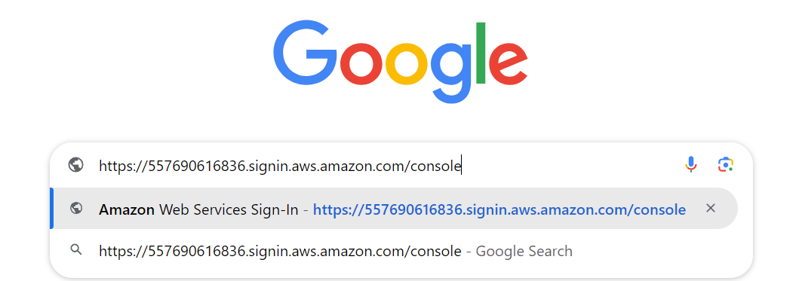

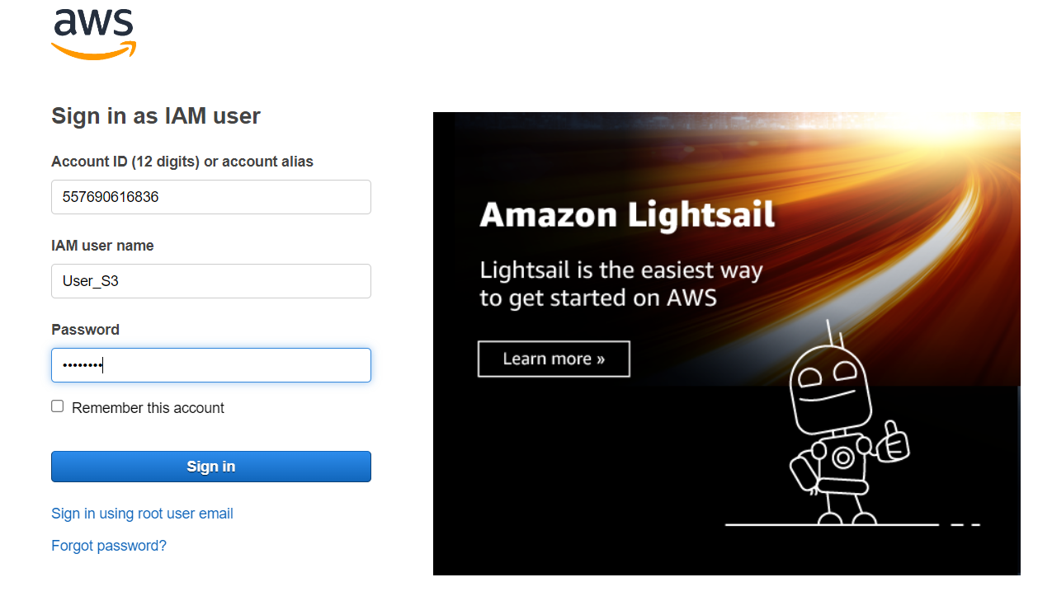

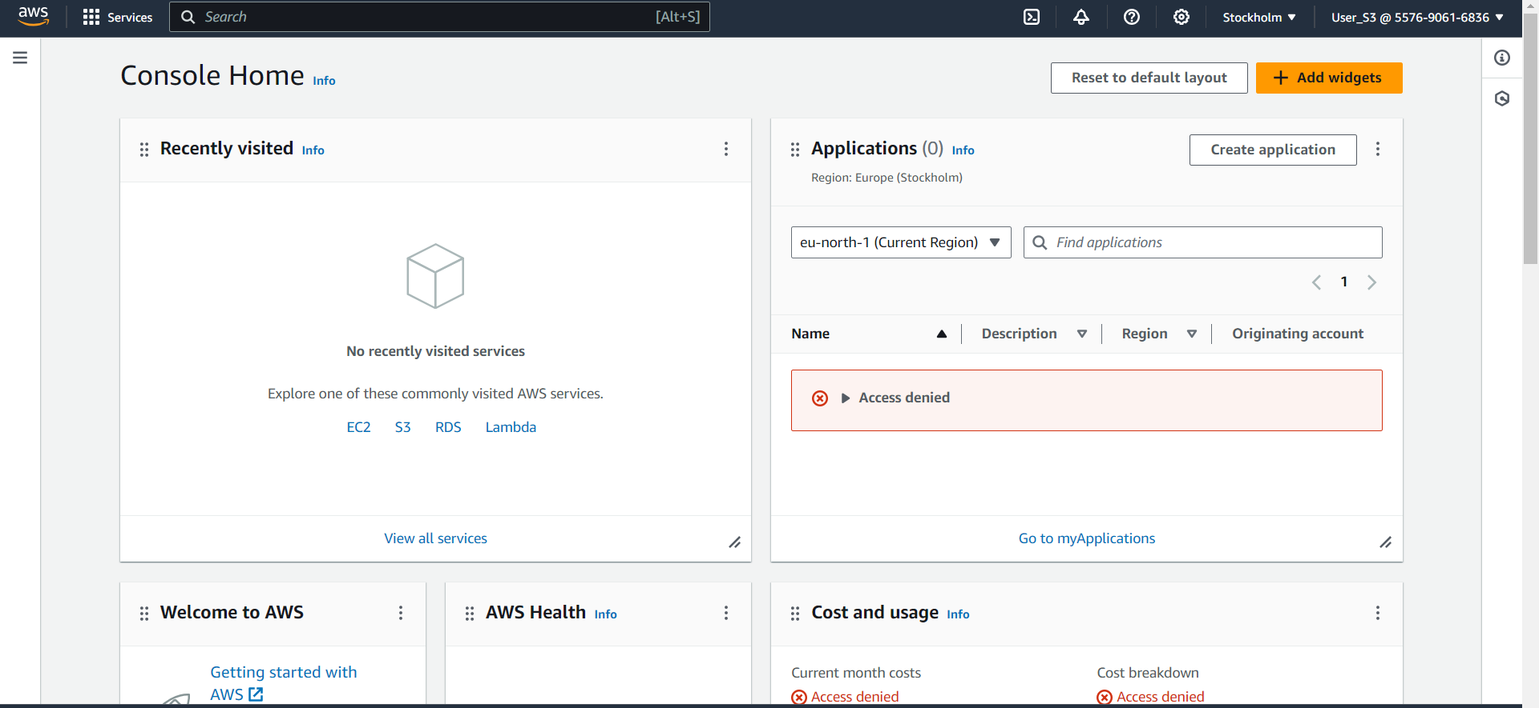

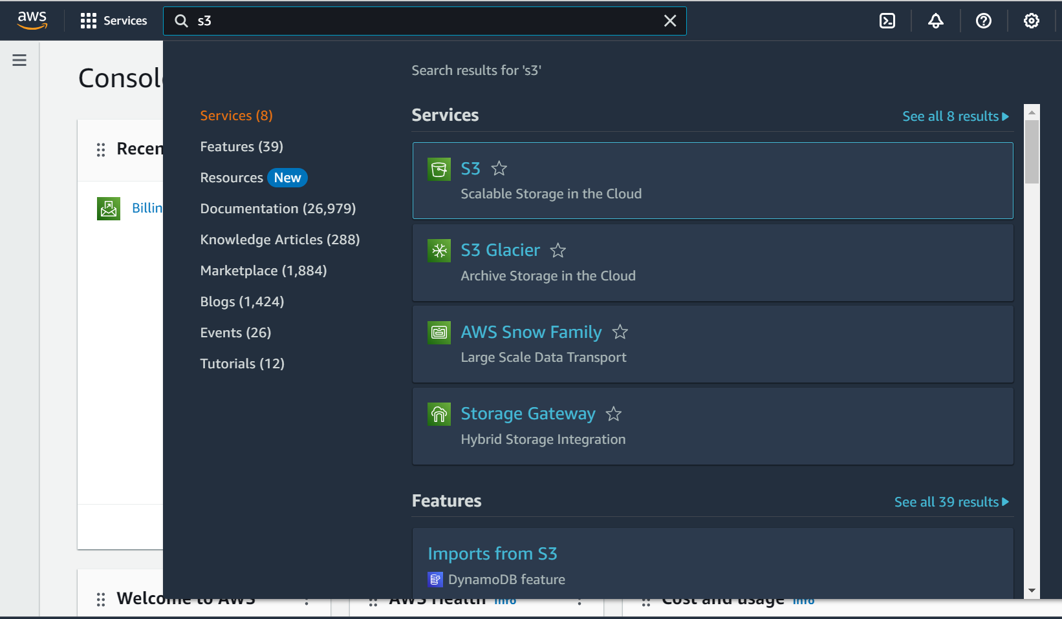

1. Click "Create bucket," enter a unique bucket name, and select the AWS region.

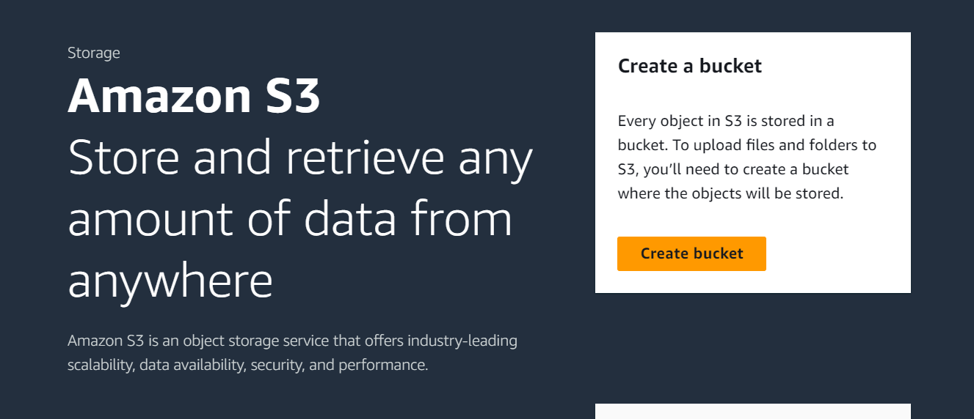

1. Configure the bucket settings, including public access and permissions as needed.

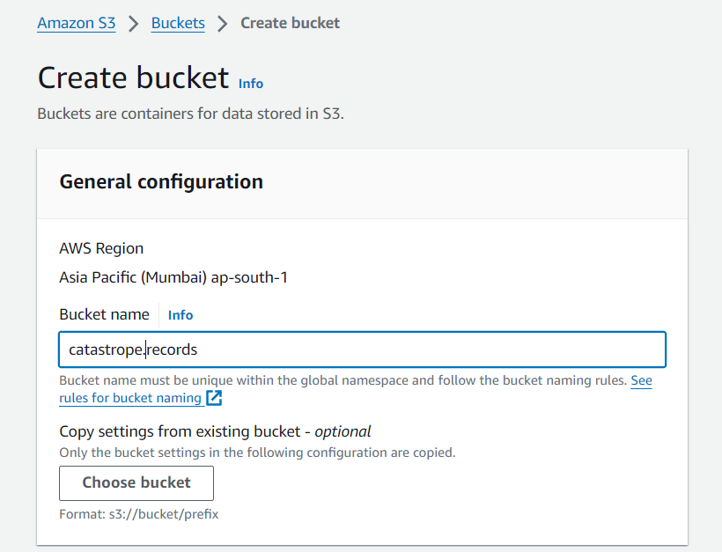

Enter a unique bucket name that follows AWS bucket naming rules in the "Bucket name" field. Ensure the name is unique within the global namespace.

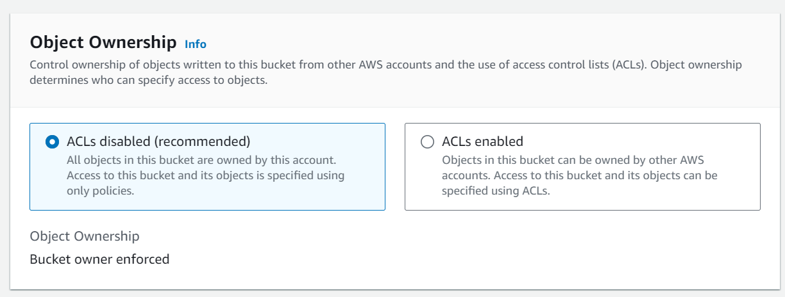

Choose "ACLs disabled (recommended)" to ensure all objects in the bucket are owned by your account, with access specified using only policies. Select "Bucket owner enforced" to control object ownership and specify access exclusively through bucket policies.

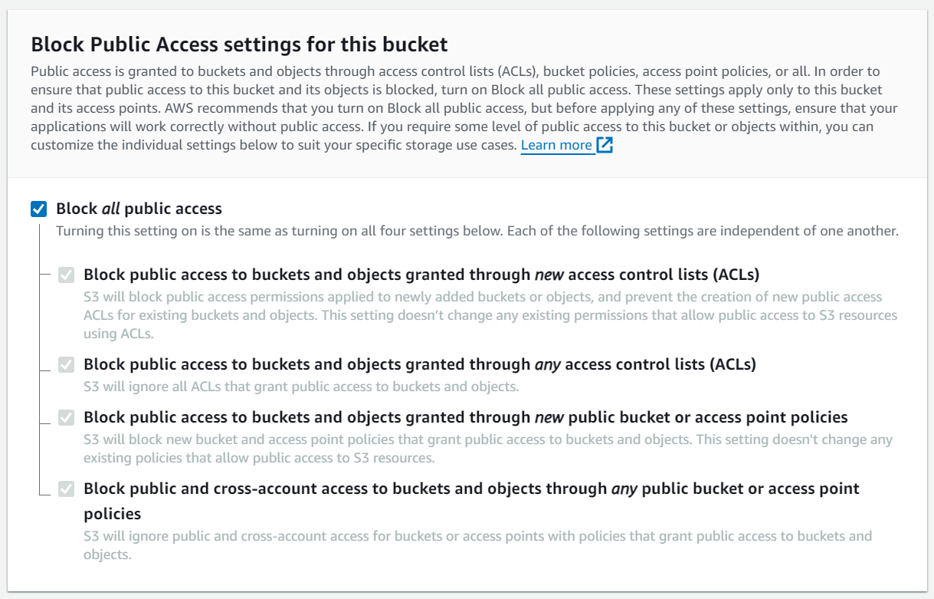

To ensure the highest security, enable "Block all public access" to prevent public access to the bucket and its objects through any ACLs or policies. Customize individual settings if specific public access is required, ensuring your applications function correctly without public access.

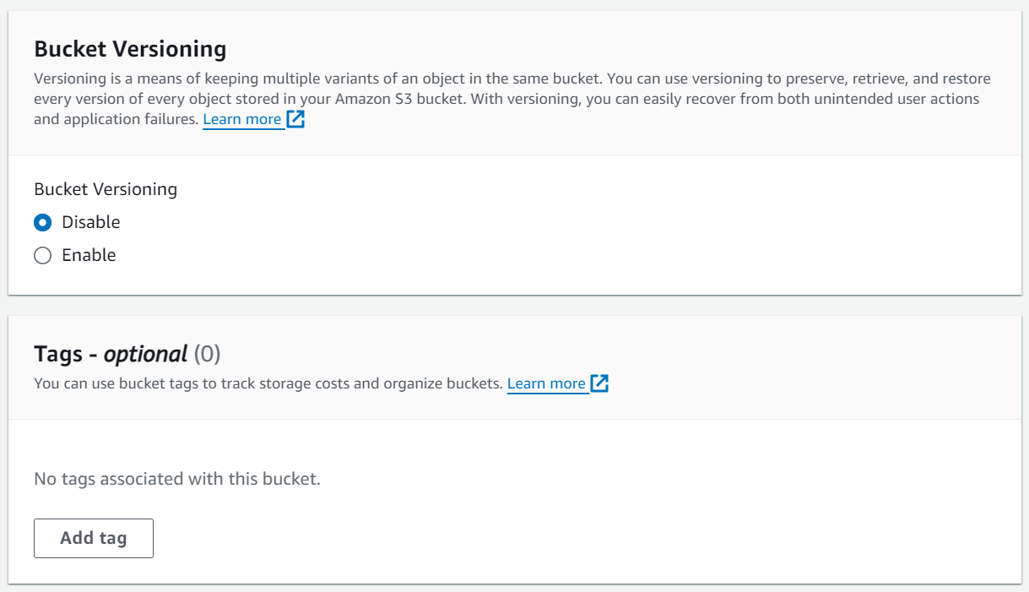

Enable "Bucket Versioning" to keep multiple variants of an object in the same bucket, allowing you to preserve, retrieve, and restore every version of stored objects. This helps recover from unintended actions and application failures.

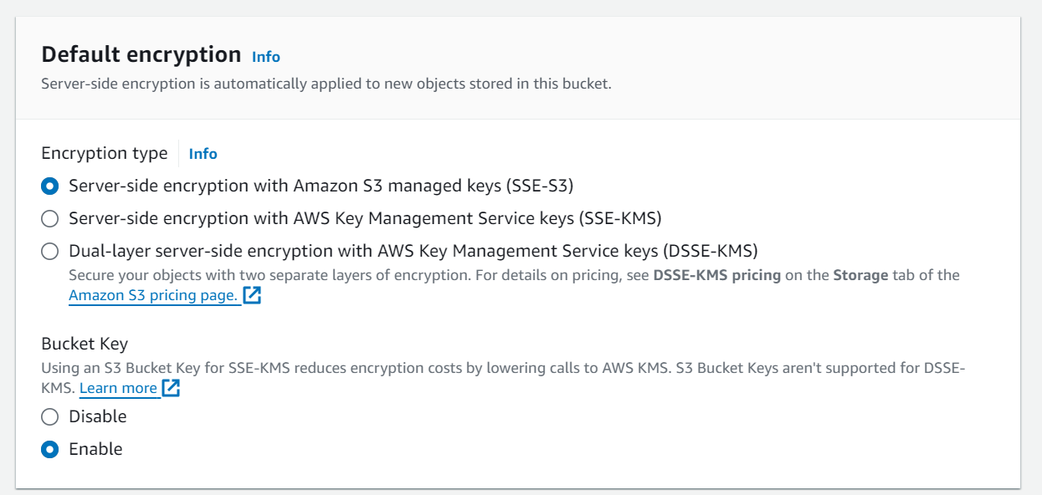

Enable "Default encryption" to automatically apply server-side encryption to new objects stored in the bucket. Choose between SSE-S3 for Amazon S3 managed keys, SSE-KMS for AWS Key Management Service keys, or DSSE-KMS for dual-layer encryption. Consider using an S3 Bucket Key with SSE-KMS to reduce encryption costs.

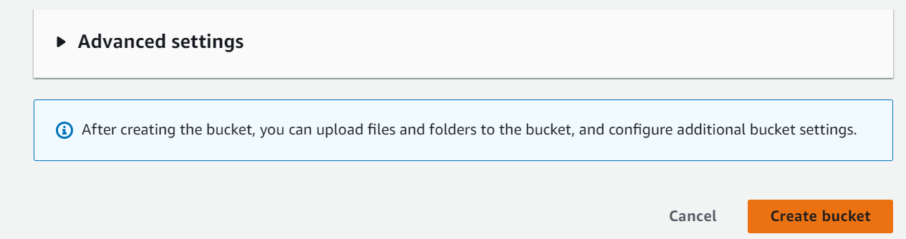

1. Review and create the bucket.

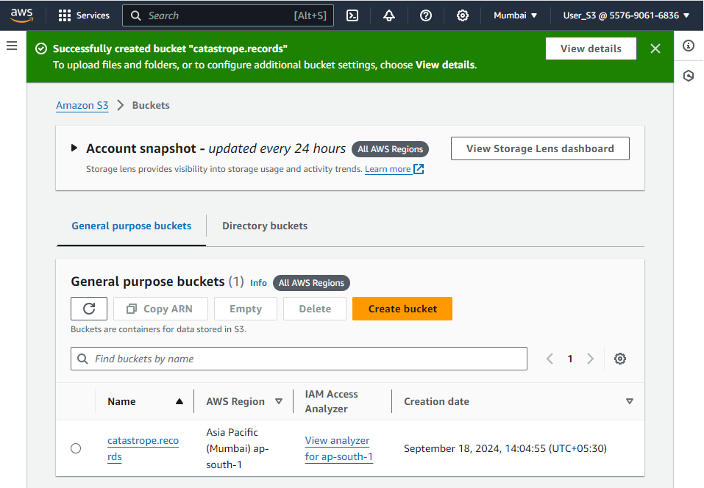

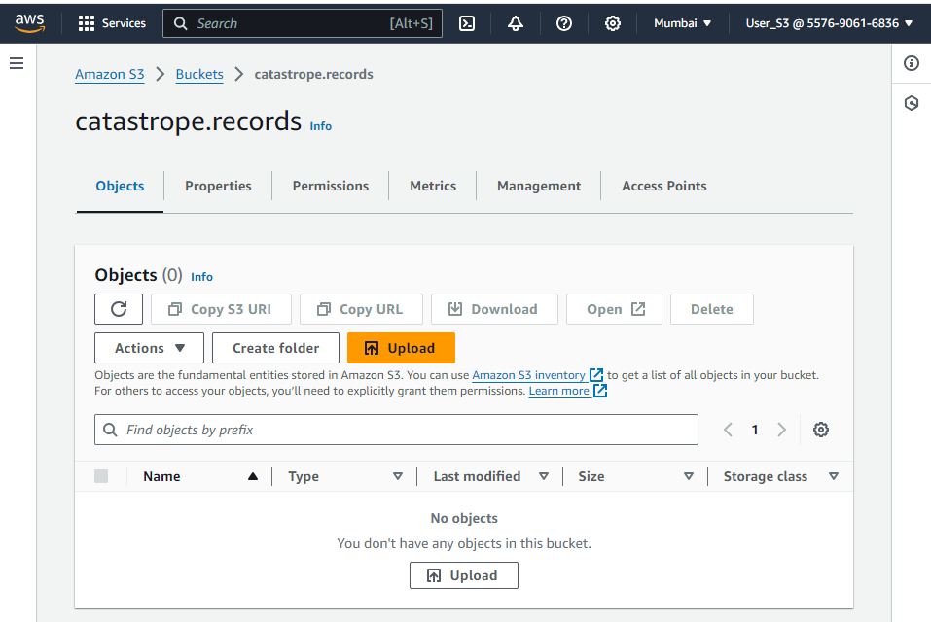

Review the bucket settings to ensure they align with your security and access requirements. Verify configurations such as public access settings, encryption options, and versioning to confirm they meet your storage and compliance needs.

1. Select the desired S3 bucket where you want to upload files.

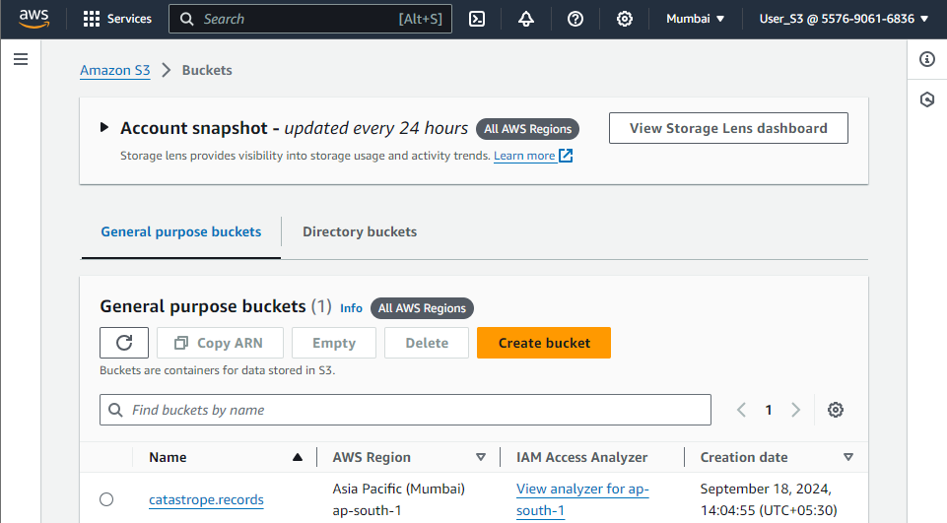

To upload files, first select the desired S3 bucket from your list of buckets. This will ensure that the files are uploaded to the correct storage location.

1. Click "Upload," then drag and drop or select the files to upload



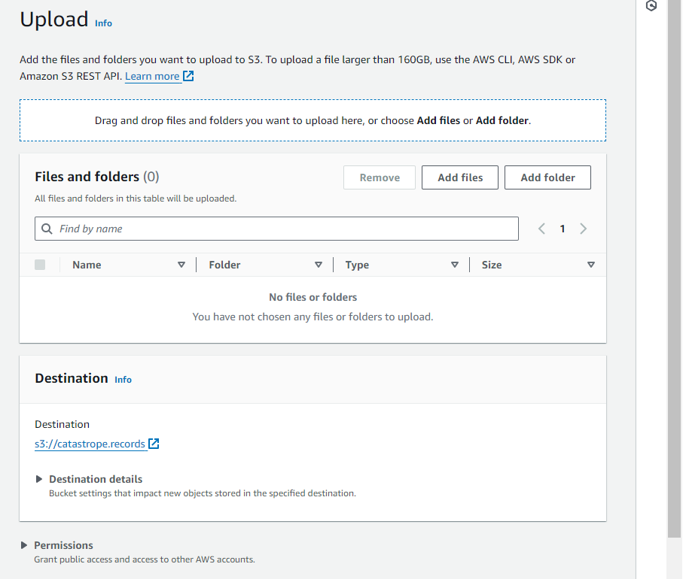

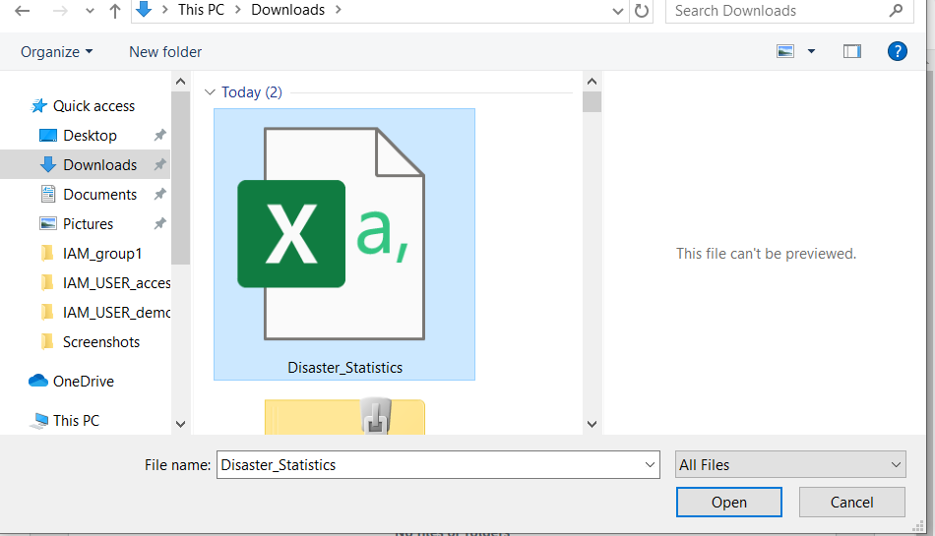

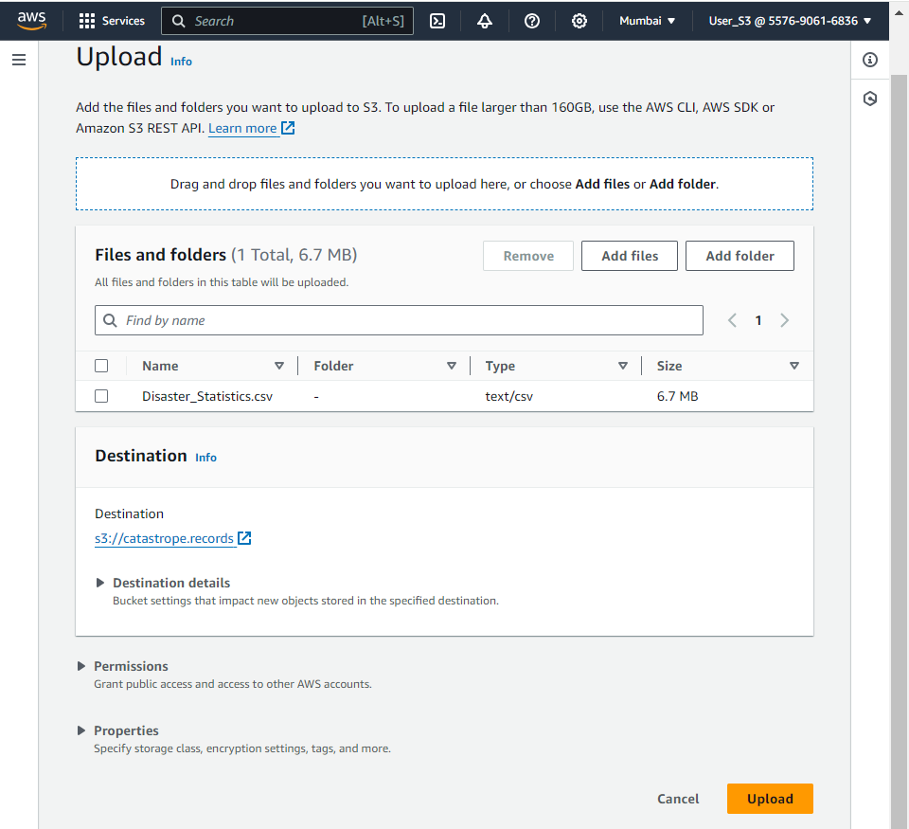

Click "Upload" and then either drag and drop the files or use the file picker to select the documents you want to upload. This will start the upload process for your chosen files.

1. Monitor the upload progress and verify that the files are successfully added to the bucket.

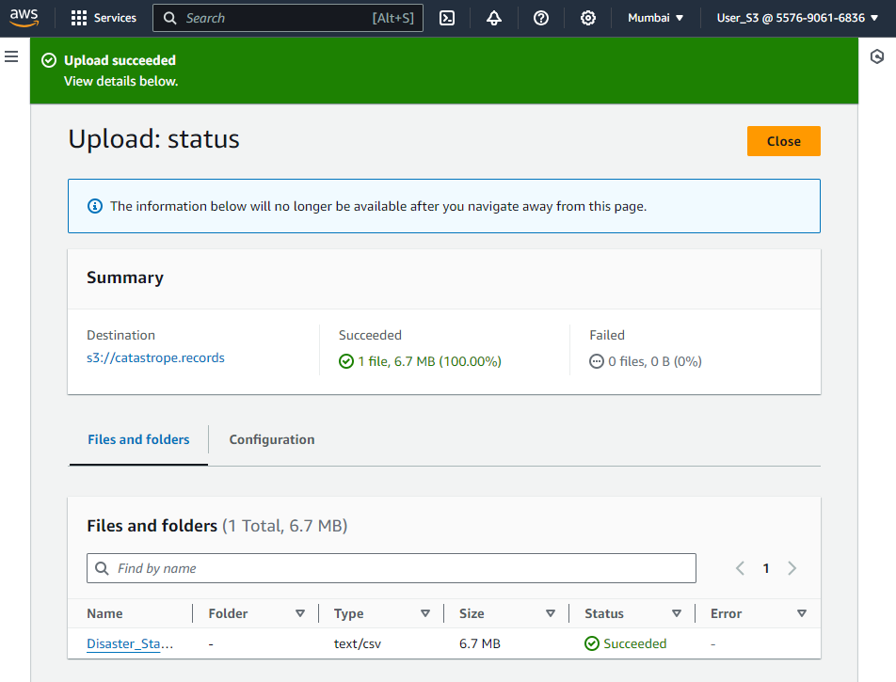

Monitor the upload progress to ensure the files are being transferred successfully. Once completed, verify that the files are correctly listed in your S3 bucket.

**Conclusion:**

By implementing a streamlined process for uploading disaster-related data to Amazon S3, RapidRelief Solutions will significantly improve the organization and accessibility of critical information. This approach ensures secure storage, reduces errors, and speeds up data handling, leading to more efficient disaster management. With better-organized data in Amazon S3, the organization will be better equipped to make informed decisions and respond more effectively to disasters.