**MelodyHub’s AWS Cost Guard: Zero-Spend Alerts and Reports**

**Problem Statement:**

MelodyHub Inc., a digital music startup, leverages AWS Free Tier services to support its streaming and artist management platform. As the user base expanded, the company encountered unexpected billing increases due to exceeding Free Tier limits, diverting attention from key development activities. To resolve this, the CTO initiated a project to implement a zero-spend alert system using AWS Billing and Cost Management to track usage and send alerts when approaching Free Tier thresholds. This solution allows MelodyHub to maintain effective cost control, enabling the team to focus on growing the platform without concerns about unplanned charges.



**Pre-requisites:**

1. AWS Account Setup: [https://youtu.be/CjKhQoYeR4Q?si=ui8Bvk_M4FfVM-D](https://youtu.be/CjKhQoYeR4Q?si=ui8Bvk_M4FfVM-Dh)h

### 2. Basic Knowledge of Amazon Billing and Cost Management: https://youtu.be/t7Ib395iyzw?feature=shared

**Objective:**

To implement a zero-spend alert system for MelodyHub Inc. using AWS Billing and Cost Management to monitor Free Tier usage and send timely alerts when nearing budget limits. This system aims to prevent unexpected charges, maintain budget control, and allow developers to focus on platform growth without financial concerns.

**Tasks:**

1. Create an AWS account or log in to an existing one.
2. Enable Billing Alerts.
3. Create a Cost Budget for Monitoring Free Tier Usage
4. Check Monthly Cost and Usage Reports
5. Verify Alerts and Reports

**Solution Development Procedure:**

**Step 1: Create an AWS account or log in to an existing one.**

* Open your browser and go to the [AWS Management Console](https://aws.amazon.com/console/).Enter your AWS account credentials and log in.

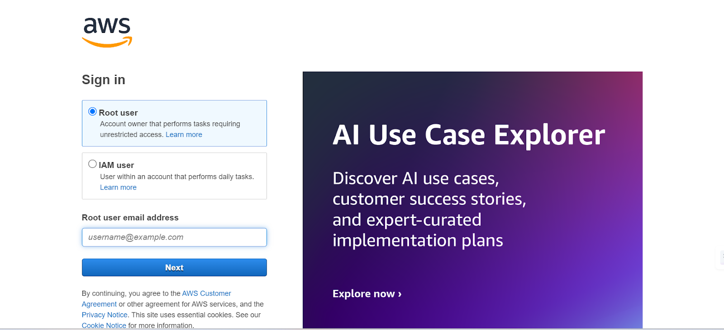

**Step 2: Enable Billing Alerts.**

* Go to the [AWS Billing Console](https://console.aws.amazon.com/billing/). Or Search for Billing and Cost Management in the AWS Console Search Bar.

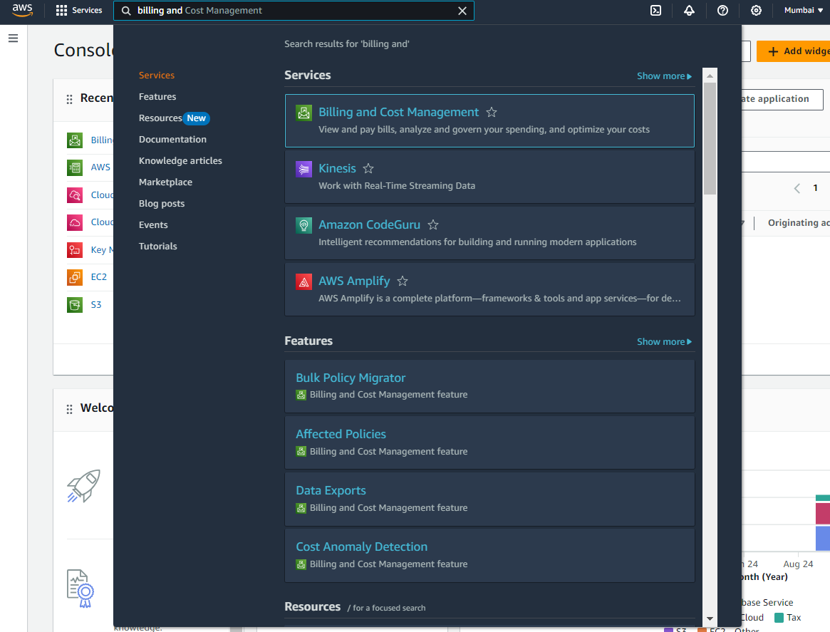

* Click on **Billing Preferences** in the left menu.

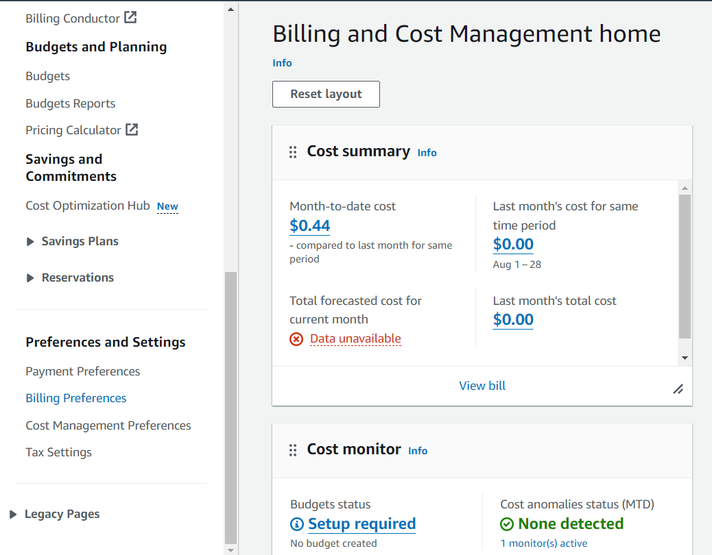

* Enable the checkbox for **Receive Free Tier Usage Alerts** and Add your email address to receive notifications about free tier usage .

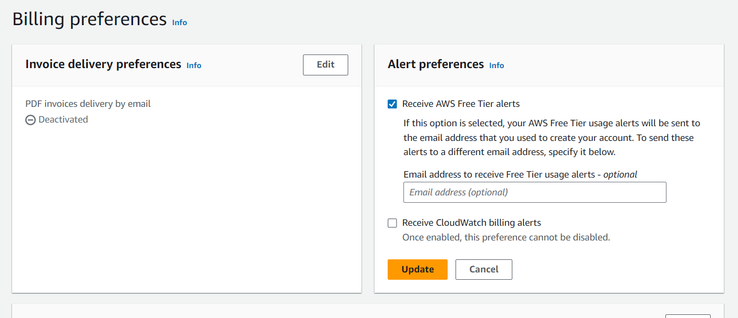

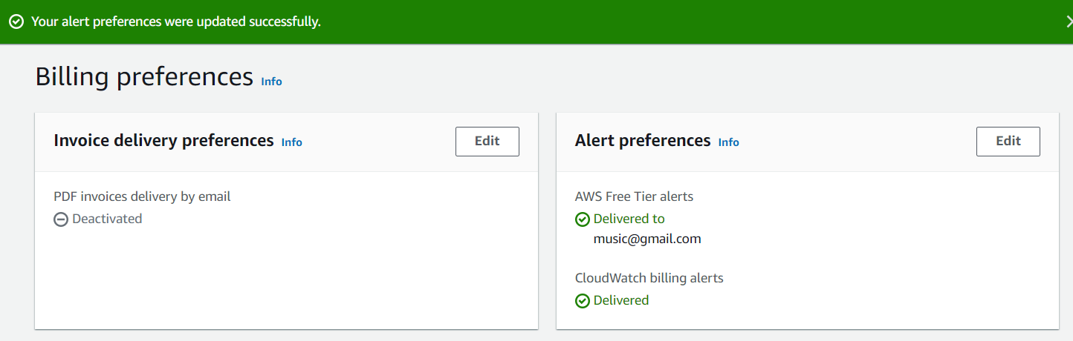

#### **Step 3: Create a Cost Budget for Monitoring Free Tier Usage**

#### On the left-hand sidebar, click on **Budgets** under **Cost Management**.

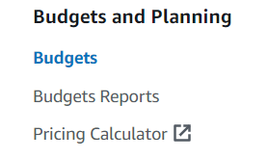

**Navigate to Budgets**:

* Go to the **Billing Console** and select **Budgets** → **Create Budget**.

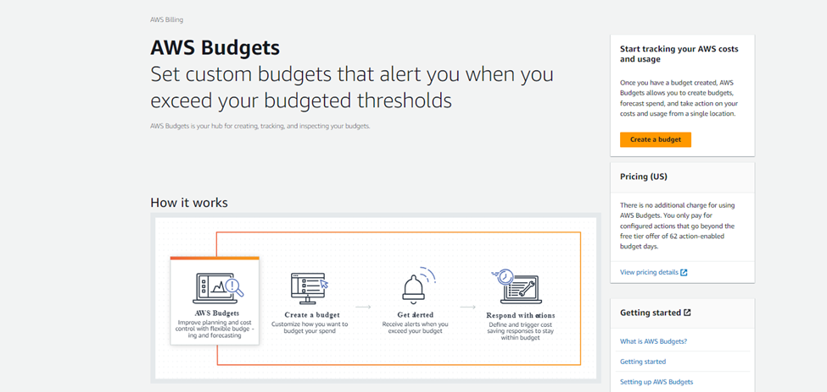

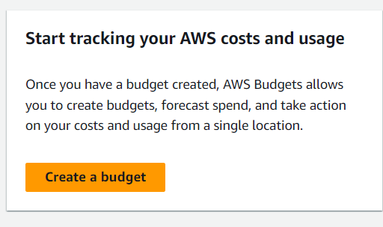

**Set Up a Cost Budget**:

* Choose **Cost Budget**.

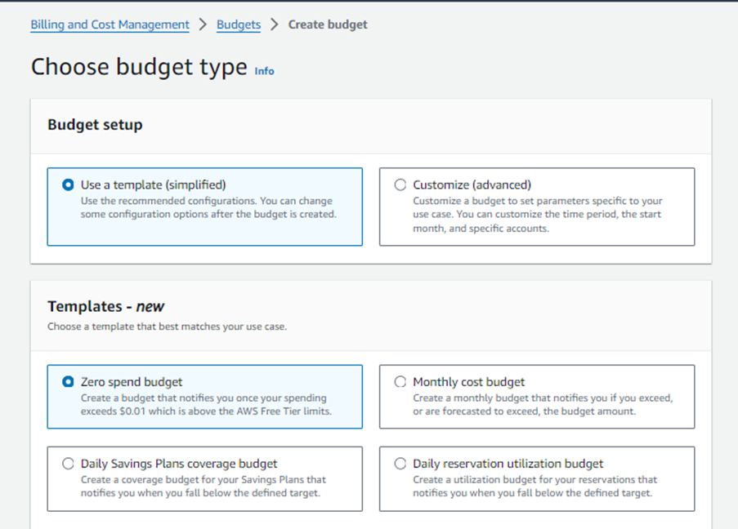

* **Budget Name**: Use a descriptive name such as *Free Tier Monitoring* and  **Email Recipients**: Add the email addresses where notifications should be sent. Separate multiple email addresses with commas if needed..

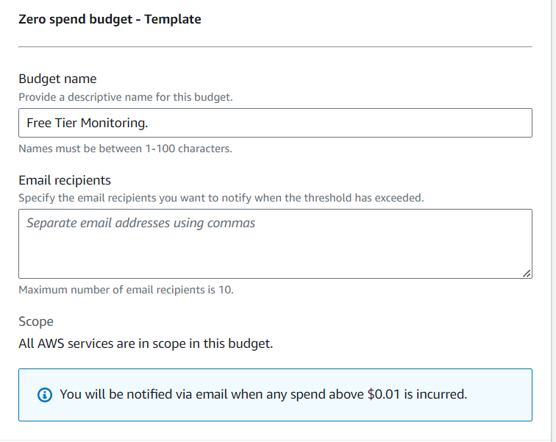

* **Create the Budget** and confirm the email subscription if prompted and Click the **Create Budget** button.

.

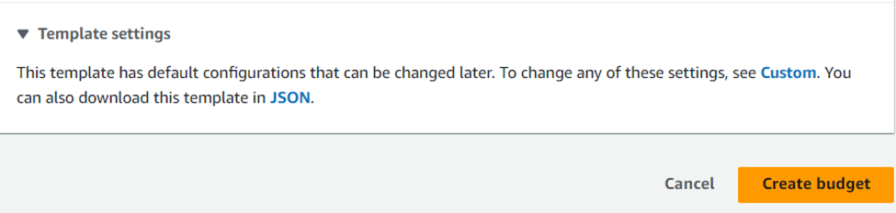

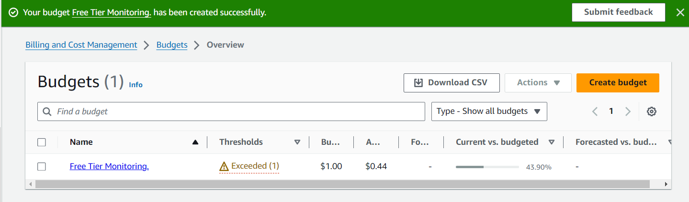

**Step 4: Check Monthly Cost and Usage Reports**

* In Budgets ,Click on the Name of budget, here Free Tier Monitoring.



* **Detailed Monthly Cost and Usage Report**.

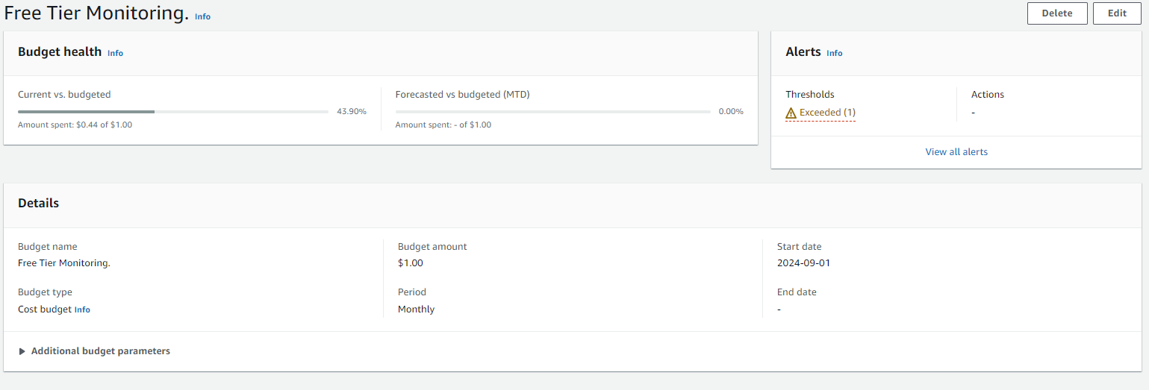

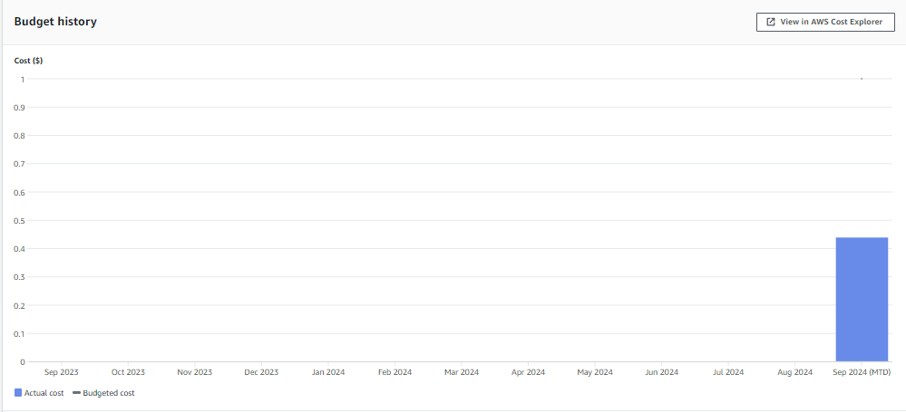

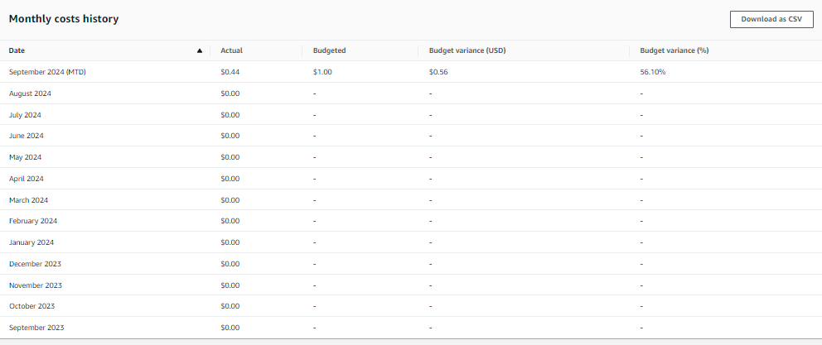

#### **Step 6: Verify Alerts and Reports**

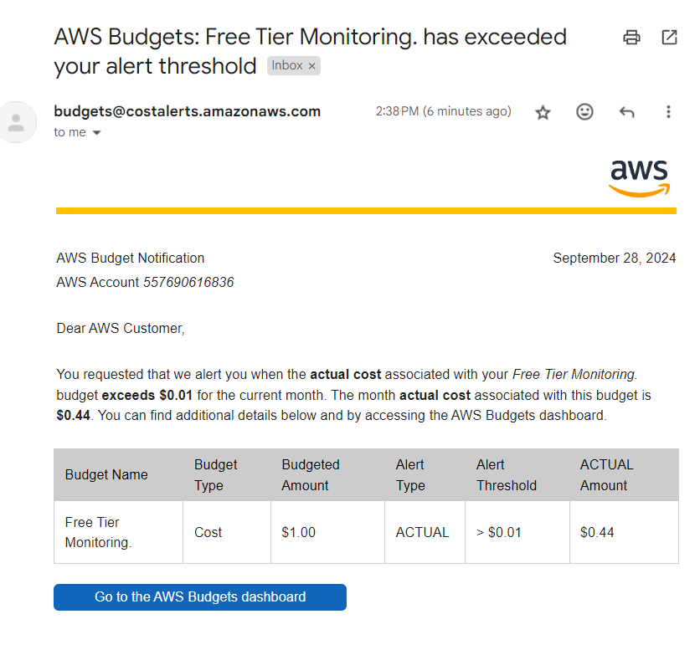

**Conclusion:**

By setting up a **Zero-Spend Alert System**, MelodyHub Inc. ensures that immediate notifications are triggered whenever AWS costs exceed a minimal threshold (e.g., $0.01). This proactive approach to cost management allows MelodyHub to closely monitor cloud spending, especially while leveraging AWS Free Tier services. The system helps prevent unexpected charges and ensures that the platform stays within its budget, making it ideal for maintaining strict cost control and avoiding surprise bills. This simple yet effective solution is crucial for MelodyHub’s operations as it scales its music platform.