**Track and Discover Telugu Cinema with ManaCine**

**Problem Statement:**

**ManaCine**, a popular platform dedicated to the Telugu film industry, observed that many users face difficulties managing their watchlists. With the constant influx of Telugu movie releases across multiple platforms, users often struggle to track movies they plan to watch, have already watched, or wish to recommend. ManaCine aims to resolve this issue by creating a cloud-based Telugu Movie Watchlist Tracker using DynamoDB, allowing users to effectively manage and categorize their Telugu movie collections.

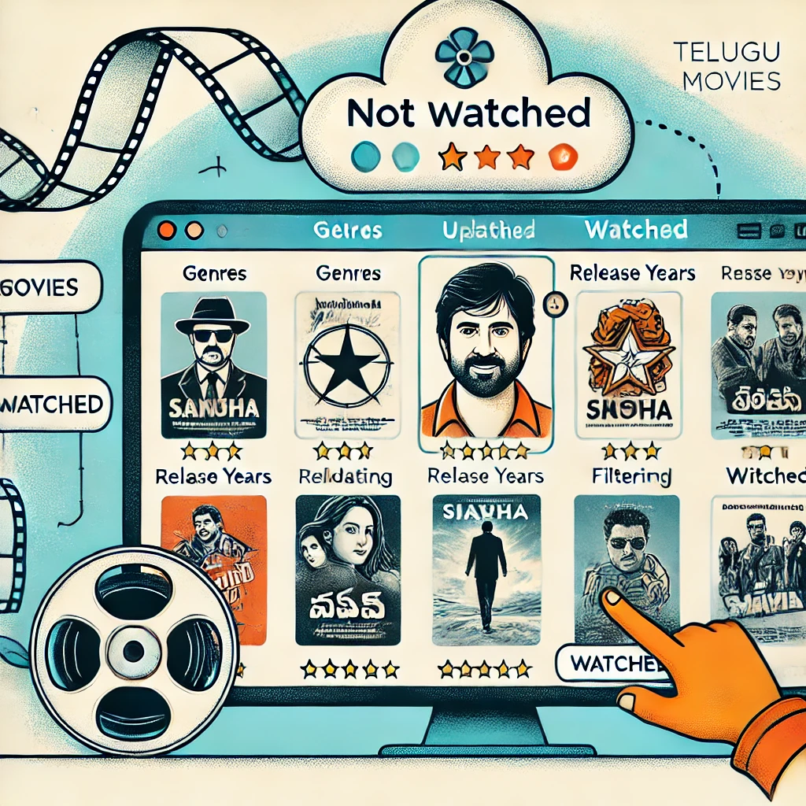

**Pre-requisites:**

### 1. AWS Account Setup: [https://youtu.be/CjKhQoYeR4Q?si=ui8Bvk_M4FfVM-D](https://youtu.be/CjKhQoYeR4Q?si=ui8Bvk_M4FfVM-Dh)h

### 2. Understanding of IAM: <https://youtu.be/gsgdAyGhV0o?si=3qg-bULgkD4LXNvR>

### 3. Basic Knowledge of Amazon DynamoDb: <https://www.youtube.com/watch?v=2mVR_Qgx_RU>

**Objective:**

The objective of ManaCine's Telugu Movie Watchlist Tracker is to offer a cloud-based solution, powered by DynamoDB, that enables users to organize and manage their Telugu movie watchlists. Users can add, update, and filter movies by genre, release year, and watched status, making it easy to track what they’ve watched, plan to watch, or recommend. This tool will improve user engagement by providing an organized, personalized movie management experience on the ManaCine platform.

**Tasks:**

1. Log in to the AWS Management Console and navigate to DynamoDB.
2. Create a new DynamoDB table named Movies with UserID as the partition key
3. Add order records with fields like MovieID, User_1, MovieName, ReleaseYear,Genre,WatchedStatus and Rating.
4. Update an existing movie record by changing its WatchedStatus (e.g., from "Not Watched" to "Watched") and adding a rating.
5. Delete a movie from the system when the user removes it from their watchlist.
6. Verify that data is added, updated, and deleted correctly by querying the table

**Solution Development Procedure:**

#### **Step 1: Log in to AWS Management Console and Navigate to DynamoDB**

#### 

#### Open the AWS Management Console and sign in with your credentials.

Use the search bar to find and select DynamoDB.

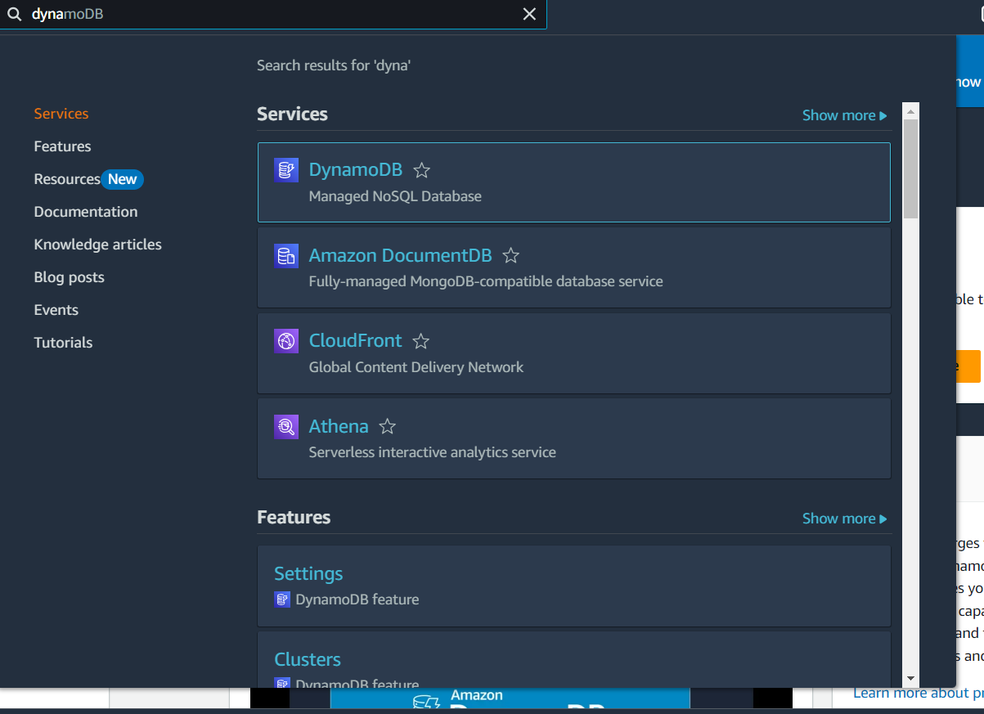

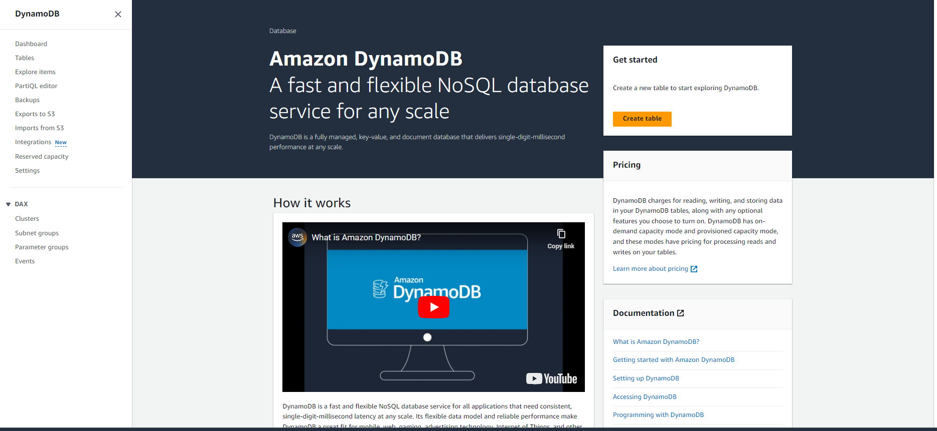

**Step 2:** Create a new DynamoDB table named Movies with UserID as the partition key

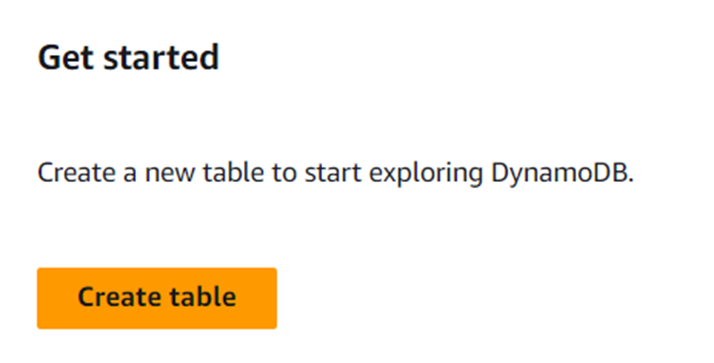

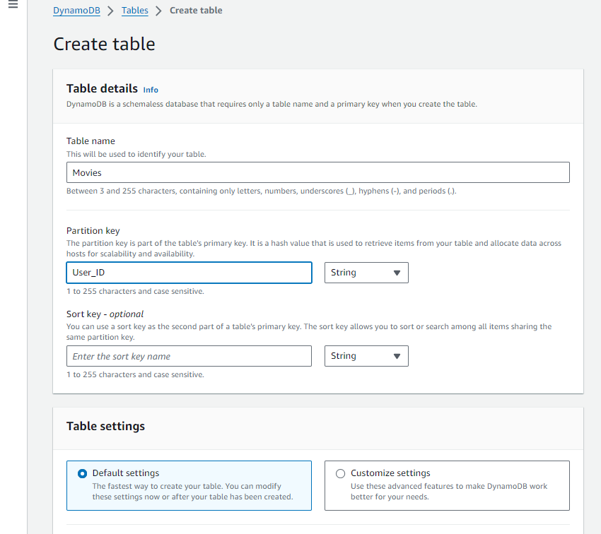

Set the Table Name to Movies.  
Set the Partition Key to OrderID (Type: String).

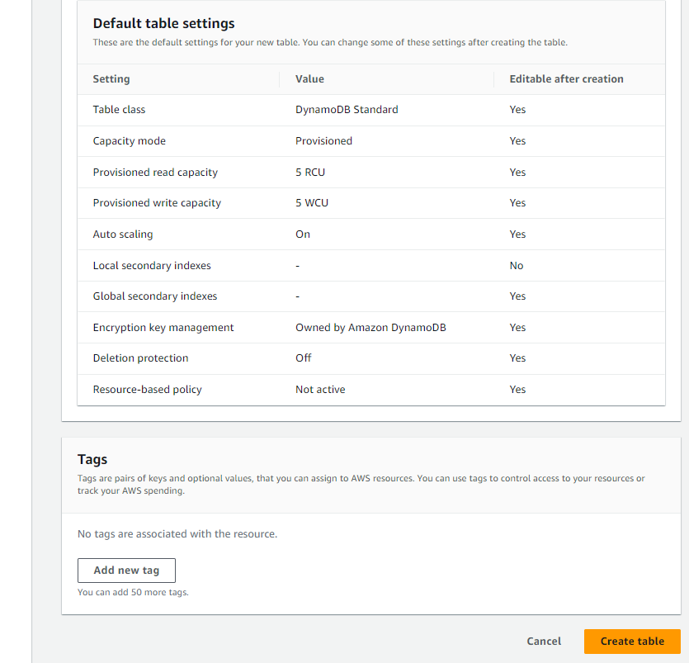

Click **Create Table** to complete the table setup.

#### 

Now the Table is created

#### 

#### 

#### 

#### **Step 3:** Add order records with fields like MovieID, User_1, MovieName, ReleaseYear,Genre,WatchedStatus and Rating.

#### 

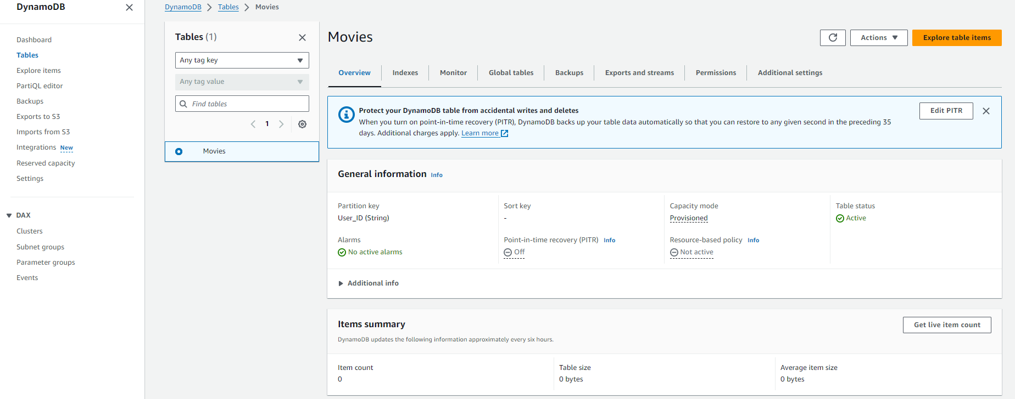

Once the table is created, go to the Explore items tab.

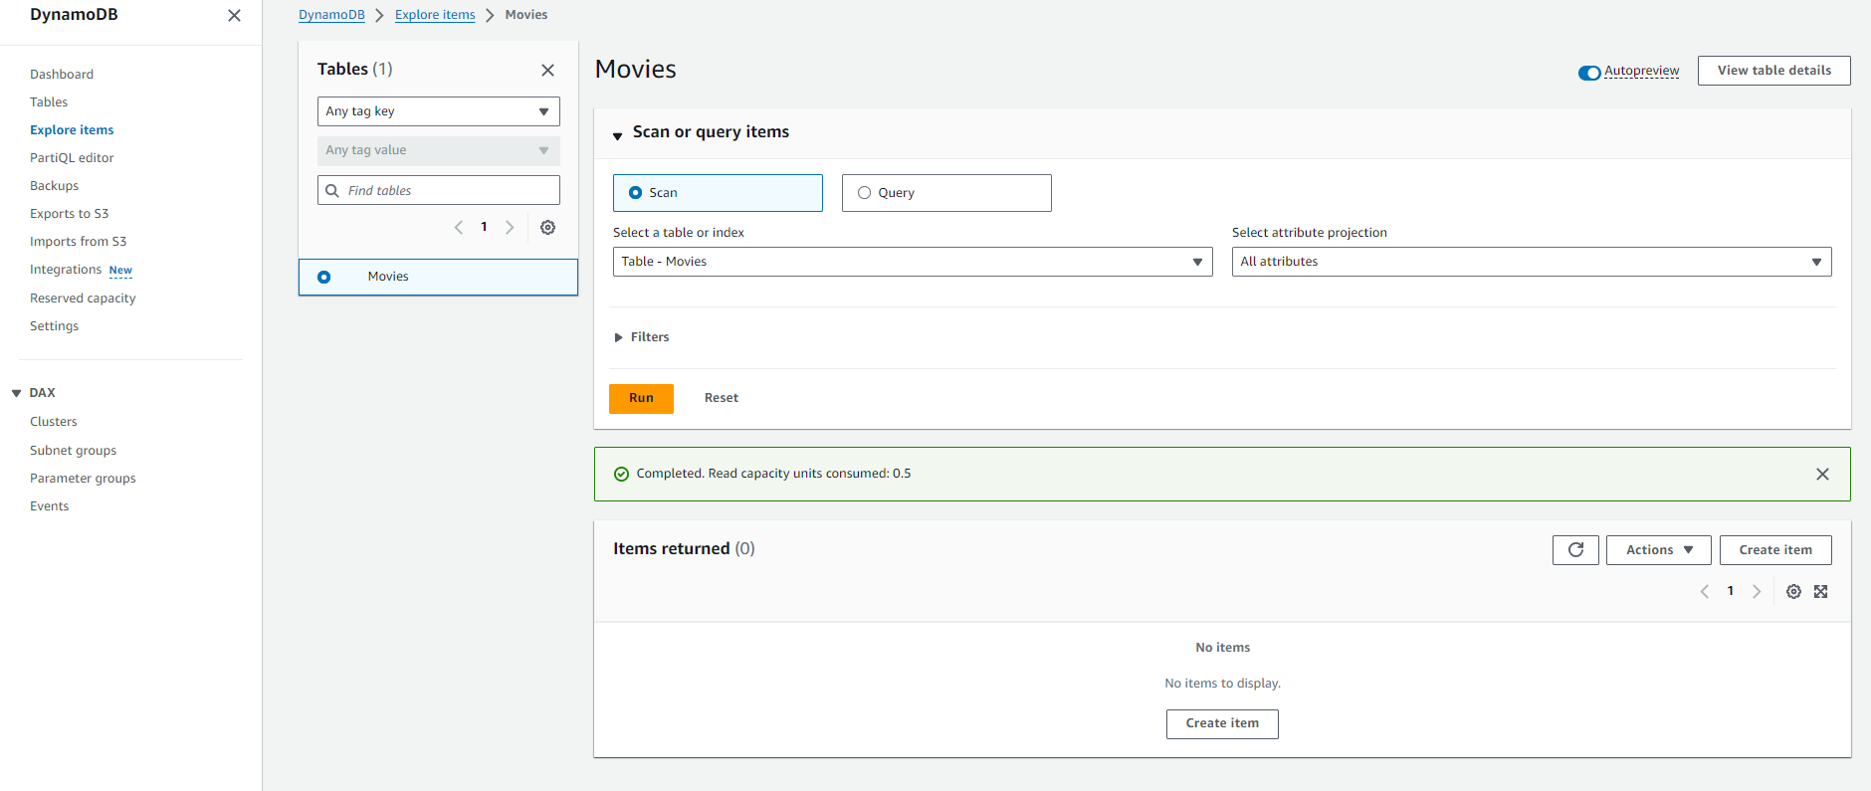

Click **Create Item**

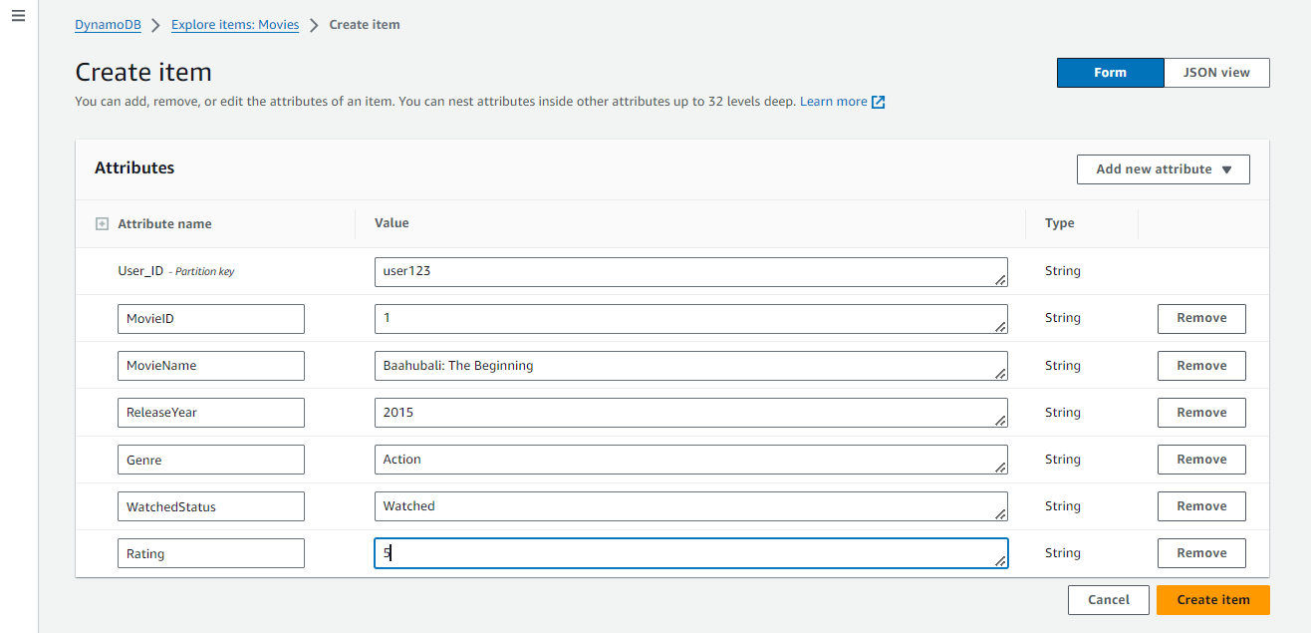

Input the following order details:

* + **UserID**
  + **MovieID**
  + **MovieName**
  + **ReleaseYear**
  + **Genre**
  + **WatchedStatus**
  + **Rating**And click on **create item**

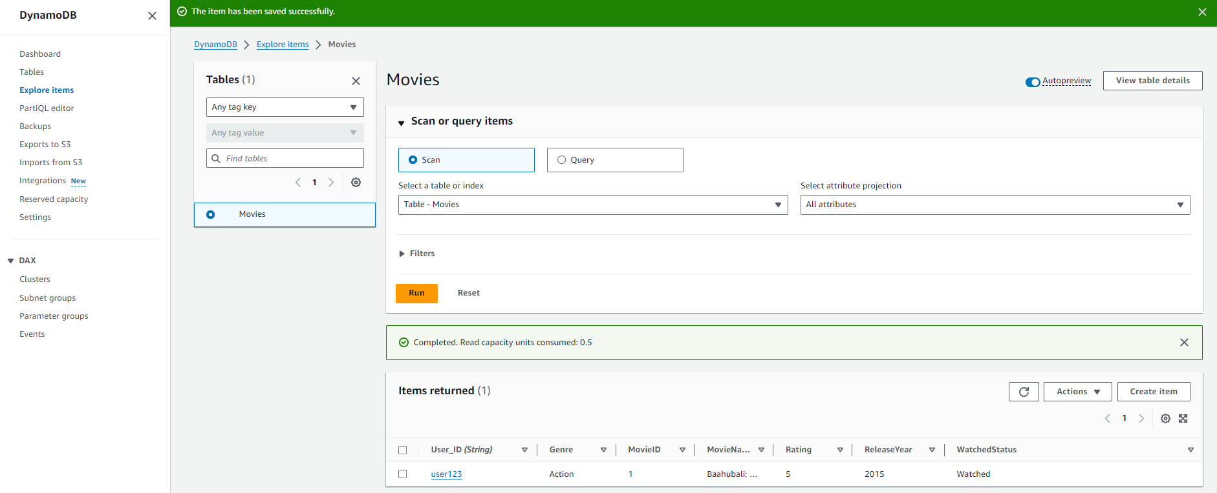  
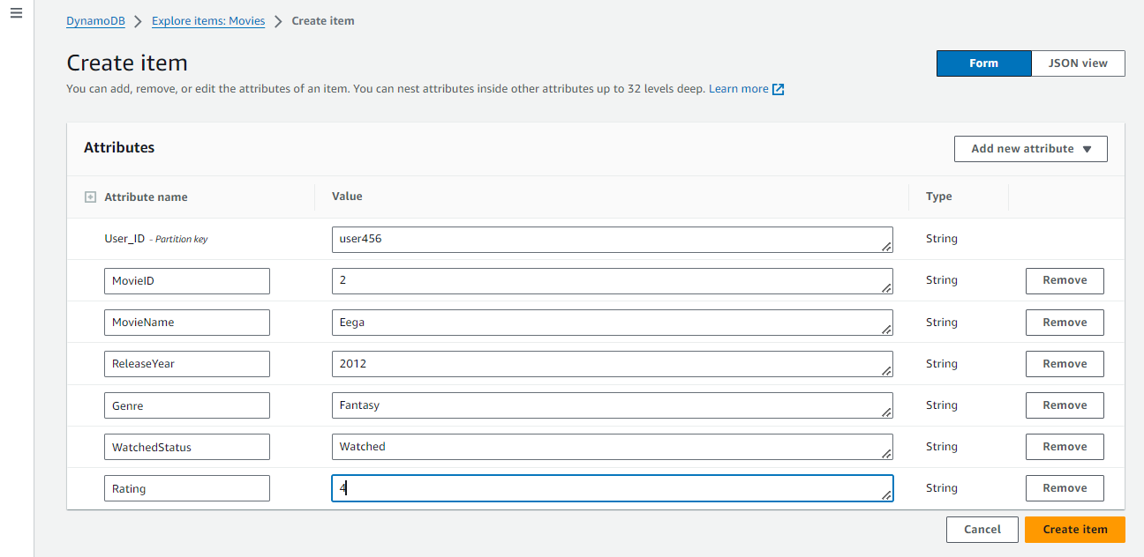  
 Repeat the process to add more items and

Click **Create item** to store the item.

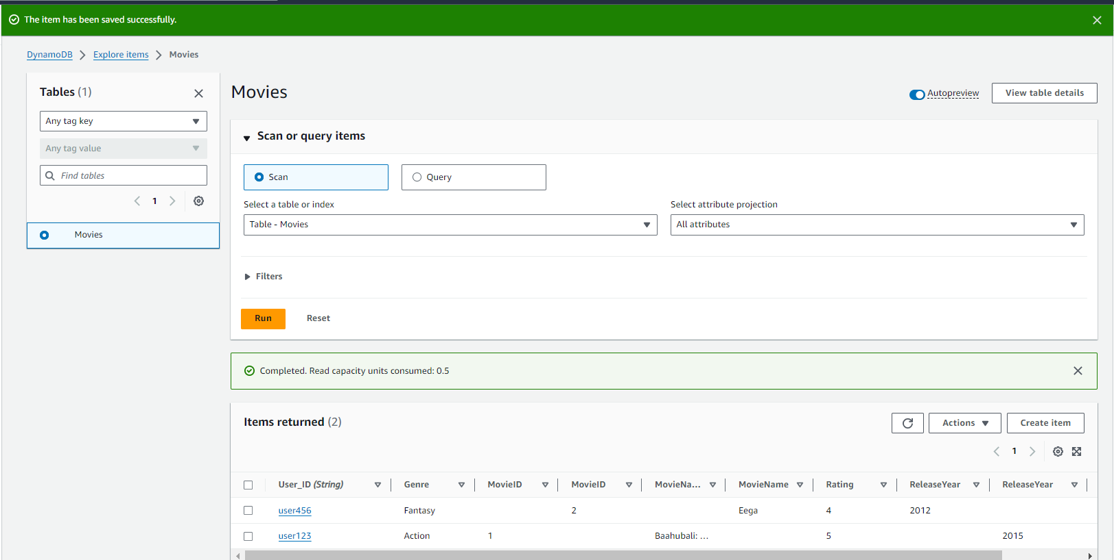

**Step 4:** Update an existing movie record by changing its WatchedStatus (e.g., from "Not Watched" to "Watched") and adding a rating.

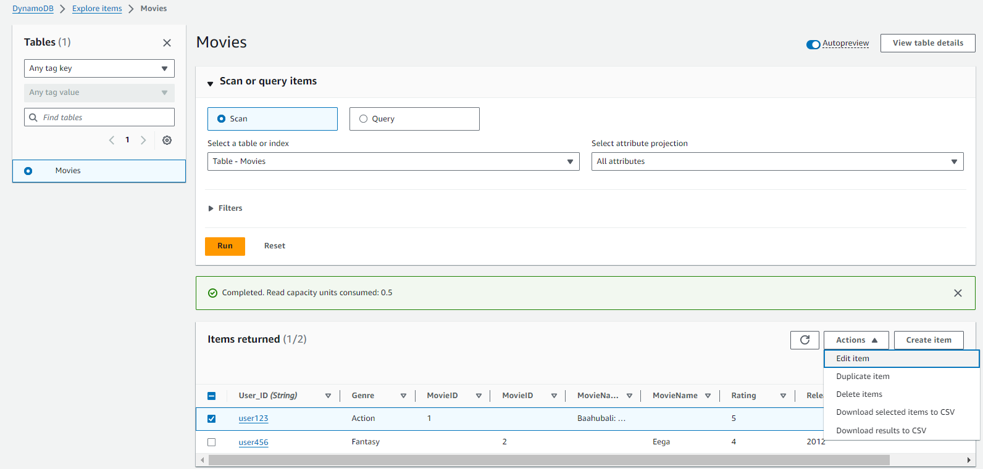  
In the **Items** tab, locate the item you want to update (e.g., UserID = "User123").  
Select the item and click on the Action button as shown in the above image and select Edit item.

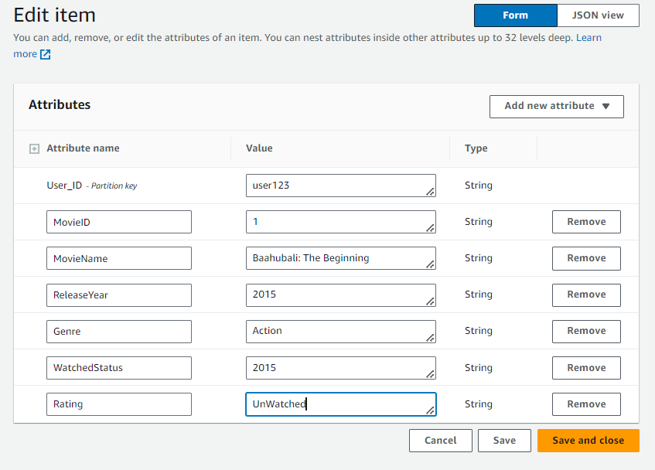  
 For example in the Rating section the value is changed from watched to unwatched, then Click on **Save and close** to apply the update and verify that the status has been changed.

**Step 5:** Delete a movie from the system when the user removes it from their watchlist.

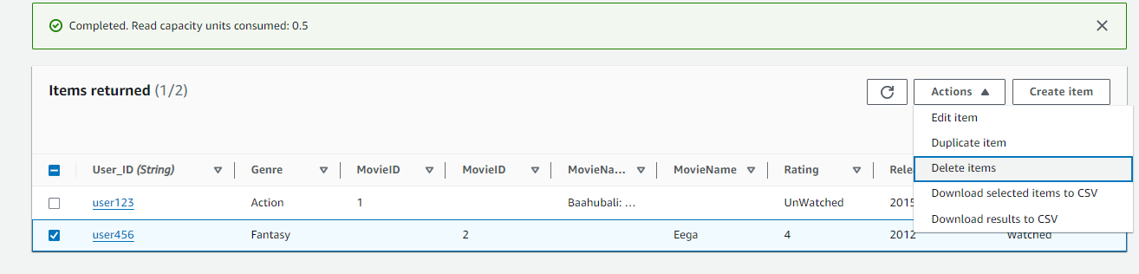  
In the **Items** tab, find the order to be deleted (e.g., UserID = "User456").  
  
Select the UserId and click on the actions button then select Delete items and

Confirm the deletion and ensure the item has been removed.

**Step 5:** Verify that data is added, updated, and deleted correctly by querying the table

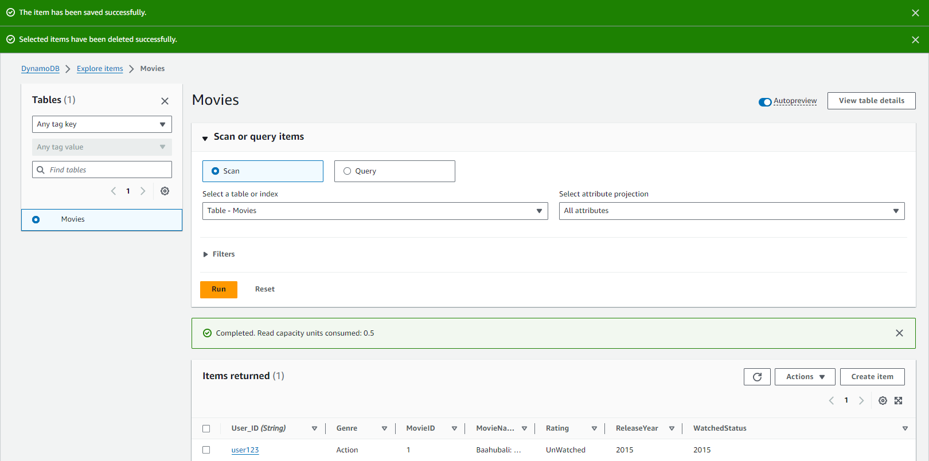

Everything is fine .

**Conclusion:**

The Telugu Movie Watchlist Tracker project successfully addresses the challenge of managing movie lists for users of ManaCine. By leveraging AWS DynamoDB, the platform enables users to efficiently add, update, categorize, and delete Telugu movies from their watchlists. The seamless cloud-based solution ensures that users can track their watched and unwatched movies, apply filters by genre or year, and even assign ratings. This project enhances user experience by providing a personalized, organized, and accessible way to manage movie watchlists, making it easier for fans to keep up with the latest Telugu releases.