Low Level Design and Unit Test Plan
for
<Component Name>

<Online Banking System>
Prepared by/Modified by |  | Role |  | Date of preparation
Alekhya Poduri |  | Team Member |  | 13-02-2018
Reviewed by |  | Role |  | Date of Review
Approved by |  | Role |  | Date of Approval
Circulation List |  |  | Version number of the template |  | 1.8
Version number of the work product | <Provide Version number of work product>

TABLE OF CONTENTS

1. Description of the Component 4
2. Dependencies / Assumptions 4
3. Reference Documents 4
4. Screen Shots 4
4.1 CRUD Matrix for Tables 4
4.2 Data Mapping Matrix 5
4.3 Field Validations 5
5. Re-usable Routines/Components 5
5.1 Class hierarchy 5
5.2 Multiple class relationship 5
5.3 Classes 6
5.4 Files 6
6. Queries 6
7. Action Flow / Program Specification / Pseudocode 6
7.1 Action: <Page ON_LOAD()> 6
7.2 Action: <Button ON_CLICK()> 7
8. Stored Procedures 8
9. Session Variables 8
10. Messages 8
11. Traceability Matrix 9
12. Change References 9
13. Test Environment 9
14. Test- Completion Criteria 10
15. Test- STOP Criteria 10
Revision History 11

Description of the Component
<Brief description of the Component>

Online banking (or Internet banking or E-banking) allows customers to conduct financial transactions on a secure website.

Dependencies / Assumptions
<Dependencies & Assumptions, if any>

Reference Documents
# | Reference | Description

Screen Shots
<Enclose the appropriate screenshots>
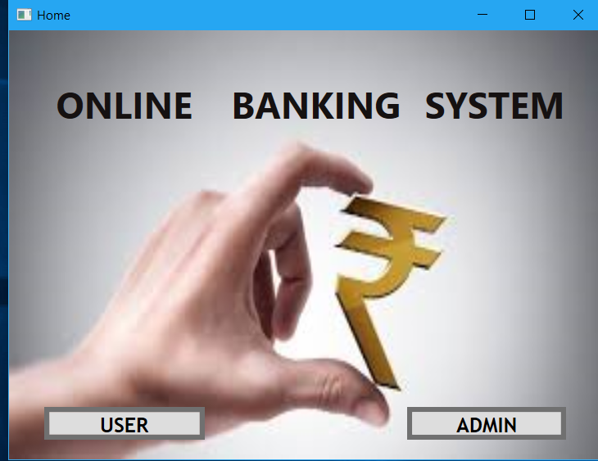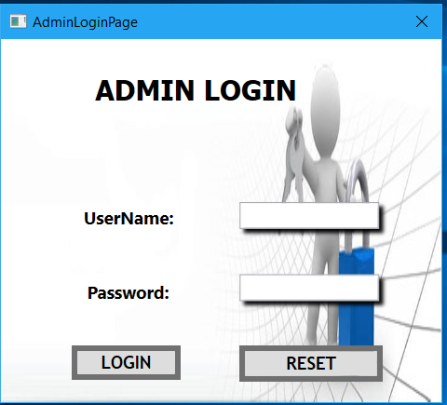

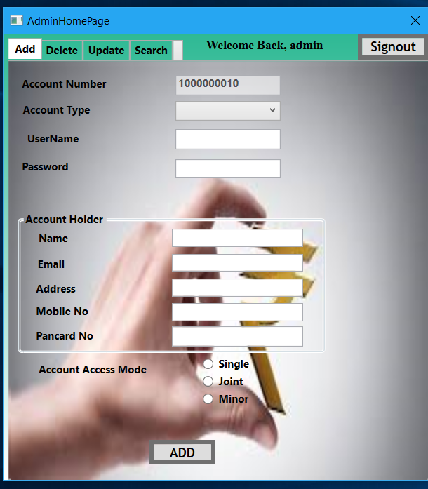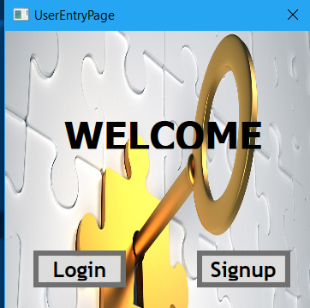
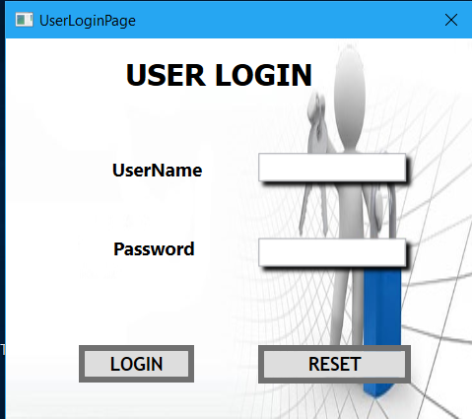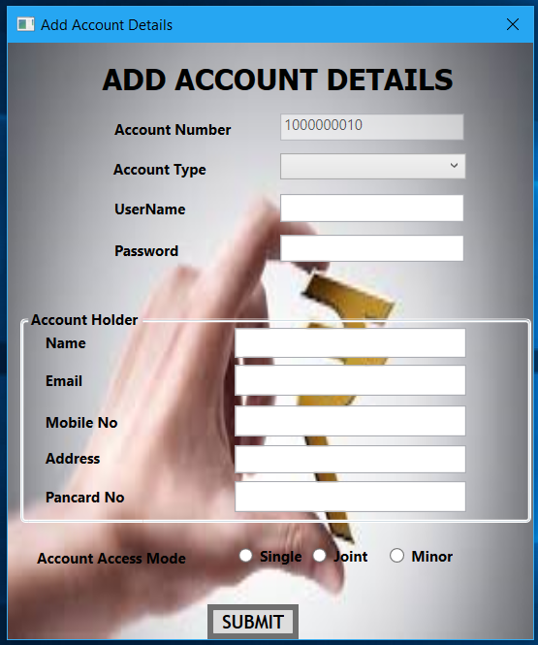

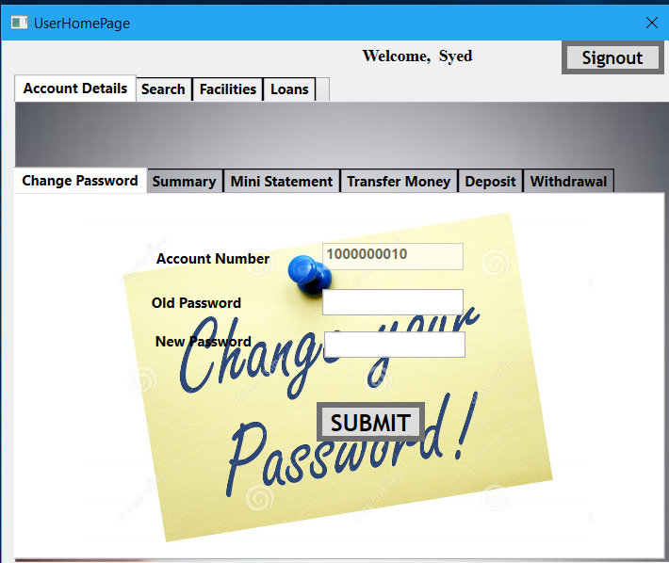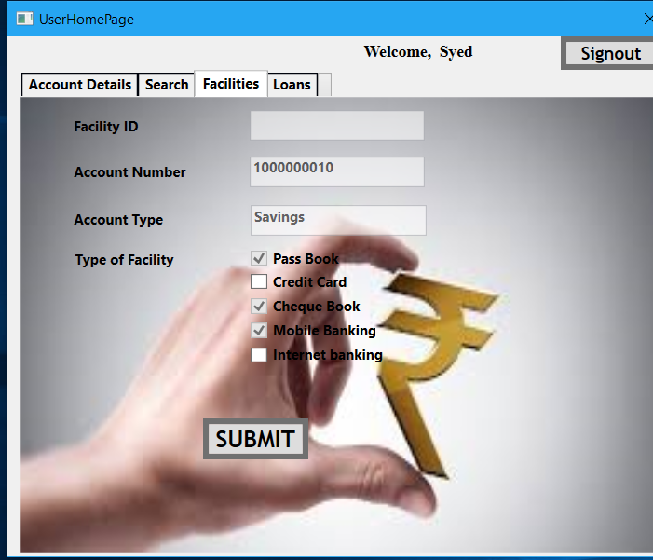

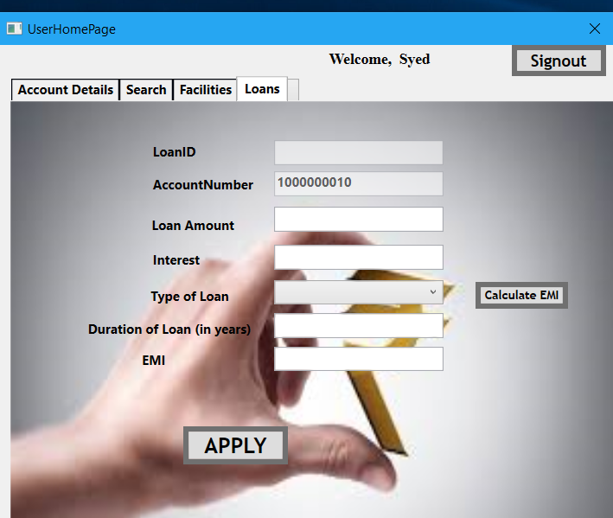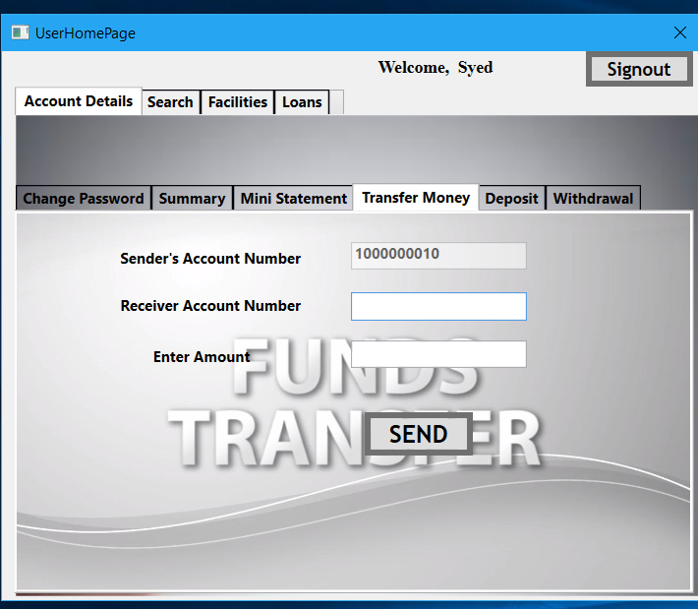

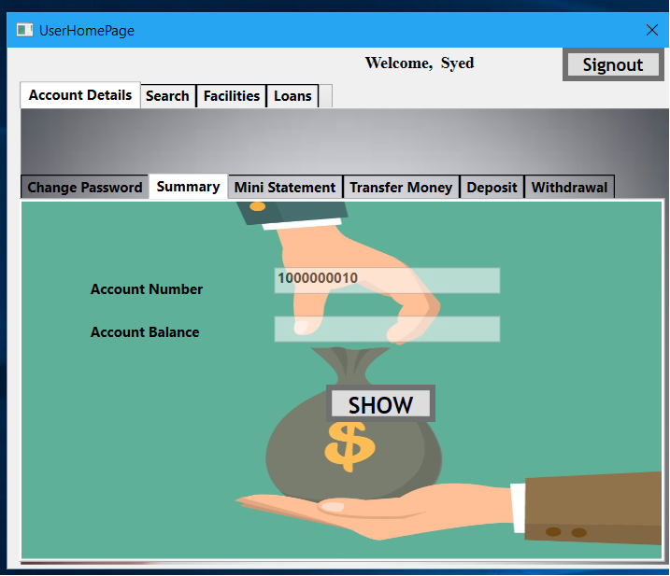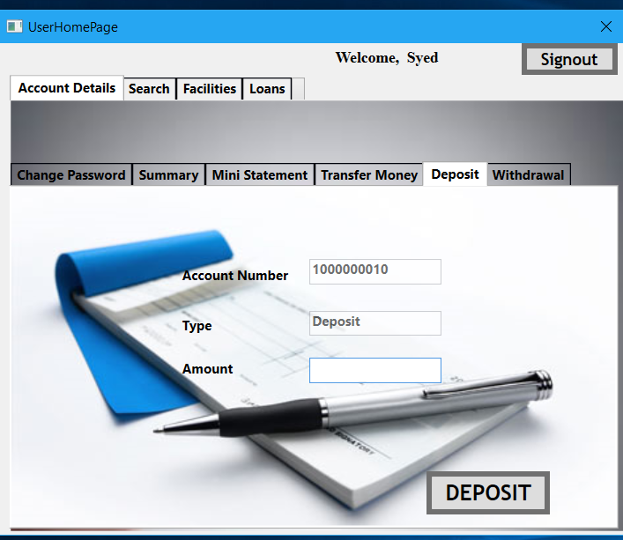

CRUD Matrix for Tables
# | Table Name | Create | Read | Update | Delete
 | Account Master
 | Transactions
 | Facilities
 | LoginCreds
 | Loans

Data Mapping Matrix

# | Screen Label | Field Source | Field Type | Data Type | Max Len | Data Flow | Mandatory

Legend
D → UI (Database to User Interface)
UI → D (User Interface to Database)
UI (User Interface Only)

Field Validations
# | Field | Validation(s)
 | PancardNo | Pan card number contains alphabets and numbers.  Pan Card Number cannot be less than or greater than 10 digits.
 | Name, Address, PanNo, MobileNo | Fields cannot be empty.
 | Mobile No | Length of the Mobile No should be 15.

Re-usable Routines/Components

Class hierarchy

Multiple class relationship

Classes
# | LLD Name | Class Name | Method Name | Method Description

Files
# | File Name | Description
1. | <Other existing Common routines names, incase of usage for building this component> | <Desc. of Common routines >
2.

Queries
Query. No | Query

Action Flow / Program Specification / Pseudocode

Action: <Page ON_LOAD ()>
Description:
<Brief Description>
Process:
<When the page is loaded>
Pseudo code:
- Client Side Scripting
- Server Side Scripting
- Messages
Message No | Type | Message Text

- Test Cases
Pseudo Code Ref | Test Case ID | Severity | Test Condition | Test Case | Test Data | Expected Result | Remarks
 |  | <S1/S2/S3> | <Form load> | <This cell describes how to test i.e. the detailed testing procedure> | <Where ever applicable>

Action: <Button ON_CLICK()>
Description:
<Brief Description>
Process:
<When the page is loaded>
Pseudo code:
- Client Side Scripting
- Server Side Scripting
- Messages
Message No | Type | Message Text

- Test cases
Pseudo Code Ref | Test Case ID | Severity | Test Condition | Test Case | Test Data | Expected Result | Remarks
 |  | <S1/S2/S3> | <On Click> | <This cell describes how to test i.e. the detailed testing procedure> | <Where ever applicable>

Stored Procedures
SP. No | Stored Procedure Name  (with Description) | Input/Out Parameters | Type | Size

Session Variables
# | Name and Type | Purpose

Messages
#. | Type | Message Text
 | <Warning/Information/Validation/Error>

Traceability Matrix
Action Description/ Pseudo Code | HLD/URS reference

Change References
# | Reference(Mails with Subject/ Query / Feedback) | Date Received | Change Description

Test Environment
# | Environment | Description | Version

Test- Completion Criteria
# | Criteria
1 | <Class partitioning is tested>
2 | <Boundary values are tested>
3 | <All branches and statements are covered>
4 | <Number of residual defects are <= x/KLOC>
5 | <Rate of discovering defects <= x/hr of testing>
6 | <Discovered defect density within control limits>
7 | <Test coverage for all the applicable FDA regulatory requirements>
8 | <any other criteria>

Test- STOP Criteria
# | Criteria
1 | <X number of S1 category Defects were identified >
2 | < 80% of test cases applied so far have failed >
3 | < X number of test cases failed while testing applicable FDA regulatory requirements>
4 | <any other criteria>

Revision History
# | Date | Version # | Section / Page # changed | Details of changes made

