NAME: R. ALEKHYA Emp code: 802655

------------------------------------------------------------------------------------

# **Real-Time Project Exercise – MuleSoft Transport Management**

--------------------------------------------------------------------------------------------

* TripEasy is a startup company providing a platform to perform booking services for land, air and sea transport across the world.
* This platform will enable customers to query location routes and the departure schedule from multiple transport providers, and make booking directly to the platform.
* The platform will enable the customer to make payments, and issues tickets to the customers.
* This platform will connect to the respective transport providers back end systems, to query for the available routes and schedules and make purchases, track their booking and make changes to their bookings.
* This platform will also provide the capability for the regulatory agencies to manage their bookings, and all updates will be reflected to the transport provider back-end system.

**API-LED CONNECTIVITY:**

* [API-led connectivity](https://www.mulesoft.com/lp/whitepaper/api/api-led-connectivity) is a methodical way to connect data to applications through reusable and purposeful [APIs](https://www.mulesoft.com/resources/api/what-is-an-api).
* These APIs are developed to play a specific role – unlocking data from systems, composing data into processes, or delivering an experience.

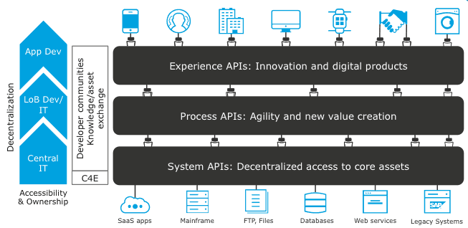

API LANDSCAPE:

These are the APIs I am going to design.

**EXTERNAL SYSTEM travelOnTip API:**

**---------------------------------------------------------------------------------**

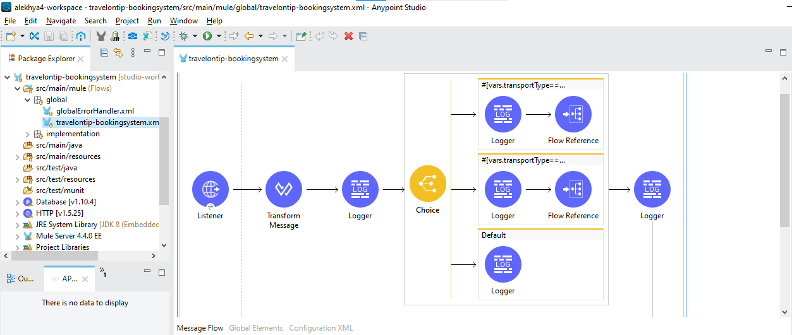

Global configuration of http listener and Database:

--------------------------------------------------------

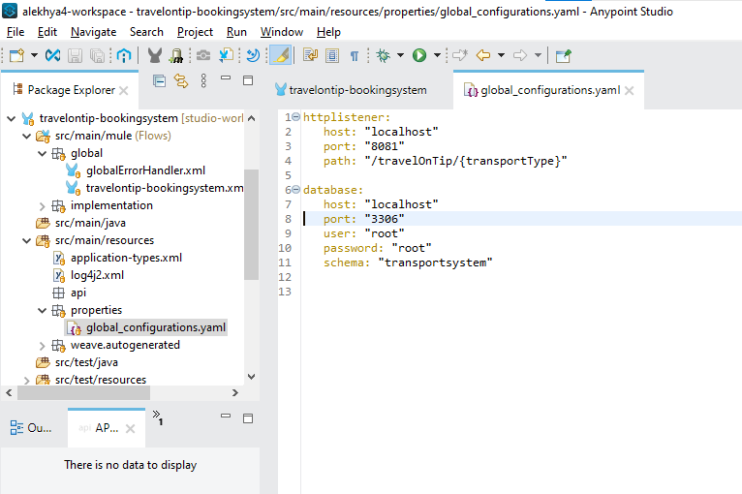

Get Routes implementation:

----------------------------------

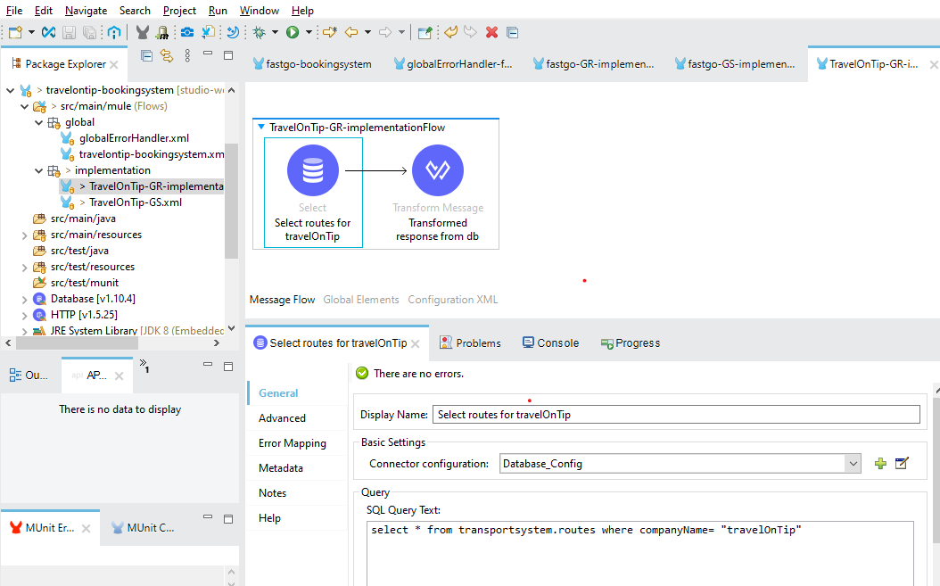

Get schedules implementation:-

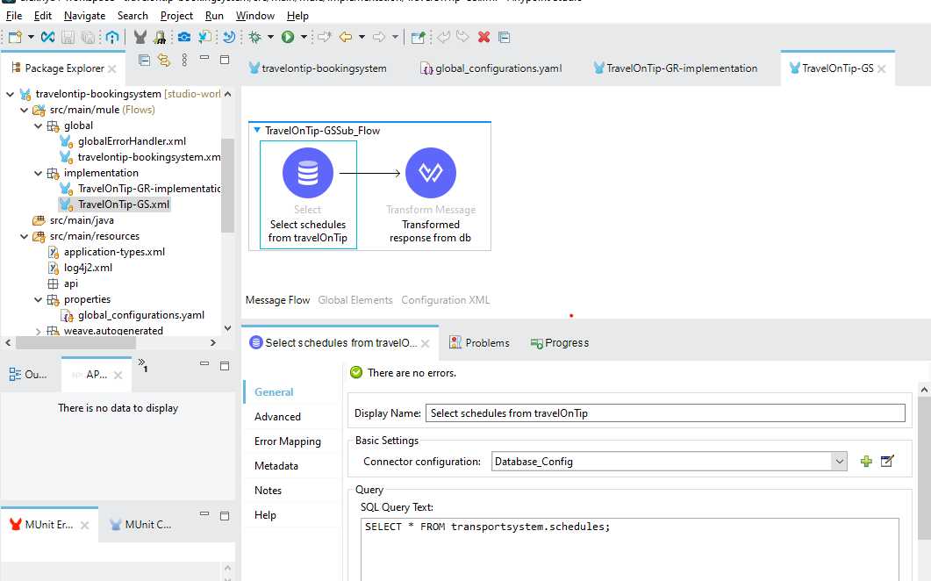

Output: http://localhost:8081/travelOnTip/routes

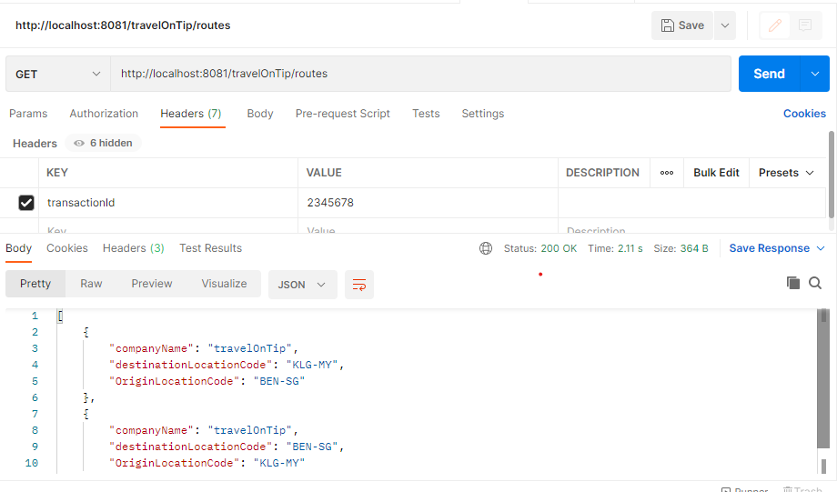

http://localhost:8081/travelOnTip/schedules

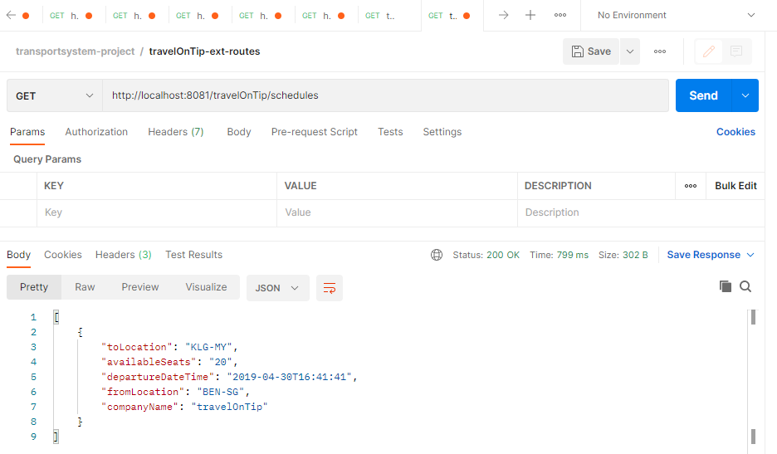

**FASTGO-EXT-SYSTEM:**

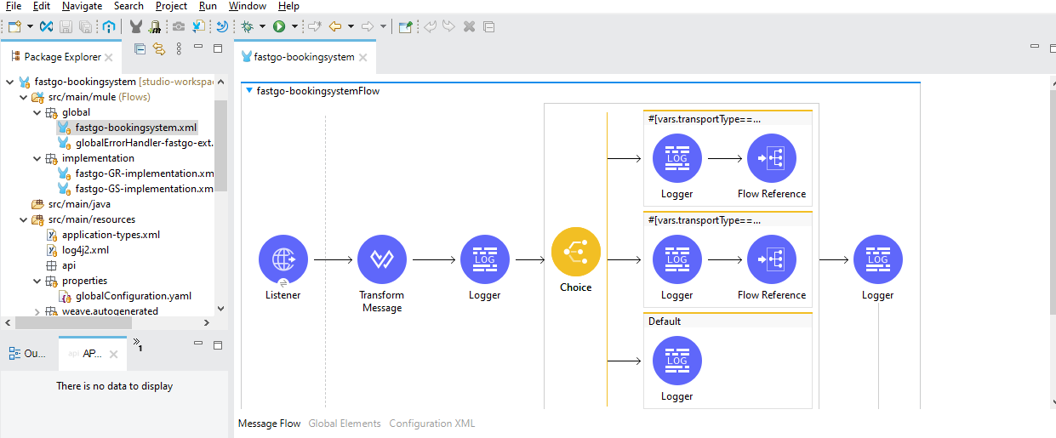

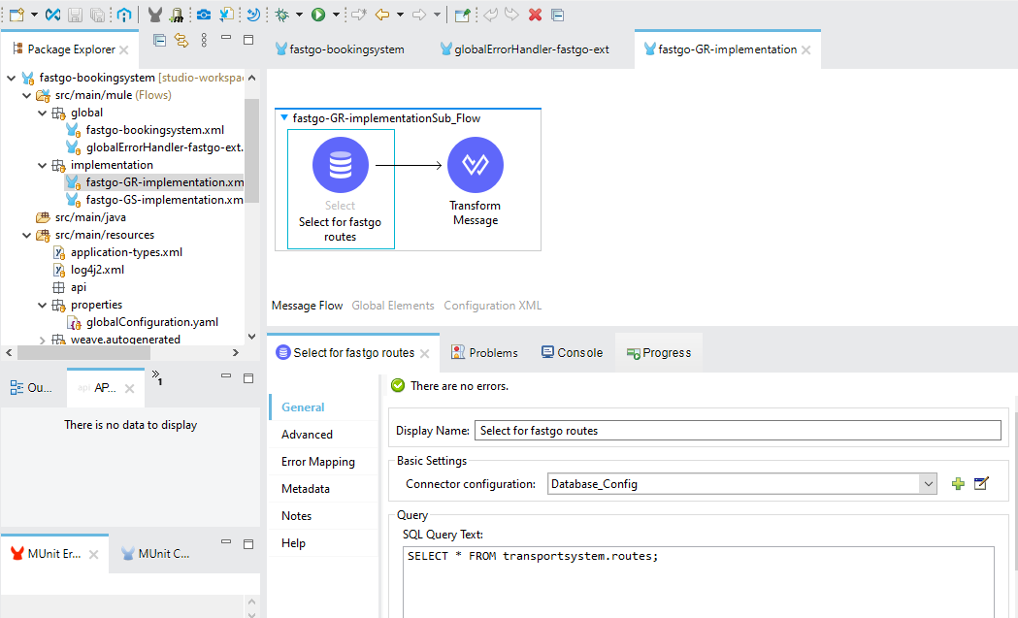

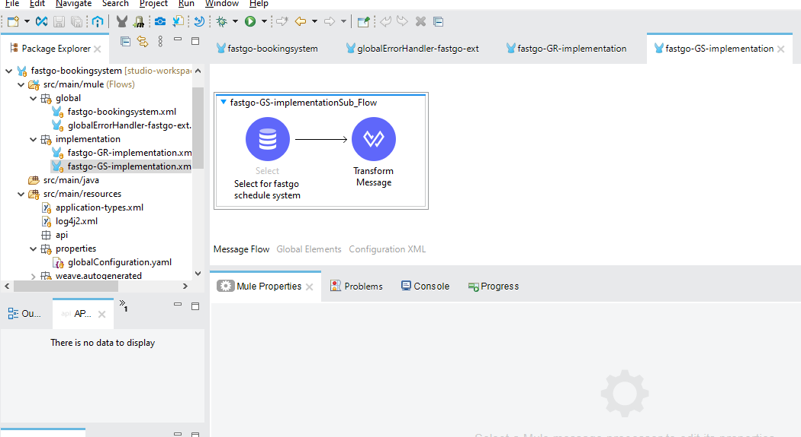

OUTPUT:

----------

http://localhost:8082/fastGo/routes

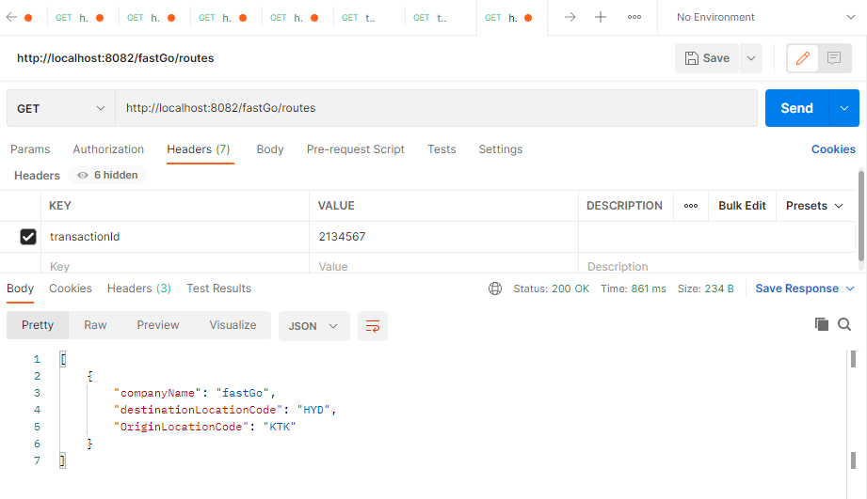

http://localhost:8082/fastGo/schedules

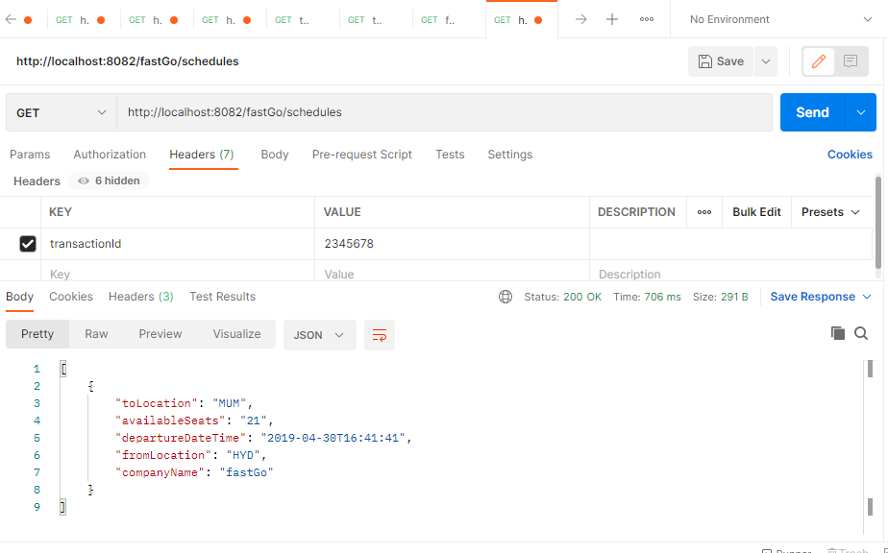

**SYSTEM-API-TRAVELONTIP:**

**---------------------------------------------------------------------------------**

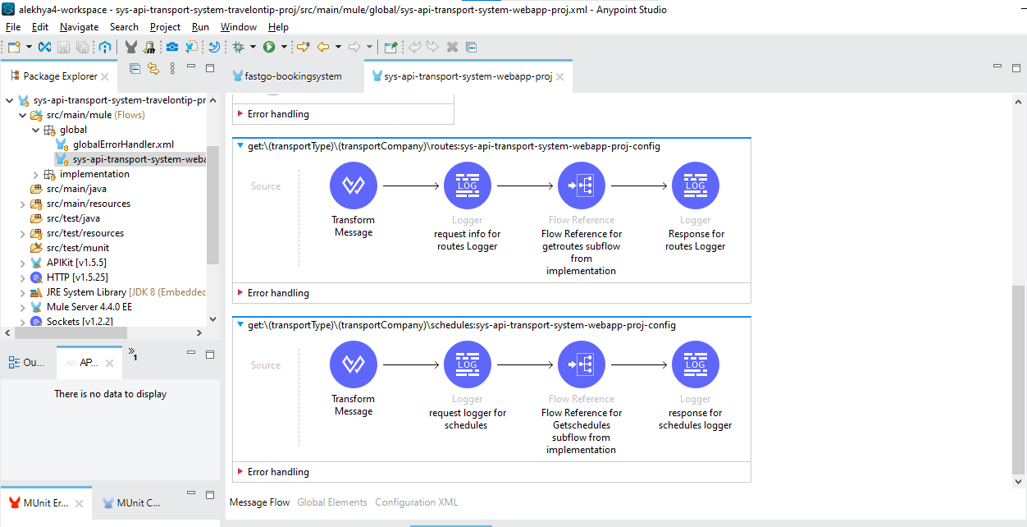

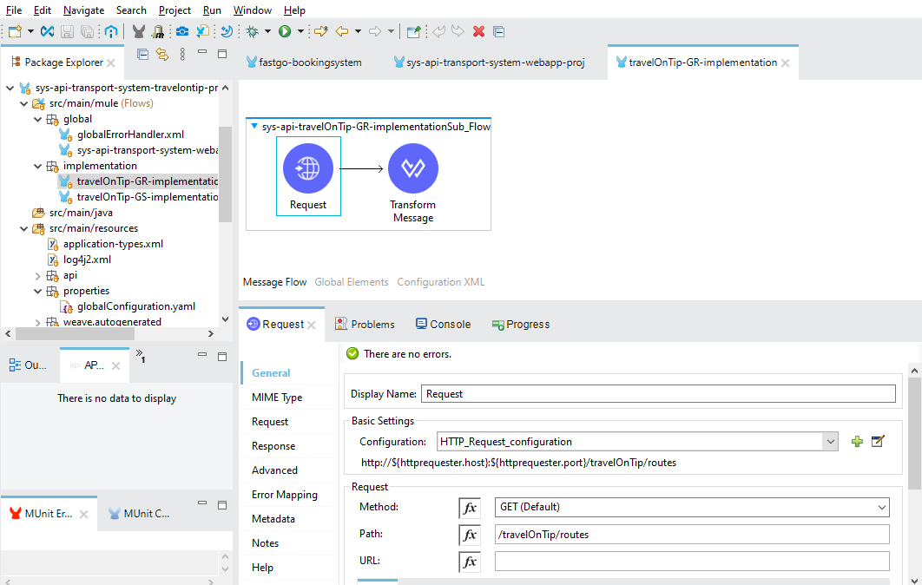

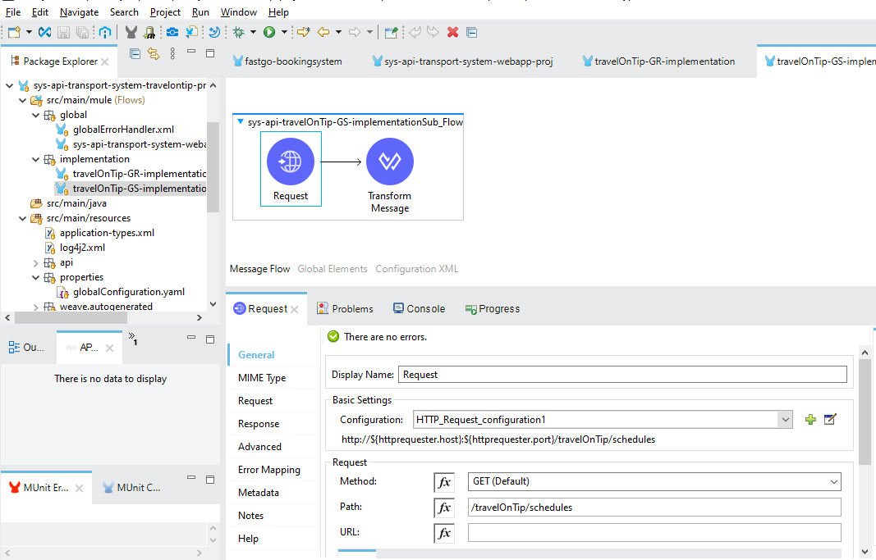

http://localhost:8083/api/Bus/travelOnTip/routes

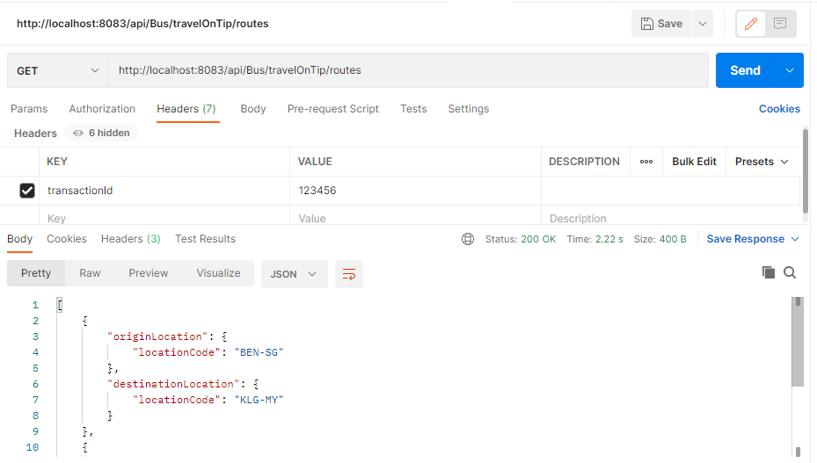

http://localhost:8083/api/Bus/travelOnTip/schedules

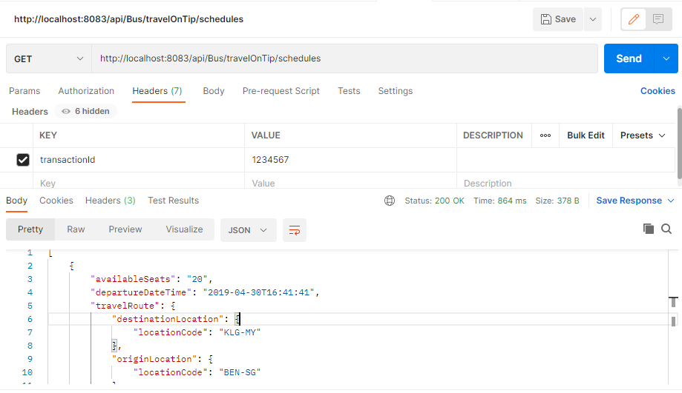

**SYSTEM API-FASTGO:**

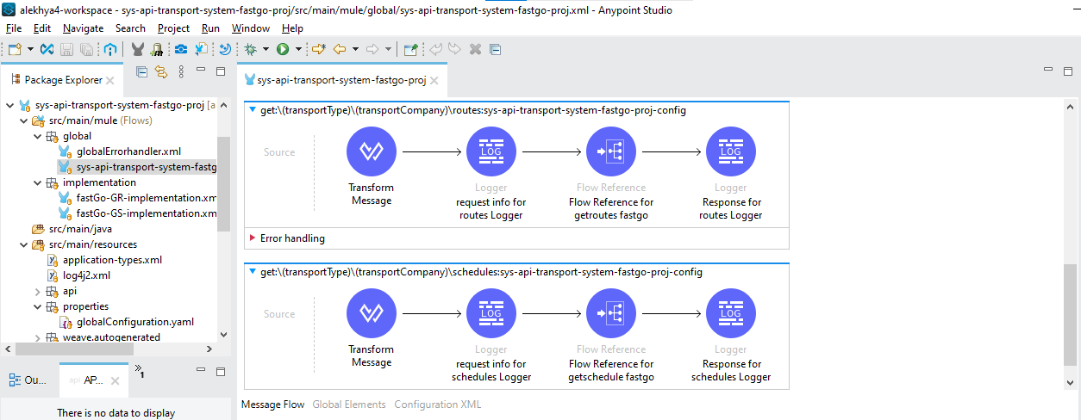

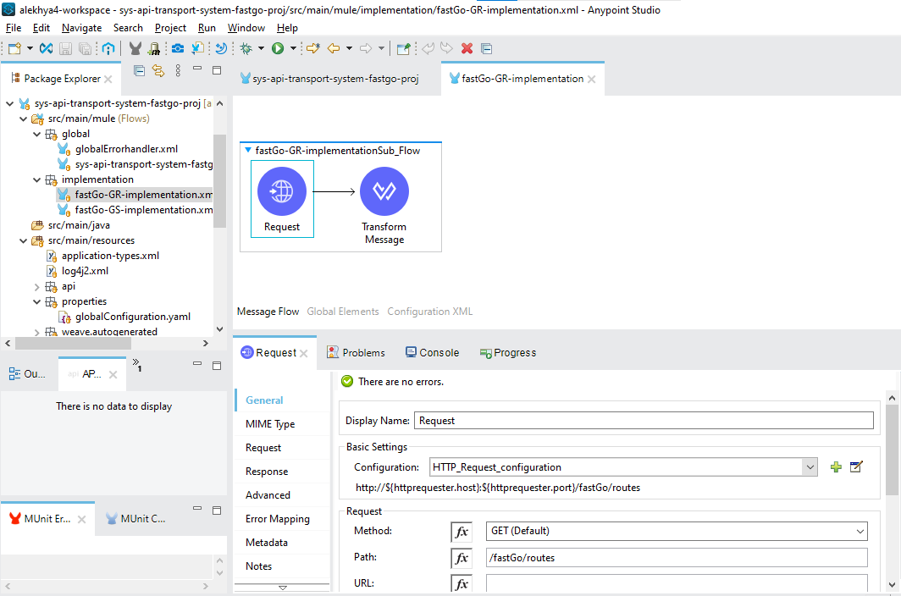

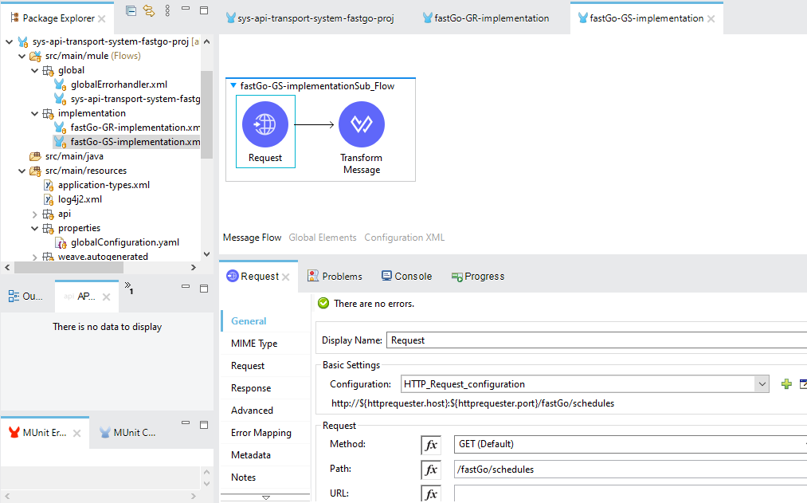

http://localhost:8084/api/bus/fastGo/routes

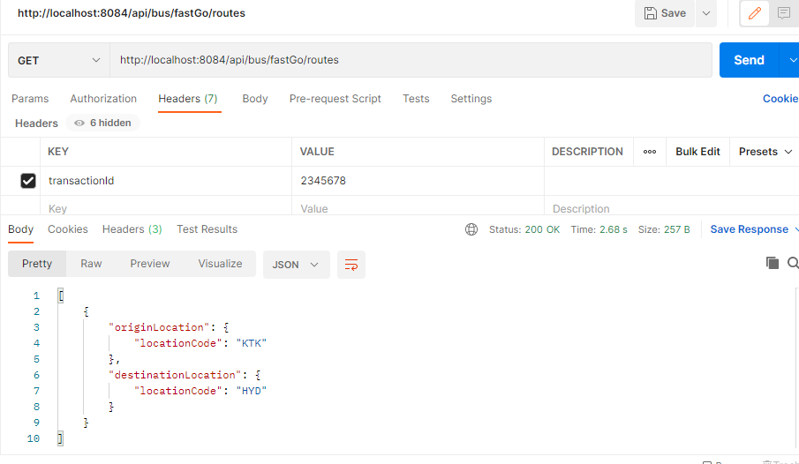

http://localhost:8084/api/bus/fastGo/schedules

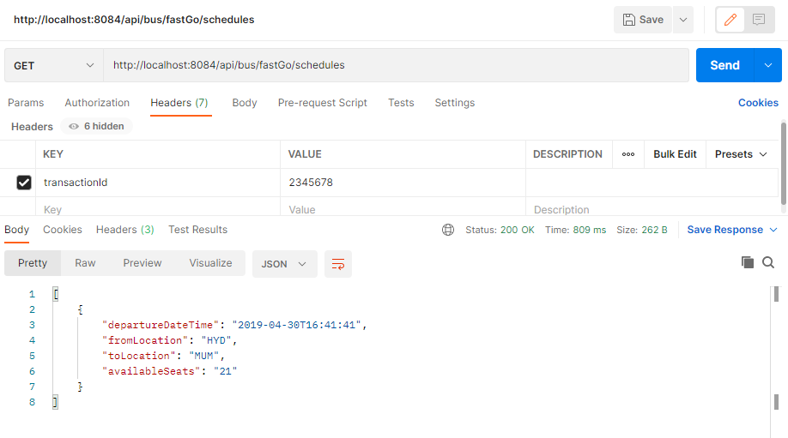

**PROCESS API :**

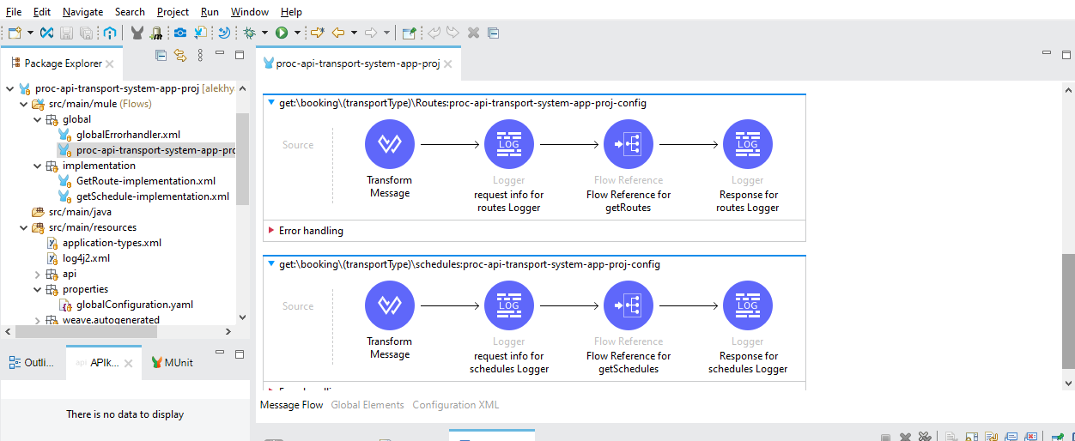

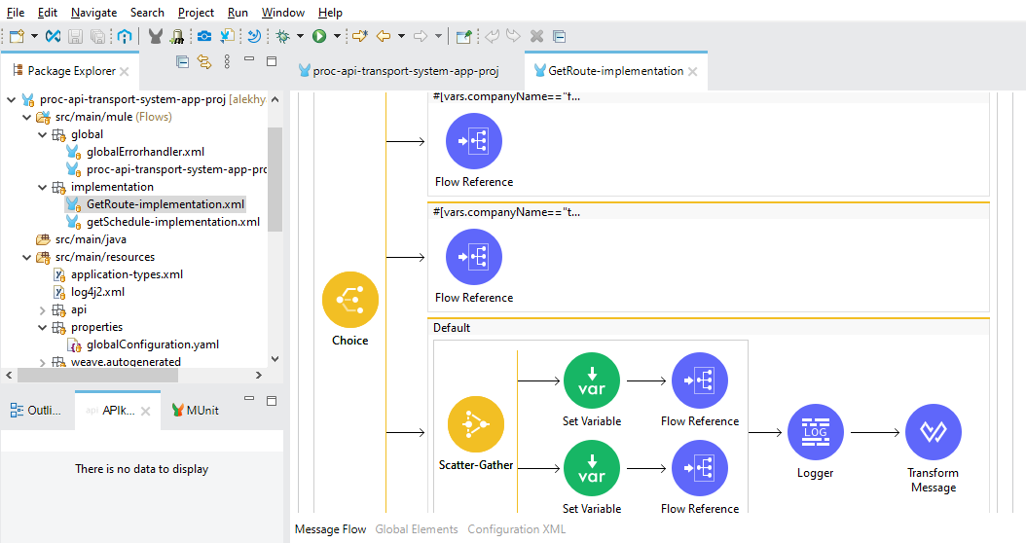

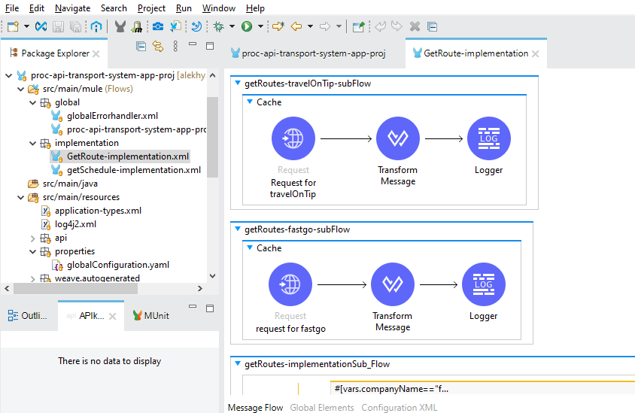

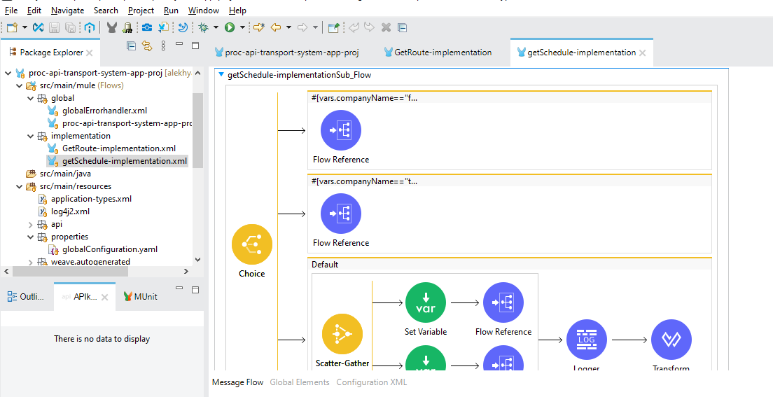

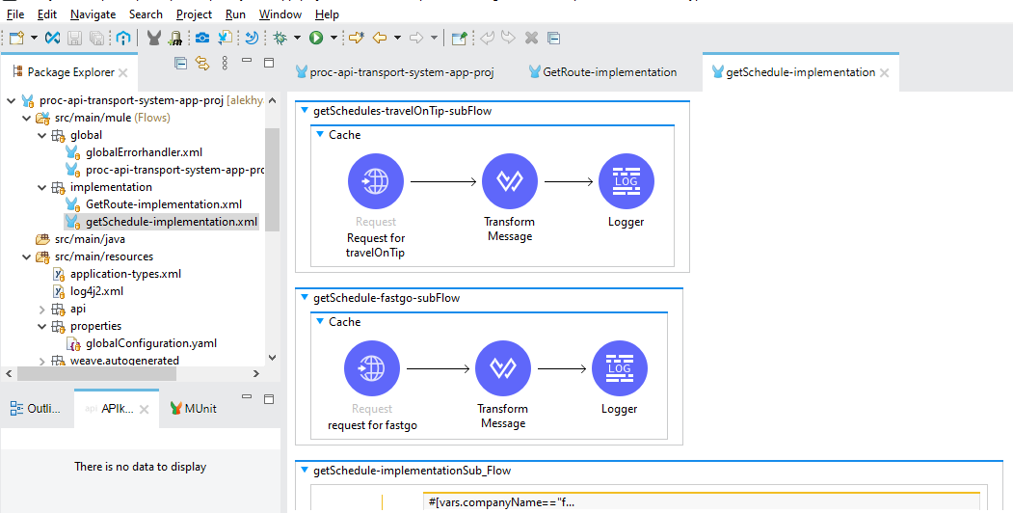

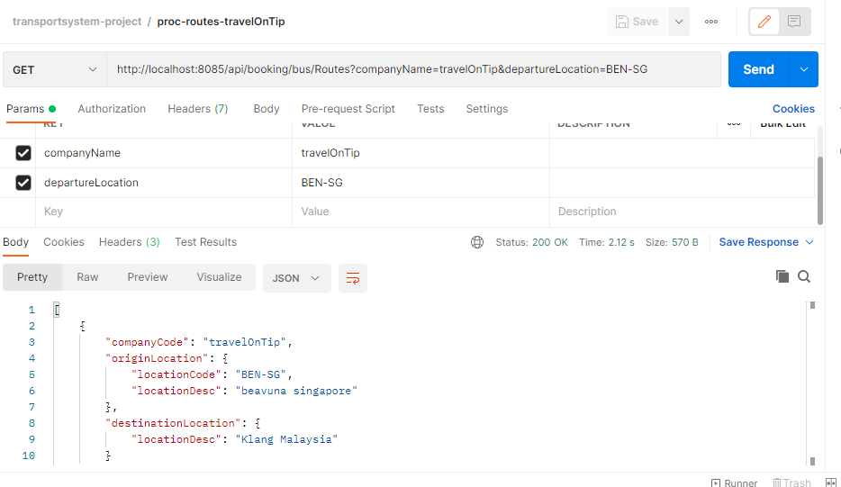

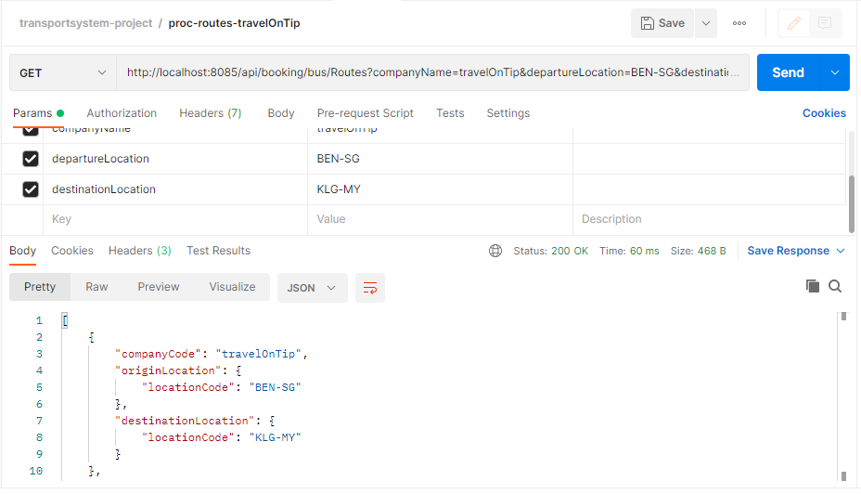

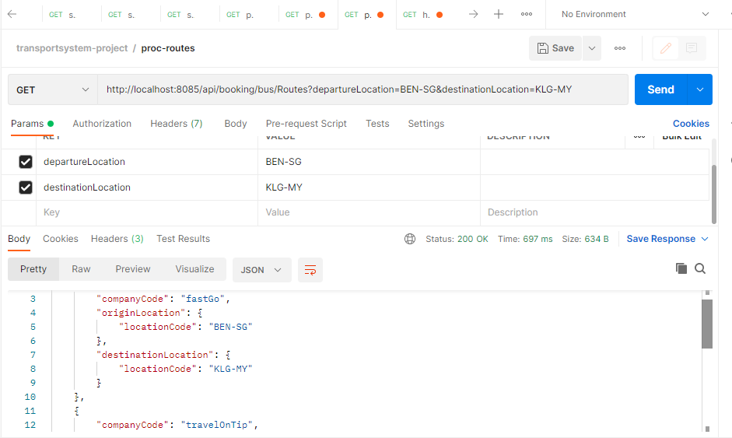

http://localhost:8085/api/booking/bus/schedules?departureLocation=BEN-SG&destinationLocation=KLG-MY

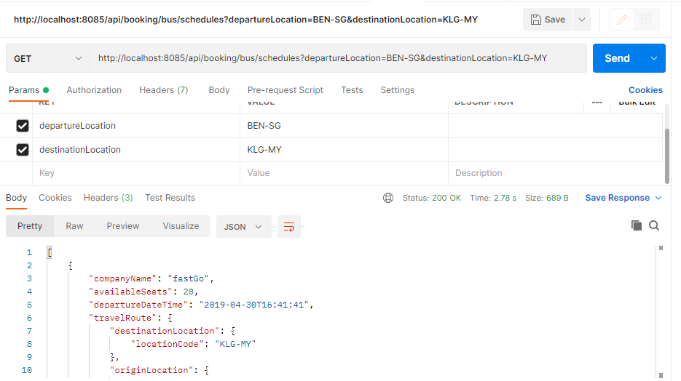

**exp-api-transport-system-web-app:**

**--------------------------------------------**

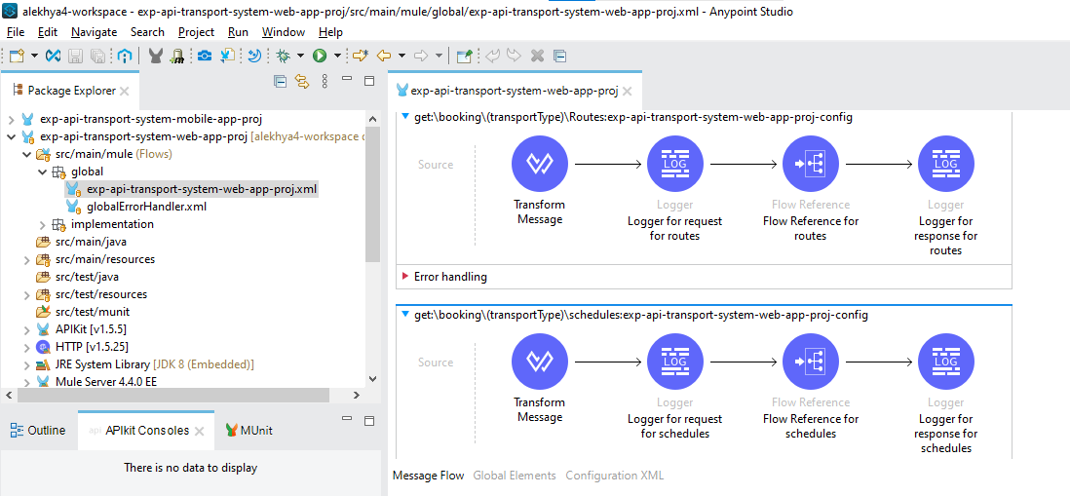

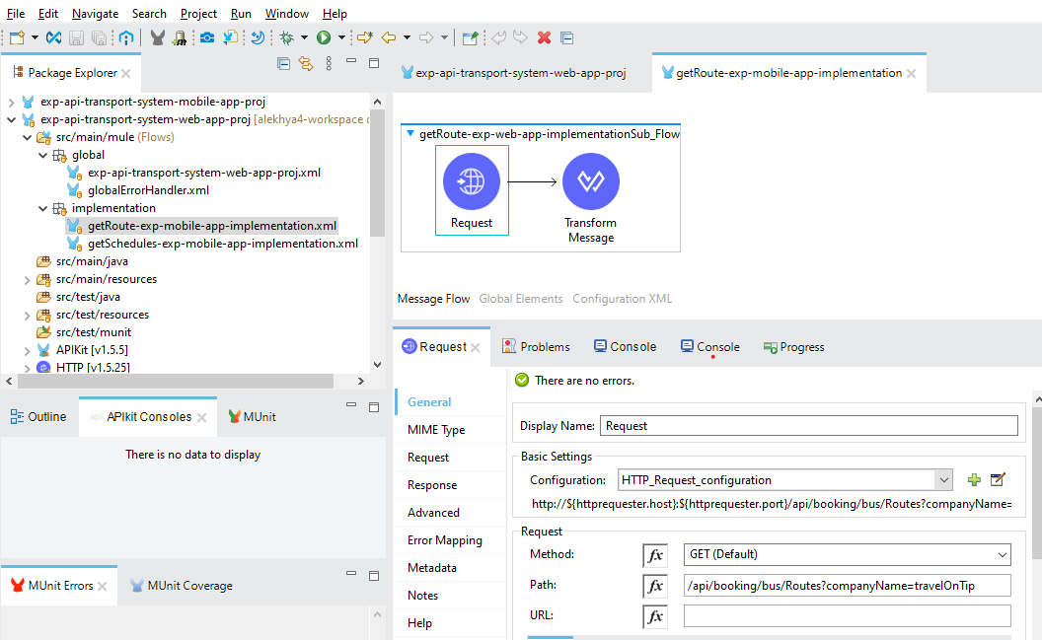

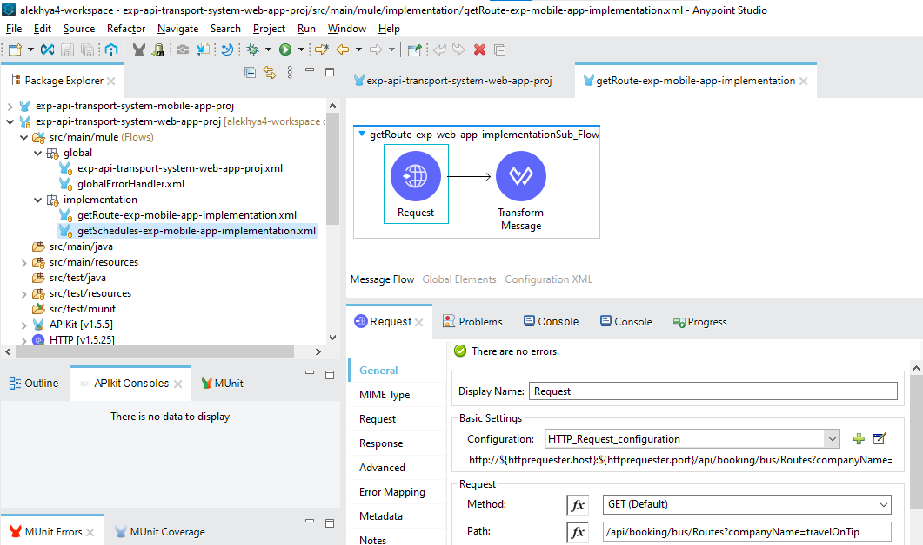

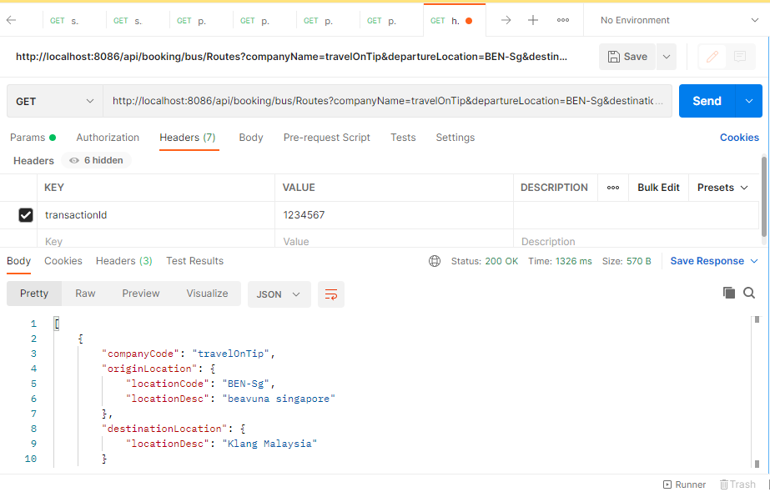

**Exp-api-transport-system-mobile-app:**

