PART 1

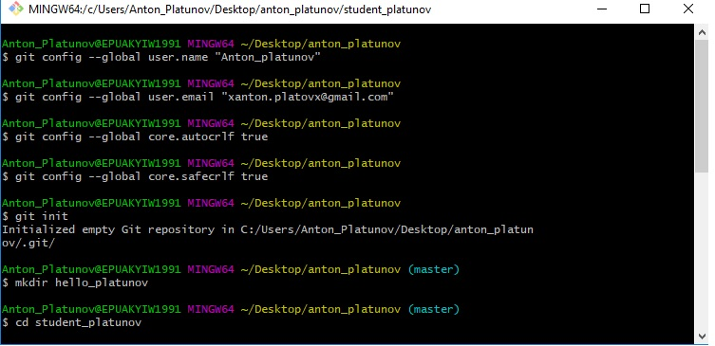

1. created repository “anton_platunov” and made configuration, initialized git

1.1 added work directory “student_platunov”

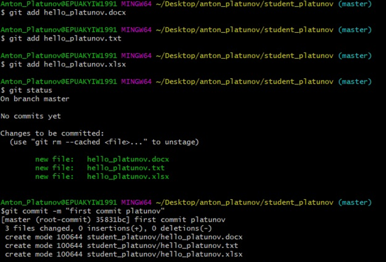1.2 created three folders: -hello_platunov.docx

-hello_platunov.txt

-hello_platunov.xlsx

And I had added to git after that made commit;

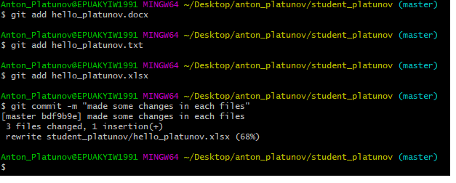

1.3

Had made changes in each file, made commit

Part 2

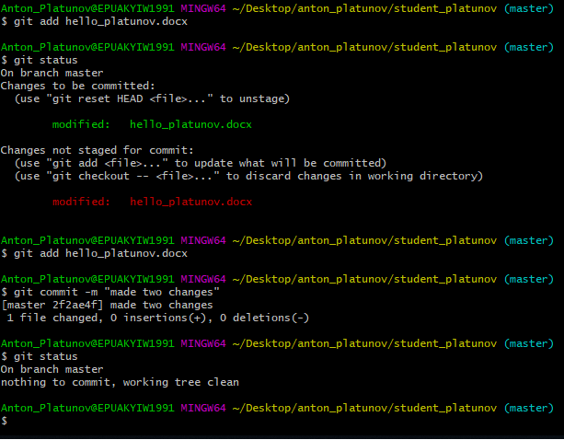

2.1 had made changes in “hello_platunov.docx”, added this file .

2.2 had repeated previous action (2.1), made commit and checked git status

2.3 Conclusion: I have made two changes: firstly, I had made first change in “hello_platunov.docx” and than added “hello_platunov.docx”. Than I made second change “hello_platunov.docx”, added this file, made commit ” [master 2f2ae4f]”. After each change we have to add file.

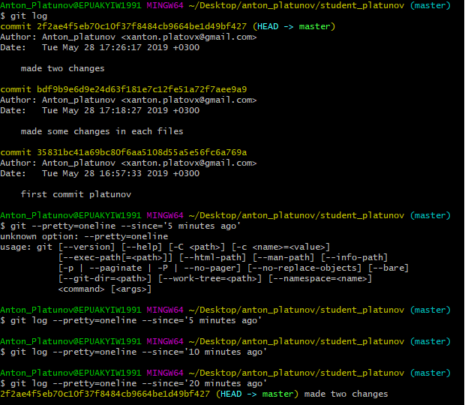

2.4 after **“$ git log”** and **“$ git log --pretty=oneline --since='20 minutes ago' “**

Part 3

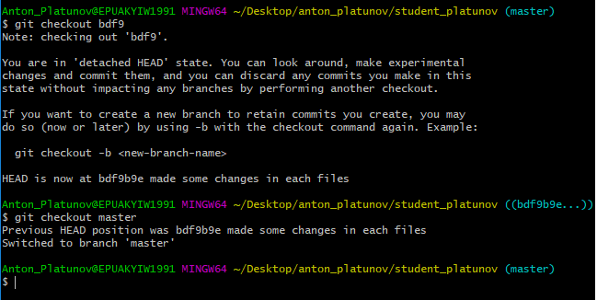

3.1 I had made git checkout < bdf9b9e6d9e24d63f181e7c12fe51a72f7aee9a9> than returned back to last commit <master>

Part 4

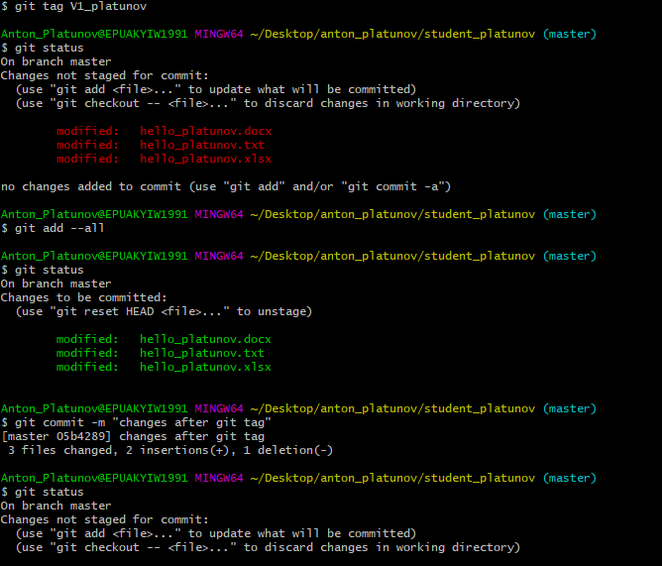

4.1 Made tag “V1_platunov”

4.2 Made two commits

4.3 Made checkout to tag “V1_platunov”

4.4 Returned to “master”

Part 5

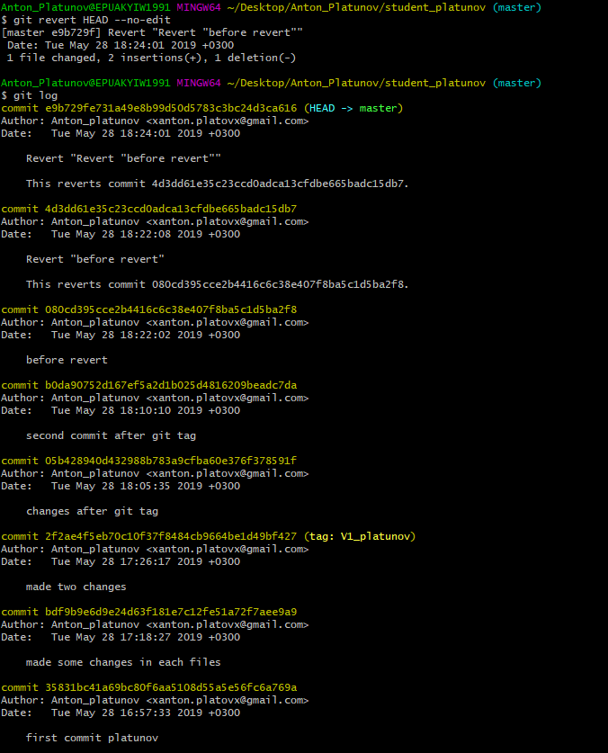

5.1 Made some changes in directory , added all changed files ,made commit

5.2 Made revert to the last commit, showed log.