Part 1

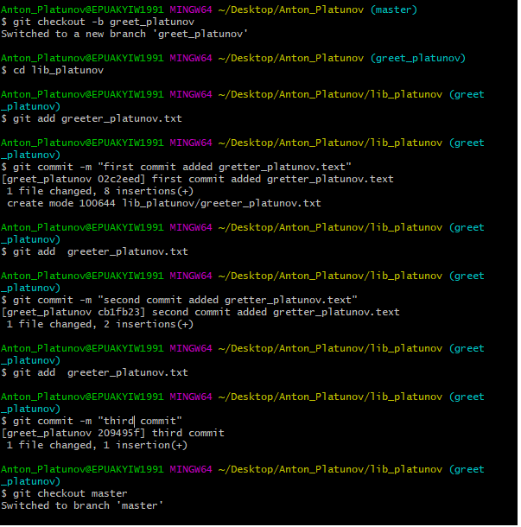

1.1 I couldn’t create REAMDE file, because I used <master> branch and directory <lib_platunov> was in the <greeting_platunov> branch.

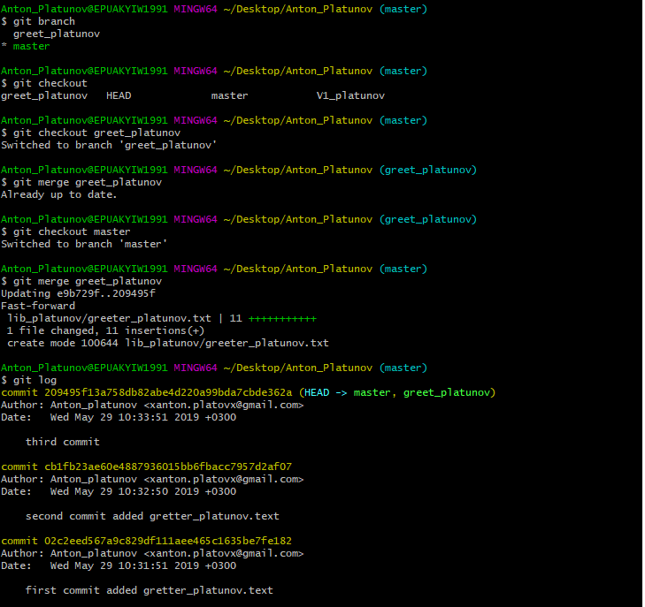

Part 3

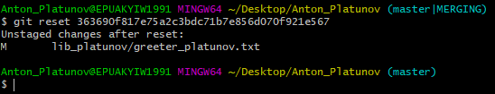3.3 Made reset to the commit before merge

Part 4

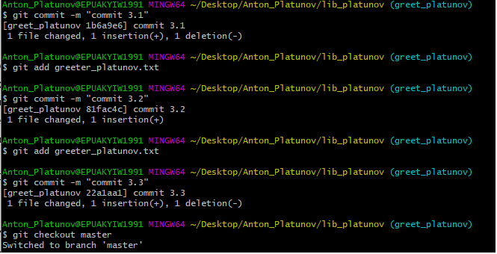

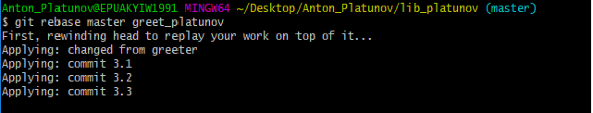

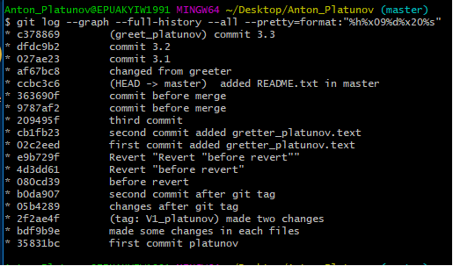

3.5.Made rebase. “$git merge” apply all unique commits from branch A into branch B in one commit with final result and doesn’t rewrite commit history, just adds one new commit.

“git rebase gets all unique commits from both branches and applies them one by one.

**“$git rebase”** rewrites commit history but doesn’t create extra commit for merging

Part 5



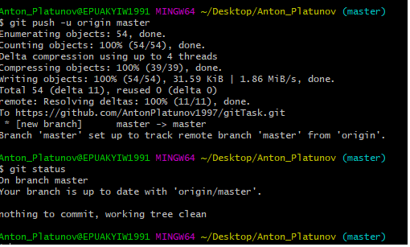

I am student 1

5.1 Created repository on the GitHub, and pushed all files to the repository, mage “git status”

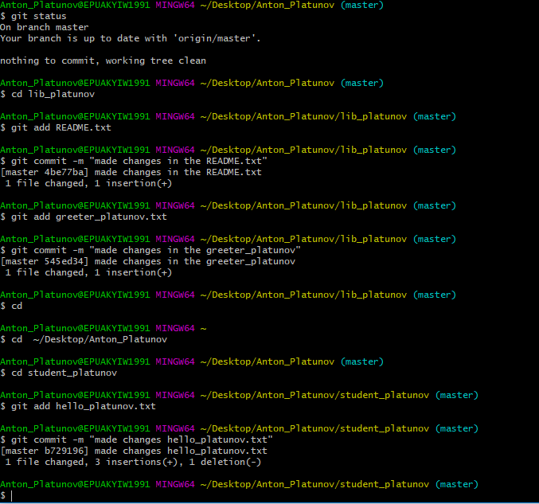

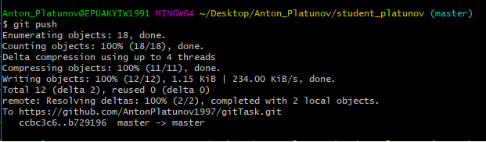

5.2 had made three commits than made push.