Федеральное агентство связи

Федеральное государственное бюджетное образовательное учреждение

высшего образования

«Сибирский государственный университет

телекоммуникаций и информатики»

**Курсовая работа по теме:**

«3D модели на OpenGL»

Выполнили:

студентки 4 курса

ИВТ, гр. ИП-712

Гервас А.В.

Онищенко А.В.

Проверила:

Ассистент кафедры ПМиК

Павлова Ульяна Владимировна

Новосибирск 2020 г

Оглавление

1. Задание на оценку отлично 3

2. Скриншоты 3

3. Листинг 5

1. **Задание на оценку отлично**

Создайте программу в которой нарисован стол на OpenGL ES 2.0.

На столе лежат различные фрукты/овощи (не менее 4 различных), стакан с напитком. Имеется свеча, дающее освещение (по модели Фонга).

1. **Скриншоты**

Модели были смоделированы и импортированы в android studio из blender.

Скриншоты моделирования сцены объекты которой потом переносили в мобильное приложение:

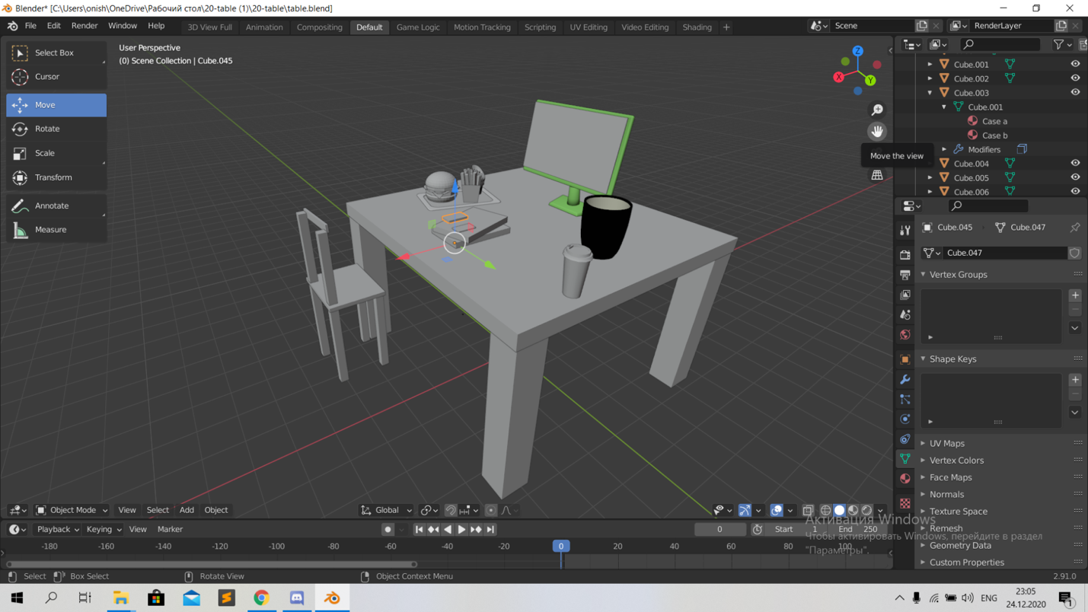

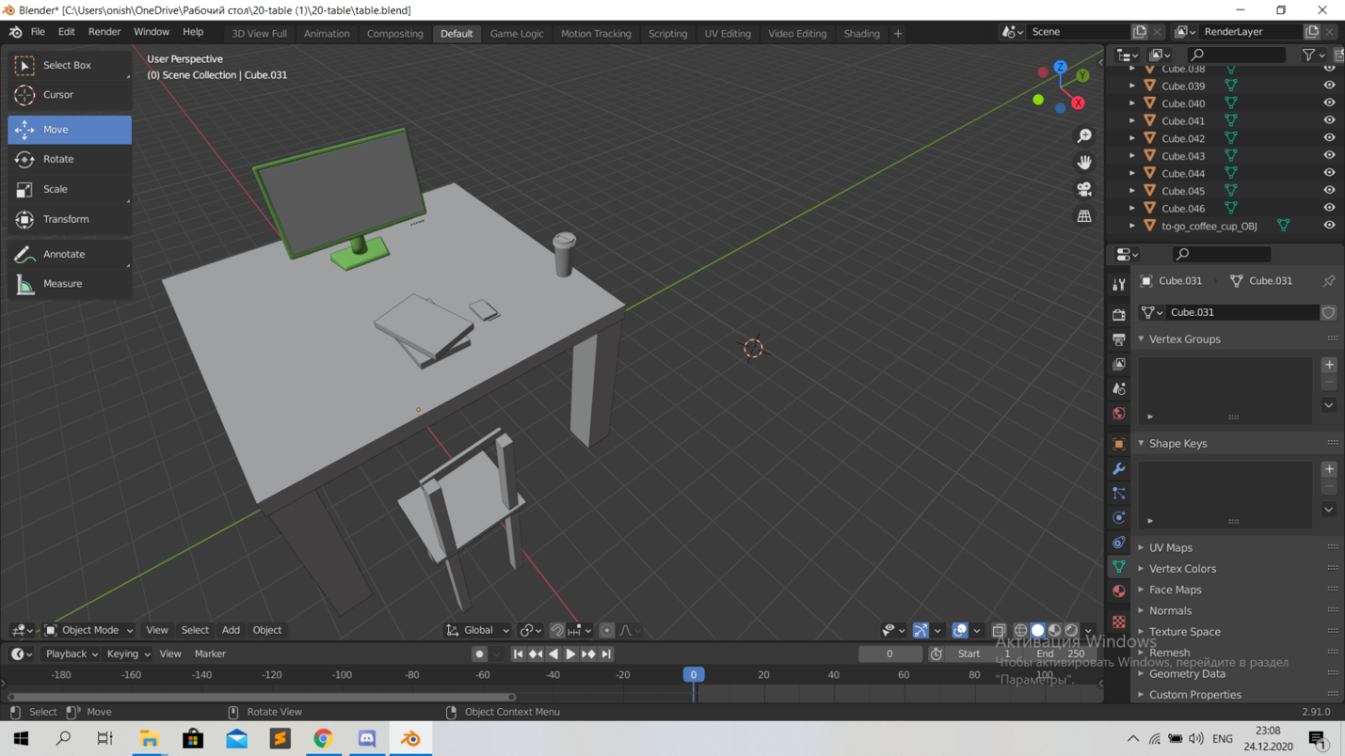

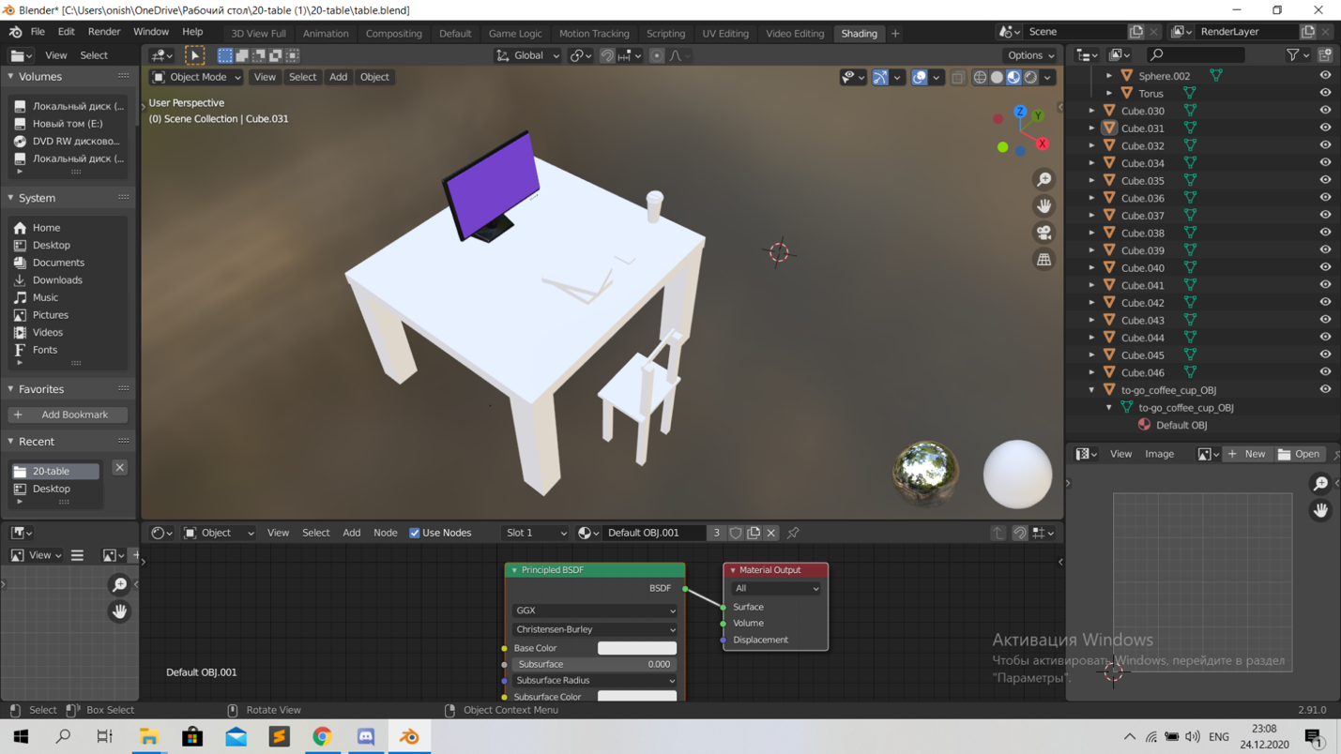

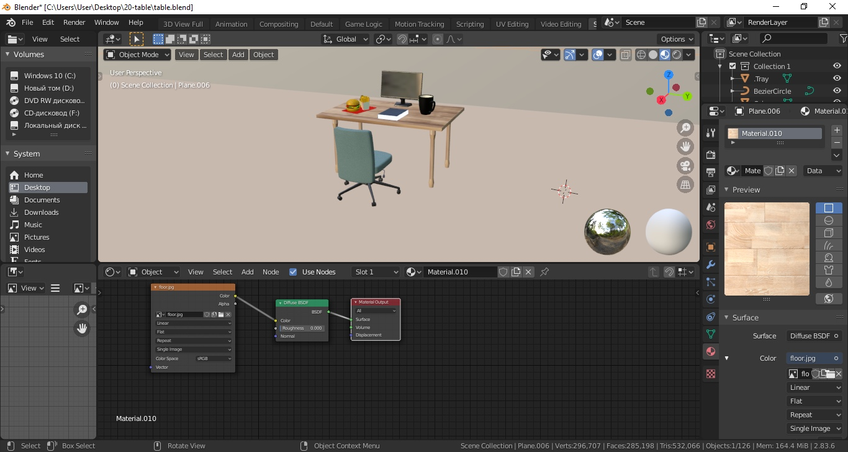

Скриншоты работы мобильного приложения:

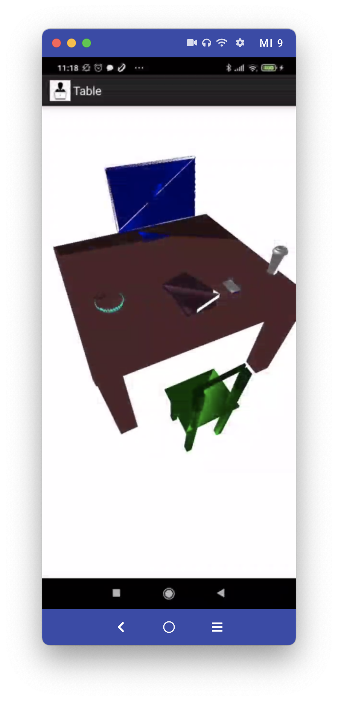

1. **Листинг**

Программа была выполнена на языке программирования java.

**MainActivity.java**

package ru.sibsutis.table;

import android.app.Activity;

import android.opengl.GLSurfaceView;

import android.os.Bundle;

import android.view.Menu;

import android.view.MenuInflater;

import android.view.MenuItem;

import android.widget.Toast;

public class MainActivity extends Activity {

@Override

public void onCreate(Bundle savedInstanceState) {

super.onCreate(savedInstanceState);

GLSurfaceView mGLSurfaceView = new GLSurfaceView(this);

mGLSurfaceView.setEGLContextClientVersion(2);

ShadowsRenderer renderer = new ShadowsRenderer(this, this);

mGLSurfaceView.setRenderer(renderer);

setContentView(mGLSurfaceView);

}

}

**Objects.java**

package ru.sibsutis.table;

import java.io.IOException;

import java.nio.ByteBuffer;

import java.nio.ByteOrder;

import java.nio.FloatBuffer;

import java.nio.ShortBuffer;

import java.util.ArrayList;

import java.util.Arrays;

import java.util.List;

import java.util.Scanner;

import android.content.Context;

import android.opengl.GLES20;

class Objects {

private FloatBuffer colorBuffer;

private FloatBuffer verticesBuffer;

private FloatBuffer normalBuffer;

private ShortBuffer facesVertexBuffer;

private ShortBuffer facesNormalBuffer;

private List<String> facesList;

Objects(Context c, float[] color, String ObjName) {

List<String> verticesList = new ArrayList<>();

facesList = new ArrayList<>();

List<String> normalList = new ArrayList<>();

try {

Scanner scanner = new Scanner(c.getAssets().open(ObjName));

while (scanner.hasNextLine()) {

String line = scanner.nextLine();

if (line.startsWith("v ")) {

verticesList.add(line);

} else if (line.startsWith("f ")) {

facesList.add(line);

} else if (line.startsWith("vn ")) {

normalList.add(line);

} else if (line.startsWith("vt ")) {

continue;

}

}

ByteBuffer buffer1 = ByteBuffer.allocateDirect(verticesList.size() * 3 * 4);

buffer1.order(ByteOrder.nativeOrder());

verticesBuffer = buffer1.asFloatBuffer();

ByteBuffer buffer2 = ByteBuffer.allocateDirect(normalList.size() * 3 * 4);

buffer2.order(ByteOrder.nativeOrder());

normalBuffer = buffer2.asFloatBuffer();

ByteBuffer buffer3 = ByteBuffer.allocateDirect(facesList.size() * 3 * 2);

buffer3.order(ByteOrder.nativeOrder());

facesVertexBuffer = buffer3.asShortBuffer();

ByteBuffer buffer4 = ByteBuffer.allocateDirect(facesList.size() * 3 * 2);

buffer4.order(ByteOrder.nativeOrder());

facesNormalBuffer = buffer4.asShortBuffer();

for (String vertex : verticesList) {

String coords[] = vertex.split(" ");

float x = Float.parseFloat(coords[1]);

float y = Float.parseFloat(coords[2]);

float z = Float.parseFloat(coords[3]);

verticesBuffer.put(x);

verticesBuffer.put(y);

verticesBuffer.put(z);

}

verticesBuffer.position(0);

for (String vertex : normalList) {

String coords[] = vertex.split(" ");

float x = Float.parseFloat(coords[1]);

float y = Float.parseFloat(coords[2]);

float z = Float.parseFloat(coords[3]);

normalBuffer.put(x);

normalBuffer.put(y);

normalBuffer.put(z);

}

normalBuffer.position(0);

for (String face : facesList) {

String vertexIndices[] = face.split(" ");

System.out.println("VertexIndices:" + Arrays.toString(vertexIndices));

String coord1[],coord2[], coord3[];

if(vertexIndices[1].contains("//"))

coord1 = vertexIndices[1].split("//");

else

coord1 = vertexIndices[1].split("/");

if(vertexIndices[2].contains("//"))

coord2 = vertexIndices[2].split("//");

else

coord2 = vertexIndices[2].split("/");

if(vertexIndices[3].contains("//"))

coord3 = vertexIndices[3].split("//");

else

coord3 = vertexIndices[3].split("/");

// coord2 = vertexIndices[2].split("//");

// coord3 = vertexIndices[3].split("//");

short vertex1 = Short.parseShort(coord1[0]);

short vertex2 = Short.parseShort(coord2[0]);

short vertex3 = Short.parseShort(coord3[0]);

facesVertexBuffer.put((short) (vertex1 - 1));

facesVertexBuffer.put((short) (vertex2 - 1));

facesVertexBuffer.put((short) (vertex3 - 1));

vertex1 = Short.parseShort(coord1[1]);

vertex2 = Short.parseShort(coord2[1]);

vertex3 = Short.parseShort(coord3[1]);

facesNormalBuffer.put((short) (vertex1 - 1));

facesNormalBuffer.put((short) (vertex2 - 1));

facesNormalBuffer.put((short) (vertex3 - 1));

}

facesVertexBuffer.position(0);

facesNormalBuffer.position(0);

verticesList.clear();

normalList.clear();

scanner.close();

} catch (IOException e) {

e.printStackTrace();

}

float[] colorData = new float[facesList.size() * 4];

for (int v = 0; v < facesList.size(); v++) {

colorData[4 * v] = color[0];

colorData[4 * v + 1] = color[1];

colorData[4 * v + 2] = color[2];

colorData[4 * v + 3] = color[3];

}

ByteBuffer bColor = ByteBuffer.allocateDirect(colorData.length * 4);

bColor.order(ByteOrder.nativeOrder());

colorBuffer = bColor.asFloatBuffer();

colorBuffer.put(colorData).position(0);

}

void render(int positionAttribute, int normalAttribute, int colorAttribute, boolean onlyPosition) {

facesVertexBuffer.position(0);

facesNormalBuffer.position(0);

verticesBuffer.position(0);

normalBuffer.position(0);

colorBuffer.position(0);

GLES20.glVertexAttribPointer(positionAttribute, 3, GLES20.GL_FLOAT, false,

0, verticesBuffer);

GLES20.glEnableVertexAttribArray(positionAttribute);

if (!onlyPosition) {

GLES20.glVertexAttribPointer(normalAttribute, 3, GLES20.GL_FLOAT, false,

0, normalBuffer);

GLES20.glEnableVertexAttribArray(normalAttribute);

GLES20.glVertexAttribPointer(colorAttribute, 4, GLES20.GL_FLOAT, false,

0, colorBuffer);

GLES20.glEnableVertexAttribArray(colorAttribute);

}

GLES20.glDrawElements(GLES20.GL_TRIANGLES, facesList.size() * 3,

GLES20.GL_UNSIGNED_SHORT, facesVertexBuffer);

}

}

**RenderProgram.java**

package ru.sibsutis.table;

import java.io.BufferedReader;

import java.io.InputStream;

import java.io.InputStreamReader;

import android.content.Context;

import android.opengl.GLES20;

import android.util.Log;

class RenderProgram {

private int mProgram;

private String mVertexS, mFragmentS;

RenderProgram(int vID, int fID, Context context) {

StringBuilder vs = new StringBuilder();

StringBuilder fs = new StringBuilder();

try {

InputStream inputStream = context.getResources().openRawResource(vID);

BufferedReader in = new BufferedReader(new InputStreamReader(inputStream));

String read = in.readLine();

while (read != null) {

vs.append(read).append("\n");

read = in.readLine();

}

vs.deleteCharAt(vs.length() - 1);

inputStream = context.getResources().openRawResource(fID);

in = new BufferedReader(new InputStreamReader(inputStream));

read = in.readLine();

while (read != null) {

fs.append(read).append("\n");

read = in.readLine();

}

fs.deleteCharAt(fs.length() - 1);

} catch (Exception e) {

Log.d("RenderProgram", "Could not read shader: " + e.getLocalizedMessage());

}

setup(vs.toString(), fs.toString());

}

private void setup(String vs, String fs) {

this.mVertexS = vs;

this.mFragmentS = fs;

if (createProgram() != 1) {

throw new RuntimeException("Error at creating shaders");

};

}

private int createProgram() {

int mVertexShader = loadShader(GLES20.GL_VERTEX_SHADER, mVertexS);

if (mVertexShader == 0) {

return 0;

}

int mPixelShader = loadShader(GLES20.GL_FRAGMENT_SHADER, mFragmentS);

if (mPixelShader == 0) {

return 0;

}

mProgram = GLES20.glCreateProgram();

if (mProgram != 0) {

GLES20.glAttachShader(mProgram, mVertexShader);

GLES20.glAttachShader(mProgram, mPixelShader);

GLES20.glLinkProgram(mProgram);

int[] linkStatus = new int[1];

GLES20.glGetProgramiv(mProgram, GLES20.GL_LINK_STATUS, linkStatus, 0);

if (linkStatus[0] != GLES20.GL_TRUE) {

Log.e("RenderProgram", "Could not link _program: ");

Log.e("RenderProgram", GLES20.glGetProgramInfoLog(mProgram));

GLES20.glDeleteProgram(mProgram);

mProgram = 0;

return 0;

}

}

else

Log.d("CreateProgram", "Could not create program");

return 1;

}

private int loadShader(int shaderType, String source) {

int shader = GLES20.glCreateShader(shaderType);

if (shader != 0) {

GLES20.glShaderSource(shader, source);

GLES20.glCompileShader(shader);

int[] compiled = new int[1];

GLES20.glGetShaderiv(shader, GLES20.GL_COMPILE_STATUS, compiled, 0);

if (compiled[0] == 0) {

Log.e("RenderProgram", "Could not compile shader " + shaderType + ":");

Log.e("RenderProgram", GLES20.glGetShaderInfoLog(shader));

GLES20.glDeleteShader(shader);

shader = 0;

}

}

return shader;

}

int getProgram() {

return mProgram;

}

}

**ShadowsRenderer.java**

package ru.sibsutis.table;

import javax.microedition.khronos.egl.EGLConfig;

import javax.microedition.khronos.opengles.GL10;

import android.content.Context;

import android.opengl.GLES20;

import android.opengl.GLSurfaceView;

import android.opengl.Matrix;

import android.util.Log;

public class ShadowsRenderer implements GLSurfaceView.Renderer {

private final MainActivity mShadowsActivity;

private RenderProgram mSimpleShadowProgram;

private RenderProgram mDepthMapProgram;

private int mActiveProgram;

private final float[] mMVPMatrix = new float[16];

private final float[] mMVMatrix = new float[16];

private final float[] mNormalMatrix = new float[16];

private final float[] mProjectionMatrix = new float[16];

private final float[] mViewMatrix = new float[16];

private final float[] mModelMatrix = new float[16];

private final float[] mLightMvpMatrix = new float[16];

private final float[] mLightProjectionMatrix = new float[16];

private final float[] mLightViewMatrix = new float[16];

private final float[] mLightPosInEyeSpace = new float[16];

private final float[] mLightPosModel = new float[]

{0.1f, 10.0f, 0.1f, 1.0f};

private float[] mActualLightPosition = new float[4];

private int mDisplayWidth;

private int mDisplayHeight;

private float s = 0;

private int mShadowMapWidth;

private int mShadowMapHeight;

private int[] fboId;

private int[] renderTextureId;

private int scene_mvpMatrixUniform;

private int scene_mvMatrixUniform;

private int scene_normalMatrixUniform;

private int scene_lightPosUniform;

private int scene_shadowProjMatrixUniform;

private int scene_textureUniform;

private int scene_mapStepXUniform;

private int scene_mapStepYUniform;

private int shadow_mvpMatrixUniform;

private int scene_positionAttribute;

private int scene_normalAttribute;

private int scene_colorAttribute;

private int shadow_positionAttribute;

private Context c;

private Objects table;

private Objects chair;

private Objects comp;

private Objects cup;

private Objects book;

private Objects plate;

private Objects nizhnyayabulka;

private Objects kartohakonchlas;

private Objects kruzhechka;

private Objects tel;

private Objects screen;

private Plane mPlane;

ShadowsRenderer(final MainActivity shadowsActivity, Context c) {

mShadowsActivity = shadowsActivity;

this.c = c;

}

@Override

public void onSurfaceCreated(GL10 unused, EGLConfig config) {

GLES20.glClearColor(1.0f, 1.0f, 1.0f, 1.0f);

GLES20.glEnable(GLES20.GL_DEPTH_TEST);

GLES20.glEnable(GLES20.GL_CULL_FACE);

table = new Objects(c, new float[]{0.4f, 0.2f, 0.2f, 1.0f}, "table_ikea.obj");

comp = new Objects(c, new float[]{0.0f, 0.0f, 1.0f, 1.0f}, "comp1.obj");

chair = new Objects(c, new float[]{0.0f, 0.3f, 0.0f, 1.0f}, "stulotpynoogotrudovica.obj");

book = new Objects(c, new float[]{0.4f, 0.2f, 0.3f, 1.0f}, "books.obj");

// plate = new Objects(c, new float[]{0.4f, 0.2f, 0.3f, 1.0f}, "plate.obj");

nizhnyayabulka = new Objects(c, new float[]{0.0f, 5f, 3f, 1.0f}, "nizhnyayabulka.obj");

// kartohakonchlas = new Objects(c, new float[]{1f, 0.2f, 0.3f, 1.0f}, "kartohakonchlas.obj");

kruzhechka = new Objects(c, new float[]{1f, 1f, 1f, 1.0f}, "kruzhechka.obj");

tel = new Objects(c, new float[]{1f, 1f, 1f, 1f}, "tel.obj");

screen = new Objects(c, new float[]{0.0f, 0.0f, 1f, 1f}, "screen.obj");

// mPlane = new Plane();

mSimpleShadowProgram = new RenderProgram(R.raw.depth_tex_v_with_shadow, R.raw.depth_tex_f_with_simple_shadow, mShadowsActivity);

mDepthMapProgram = new RenderProgram(R.raw.depth_tex_v_depth_map, R.raw.depth_tex_f_depth_map, mShadowsActivity);

mActiveProgram = mSimpleShadowProgram.getProgram();

}

private void generateShadowFBO() {

mShadowMapWidth = Math.round(mDisplayWidth);

mShadowMapHeight = Math.round(mDisplayHeight);

fboId = new int[1];

int[] depthTextureId = new int[1];

renderTextureId = new int[1];

GLES20.glGenFramebuffers(1, fboId, 0);

GLES20.glGenRenderbuffers(1, depthTextureId, 0);

GLES20.glBindRenderbuffer(GLES20.GL_RENDERBUFFER, depthTextureId[0]);

GLES20.glRenderbufferStorage(GLES20.GL_RENDERBUFFER, GLES20.GL_DEPTH_COMPONENT16, mShadowMapWidth, mShadowMapHeight);

GLES20.glGenTextures(1, renderTextureId, 0);

GLES20.glBindTexture(GLES20.GL_TEXTURE_2D, renderTextureId[0]);

GLES20.glTexParameteri(GLES20.GL_TEXTURE_2D, GLES20.GL_TEXTURE_MIN_FILTER, GLES20.GL_NEAREST);

GLES20.glTexParameteri(GLES20.GL_TEXTURE_2D, GLES20.GL_TEXTURE_MAG_FILTER, GLES20.GL_NEAREST);

GLES20.glTexParameteri(GLES20.GL_TEXTURE_2D, GLES20.GL_TEXTURE_WRAP_S, GLES20.GL_CLAMP_TO_EDGE);

GLES20.glTexParameteri(GLES20.GL_TEXTURE_2D, GLES20.GL_TEXTURE_WRAP_T, GLES20.GL_CLAMP_TO_EDGE);

GLES20.glBindFramebuffer(GLES20.GL_FRAMEBUFFER, fboId[0]);

GLES20.glTexImage2D(GLES20.GL_TEXTURE_2D, 0, GLES20.GL_DEPTH_COMPONENT, mShadowMapWidth, mShadowMapHeight, 0, GLES20.GL_DEPTH_COMPONENT, GLES20.GL_UNSIGNED_INT, null);

GLES20.glFramebufferTexture2D(GLES20.GL_FRAMEBUFFER, GLES20.GL_DEPTH_ATTACHMENT, GLES20.GL_TEXTURE_2D, renderTextureId[0], 0);

}

@Override

public void onSurfaceChanged(GL10 unused, int width, int height) {

mDisplayWidth = width;

mDisplayHeight = height;

GLES20.glViewport(0, 0, mDisplayWidth, mDisplayHeight);

generateShadowFBO();

float ratio = (float) mDisplayWidth / mDisplayHeight;

float bottom = -1.0f;

float top = 1.0f;

float near = 1.0f;

float far = 100.0f;

Matrix.frustumM(mProjectionMatrix, 0, -ratio, ratio, bottom, top, near, far);

Matrix.frustumM(mLightProjectionMatrix, 0, -1.1f * ratio, 1.1f * ratio, 1.1f * bottom, 1.1f * top, near, far);

}

@Override

public void onDrawFrame(GL10 unused) {

mActiveProgram = mSimpleShadowProgram.getProgram();

Matrix.setLookAtM(mViewMatrix, 0,

8, 10, 0,

0, 0, 0,

-5, 0, 0);

scene_mvpMatrixUniform = GLES20.glGetUniformLocation(mActiveProgram, "uMVPMatrix");

scene_mvMatrixUniform = GLES20.glGetUniformLocation(mActiveProgram, "uMVMatrix");

scene_normalMatrixUniform = GLES20.glGetUniformLocation(mActiveProgram, "uNormalMatrix");

scene_lightPosUniform = GLES20.glGetUniformLocation(mActiveProgram, "uLightPos");

scene_shadowProjMatrixUniform = GLES20.glGetUniformLocation(mActiveProgram, "uShadowProjMatrix");

scene_textureUniform = GLES20.glGetUniformLocation(mActiveProgram, "uShadowTexture");

scene_positionAttribute = GLES20.glGetAttribLocation(mActiveProgram, "aPosition");

scene_normalAttribute = GLES20.glGetAttribLocation(mActiveProgram, "aNormal");

scene_colorAttribute = GLES20.glGetAttribLocation(mActiveProgram, "aColor");

scene_mapStepXUniform = GLES20.glGetUniformLocation(mActiveProgram, "uxPixelOffset");

scene_mapStepYUniform = GLES20.glGetUniformLocation(mActiveProgram, "uyPixelOffset");

int shadowMapProgram = mDepthMapProgram.getProgram();

shadow_mvpMatrixUniform = GLES20.glGetUniformLocation(shadowMapProgram, "uMVPMatrix");

shadow_positionAttribute = GLES20.glGetAttribLocation(shadowMapProgram, "aShadowPosition");

float[] basicMatrix = new float[16];

Matrix.setIdentityM(basicMatrix, 0);

Matrix.multiplyMV(mActualLightPosition, 0, basicMatrix, 0, mLightPosModel, 0);

Matrix.setIdentityM(mModelMatrix, 0);

Matrix.setLookAtM(mLightViewMatrix, 0,

mActualLightPosition[0], mActualLightPosition[1], mActualLightPosition[2],

mActualLightPosition[0], -mActualLightPosition[1], mActualLightPosition[2],

-mActualLightPosition[0], 0, -mActualLightPosition[2]);

GLES20.glCullFace(GLES20.GL_FRONT);

s += 0.3f;

if (s >= 360) s -= 360;

Matrix.rotateM(mModelMatrix, 0, -25, 0, 1, 0);

renderShadowMap();

GLES20.glCullFace(GLES20.GL_BACK);

renderScene();

}

private void renderShadowMap() {

GLES20.glBindFramebuffer(GLES20.GL_FRAMEBUFFER, fboId[0]);

GLES20.glViewport(0, 0, mShadowMapWidth, mShadowMapHeight);

GLES20.glClearColor(1f, 1f, 1f, 1.0f);

GLES20.glClear(GLES20.GL_DEPTH_BUFFER_BIT | GLES20.GL_COLOR_BUFFER_BIT);

GLES20.glUseProgram(mDepthMapProgram.getProgram());

float[] tempResultMatrix = new float[16];

Matrix.multiplyMM(mLightMvpMatrix, 0, mLightViewMatrix, 0, mModelMatrix, 0);

Matrix.multiplyMM(tempResultMatrix, 0, mLightProjectionMatrix, 0, mLightMvpMatrix, 0);

System.arraycopy(tempResultMatrix, 0, mLightMvpMatrix, 0, 16);

GLES20.glUniformMatrix4fv(shadow_mvpMatrixUniform, 1, false, mLightMvpMatrix, 0);

table.render(shadow_positionAttribute, 0, 0, true);

chair.render(shadow_positionAttribute, 0, 0, true);

comp.render(shadow_positionAttribute, 0, 0, true);

book.render(shadow_positionAttribute, 0, 0, true);

// plate.render(shadow_positionAttribute, 0, 0, true);

nizhnyayabulka.render(shadow_positionAttribute, 0, 0, true);

// kartohakonchlas.render(shadow_positionAttribute, 0, 0, true);

kruzhechka.render(shadow_positionAttribute, 0, 0, true);

tel.render(shadow_positionAttribute, 0, 0, true);

screen.render(shadow_positionAttribute, 0, 0, true);

}

private void renderScene() {

GLES20.glBindFramebuffer(GLES20.GL_FRAMEBUFFER, 0);

GLES20.glClear(GLES20.GL_COLOR_BUFFER_BIT | GLES20.GL_DEPTH_BUFFER_BIT);

GLES20.glUseProgram(mActiveProgram);

GLES20.glViewport(0, 0, mDisplayWidth, mDisplayHeight);

GLES20.glUniform1f(scene_mapStepXUniform, (float) (1.0 / mShadowMapWidth));

GLES20.glUniform1f(scene_mapStepYUniform, (float) (1.0 / mShadowMapHeight));

float[] tempResultMatrix = new float[100];

float[] bias = new float[]{

0.5f, 0.0f, 0.0f, 0.0f,

0.0f, 0.5f, 0.0f, 0.0f,

0.0f, 0.0f, 0.5f, 0.0f,

0.5f, 0.5f, 0.5f, 1.0f};

float[] depthBiasMVP = new float[16];

Matrix.multiplyMM(tempResultMatrix, 0, mViewMatrix, 0, mModelMatrix, 0);

System.arraycopy(tempResultMatrix, 0, mMVMatrix, 0, 16);

GLES20.glUniformMatrix4fv(scene_mvMatrixUniform, 1, false, mMVMatrix, 0);

Matrix.invertM(tempResultMatrix, 0, mMVMatrix, 0);

Matrix.transposeM(mNormalMatrix, 0, tempResultMatrix, 0);

GLES20.glUniformMatrix4fv(scene_normalMatrixUniform, 1, false, mNormalMatrix, 0);

Matrix.multiplyMM(tempResultMatrix, 0, mProjectionMatrix, 0, mMVMatrix, 0);

System.arraycopy(tempResultMatrix, 0, mMVPMatrix, 0, 16);

GLES20.glUniformMatrix4fv(scene_mvpMatrixUniform, 1, false, mMVPMatrix, 0);

Matrix.multiplyMV(mLightPosInEyeSpace, 0, mViewMatrix, 0, mActualLightPosition, 0);

GLES20.glUniform3f(scene_lightPosUniform, mLightPosInEyeSpace[0], mLightPosInEyeSpace[1], mLightPosInEyeSpace[2]);

Matrix.multiplyMM(depthBiasMVP, 0, bias, 0, mLightMvpMatrix, 0);

System.arraycopy(depthBiasMVP, 0, mLightMvpMatrix, 0, 16);

GLES20.glUniformMatrix4fv(scene_shadowProjMatrixUniform, 1, false, mLightMvpMatrix, 0);

table.render(scene_positionAttribute, scene_normalAttribute, scene_colorAttribute, false);

chair.render(scene_positionAttribute, scene_normalAttribute, scene_colorAttribute, false);

comp.render(scene_positionAttribute, scene_normalAttribute, scene_colorAttribute, false);

book.render(scene_positionAttribute, scene_normalAttribute, scene_colorAttribute, false);

// plate.render(scene_positionAttribute, scene_normalAttribute, scene_colorAttribute, false);

nizhnyayabulka.render(scene_positionAttribute, scene_normalAttribute, scene_colorAttribute, false);

// kartohakonchlas.render(scene_positionAttribute, scene_normalAttribute, scene_colorAttribute, false);

kruzhechka.render(scene_positionAttribute, scene_normalAttribute, scene_colorAttribute, false);

tel.render(scene_positionAttribute, scene_normalAttribute, scene_colorAttribute, false);

screen.render(scene_positionAttribute, scene_normalAttribute, scene_colorAttribute, false);

// mPlane.render(scene_positionAttribute, scene_normalAttribute, scene_colorAttribute, false);

}

}