1. **Deployment diagram**

**Client:**

1) Get question

2) Send answer

**Application server:**

1) Choose question

2) Send question

3) Get answer

4) Send answer to database server

**Admin module:**

1) Provides application configurations

**Report server**

1) Get request for creation report

2) Generate report

**Report module**

1) Send request for report

2) Provides report to user

**Data configuration server**

1) Select information

2) Sent data to server

3) Save answers

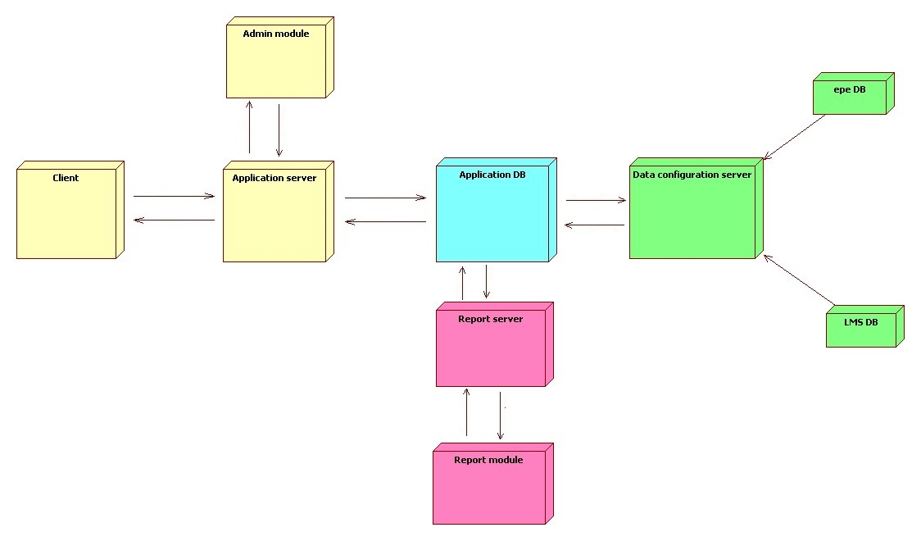

1. Entity relationship diagram

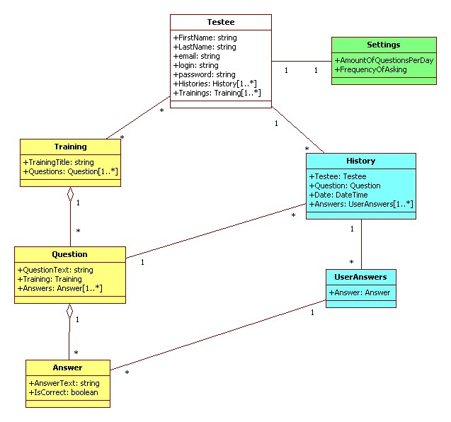

1. Database diagram:

