How-to > Visualizations

URL: <https://docs.microsoft.com/en-us/power-bi/consumer/end-user-arcgis>

# Interacting with an ArcGIS map in Power BI

**Note** ArcGIS map visualizations can be created and viewed in the Power BI service or Power BI Desktop; this tutorial uses Power BI Desktop.

This tutorial is written from the point of view of a person consuming an ArcGIS map in the Power BI service, Desktop, or mobile. Once a *report designer* shares an ArcGIS map with you, there are many ways to interact with that map. To learn more about creating an ArcGIS map, see the [Create ArcGIS maps in Power BI tutorial](https://docs.microsoft.com/en-us/power-bi/visuals/power-bi-visualizations-arcgis).

ArcGIS for Power BI is a map visualization used to enrich data, reports, and dashboards with geographic, location, and regional demographic data; smart map themes; and analytic features such as drive time, infographics, and points of interest. Combining authoritative data layers on an ArcGIS for Power BI map with spatial analysis provides more complex insight into your Power BI data.

For example, you can use ArcGIS for Power BI to provide regional insight into sales figures. The example below shows regional sales by size against a demographic layer of the 2020 [Esri Diversity Index](https://storymaps.arcgis.com/stories/94db3c9e75b54e22a0e99978ad77df54) for the selected area. An interactive pop-up for Lancaster County shows the Total Population, Household Population, and Total Households for the selected area.

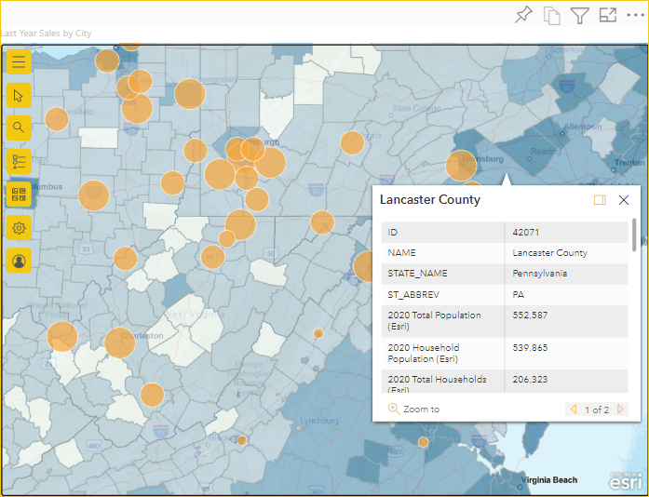

IMG: sales_Lancaster_mapArcgis.png

You might use this demographic data layer to demonstrate consumer spending patterns, select the optimal site for your next store location, make product advertising decisions, project marketing trends, and much more.

**Tip** To learn more about ArcGIS for Power BI, explore [ArcGIS for Power BI maps](https://doc.arcgis.com/en/maps-for-powerbi/use/explore-maps.htm), visit [Esri's ArcGIS for Power BI page](https://www.esri.com/powerbi) for examples and testimonials, and see [Esri’s ArcGIS for Power BI online](https://doc.arcgis.com/en/maps-for-powerbi/get-started/about-maps-for-power-bi.htm) help for training and documentation.

## User consent

ArcGIS for Power BI is provided by [Esri](https://www.esri.com). Your use of ArcGIS for Power BI is subject to Esri's [terms](https://go.microsoft.com/fwlink/?LinkID=826322) and [privacy policy](https://go.microsoft.com/fwlink/?LinkID=826323). The first time a colleague shares an ArcGIS map with you, Power BI may display a User consent prompt; you must accept the terms on the consent dialog box. This dialog box appears only the first time you use ArcGIS for Power BI.

## Interact with an ArcGIS map

The features available to you depend on whether you are the *report designer* (person who made the map) or the *consumer* (someone shared an ArcGIS map with you). If you are interacting with an ArcGIS map as a *consumer* (also known as [Reading view](https://docs.microsoft.com/en-us/power-bi/consumer/end-user-reading-view)), here are the actions available to you:

|  |  |  |
| --- | --- | --- |
| **Action** | **Premium Consumer (with view permissions)** | **Power BI Pro Consumer** |
| [View the data used to create the visualization](https://docs.microsoft.com/en-us/power-bi/consumer/end-user-show-data) | ✓ | ✓ |
| [Subscribe](https://docs.microsoft.com/en-us/power-bi/consumer/end-user-subscribe) | ✓ | ✓ |
| See the map in [focus mode and full screen mode](https://docs.microsoft.com/en-us/power-bi/consumer/end-user-focus) | ✓ | ✓ |
| [View related content](https://docs.microsoft.com/en-us/power-bi/consumer/end-user-related) | ✓ | ✓ |
| [Interact with the filters](https://docs.microsoft.com/en-us/power-bi/consumer/end-user-report-filter) set by the report designer | ✓ | ✓ |
| [Share the report](https://docs.microsoft.com/en-us/power-bi/collaborate-share/service-share-reports) | ✓ | ✓ |
| [Export the underlying data](https://docs.microsoft.com/en-us/power-bi/visuals/power-bi-visualization-export-data) | **—** | ✓ |
| [Get usage metrics](https://docs.microsoft.com/en-us/power-bi/collaborate-share/service-usage-metrics) | **—** | ✓ |
| Save a copy | **—** | ✓ |
| [Publish to the Web](https://docs.microsoft.com/en-us/power-bi/collaborate-share/service-publish-to-web) | **—** | ✓ |

## Navigate a map

When you first open an ArcGIS for Power BI map visualization in *consumer*—or Reading—view, the **Map tools** button is typically collapsed.

1. Click the **Map tools** button Map tools to expand the tools.

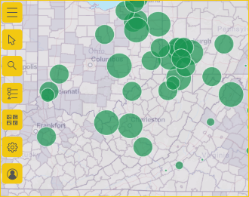

Img: expanded_mapTools.png

The **Map tools** expand to show the available features. When selected, each feature opens a task pane that provides detailed options.

**Tip** **Esri** provides [comprehensive documentation](https://go.microsoft.com/fwlink/?LinkID=828772) about using **ArcGIS for Power BI**.

### Select locations

You can choose from several tools to select locations on the map. When the map contains more than one layer, you can choose which layer is active to change the available selection tools for that layer.

To display the selection tools, follow these steps:

1. Click to expand the **Map tools** Map tools, if necessary, and click the **Selection tools** button Selection tools icon to open the **Select features** pane.

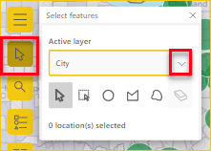

Img: selection_tools.png

1. Select the **Active layer**, if necessary.

There are several selection tools; the tools available in the **Selection tools** menu vary depending on the type of layer that is currently active.

| **Tool** | **Description** |
| --- | --- |
| **Single select** Select a single location on the map | * This is the default selection tool. * With this tool active, click a feature to select it. * Press **Ctrl**+ **click** to add or remove multiple features one at a time. * When this tool is active, you can click data features on the map to select them and trigger interactions with other visualizations. * When this tool is active, you can click a pin or a feature on a reference layer to display its tooltip. |
| **Select by rectangle** Select multiple locations on the map (rectangle) | * With this tool active, place the cursor on the map and drag a rectangle to include multiple features within the drawn rectangle. * Press **Ctrl** + **drag** to add or remove multiple features from the current selection. * When this tool is active, you cannot pan the map. * Press **Esc** to cancel drawing and pan the map. * To resume selecting, click a selection tool. |
| **Select by circle** Select multiple locations on a map (circle) | * With this tool active, place the cursor on the map to set the focus (center) point from which the circle starts and include multiple features within the circle. * Press **Ctrl** + **drag** to add or remove multiple features from the current selection. * When this tool is active, you cannot pan the map. * Press **Esc** to cancel drawing and pan the map. * To resume selecting, click a selection tool. |
| **Select by polygon** Select multiple locations on a map (polygon) | * With this tool active, begin drawing the points of a polygon on the map. * Double-click to stop drawing and complete the polygon; all features within the boundaries of the polygon are selected.   **Note** A minimum of three vertices are required to draw a polygon.   * Optionally, press **Ctrl** while drawing to enable snapping. * Press **Esc** to cancel drawing. * To resume selecting, click a selection tool. |
| **Select by freehand polygon** Select multiple locations on the map (freehand polygon) | * With this tool active, drag a freehand shape on the map to select features within that shape. * Press **Ctrl** + **drag** to add or remove multiple features from the current selection. * When this tool is active, you cannot pan the map. * Release the mouse (cursor) or press **Esc** to stop drawing and pan the map. * To resume selecting, click a selection tool. |
| **Reference layer select** Select using a reference layer | Visible only if there is a reference layer on the map and the reference layer is the **Active layer**. Select features by clicking areas on the reference layer. Features that are within a delimited area on a reference layer are highlighted; features in other areas of the map are unavailable.  For more information about reference layers, visit the [ArcGIS for Power BI help](https://doc.arcgis.com/en/power-bi/use/work-with-map-layers.htm). |
| **Drive-time select** Select using a drive-time layer | Visible if there is a search area layer (buffer or drive-time area) on the map and the search area layer is the **Active layer**. This tool is used to select data features within the defined area.  For more information about buffer or drive-time areas, visit the [ArcGIS for Power BI help](https://doc.arcgis.com/en/power-bi/design/find-nearby-locations.htm). |
| **Clear selection** Clear all selections from the map (eraser) | This tool clears all selections; it is only active after selections have been made on the map. |

1. Select one or more locations or features on the map.

You can select a maximum of 250 data points at a time.

For more information about selection tools, visit the [ArcGIS for Power BI help](https://doc.arcgis.com/en/power-bi/use/select-features-on-the-map.htm).

### Pin a location

Pin a specific address, place, or point of interest on the map. For this tutorial, you’ll search for the Washington Monument.

To pin a location, follow these steps:

1. Click to expand the **Map tools** Map tools, if necessary, and click the **Search** button Search icon to open the **Search** pane.
2. Type the keywords Washington Monument in the search field.

Keywords can include an address, place, or point of interest. As you type, similar recent searches or suggestions based on similar keywords appear.

1. From the results list, choose **Washington Monument, 2 15th St NW, Washington DC 20024 USA** and click **Close** close button.

A symbol appears on the map, and the map automatically zooms to the location, pinning it for the duration of your session. Pins remain in place on the map only during the current session; you cannot save a pinned location with the map.

For more information about pinning a location, visit the [ArcGIS for Power BI help](https://doc.arcgis.com/en/power-bi/use/pin-locations.htm).

### View, show, or hide layers

As a report *consumer*, you can show or hide a layer, change the sequence in which a layer is shown, and zoom to a layer’s data boundaries, provided the *report designer* has not locked the map’s extent.

To view your map’s layers, follow these steps:

1. Click to expand the **Map tools** Map tools, if necessary, and click the **Layers** button Layers icon to open the **Layers** pane.
   * To hide a layer, click the **hide** button Hide layer button; to show a hidden layer, click the **show** button Show a hidden layer button.
   * To change the sequence in which a layer is shown on the map, for example, to display a Demographic reference layer on top of the data layer, drag the reference layer to the top of the list of layers in the **Layers** pane.
   * To zoom to the extent of the layer’s data boundaries, click the **more options** button Layer options and click **Zoom to layer** zoom to layer button.

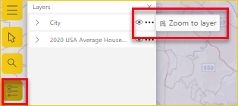

IMG: zoom_to_layer_image.png

**Note** If the *report designer* has locked the map’s extent, **Zoom to layer** will be unavailable.

You can also use the **Filters** pane to filter layer content on your ArcGIS for Power BI map based on the available data added by the *report designer*.

For more information about working with layers, visit the [ArcGIS for Power BI help](https://doc.arcgis.com/en/power-bi/use/work-with-map-layers.htm).

#### Filter map layers

The **Filters** pane contains data added by the *report designer*.

To filter your map content, do the following:

1. Expand the **Filters** pane to the right of the map visualization.

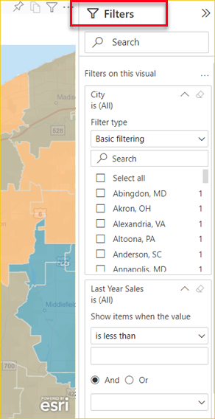

IMG: filters_menu.png

1. Select items based on what is available from the *report designer*. You can choose **Basic filtering**, to choose from data shown on the map, or **Advanced filtering**, to narrow content by specific parameters.

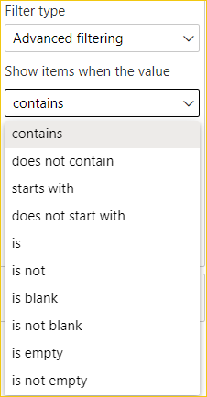

IMG: advanced_filtering.png

1. You can also filter specific measure metrics by Boolean or value parameters when these are available.

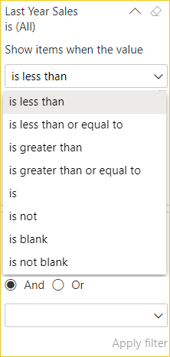

IMG: boolean_parameters.png

1. When you have selected your filter options, click **Apply filter**.

The map is filtered by your selections.

### Change the basemap

A basemap provides a background, or visual context, for the data in a map. For example, a basemap showing streets can provide context for address data. As a *report consumer*, four basemaps are provided to you: Dark Gray Canvas, Light Gray Canvas, OpenStreetMap, and Streets.

**Note** The *report designer* must have made basemaps available to you when designing the report. When unavailable, you will not see the **Basemap** button Basemap tools icon in the Map tools.

To change the basemap, follow these steps:

1. Click to expand the **Map tools** Map tools, if necessary, and click the **Basemap** button Basemap tools icon to display the gallery of available basemaps.
2. Select the **Dark Gray Canvas** basemap.

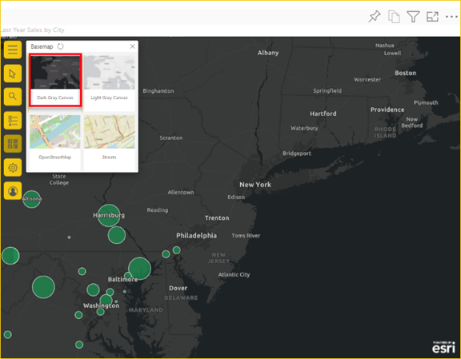

IMG: change_basemap.png

The map updates to the new basemap.

For more information about changing the basemap, visit the [ArcGIS for Power BI help](https://doc.arcgis.com/en/power-bi/use/change-the-basemap.htm).

### Get help

Esri provides comprehensive online documentation for ArcGIS for Power BI.

**To access the ArcGIS for Power BI online help from the visualization, follow these steps:**

1. Click to expand the **Map tools** Map tools, if necessary, and click the **Settings** button Settings tool icon.
2. In the **Settings** pane, click the **Help** button.

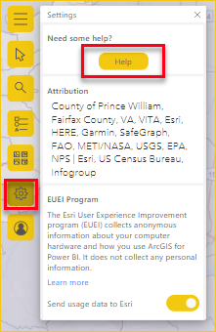

IMG: settings_help.png

1. Click **OK** in the confirmation window that appears.

The ArcGIS for Power BI online help opens in a browser window.

From here you can do the following:

* Find answers to [frequently asked questions](https://doc.arcgis.com/en/power-bi/get-started/pbi-faq.htm) about ArcGIS for Power BI.
* Ask questions, find the latest information, report issues, and find answers on the Power BI [community thread related to **ArcGIS for Power BI**](https://community.powerbi.com/t5/Desktop/ArcGIS-Maps-for-Power-BI-Preview-Discussion/td-p/72947).
* Give a suggestion for an improvement by submitting it to the [Power BI Ideas list](https://ideas.powerbi.com/).

On the **Settings** pane, you can also view attribution for your map, read about the [Esri EUEI (End User Experience) program](https://doc.arcgis.com/en/power-bi/get-started/euei-program.htm), and turn **Send usage data to Esri** on or off.

### Use Tooltips

If the map has a reference layer, select a location to display its details in a [tooltip](https://doc.arcgis.com/en/power-bi/use/view-tooltips-consumers.htm). The example below shows a tooltip for the Cleveland, Ohio, 2020 Total Population broken down by five-year age increments added to the map by this *report designer*.

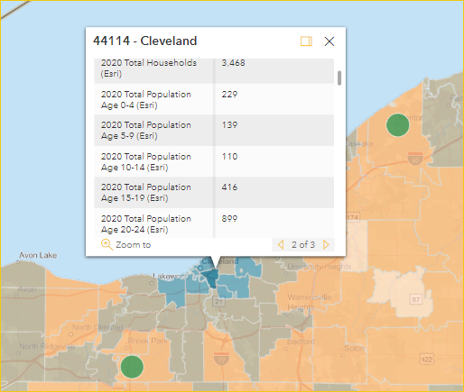

IMG: Cleveland_Demographics.png

Hover your pointer over basemap location symbols to display details in a tooltip.

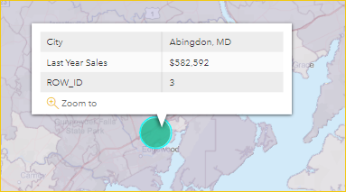

IMG: abingdonSalesTooltip.png

**Tip** You may have to zoom in to select a specific location. If there are overlapping locations, Power BI will present you with more than one tooltip at a time. Select the arrows to move between the tooltips.

IMG: tooltip_multiple.png

### Use infographics

If the *report designer* added an [Infographics layer](https://doc.arcgis.com/en/power-bi/use/view-infographics-consumer.htm) to the ArcGIS map, you will see additional data displayed in the upper right corner of the map. For example, here the *report designer* added 2021 Median Household Income.

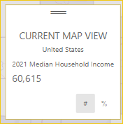

IMG: infographic_medianHH.png

## Considerations and limitations

ArcGIS for Power BI is available in the following services and applications:

| Service/Application | Availability |
| --- | --- |
| Power BI Desktop | Yes |
| Power BI service (powerbi.com) | Yes |
| Power BI mobile applications* | Yes |
| Power BI publish to web | Yes, for designers signed in to a valid, licensed [ArcGIS account](https://doc.arcgis.com/en/power-bi/use/sign-in-to-arcgis.htm) |
| Power BI Embedded | Yes, for designers signed in to a valid, licensed [ArcGIS account](https://doc.arcgis.com/en/power-bi/use/sign-in-to-arcgis.htm) |
| Power BI service embedding (powerbi.com) | No |
| Power BI Report Server | Yes, when signed in to a valid ArcGIS Enterprise account through Report Server (online environment only); not supported in a disconnected environment or with ArcGIS Online.  Accessing Report Server with ArcGIS for Power BI consumes ArcGIS credits; for more information about credits, visit [Understand credits](https://doc.arcgis.com/en/arcgis-online/administer/credits.htm). |

*In mobile environments, you can view maps created using the ArcGIS for Power BI visualization included with Power BI ([Standard account](https://docstg.arcgis.com/en/maps-for-powerbi/get-started/account-types.htm)). Maps that contain premium content from ArcGIS are not supported in mobile environments.

In services or applications for which ArcGIS for Power BI is not available, ArcGIS visualizations will show as an empty visual with the Power BI logo.

## **FAQ**

**How does ArcGIS for Power BI work with Power BI data?**

ArcGIS for Power BI is provided by [Esri](http://www.esri.com); see the User consent section of this document. When you provide your consent, any data you use that is connected to the map visualization is sent to Esri’s services for geocoding, meaning location information is transformed into latitude and longitude coordinates that can be represented in a map. Through ArcGIS for Power BI, Esri provides a number of services to enrich your data, including basemaps, spatial analytics, location services, demographic data, and other authoritative data layers. ArcGIS for Power BI interacts with Power BI using an SSL connection protected by a certificate that is provided and maintained by Esri. See Esri’s [ArcGIS for Power BI product page](https://www.esri.com/powerbi) for additional information about ArcGIS Map for Power BI.

**What is an ArcGIS account?**

Esri offers an Esri [ArcGIS account](https://www.esri.com/en-us/arcgis/products/arcgis-for-power-bi/buy) through ArcGIS for Power BI. Adding an ArcGIS account to Power BI can greatly enhance your mapping visualization capabilities by adding an extensive library of data reference layers and geoenrichment.

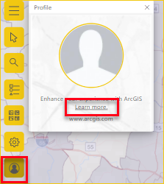

IMG: sign-up.png

Power BI does not send personal information about you to Esri; this is a separate relationship with a third-party vendor. Once you add ArcGIS account content to your ArcGIS for Power BI visualization, you will have access to all the Esri content and data associated with your account, role, and organization. Any other Power BI user with whom you share that data—whether within your organization or the public—may also need an ArcGIS account to view shared, potentially licensed content. For details about account types and data limitations, visit the [ArcGIS for Power BI online help](https://doc.arcgis.com/en/maps-for-powerbi/get-started/account-types.htm).

For technical or detailed questions about ArcGIS for Power BI, see [Esri’s ArcGIS for Power BI online](https://doc.arcgis.com/en/maps-for-powerbi/get-started/about-maps-for-power-bi.htm) help or reach out to Esri [Technical Support](https://www.esri.com/en-us/contact#c=us&t=5).

The following table compares the standard features available to all Power BI users to those available to users signed in to a valid, licensed [ArcGIS account](https://doc.arcgis.com/en/power-bi/use/sign-in-to-arcgis.htm):

| **Feature** | **Standard Microsoft Licensed User Standard (included with Power BI)** | **Sign in to ArcGIS Online Sign in to ArcGIS Enterprise With your ArcGIS account** |
| --- | --- | --- |
| **Basemaps** | 4 basic basemaps | All Esri basemaps; access to your organization's basemaps, includes any custom basemaps |
| **Geocoding** | 3,500 locations per map | 10,000 locations per map |
| 10,000 locations per month | No monthly limit |
| **Reference layers** | 10 curated reference layers that contain U.S. demographic data | Access to all global web maps and layers as defined by your ArcGIS organization/account; includes access to [ArcGIS Living Atlas of the World](https://livingatlas.arcgis.com/en/home/) maps and layers (feature services) |
| Publicly shared feature layers in ArcGIS | Publicly shared feature layers in ArcGIS |
| **Infographics** | A curated gallery of U.S. demographic data variables | Access to all global demographic data variables as defined by your ArcGIS organization/account; includes access to the ArcGIS GeoEnrichment data browser |
| A maximum of two variables | A maximum of five variables |
| Support for **Drive Time** and **Radius** settings | Support for all distance and travel settings |

**The ArcGIS map is not showing up**

If you are a *report consumer* and do not have the correct permissions or are using services or applications for which ArcGIS for Power BI is unavailable, the visualization will show as empty with the Power BI logo.

**I'm not seeing all my information on the map**

When geocoding latitude-longitude on a map, you can display up to 30,000 data points. When geocoding data points such as ZIP codes or street addresses, you can geocode up to the first 15,000 data points. Place-names and countries are not subject to the 15,000 data point geocoding limit.

**Is there a charge for using ArcGIS for Power BI?**

ArcGIS for Power BI is available to all Power BI users at no additional cost. It is a component provided by [Esri](https://www.esri.com/) and your use is subject to its terms and privacy policy; see User consent. If you sign up for an Esri [ArcGIS account](https://doc.arcgis.com/en/power-bi/use/sign-in-to-arcgis.htm), there are costs associated; visit the [ArcGIS for Power BI online help](https://doc.arcgis.com/en/maps-for-powerbi/get-started/account-types.htm) for details.

**Can I view my ArcGIS maps offline?**

No, Power BI needs network connectivity to display the maps.

## Next steps

* **Help:** **Esri**provides [comprehensive documentation](https://go.microsoft.com/fwlink/?LinkID=828772) about the **ArcGIS for Power BI feature set**.
* **Community thread:** You can ask questions, find the latest information, report issues, and find answers on the Power BI [community thread related to ArcGIS for Power BI](https://community.powerbi.com/t5/Desktop/ArcGIS-Maps-for-Power-BI-Preview-Discussion/td-p/72947).
* **Product information:** See the [Esri ArcGIS for Power BI product page](https://www.esri.com/powerbi).