**UI Evaluation Group 6**

For our evaluation we have decided to use the Observational Studies approach. The reason we are using this approach over because this way we can watch the users use the information gathered from watching them to analyse our UI. Also, if the user is stuck, we can take note of that and if they ask any questions, we are there to help them too. Once we finish observing the users, we are then in the same room to ask the user questions about the UI. This way we can get a range of different results both from what we can see when the user is using the program as well as being able to get more specific results for when we talk to the user at the end.

For our evaluation we will be evaluating 3 things. How easy is it for users to access visualised data on both the staff and patient side, how easy the UI is to navigate overall and is the UI easily understandable. There are a range of methods we are going to use. Such as Creating tasks for them, timing the user, counting errors and asking the user questions based on what we’re evaluating such as how easy the UI was to use and what could be changed. This way we can get a range of results.

To test how easy is it for users to access visualised data on both the staff and patient side we will be doing a very similar thing throughout the application. First, we will be starting with the patient’s side of the application and set them up a few simple tasks for them to complete and see how they get on. We still ask the user to first use the watch. From here we will give them the task to find all available data available on the watch. This will be blood pressure, heart rate and steps. While the user is completing these tasks, we will be taking notes on how quickly they can complete these tasks, how many errors they made and how many questions they ask If they’re stuck. Once they have finished the tasks, we will then ask them how easy the data was to find, was the UI clear on a rating 1-10 on how to use it and if there is anything, they would change about the watch

Next, we will give the users the patients APP. Once they load the APP we will first ask the User to login to the APP using a username and password provided by us and then find the 4 pieces of data that are sent from the watch (blood pressure, heart rate, steps and sleep pattern) in a specific order. While this is taking place, we will consider how long it takes for them to do so as well as how many errors are made. Then we will set them the task up uploading data using the remaining links. Again, taking to account how long it takes and how many errors are done. Once they have finished the tasks, we will then ask them how easy the data was to find, was the UI clear on how to use it on a rating 1-10 and if there is anything, they would change about the APP

For this test we will be asking the user to go to the staff side of application and again we will be setting them with Tasks. The first will be asking them to find a specific patient given by using the filters. We will ask them to use 1,2 and 3 filters to find them. We will consider how long it takes them and if they make any errors. Once finished we will Ask them how clear it is to use, how clear the UI is on a rating 1 to 10 and is there anything they’d change.

Finally, we will ask them to find the more specific information about the patient used in the filters. We will time them again on how long it takes to find this as well as any errors. Once the details have been found, such as data from the APP and watch, we will ask the users how easy it was to navigate to, how clear the UI is on a scale of 1 to 10 and if there is anything they would change.

**Plan for evaluation**

**Scope:** UI of Patient Side Watch, UI of Patient Side APP, and the UI of Staff Side System

**Purpose:** To find out how easy is it for users to access visualised data on both the staff and patient side, how easy the UI is to navigate overall and is the UI easily understandable on a scale of 1 – 10. As well as if there are any changes that could be make, to improve the watch. For this watch how, clear it is that you have to swipe to view other information and how clear the information is on those pages to the user. For the APP we are testing how easy it is to use as well as how clear it is to the user on how to add data, and the colour scheme used. For the staff side we will be mainly testing how easy it is to find patients and how clear the patient’s data is.

**Schedule & Location:** Sheffield Hallam University Library, 1pm while 2pm.

**Sessions:** The session will last up to an hour. In this session we will start by loading the application front end one at a time. The user will then evaluate the UI through a series of tasks and questions at the end before moving onto the next UI. At the end we will compare results between users to work out averages and generate results to analyse.

**Equipment:** Equipment we will need for this is a laptop or computer, with nodes.js and react installed, a paper and pen for writing notes depending on questions asked as well as a stopwatch to time the users task completion time.

**Participants:** We will be using 3 general user participants for this test**.** These participants will be asked prior to evaluation so that they are aware or what to expect.

**Scenarios:** We will have 5 timed tasks where we work out how easy and clear the UI’s are to use. We also have 3 scale tasks where we let the users look at the data on screen to test if the data is clear and easy to understand. We will also have a satisfactory task where we ask them to evaluate the UI’s overall using unsatisfactory, satisfactory, more than satisfactory. Most of the test are general usability tests where we are working out if the UI is easy to use where others and more data based. We can also ask the user about the general appeal of the UI what parts they liked and didn’t like. This would be a test for design patterns. Overall we have about 9 tests.

**Subjective Metrics:** On a scale of 1 to ten how clear is it to use, what about the UI testing would you change and how easy is it to navigate, unsatisfactory, satisfactory, more than satisfactory. At the end, overall, how did they feel about the UI.

**Objective Metrics:**  The results from the Subjective questions, how well things went and how much they liked it, as well as how many errors occurred, how long it look to complete the tasks any time a user has had to ask a question.

**Roles:** I will be working with the user asking the questions and generally communicating with the user. Alek will be keeping an eye on the user as well as timing their response.

**Ethical Considerations:**

There are we few factors in this process that could create ethical issues and how we have avoided some. For example, when we demo the program, we have opted to give the users pre-set login details for the APP. This is because we don’t want to be storing people’s personal information in case the user doesn’t want their data being used in this test or in case the data input is used for something else. This would be unethical as it is their personal information and only, they should be able to decide what they do with it. Also, if we were to store their data, we would need it in writing that they are letting us use the information or at the absolute least video proof of the user giving us the permission to use this.

An ethical issue we haven’t considered, and we probably should have taken into account is that it isn’t able to be used by everyone even though it should be. People with colour blindness or who is visual impaired may struggle to use it. If we were to get around this ethical issue, we would need to add a functionality to the system that helped people who are visually impaired. Such as for the colour blind a button that would change the colour scheme or for the visually impaired, maybe a button to change the size of the objects on screen or even voice control.

**Evaluation Report**

After completing the evaluation on our UI a few things were brought to light about not just how our application works but how it looks and how good of a UI the application has. Overall, though looking all the tasks in the evaluation and the evaluation overall was a success. There were very little comments about changes as we worked through the tasks

|  |  |  |  |
| --- | --- | --- | --- |
| **Task 1 - Watch** | **1-3** | **4-7** | **8-10** |
| How easy is it to use? | 0 | 0 | 3 |
| How clear is it to use? | 0 | 0 | 3 |
| How clear was the data available | 0 | 0 | 3 |

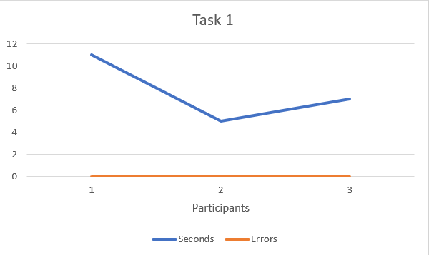

Looking at Task 1 all 3 users were very happy with how it looked, how easy it was to use as well as how clear the data was displayed on the screen. All 3 participants were able to complete this task quite quickly and with no errors at all. All in all, the applications watch interface was very successful. The only comments about this interface was it needed a little more colour and items needed to be bigger.

From this we can clearly see that the UI for the watch is easy to use and all the data available is clear enough for the user to understand or at least be able to access. All the data on screen was clear and understandable.

|  |  |  |  |
| --- | --- | --- | --- |
| **Task 2 – patient app data find** | **1-3** | **4-7** | **8-10** |
| How easy is it to use? | 0 | 0 | 3 |
| How clear is it to use? | 0 | 2 | 1 |
| How clear was the data available | 0 | 0 | 3 |

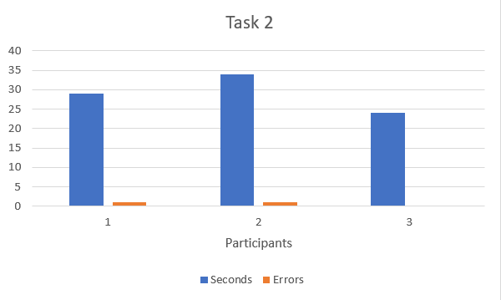

Task 2 looking at the results was also quite successful but not as successful due to the increased numbers of errors and the lower scores on the UI itself. After talking to the participants after the task they all found an issue with telling the difference between heart rate and blood pressure with just the icons we provided. Overall though they were able to complete the task with very little errors and still in quite a reasonable time too. It wasn’t unusable or difficult to use just a little confusing at times or unclear. Again, all the data on screen was clear and understandable.

|  |  |  |  |
| --- | --- | --- | --- |
| **Task 3 – patient app data entry** | **1-3** | **4-7** | **8-10** |
| How easy is it to use? | 0 | 1 | 2 |
| How clear is it to use? | 0 | 1 | 2 |
| How clear was the data available | 0 | 0 | 3 |

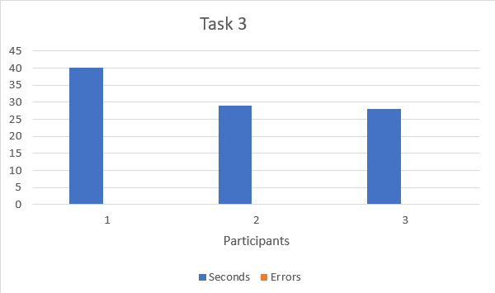

Task 3 was also quite successful to a certain level. Generally, the UI was clear and easy to use but did have a few minor issues with it that cause the user to become a little confused. There weren’t any errors from any of the users, but the speed became longer than we expected due to the confusing with the inputs themselves. This was due to the lack of verification from the input box. So, users were unsure if they had completed the task or not. Again, all the data on screen was clear and understandable.

|  |  |  |  |
| --- | --- | --- | --- |
| **Task 4 – Staff app filters** | **1-3** | **4-7** | **8-10** |
| How easy is it to use? | 0 | 2 | 1 |
| How clear is it to use? | 0 | 3 | 0 |
| How clear was the data available | 0 | 0 | 3 |

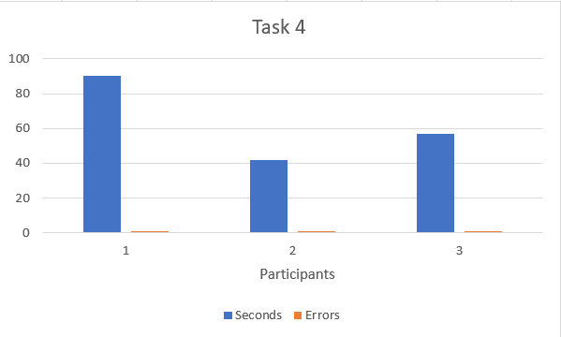

This task was also a success but not as big of a success as the previous tasks due to an issue with how clear the filters were and how they work. Looking at the results all the users made a mistake here with the filters due to a spelling error. This is because the filters needed exact data adding to it instead of something like it. Overall, the filters for the staff weren’t clear how to use because it was unclear If they were filters or how the filters worked. It was also not so easy to use. This was because you must press the filter button again every time a new filter was added instead of it doing this automatically. So, filters were constantly having to be emptied and submitted again to use a different filter. Again, all the data on screen was clear and understandable.

|  |  |  |  |
| --- | --- | --- | --- |
| **Task 5 – Staff app viewing patient data** | **1-3** | **4-7** | **8-10** |
| How easy is it to use? | 0 | 0 | 3 |
| How clear is it to use? | 0 | 0 | 3 |
| How clear was the data available | 0 | 0 | 3 |

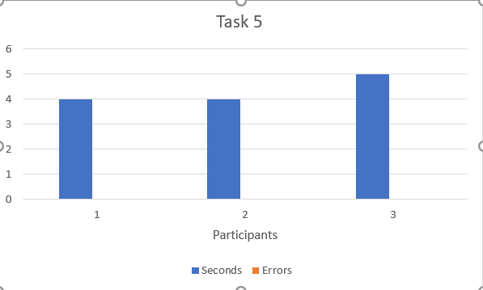

Finally, Task 5. Task 5 was a test for the patient details and how easy they are to access. Looking at the results all 3 users thought finding and viewing these additional details was very easy to complete and very clear on how to do so. Even looking at the users’ time and errors graph you can clearly see that they were all able to do this task quite quickly with literally no errors. The link to the patient details was clear and well positioned so that the user can easily see what the link does. Also, all the data that it displays is very clear as you can tell from ‘how clear the data available’ is. All 3 users thought it was very clear on what the data was and how it was displayed so they could see it and understand it with ease.

Overall, I believe the UI to be a success looking at all the results with the usability of the UI overall being quite clear and quite easy to use and all the data being very clear and easy to understand. A few comments were added on what could be used to help improve the UI and its functionality.

**Re-design suggestions**

During our evaluation we asked the users a few questions to see what could be improved and how it could be done. Some were only minor changes others were slightly more larger suggestions due to the results of how uneasy or how unclear something is.

The first of the changes were those for the patient side of the application. Some of these were simple Ui changes like adding colour to the UI’s others were a little more important as it clears up how to use the UI. The first big re-design change would be to add labels under each symbol on the patient phone app home page as well as on each of their individual pages. The users struggled to tell the difference between heart rate and blood pressure. So, by adding labels to the underneath of each of these icons the user will be able to identify which is which.

Another design change we should add to the UI is verification when something is added in the input page. Now all it does is upload data and not let you know if it uploaded correctly or if there was an error or anything. Nothing visually happens. To fix this we could add a modal to the input box that says if it was successful or not. This way the user will know if the data was uploaded or not, so they know how to respond.

For the staff side of the application there is only really 1 feature we really need to make changes to. First, the filters would need labels adding to them, so the user is able to identify them as filters. This is due to the fact most of the users found the filters part of the staff UI a little unclear. If we add labels into those filters the user would be able to identify what they are.

A smaller UI feature to add to the staff side is on the table displaying all the patients. Add a title for the final column so that the user can identify that, that column is for the links that at the end of the row. Without it the user would have to assume that the link labelled ‘details’ is the more in depth details the user is looking for.