Alternative Gateway

Aleksandar Zoric James Nagle

**Introduction**

As we ran into some difficulties with our last suggested gateway, this is the alternative. The URL link is below where it can be purchased. Keep in mind that you have to contact the seller to make a payment.

I looked at some other sites where they may be selling this gateway but I had no luck with it, therefore this is the only site at the moment where a purchase can be made. Hopefully the site will not lead you to any errors.

Below, you have a couple of images of the gateway and description for a quick review.

**Gateway:**

Our suggestion for the gateway is shown below in figure 1.1.

**Price: US $14 - 22 / Piece**

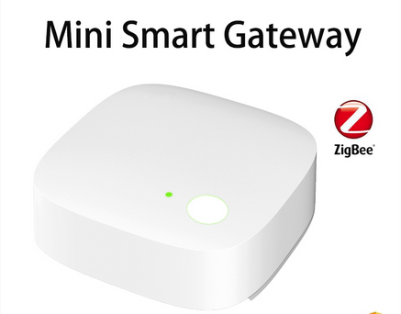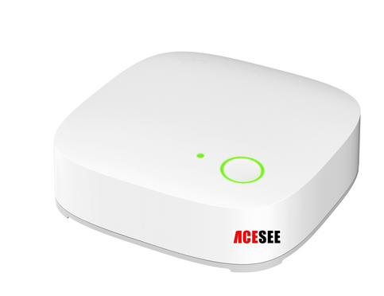

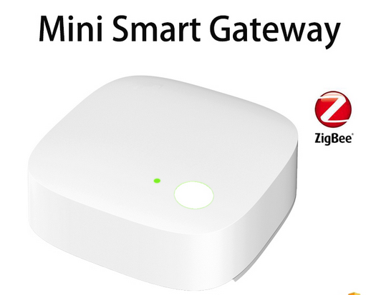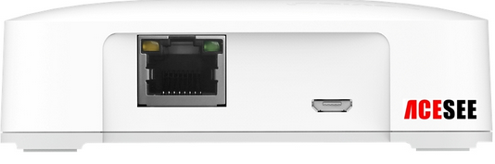

Fig 1.1

**Description:**

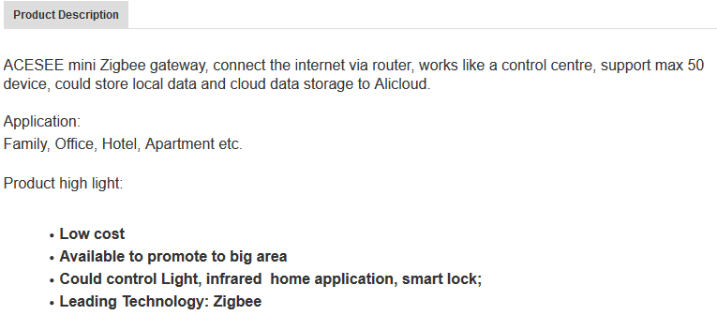

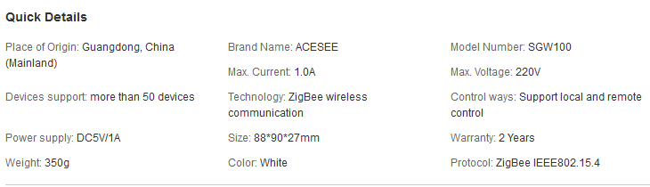

Fig 1.2

***URL for the above gateway:***

http://gzacesee.en.alibaba.com/product/60380510118-802548445/ACESEE_Zigbee_home_automation_mini_smart_gateway_smart_home_product.html