Cheaper Solution to Gateway and use of Kii Cloud Service

Aleksandar Zoric James Nagle

**Introduction/Given Task**

From our last discussion, the task was to find a cheaper solution purchasing a gateway. The iDigi cloud kit we first suggested was a little too expensive and included items that we did not need.

So, we have been doing some thinking, researching and thought that, if our adapters are being shipped from China (*the adapters we were given to inspect*), why not get a gateway also shipped from there? It is cheaper and we can purchase the gateways in bulk if needed.

After searching through a few sites, we managed to get 5 different gateways ranging price from $20 to $80. After some more insight into these gateways we have realized that there was not much difference between the $20 and the $80 gateway.

**Gateway 1:**

Our suggestion for the gateway is shown below in figure 1.1.

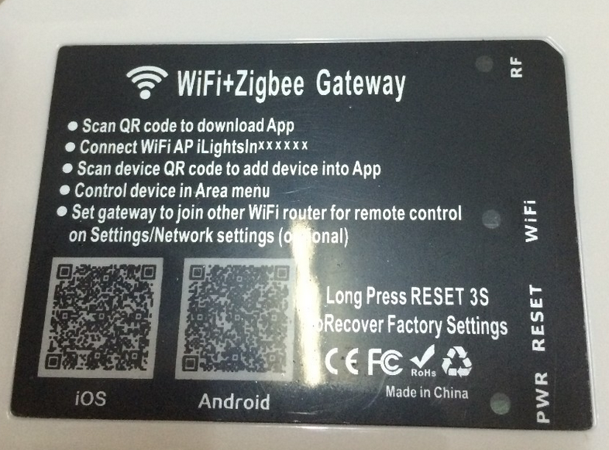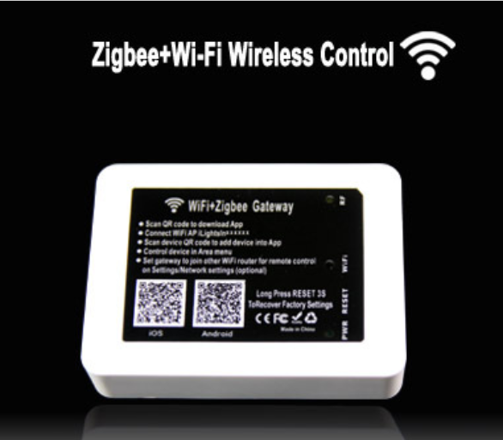 Fig 1.1

***URL for the above gateway:***

http://www.aliexpress.com/item/E-LINK-for-control-Zigbee-lighting-equipment-and-the-development-of-a-gateway-for-smart-bulb/32356310157.html?spm=2114.30010308.3.41.bq2ejk&ws_ab_test=searchweb201556_6,searchweb201644_2_505_506_503_504_9911_502_10001_10002_10017_10010_10005_10011_10006_10003_10004_10009_10008,searchweb201560_2,searchweb1451318400_-1,searchweb1451318411_6449&btsid=565dde9e-3cb3-4b06-bc20-6269e2d9c4fc

The gateway shown if fig 1.1 is (US) $32 per piece, and 5% cheaper if bought in bulk per piece. We believe this gateway would work for the intended project. Of course, there is much more information regarding this gateway on the website if you wish to view. (URL above).

**Gateway 2:**

Our second suggestion for the gateway is shown below in figure 1.2.

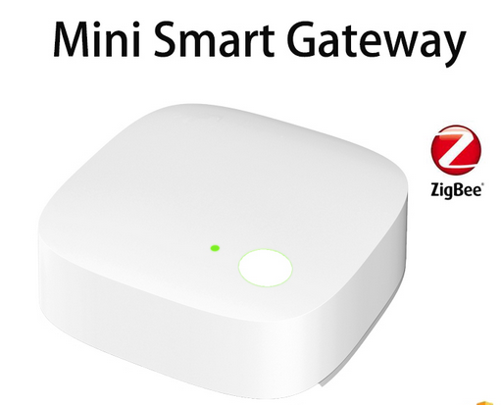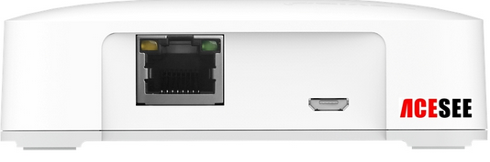

Fig 1.2

The gateway shown in Fig 1.2 is even cheaper than our previous suggestion, at only (US) $18 per piece but with this gateway, we can only purchase in bulk, 1000 pieces minimum.

In terms of features between the two gateways, there is not much difference. Of course you can visit both URL’s and decide for yourself if you prefer. The only difference I can see between the two is the max number of nodes and the distance it can control.

***URL for the above gateway:***

http://www.alibaba.com/product-detail/ACESEE-new-products-smart-home-automation_60376647114.html

**Kii Cloud Service (Keith’s Suggestion)**

We have looked at Keith’s suggestion regarding the Kii cloud service and we defiantly agree that we could use this service. We went through the website to try and find out as much information as possible, there are a lot of features/services that they provide such as analytic tools, but we would not need all of them, if any other than the cloud service.

**Conclusion**

There is not much we can say anymore regarding the Kii Cloud, other than it being able to correspond with our gateway suggestions above, we do not see why it should not, but a second look is no harm of course. The gateway from iDigi being around (US) $140 per kit; the two gateways above, if compatible for our project, are much cheaper than that and the cheapest we found.

If possible, we would like if Keith or someone with high knowledge regarding gateway products could take a quick look at the two gateway suggestions and confirm compatibility for the intended project, in simple terms, would those gateways work for what we need it for?

Kind Regards,

*Aleksandar Zoric, James Nagle*