Updated Prototype

**Introduction**

This document contains the updated design and features prototype for the intended application.

\**Keep in mind that this prototype might change as we proceed with the design and planning stage.*

I will explain what features are enabled on each screen for the user to interact with and how this prototype is a little different than the previous.

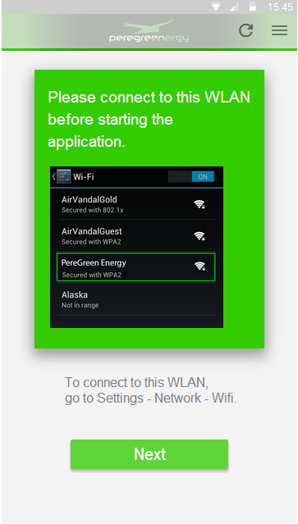

This is the very first thing the user will see when the application opens. This screen contains information that asks the user to connect to the WLAN (Gateway). It also contains a ‘Next’ button which will explain what to do after the user has connected to the WLAN.

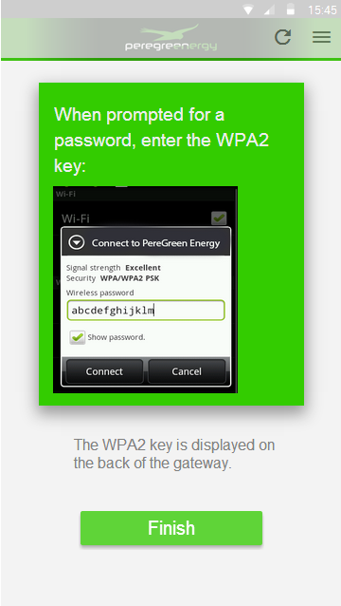

Once the ‘Next’ button is clicked on the previous page, this screen will appear. This screen asks the users to enter the password (WPA-2) in order to connect to the WLAN and where this password is located.

*After some research, this method of connecting to the WLAN is very popular. Most similar application I have researched use this approach.*

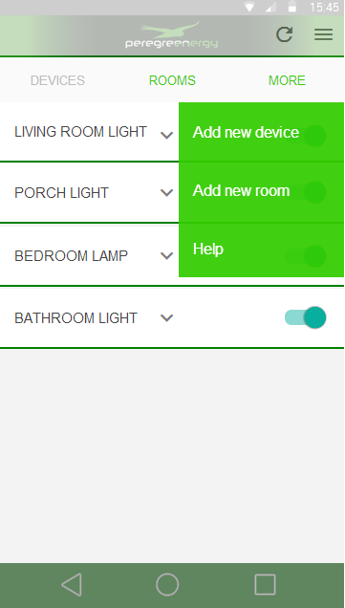

On our previous prototype, we did not have this option, to add a new device or create a group of devices (Rooms). For the user to see these options, they must first click the ‘More’ button which will then display a drop down menu as shown above.

This is very simple for the user to get used to and why I chose to use this method. Like mentioned earlier, it is also common to use this method to add new devices among other application that are similar.

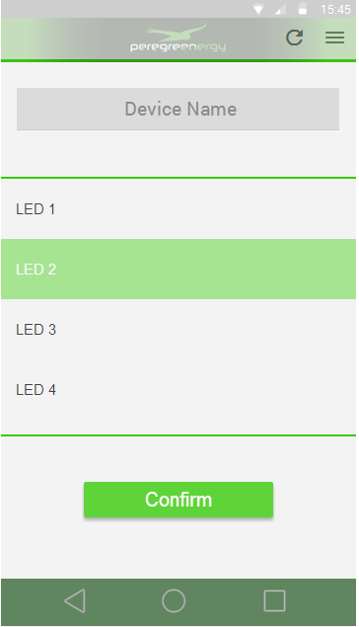

So if we decide to add a new device, this is the screen we will see. I wanted to go with a very simple design where there is no need to explain what each design element is to the user and I believe this captures that.

We have the option to name the device at the very top and click on one of the devices, which will then be highlighted to indicate what device is going to be added, once the ‘Confirm’ button is clicked the device will be added and the user will be able to interact with it.

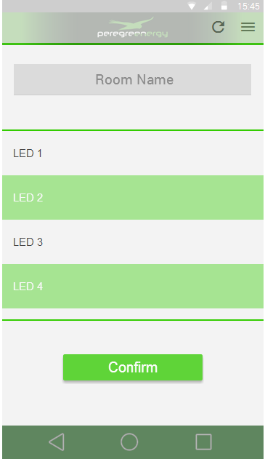

This screen will display if we wish to a group of devices, ‘Rooms’ as I call them. Like previously, we have the option the name the room and default names of the devices will be displayed below, except here we can click on multiple devices which will then be highlighted indicating that this is the devices that will be added to this ‘Room’. Once the ‘Confirm’ button is clicked, the room will be created and the devices will be added.

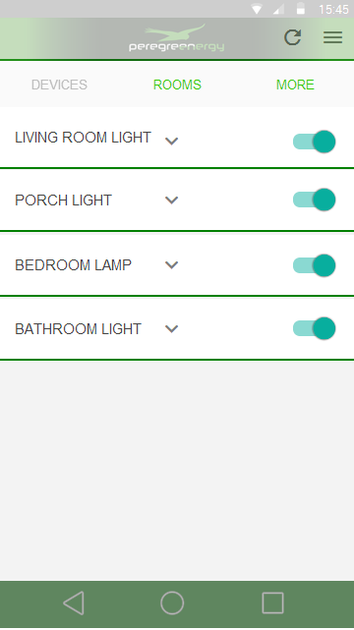

Once the user has added a few devices, they will be displayed as such. And by once click of a button (On the right of the name) it will turn on or off the light.

We can also see the drop down arrow which indicates that there is more options to be viewed or interacted with.

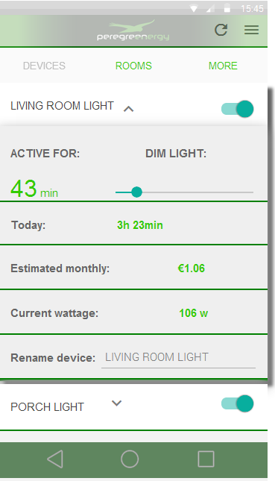

And this is what we see if we click the drop down menu. It contains a lot of useful information for the user and from here, we can also rename the device to whatever we want.

You can see the information part of the application is displayed so that the list of devices are in the background, this is the impression I want to give to the users.

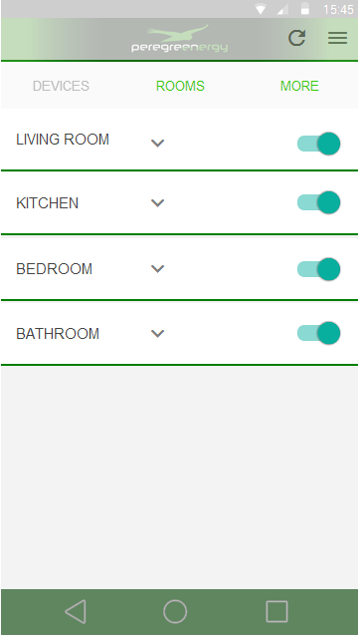

This screen will display when the ‘Rooms’ button in the tab above is clicked, it displays a list of all rooms created. With the click of a button on the right, we can turn on or off all the lights in that rooms.

Also, we have a drop down arrow here indicating that there is more information to be viewed and for the user to interact with.

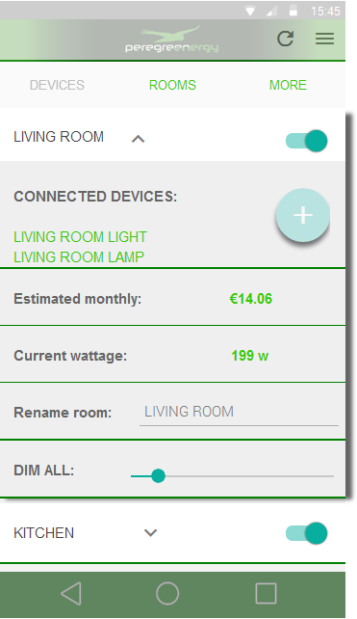

This screen will be displayed if the user clicks the drop down arrow, it contains some useful information like all the connected devices, and it gives us the option to rename the room to something else. We can also dim all the lights in that room if we wish.

The plus icon next to the ‘Connected Devices’ is to add a new device to the room.

**Conclusion**

As you can see in this prototype, the colour scheme has changed and a few new features were added.

I have researched a few applications that are similar to what we intend to do and they all had similar approaches to design like displayed above. It is best to be consistent and design an application based on what the users are already used to, and I believe this prototype captures that.

Of course, once we start designing this prototype in code, some design elements may change e.g. the android buttons to turn on or off the lights could be updated to some new design which could look a little different but have the same abilities.

The colour scheme for the titles and some background, I have got these from the document I was emailed sometime at the beginning when we started working on this project.

Now, I am not sure if you are aware, but the very bottom bar of each page, the dark green bar that has the basic android options, this is only a design ‘placement’ I have inserted just for displaying purposes. This could be different depending on the users theme on their android device.