App Prototype Design

Aleksandar Zoric James Nagle

**Introduction**

This is only a prototype design for the app. Not the *final* design.

We will use this prototype to discuss some design elements e.g.

* Colour scheme
* What features to include and what not to include
* Button design/slider design
* Logo/size
* Font/size

Etc.

*Before we decide to start any coding, we need to all agree on the design of the app.*

We would add other screens to the app, which are not included in the prototype below. This prototype is only a demonstration so that we could see all the design features and elements and agree on them.

* *Please note in the prototype images, where ‘PereGreen Energy’ is written at the very top, this is only for demonstration purposes. We would change this to the actual logo.*

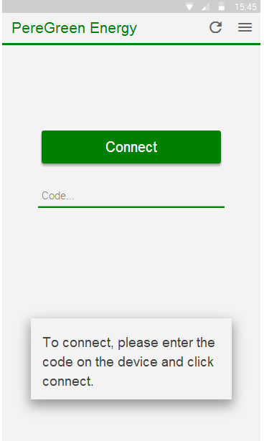 Fig 1.1

This is the screen the user would first see when he/she has purchased the product for the very first time. By ‘code’ I mean some type of authentication, just so that the user can register their app with the physical hardware. This is due to change as we still need to discuss some security issues.

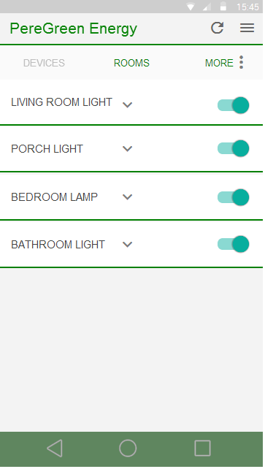 Fig 1.2

This is the main screen for all the connected devices. From here the user can switch off any light by using the toggle button on the right or, hit the drop down arrow next to the device name which would open some information related to that device. Shown in the next image.

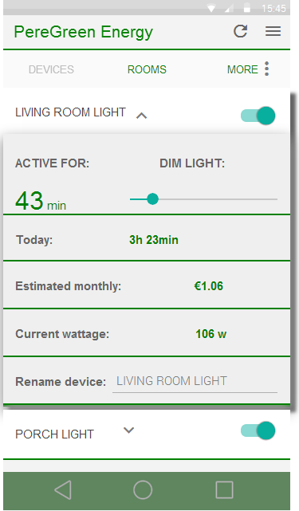Fig 1.3

This screen appears when the user hit the drop down arrow on the previous image. From here we can dim our light, would could rename the device and we could see all necessary information shown above which is useful to the user.

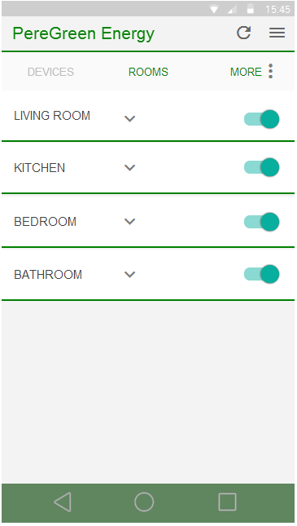 Fig 1.4

This screen shows all the rooms in a household, each room has multiple devices which the user can control as a whole. If toggle button on the right is clicked, this would turn off all lights in that room. And as previously, if the drop down button is hit, additional information is displayed regarding that room. Shown below.

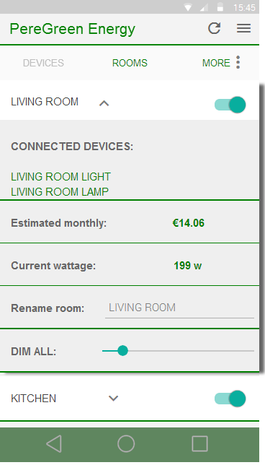 Fig 1.5

Here we can see all the connected devices in a specific room, we can dim all the lights in a room or rename the room to something else. We also have some useful information for the user which is shown above.

**Conclusion**

If you have not realized yet, but currently in the prototype we do not have a screen that shows how each device or room would be added/created. This is something small and we will think about how we would implement it and discuss it with everybody once decided.

Also keep in mind that this prototype displayed just some basic features that we tend to add. After some research on similar apps, they all had the above features in common.

Also we are aware that the PIR sensor and similar are implemented in the hardware and we tend to add functions for these sensors in the software as soon as we can, but we need to design an app first that has all the basic/simple features first, then we can worry about the PIR sensor and such.

Kind Regards,

*Aleksandar Zoric, James Nagle*