Network Topology Suggestion

Aleksandar Zoric James Nagle

**Research Introduction**

After some intensive research, I believe we have come to a solution which would work. On our last meeting, we have talked about a possible solution by implementing a gateway which would enable us to send and receive data to and from the cloud/server.

*Digi* *International*, a company that manufactures Zigbee enabled devices, modules etc. was a part of our research. Here we have looked at something called ‘XBee Zigbee Cloud Kit’. We have concentrated our research on this kit to see if it has the features and the ability to achieve what we intend to with this project, and we believe it does.

This kit once purchased includes:

* (1) XBee ZigBee Module
* (1) XBee USB Development Board w/ Breadboard
* (1) XBee Gateway - ZigBee
* Package of components including resistors, relay, buttons, and LEDs
* Access to our cloud-based application, designed specifically for the XBee ZigBee Cloud Kit
* All necessary antennas, power supplies, and cables

A simple network topology that this company, *Digi* *International*, used as an example is as follows:

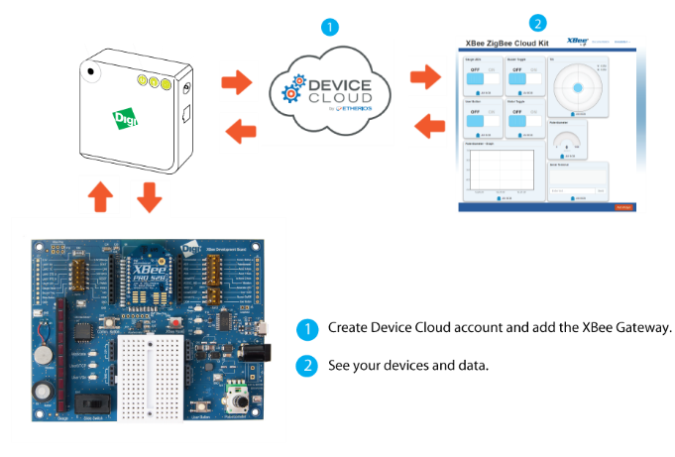*Fig 1.1*

**Suggestion**

In the above example, *Digi* *International* displayed the steps how this cloud kit works e.g. XBee Development board > Gateway > Cloud and also in the opposite direction.

Now, we have ran into a difficult question being: ‘Can we use this already existing kit to connect up to our own custom built server?’ We thought you may have an answer or solution to this.

So our network topology would look something like this:

*Fig 1.2*

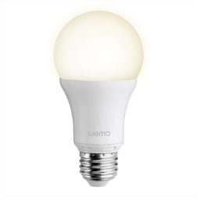 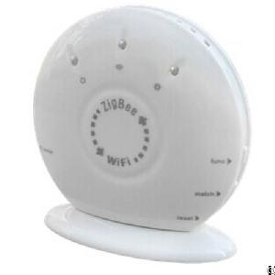 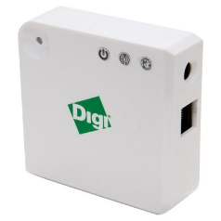

**Adapter Master Gateway Cloud**

*Points Considered:*

* So we would have a cloud service where the user creates a new account and enters the gateway mac address, name and description and connects the devices (Master). Once everything is connected, it would display a *dashboard* where the user can interact with the adapters e.g. turn LED lights on/off, dim at 40% etc.
* Basically, the user would be opening a webpage and one main advantage of this is that it can be opened on any device (Desktop, phone, tablet) regardless of its platform, as long as it is connected to the internet.
* In Fig 1.1, a change on the server can be picked up by the development board included, so if have the dashboard on our phone, click to turn off a light, this will be transmitted to the Zigbee device (Master).
* By having a small widget on the users phone, tablet or desktop, once clicked it would re-direct them to the dashboard (Webpage). By having this feature we would also eliminate the thought of limiting other devices. E.g. if we build a Zigbee module for a vehicle, we can build a corresponding widget for our cloud service.
* Also, implementation of an emergency protocol is recommended, if the internet on the premises is disabled for some reason, the users’ device (e.g. phone) would directly connect to the gateway.

**Conclusion:**

After a short discussion, we have debated on, do we build our own gateway or use the *Digi*

*International* supplied gateway.

*Few Suggestions to be considered are as follows:*

We can create a device cloud widget, sell the adapters and let the users’ purchase the cloud kit, then they would sign up for the cloud service, install the widget an begin interacting with the adapters via the dashboard.

Or we can build a gateway rather than purchasing it, build a cloud service, and we will also have the corresponding widget.