|  |  |  |
| --- | --- | --- |
| Project Team |  |  |
| Rozalina Miladinova 3285588  Aleksandar Georgiev 3229742  Nidhi Sharma 3233006  Nguyen Bao Quoc 3477347  Fares Alsalama 3396029 |  |  |



**Iteration1 plan**

|  |
| --- |
|  |
|  |

Contents

Introduction 3

Goal 3

Work Schedule Breakdown 4

Phasing 5

Iteration 1 5

## Introduction

This document will provide information about the plan which will be followed during Iteration one of the Airport baggage simulation. In the sections below can be found:

* Information about the goal for this iteration
* Information about which use cases are chosen and on which parts we will focus during this iteration
* Work schedule breakdown

## Goal

The main goal for this iteration is to deliver a proof of concept for the simulation with the basic functionalities. These functionalities include one check-in desk, one conveyer belt line, two drop-off points, security checks. Statistics will be displayed of how much luggage has been processed for a given time and how many security checks have been performed. Thus, by the end of this phase we can decide how we are going to proceed in the next two phases.

## Work Schedule Breakdown

|  |  |
| --- | --- |
| Task name | Assigned to |
| Documentation | |
| User requirements specification document | Nidhi Sharma, Rozalina Miladinova, Fares Alsalama |
| Design document | Nguyen Quoc, Aleksandar Georgiev, Sander Van Bemmel |
| Work division document | Aleksandar Georgiev, Sander Van Bemmel, Nidhi Sharma, Rozalina Miladinova, Fares Alsalama, Nguyen Quoc |
| Implementation | |
| Proof of concept GUI | Nidhi Sharma, Rozalina Miladinova, Fares Alsalama |
| Sample Statistics Overview | Fares Alsalama |
| Design class diagram | Aleksandar Georgiev |
| Classes implementation | Nguyen Quoc |
| Sequence diagram | Sander Van Bemmel |

## 

## Phasing

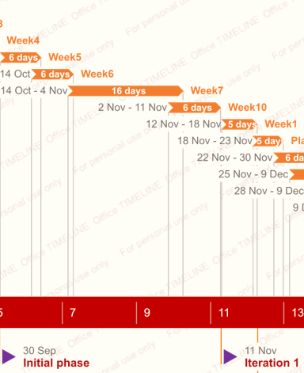

|  |  |  |
| --- | --- | --- |
| Iteration 1 | week5-week10 | Design document Iteration 1  Updated version of URS  Work division report  Test report  Proof of concept  Plan for Iteration 2 |
| End date: 11.11.2019 | | |

## Iteration 1

##### Activity5: Week5

Tasks for the activity are:

* Present URs to your tutor
* Discuss
* Update URS

Estimated duration is one week and 4 man hours.

Deliverables for milestone **M3** are:

* Updated version of URS

##### Activity6: Week6

Tasks for the activity are:

* Code
* Create concept version plan for iteration 2

Estimated duration is one week and 4 man hours.

Deliverables for milestone **M3** are:

* Concept version of plan for iteration 2

##### Activity7: Week7

Tasks for the activity are:

* Code
* Debug
* Update work division report

Estimated duration is one week and 4 man hours.

Deliverables for milestone **M3** are:

* Final URs for iteration 1
* Final version of plan for iteration 2
* Source code of proof of concept
* Proof of concept
* Updated version of work division

##### Activity8: Week10

Tasks for the activity are:

* UML Class diagram(s) & the non-trivial sequence diagram(s)

Estimated duration is one week and 4 man hours.

Deliverables for milestone **M3** are:

* UML Class diagram(s) & non-trivial sequence diagram(s) of proof of concept