|  |  |  |
| --- | --- | --- |
| Project Team |  |  |
| Rozalina Miladinova 3285588  Aleksandar Georgiev 3229742  Nidhi Sharma 3233006  Nguyen Bao Quoc 3477347  Fares Alsalama 3396029 |  |  |



**Iteration2 plan**

|  |
| --- |
|  |

Contents

Introduction 3

Goal 3

Work Schedule Breakdown 4

Phasing 5

Iteration 1 5

## Introduction

This document will provide information about the plan which will be followed during Iteration two of the Airport baggage simulation. In the sections below can be found:

* Information about the goal for this iteration
* Information about which parts we will focus during this iteration
* Work schedule breakdown

## Goal

The main goal for this iteration is to deliver a solution that provides the user with a possibility to draw its own map of the airport. Furthermore, we will add and edit the functionalities of the code behind. Then, by doing the unit tests we will validate the above mentioned.

## Work Schedule Breakdown

|  |  |
| --- | --- |
| Task name | Assigned to |
| Requirements | |
| Discover and analyze the requirements | Aleksandar Georgiev, Sander Van Bemmel, Nidhi Sharma, Rozalina Miladinova, Fares Alsalama, Nguyen Quoc |
| Documentation | |
| User requirements specification document | Nidhi Sharma, Rozalina Miladinova, Fares Alsalama |
| Design document | Nguyen Quoc, Aleksandar Georgiev, Sander Van Bemmel |
| Work division document | Rozalina Miladinova |
| Final version of plan for iteration 3 | Aleksandar Georgiev, Sander Van Bemmel, Nidhi Sharma, Rozalina Miladinova, Fares Alsalama, Nguyen Quoc |
| Implementation | |
| GUI drawing logic | Nidhi Sharma, Rozalina Miladinova, Fares Alsalama, Aleksandar Georgiev |
| Unit tests | Aleksandar Georgiev, Sander Van Bemmel, Nguyen Quoc |
| Statististics Logic and Overview | Nguyen Quoc, Fares Alsalama, Sander Van Bemmel |
|  |  |

## Phasing

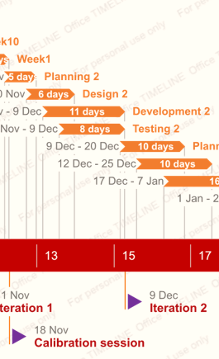

|  |  |  |
| --- | --- | --- |
| Iteration 2 | Week2-week4 | Design document Iteration 2  Updated version of URS  Work division report  Test report  Proof of concept  Plan for Iteration 3 |
| End date: 09.12.2019 | | |

## 

## Iteration 2

##### Activity10: Planning

Tasks for the activity are:

* Research and analyze the requirements
* Research on similar solutions design
* Plan and write iteration 3
* Do work division

Estimated duration is one week and 4 man hours.

Deliverables for milestone **M5** are:

* Complete version of plan for iteration 3
* Updated version of work division report

##### Activity11: Design

Tasks for the activity are:

* Complete Sequence diagram
* Complete Class diagram
* Design the GUI

Estimated duration is one week and 4 man hours.

Deliverables for milestone **M5** are:

* Final URS & design document

##### Activity12: Development

Tasks for the activity are:

* Classes and methods implementation
* Start coding basic functionalities

Estimated duration is one week and 4 man hours.

Deliverables for milestone **M5** are:

* Source code of prototype
* Prototype

##### Activity12: Testing

Tasks for the activity are:

* Unit tests

Estimated duration is one week and 4 man hours.

Deliverables for milestone **M5** are:

* Unit tests of prototype