|  |  |  |
| --- | --- | --- |
| Project Team |  |  |
| Rozalina Miladinova 3285588  Aleksandar Georgiev 3229742  Nidhi Sharma 3233006  Nguyen Bao Quoc 3477347  Fares Alsalama 3396029 |  |  |



**Iteration1 plan**

|  |
| --- |
|  |

Contents

Introduction 3

Goal 3

Work Schedule Breakdown 4

Phasing 5

Iteration 1 5

## Introduction

This document will provide information about the plan which will be followed during Iteration one of the Airport baggage simulation. In the sections below can be found:

* Information about the goal for this iteration
* Information about which use cases are chosen and on which parts we will focus during this iteration
* Work schedule breakdown

## Goal

The main goal of this iteration is to import/export the simulation models(settings) needed to run the simulation. We are going to work on making the visualization smoother and extending the statistics. Furthermore, our secondary goal is to fix any bug that is left from the previous iterations.

## Work Schedule Breakdown

|  |  |
| --- | --- |
| Task name | Assigned to |
| Requirements | |
| Discover and analyze the requirements | Aleksandar Georgiev, Sander Van Bemmel, Nidhi Sharma, Rozalina Miladinova, Fares Alsalama, Nguyen Quoc |
| Documentation | |
| User requirements specification document | Nidhi Sharma, Rozalina Miladinova, Fares Alsalama |
| Design document | Nguyen Quoc, Aleksandar Georgiev, Sander Van Bemmel |
| Work division document | Rozalina Miladinova |
| Final version of plan for iteration 3 | Aleksandar Georgiev, Sander Van Bemmel, Nidhi Sharma, Rozalina Miladinova, Fares Alsalama, Nguyen Quoc |
| Implementation | |
| Import/Export Models | Aleksandar Georgiev, Sander Van Bemmel, Nidhi Sharma, Rozalina Miladinova, Fares Alsalama, Nguyen Quoc |
| Unit tests | Aleksandar Georgiev, Sander Van Bemmel, Nguyen Quoc |
| Statististics Logic and Overview | Nguyen Quoc, Fares Alsalama, Sander Van Bemmel |
|  |  |

## Phasing

|  |  |  |
| --- | --- | --- |
| Iteration  3 | Week15-week17 | Design document  URS  Work division report  Unit tests for final product  Source code for final product  Final product |
| End date: 17.01.2020 | | |

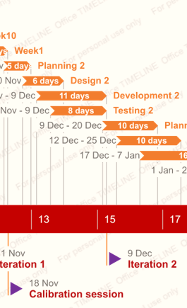

## 

## Iteration 3

##### Activity1: Week15

Tasks for the activity are:

* Present URs to your tutor
* Discuss
* Update URS

Estimated duration is one week and 4man hours.

Deliverables for milestone **M3** are:

* Updated version of URS

##### Activity6: Week6

Tasks for the activity are:

* Code
* Create concept version plan for iteration 2

Estimated duration is one week and 4man hours.

Deliverables for milestone **M3** are:

* Concept version of plan for iteration 2

##### Activity7: Week7

Tasks for the activity are:

* Code
* Debug
* Update work division report

Estimated duration is one week and 4man hours.

Deliverables for milestone **M3** are:

* Final URs for iteration 1
* Final version of plan for iteration 2
* Source code of proof of concept
* Proof of concept
* Updated version of work division

##### Activity8: Week10

Tasks for the activity are:

* UML Class diagram(s) & the non-trivial sequence diagram(s)

Estimated duration is one week and 4man hours.

Deliverables for milestone **M3** are:

* UML Class diagram(s) & non-trivial sequence diagram(s) of proof of concept