|  |  |  |
| --- | --- | --- |
| Project Team |  |  |
| Rozalina Miladinova 3285588  Aleksandar Georgiev 3229742  Nidhi Sharma 3233006  Nguyen Bao Quoc 3477347  Fares Alsalama |  |  |



**Airport baggage simulator**

**Project Plan**

|  |
| --- |
|  |

Contents

Introduction 3

Project Statement 3

Formal Client 3

Project Leader 3

Current Situation 4

Problem Description 4

Project Goal 4

Project Deliverables and Non-deliverables 4

Project Risks 5

Project Constraints 5

Project phansing/example/ 6

Phase 1: Initiation /example/ 7

Activity1: Start-up the project 7

# Introduction

## Project Statement

This document will define the development of the Airport Luggage simulation system. The plan will detail the goals and objectives, milestones and constraints and will also serve as an agreement between the team and the formal client.

## Formal Client

A representative from SIM Software, board of management, Mrs. Qin Zhao is our formal client. She will answer on behalf of the company and will be monitoring our results during the project.

#### **Contact information**

Qin Zhao

Rachelsmolen 1

5612MA Eindhoven

q.zhao@fontys.nl

0689324563

Working days: Monday to Friday

## Project Leader

Mis Rozalina Miladinova, student of Fontys ICT Eindhoven is the project leader. Nidhi Sharma, Fares Alsalama, Aleksandar Georgiev, Sander van Bemmel, Nguyen Bao Quoc are members of the team.

#### **Contact Information**

Rozalina Miladinova

Condensatorstraat 3,

Eindhoven rozituu@gmail.com

Working Days: Monday to Friday

## Current Situation

SIM Software Inc. is a fast-growing company aiming at innovative solutions for simulation problems. In the last few years, SIM software has focused on traffic simulation software, but the company would like to extend its expertise to cover a broader area of s**imulation software. Therefore,** the company asks for other project proposals in the area of simulation software. Our team was assigned to give such a proposal and develop our idea for simulation software into an application. Our idea must be approved by the client.

## Problem Description

View and edit this document in Word on your computer, tablet, or phone. You can edit text; easily insert content such as pictures, shapes, and tables; and seamlessly save the document to the cloud from Word on your Windows, Mac, Android, or iOS device.

## Project Goal

Our team has a task from SIM Software Inc. to make a project proposal in the area of simulation software. The purpose of this task is to help the company extent its expertise in order to cover broader area of simulation software.

The goal of this project is to provide the user with a simulation application that will aid him in determining the optimal distribution of resources in a baggage transportation and distribution system.

**Project Product**

The product of this project will be a simulation application, developed on Microsoft’s Windows Forms, that will simulate the flow of incoming passengers to check-ins, passing the baggage through the check-in, conveyor, security, main process area(which will redirect the baggage to a certain drop-off) and finally the drop-off.  The user will be able to alter specifics of the system at any moment while the simulation is running, such as the flight settings, the amount of check-in gates, securities and drop-offs. Based on that simulation, the application will give information to the user in the form of statistics. The simulation will display the results live in the GUI and will also store them in a file.

## Project Deliverables and Non-deliverables

View and edit this document in Word on your computer, tablet, or phone. You can edit text; easily insert content such as pictures, shapes, and tables; and seamlessly save the document to the cloud from Word on your Windows, Mac, Android, or iOS device.

## Project Risks

View and edit this document in Word on your computer, tablet, or phone. You can edit text; easily insert content such as pictures, shapes, and tables; and seamlessly save the document to the cloud from Word on your Windows, Mac, Android, or iOS device.

## Project Constraints

View and edit this document in Word on your computer, tablet, or phone. You can edit text; easily insert content such as pictures, shapes, and tables; and seamlessly save the document to the cloud from Word on your Windows, Mac, Android, or iOS device.

# Project phansing/example/

Use this section to give a brief summary of your financials, highlighting important points. Some of the sample text in this document indicates the name of the style applied, so that you can easily apply the same formatting again.

Example

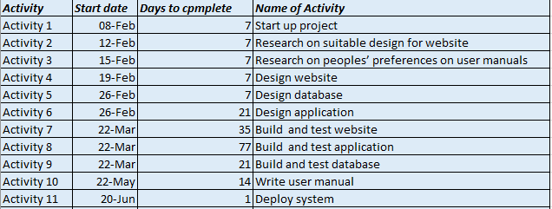

**deploy**

**build and test**

**initiation**

**analysis and design**

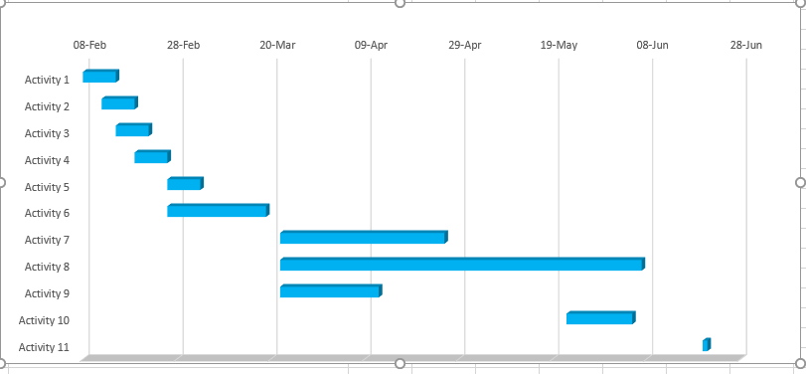

## Phase 1: Initiation /example/

In the following section of the document we describe each and every step of the project. We provide detailed information such as deliverables and estimated time in this part of the document.

### Activity1: Start-up the project

Tasks for the activity are:

* Interview the client
* Discuss current situation, problems, desired end situation
* Set the project goal together with the client
* Organise the team
* Organise resources
* Kick off meeting

Estimated duration is one week and 7 man hours.

Deliverables for milestone **M1** are:

* The Project plan
* The Set up document

|  |
| --- |
|  |