Manual Testing assignment

Task1.

Used browser:

Google Chrome

Version 101.0.4951.54

1.Search bars doesn’t work

Pressing search button without text.

The website has 3 search bars,all of them lead to a new page that has written "Unauthorized".

Steps to reproduce:

1.Open <https://www.arngren.net/>.

2. locate the search bar:

1.top-middle

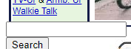2.middle-left

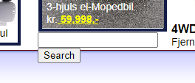3.bottom-middle

3.Press the Search button .

The search bar does not fulfill its purpose, instead it just opens new form of the website that has text "Unauthorized"

2.Search bars doesn’t work

Pressing search button with text.

The website has 3 search bars,all of them lead to a new page that has written "Unauthorized".

Steps to reproduce:

1.Open <https://www.arngren.net/>.

2. locate the search bar:

1.top-middle

2.middle-left

3.bottom-middle

3.In the input field write “Fatbike”,thats one of their products that can be found on the website.

4.Press the Search button .

The search bar does not fulfill its purpose, instead it just opens new form of the website that has text "Unauthorized"

3.Image leads to another item that isn't represented by the image

Steps to reproduce:

1.Open <https://www.arngren.net/>.

2.Locate the image of Santa Claus,its located at the bottom-left corner of the website.



3.Click on the Santa Claus

After clicking on the image,we are taken to page for RC-Tiger Tank

4.Layout of the website.

Steps to reproduce:

1.Open <https://www.arngren.net/>.

2.Pull the horizontal bar to the right.

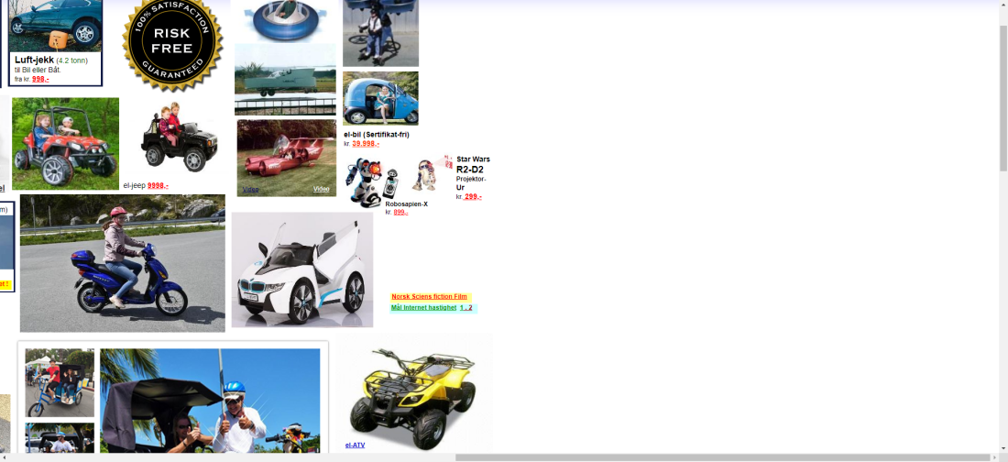

The layout is hazardous,many of the pictures are overlapping.

4.The Alarm Page

Steps to reproduce:

1.Open <https://www.arngren.net/>.

2. Locate the nav bar of the site,located on the left side.

3.Locate text “Alarm”.

4.Click on the text.

.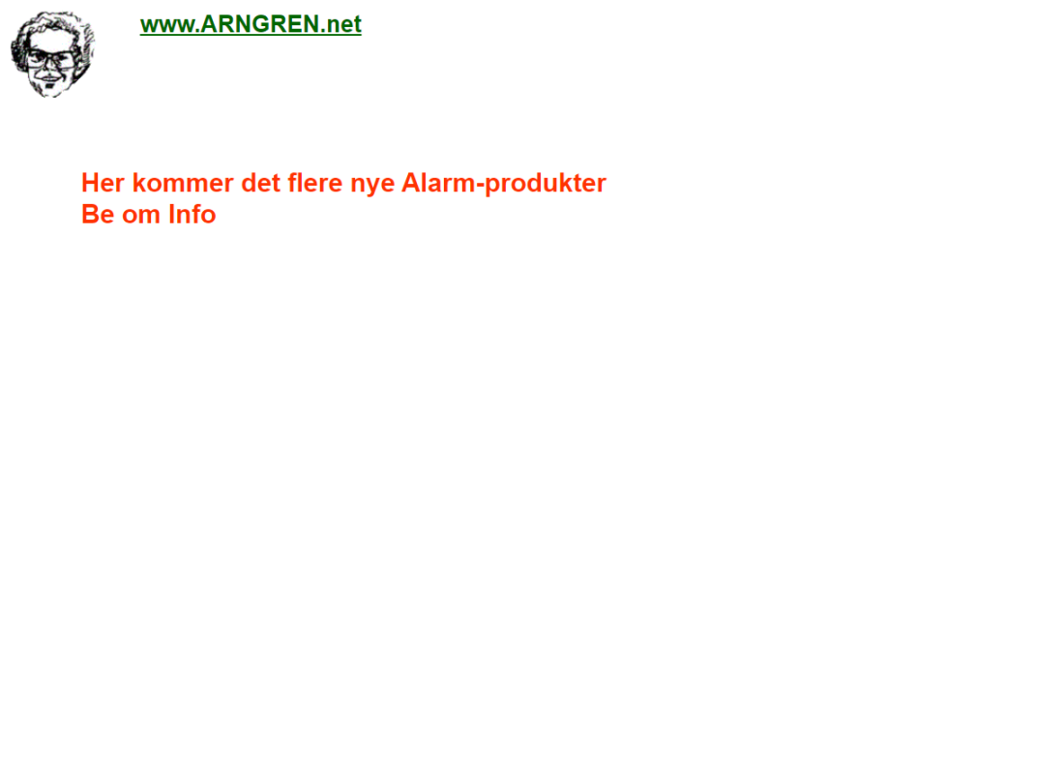

On the page the only thing that we can se is a image of a head and some text.

All of the information about the product and its images are missing.

5.The DVD-Spiller Page

Steps to reproduce:

1.Open <https://www.arngren.net/>.

2. Locate the nav bar of the site,located on the left side.

3.Locate text “DVD-Spiller”.

4.Click on the text.

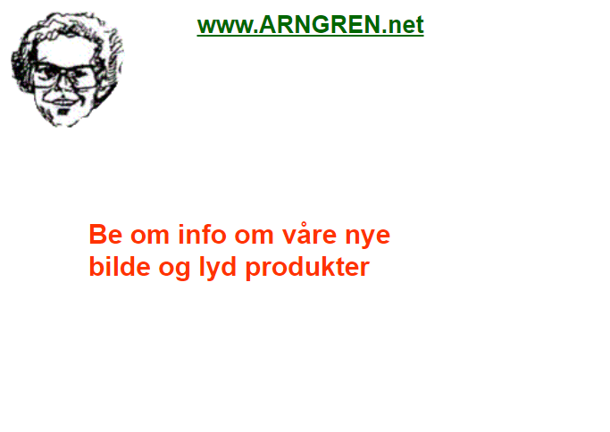

On the page the only thing that we can se is a image of a head and some text.

All of the information about the product and its images are missing.

6.Two links that lead to the same website form

Steps to reproduce:

1.Open <https://www.arngren.net/>.

2. Locate the nav bar of the site,located on the left side.

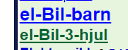

7.The Dab-Radioer Page

Steps to reproduce:

1.Open <https://www.arngren.net/>.

2. Locate the nav bar of the site,located on the left side.

3.Locate text “DAB”.

4.Click on the text.

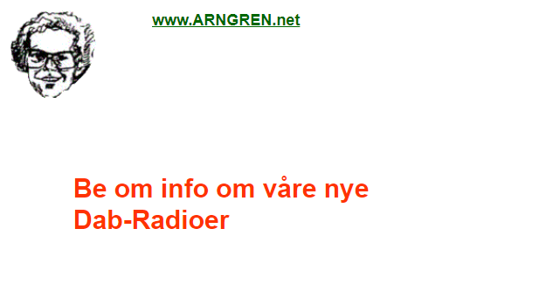

On the page the only thing that we can se is a image of a head and some text.

All of the information about the product and its images are missing.

8.Two links that lead to the same website form

Steps to reproduce:

1.Open <https://www.arngren.net/>.

2. Locate the nav bar of the site,located on the left side.



9.The number 2 leads to the wrong href

Steps to reproduce:

1.Open <https://www.arngren.net/>.

2. Locate the nav bar of the site,located on the left side.

3.Click on the el-Sykkel-1 its lead to a page for electrical cycles.

Wile when you press on number 2 it takes you to page for Far bikes.

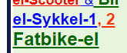

10.The Text is separated into multiple spans

Steps to reproduce:

1.Open <https://www.arngren.net/>.

2. Locate the nav bar of the site,located on the left side.

3.locate text “[Robot-Støvsuger](http://www.arngren.net/stovsug.html)”, hover on it with the moused to see that its separated into multiple spans



11.The Robot-Stovsuger Page

Steps to reproduce:

1.Open <https://www.arngren.net/>.

2. Locate the nav bar of the site,located on the left side.

3.Locate text “[Robot-Støvsuger](http://www.arngren.net/stovsug.html)”.

4.Click on the text.

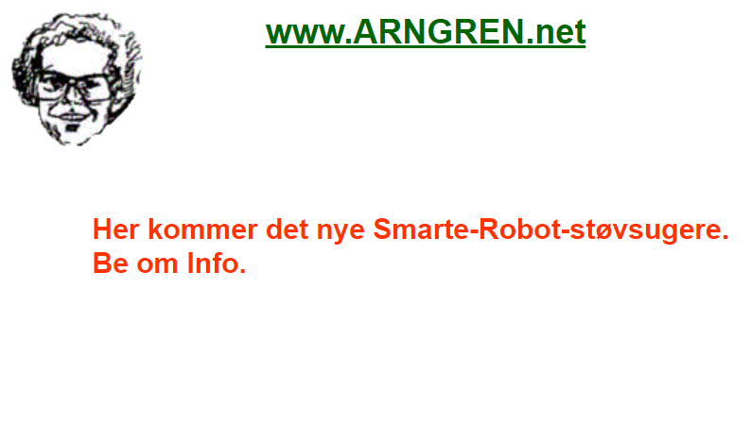

On the page the only thing that we can se is a image of a head and some text.

All of the information about the product and its images are missing.

12.The Walkie Talk Page

Steps to reproduce:

1.Open <https://www.arngren.net/>.

2. Locate the nav bar of the site,located on the left side.

3.Locate text “[Walkie Talk](http://www.arngren.net/walki-talki-babysitter.html)”.

4.Click on the text.

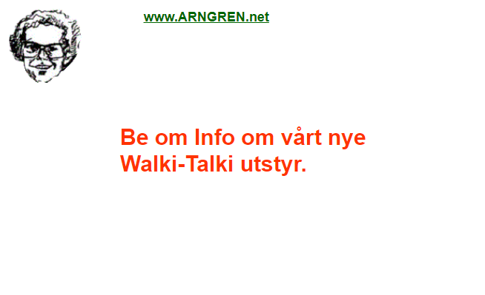

On the page the only thing that we can se is a image of a head and some text.

All of the information about the product and its images are missing.

13.The TV-Ur Page

Steps to reproduce:

1.Open <https://www.arngren.net/>.

2. Locate the nav bar of the site,located on the left side.

3.Locate text “[TV-Ur](http://www.arngren.net/TV-ur.html)”.

4.Click on the text.

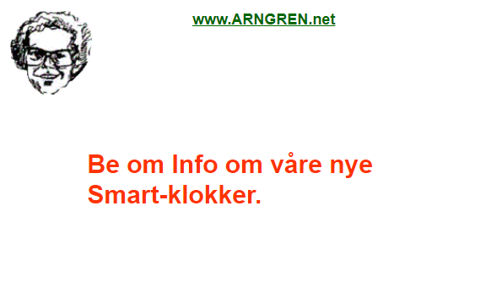

On the page the only thing that we can se is a image of a head and some text.

All of the information about the product and its images are missing.

14.Text in navbar reapating

Steps to reproduce:

1.Open <https://www.arngren.net/>.

2. Locate the nav bar of the site,located on the left side.

On the top and the bottom of the image you can see the same text.

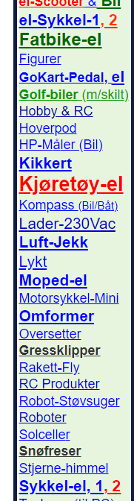

And same as the issue number 9. the texts lead to different hrefs.

15.The href of this text leads to a webpage that doesnt work.

Steps to reproduce:

1.Open <https://www.arngren.net/>.

2. Locate the nav bar of the site,located on the left side.

3.Locate text “Snofreser”.

4.Click on the text.

href="http://https://gratis-annonse.no/belte-kr-annonse.html"

