Manual Testing assignment

Task1.

Used browser:

Google Chrome

Version 101.0.4951.54

1.Search bars doesn’t work

Pressing search button without text.

The website has a search bar ,when used it goes to another form where it says "Unauthorized".

Steps to reproduce:

1.Open <http://gatesnfences.com/>

2.locate the search bar:

3.Press the Search button .

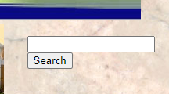

The search bar does not fulfill its purpose, instead it just opens new form of the website that has text "Unauthorized"

Linked text opens page in new tab

Steps to reproduce:

1.Open <http://gatesnfences.com/>

2.Click on “**[Wrought Iron Gates](http://www.gatesnfences.com/Electric_Driveway_gates_2_html.html" \t "http://gatesnfences.com/_blank)**” - It will open the page in a new tab-all of the highlighted texts do the same.