Databases and XML: Home assignment 1

# Data modelling and SQL

The purpose of this home assignment is, that you train the elements from data modelling and SQL,

which have been worked with during the first lecture day.

# 1. Data model

You are to create the data model for a blogging system with the following features and

characteristics:

• Users can register with necessary properties.

• Users can have different roles, i.e. author, admin, commentator.

• Blogposts can be created with i.e. title, content, featured image.

• Blog posts can have a number of categories.

• Blogposts can have a number of tags.

• Blog posts can have different statuses like pending, published, archived, hidden.

The data model (the design) shall contain

• entities with attributes and keys.

• relations with cardinality and participation.Databases and XML: Home assignment 1

## 1.

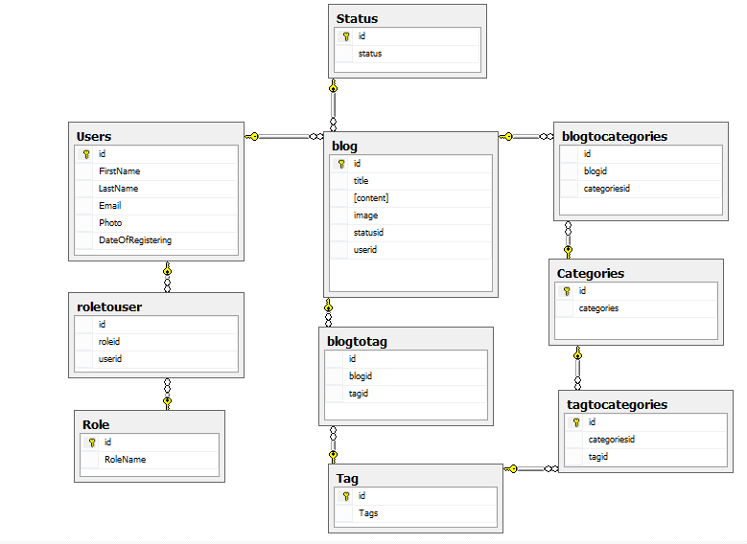

# 2. SQL

When solving the assignments below, it may be a good idea to create the tables in SQL Server

Management Studio and insert realistic data, that enables you to test whether the SQL statements

works as planned.

1. Which SQL statement(s) can be used to create a blogpost, when there has to be an indication

of the user who has created the blogpost, it has to be connected to a category, tagged by two

tags and have status pending?

2. Which SQL statement(s) can be used to fetch the tags that a particular blogpost is tagged with?

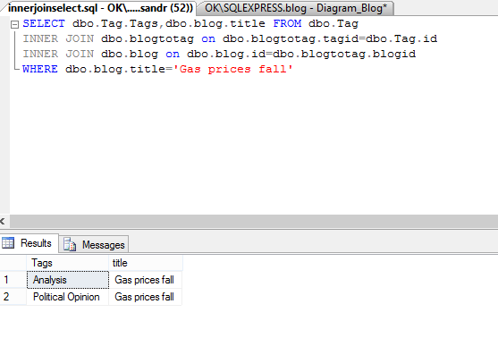

3. Which SQL statement(s) can be used to show the 10 latest published blogposts?

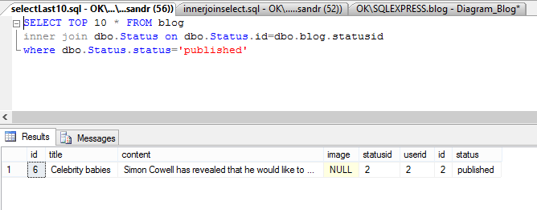

4. Which SQL statement(s) can be used to show the number of blogposts for all categories that

contains at least one blogpost?

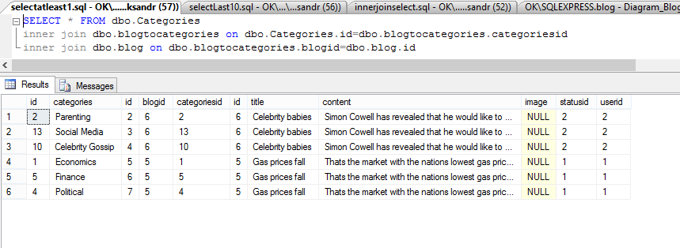

5. Which SQL statement(s) can be used to perform a full text search in both title and content for

blogposts?

SELECT dbo.blog.id FROM dbo.blog

WHERE CONTAINS( blog.content,'Simon Cowell')

SELECT

FROM

JOIN

WHERE

GROUP BY

HAVING

DELETE FROM USER

Dbcc checkident(user,reseed,0)

DELETE FROM ROLE

Dbcc checkident(role,reseed,0)

INSERT INTO ROLE

VALUES(‘ ’,’ ’)

INSERT INTO USER

VALUES (‘ ’,’ ’)