Name: Aleksander Rodriguez

|  |  |  |  |  |
| --- | --- | --- | --- | --- |
|  | Base 2 | Base 8 | Base 10 | Base 16 |
| 10 | 2433 | 1087.1 | 927.5 | 995.6 |
| 100 | 23092.5 | 8681.7 | 7032.6 | 5030.3 |
| 1000 | 231087 | 83406 | 68101.6 | 53258.6 |
| 10000 | 1.45E+06 | 653796 | 534353 | 462440 |

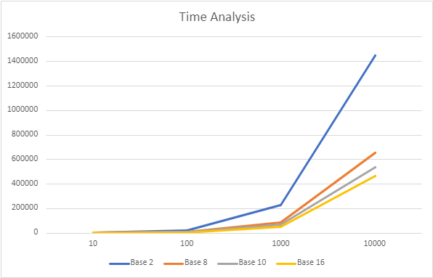

After completing the experiment and plotting the time analysis in reference to the size of the array and using the radix sort with a specified base we can say that the number of the base matters. One can conclude that as the base gets larger the less time it takes to perform a radix sort. There are instances where bases 8, 10, and 16 are close in time but that is only because we are limited to the size of each number stored in the array between 0-9999. For example, the largest number in hexadecimal in this range is four digits which is the same for decimal. But there are numbers in this range where a decimal could be four digits in size and a hexadecimal could be only three digits in size. The smaller number of digits creates a better time performance.

In the end, the larger base could be best for performance in time, but it will also take up more memory. So it is best to understand the data you are working with and determine the best base as needed.