We do this project by using several steps :

1. Let $A$ be the vector of sample data. Firstly, we reshape $A$ into a 2-by-((length of $A$)/2) matrix using “*reshape*” from MATLAB in order to make our works easier.
2. After that, we create a smooth curve by the following steps :

* We form a segment (window) using a parameter $n$ as the number of adjacent data points to be included in their corresponding windows. For instance, for $n = 10$, we form a window consists of 10 data points.
* We iterate this until we reach the last points of sample data.
* When creating a window, we overlap **the first half part** of the new window with **the last half part** of the previous window. For example, in case of $n=10$, take 5 points from the last half part of window 1, and use them as the 5 first points of window 2. We do this because we want the points from a window have influence for the next window. If we do this, the two sub-curves will be close and similar, therefore will create a smooth curve.
* Then, we do least square approximation in each window to create a complete curve by quadratic function. This algorithm corresponds to page 43 of Lecture 03, based on the following equation :

$$\underset{f∈span(B)}{argmin}{\sum_{j=1}^{m}{{(f\left(x_{j}\right)-y_{j})}^{2}}}$$

1. For each window, determine 2 points of the curve to create B-splines. We want a constant distance between :

* two points on a window, and
* the first point of *k*-th window and the last point of (*k-1*)-th window.

Therefore, we choose points in position $t=3.75$ and $t=6.25$ because we observe that they give a constant distance that we want. We can illustrate this as a figure below :

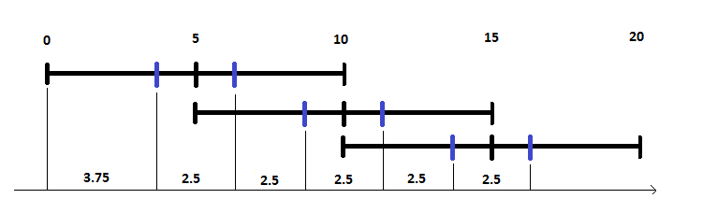

**Figure 1** Illustration of constant distances

1. After determining all control points, we run the de Boor algorithm to find the curve point $x(t)$ of the B-splines curve.

To do this, we refer to algorithm in page 32 of Lecture 09, as follows :

1. Search index $r$ with $t_{r}≤t<t_{r+1}$
2. For $i=r-k+1,….,r$

$$d_{i}^{0}=d_{i}$$

for $j=1,…..,k-1$

for $i=r-k+1+j,….,r$

$d_{i}^{j}=\left(1-α_{i}^{j}\right).d_{i-1}^{j-1}+α_{i}^{j}.d_{i}^{j-1}$

with $α_{i}^{j}=\frac{t-t_{i}}{t_{i+k-j}-t_{i}}$

Then, $d_{r}^{k-1}=x(t)$