Отчет по Лабораторной № 3 по предмету мат модели

Авферонок А,С

группа в3530904/80022

Вариант № 15

Построение траектории поиска

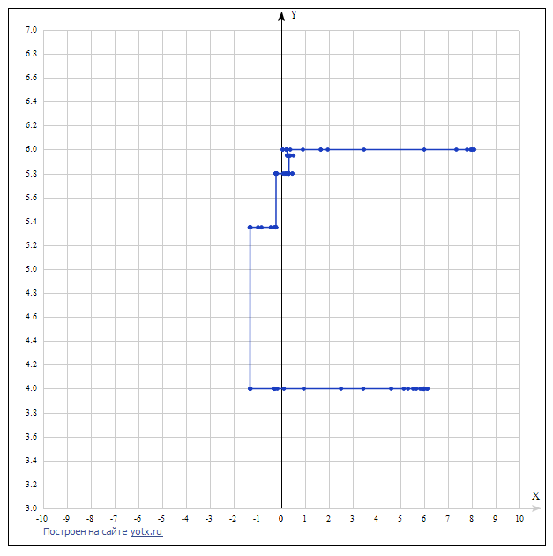

|  |  |  |
| --- | --- | --- |
| A1 | B3 | cf |
| 8 | 6 | 8988.03 |
| 7.95 | 6 | 8951.75 |
| 7.8 | 6 | 8843.82 |
| 7.35 | 6 | 8529.59 |
| 8.025 | 6 | 5689.63 |
| 1.5703 | 6 | 5468.34 |
| 1.5703 | 6 | 5433.97 |
| 0.25137 | 6 | 5432.2 |
| 0.21505 | 6 | 5434.52 |
| 0.225137 | 6 | 5431.73 |
| 0.2357 | 6 | 5429.79 |
| 0.25298 | 6 | 5424.52 |
| 0.2298 | 6 | 5364.13 |
| 0.2872 | 5.95 | 5348.75 |
| 0.255059 | 5.95 | 5339.63 |
| 0.21395 | 5.95 | 5339.13 |
| 0.280 | 5.95 | 5339.85 |
| 0.33718 | 5.95 | 5339.60 |
| 0.5087 | 5.95 | 5339.36 |
| 0.380181 | 5.95 | 5339.94 |
| 0.3103 | 5.95 | 5339.42 |
| 0.251892 | 5.95 | 5339.36 |
| 0.38109 | 5.95 | 5339.94 |
| 0.3205 | 5.95 | 5339.37 |
| 0.3203 | 5.95 | 5339.44 |
| 0.3205 | 5.8 | 5339.36 |
| 0.312027 | 5.8 | 5339.33 |
| 0.23919 | 5.8 | 5339.30 |
| 0.5575 | 5.8 | 5321.85 |
| 0.9057 | 5.8 | 5321.83 |
| 0.31801 | 5.8 | 5321.82 |
| 0.07918 | 5.8 | 5321.79 |
| 0.192 | 5.8 | 5321.7 |
| 0.31801 | 5.8 | 5321.63 |
| 0.135379 | 5.8 | 5321.42 |
| 0.2271 | 5.8 | 5321.84 |
| 0.31801 | 5.8 | 5321.02 |
| 0.18105 | 5.8 | 5321.62 |
| -0.2953 | 5.8 | 5321.54 |
| -0.21529 | 5.8 | 5320.71 |
| -0.18105 | 5.8 | 5320.62 |
| -0.23218 | 5.8 | 5320.6 |
| -0.20731 | 5.8 | 5285.98 |
| -0.219575 | 5.8 | 5285.73 |
| -0.23218 | 5.8 | 5285.66 |
| -0.213153 | 5.8 | 5285.59 |
| -0.22278 | 5.8 | 5285.39 |
| -0.23218 | 5.8 | 5285.28 |
| -0.21799 | 5.8 | 5294.12 |
| -0.22519 | 5.8 | 5286.69 |
| -0.221582 | 5.8 | 5285.55 |
| -0.22278 | 5.8 | 5285.53 |
| -0.223388 | 5.35 | 5285.54 |
| -0.22519 | 5.35 | 5285.45 |
| -0.23012 | 5.35 | 5285.43 |
| -0.287 | 5.35 | 5285.28 |
| -0.29532 | 5.35 | 5285.27 |
| -1.31133 | 5.35 | 5285.26 |
| -1.31775 | 5.35 | 5285.25 |
| -1.31133 | 4 | 5285.24 |
| -1.3013 | 4 | 5285.22 |
| -1.2910 | 4 | 5285.2 |
| -0.31775 | 4 | 5081.01 |
| -0.3013 | 4 | 5081 |
| -0.20201 | 4 | 5080.97 |
| -0.172 | 4 | 5080.9 |
| 0.110107 | 4 | 5080.83 |
| 0.93299 | 4 | 5081.82 |
| 3.288 | 4 | 5081.01 |
| 5.3175 | 4 | 5080.85 |
| 2.5055 | 4 | 5080.82 |
| 5.90 | 4 | 5080.81 |
| 5.1181 | 4 | 5080.8 |
| 5.9329 | 4 | 4950.45 |
| 5.53725 | 4 | 4950.41 |
| 5.1301 | 4 | 4947.53 |
| 5.3383 | 4 | 4939.64 |
| 5.98212 | 4 | 4916 |
| 5.1301 | 4 | 4845.05 |
| 5.90798 | 4 | 4632.23 |
| 5.98 | 4 | 3973.24 |
| 5.9701 | 4 | 2809.13 |
| 5.9358 | 4 | 920.105 |
| 5.971 | 4 | 920.301 |
| 5.97531 | 4 | 920.105 |
| 5.97922 | 4 | 951.167 |
| 5.9729 | 4 | 920.105 |
| 5.9783 | 4 | 737.849 |
| 5.9755 | 4 | 641.82 |

Код программы

#include <iostream>

#include <conio.h>

#include <math.h>

#include <fstream>

#include <cmath>

using namespace std;

double func (double a1, double t, double mass[400])

{

double h = 0.5, k = 5, x = 4;

double z1 = 0, z2 = 0, z3 = 0, dz1 = 0, dz2 = 0, y=0;

double st = 0;

for(int i=0;i<400;i++)

{

dz1 = z1 + h*z2;

dz2 = z2 + h*(1/pow(t,2))*(x-z1-z2);

y = k*(z1 - 2*a1*z2 + pow(a1,2)*z3);

z1 = dz1 , z2 = dz2;

st = st+ abs(mass[i]-y);

}

ofstream on;

on.open("res.txt",ios::app);

on <<st<<" "<<a1<<" "<<t<<" "<<endl;

return st;

}

int **main**()

{

int i = 0;

double mass[400];

ifstream in("gen.txt");

for(int i=0;i<400;++i)

{

in >> mass[i];

}

in.close();

i = 0;

double a1 = 8.0, t = 6.0;

double stepA = 0.1;

double stepB = 0.1;

double tmpSum;

double sum = func(a1,t,mass);

do {

i++;

tmpSum = func(a1 + stepA,t, mass);

if (abs(tmpSum - sum) > 0.001) {

if (tmpSum < sum) {

a1 += stepA;

stepA *= 3;

sum = tmpSum;

}

else {

stepA *= -0.5;

}

continue;

}

tmpSum = func(a1,t + stepB, mass);

if (abs(tmpSum - sum) > 0.001) {

if (tmpSum < sum) {

t += stepB;

stepB *= 3;

sum = tmpSum;

}

else {

stepB *= -0.5;

}

continue;

}

break;

}

while (true);

return 0;

}

Сравнение графиков

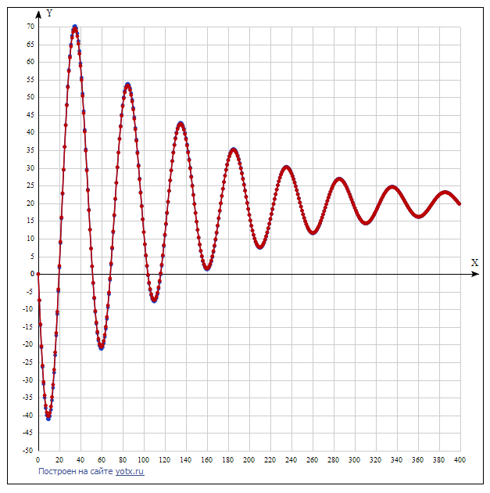

Графики получились примерно одинаковые