Control points

**seo-fast.ru**

**enterControlPoint (enter)**

Size: 15 x 17

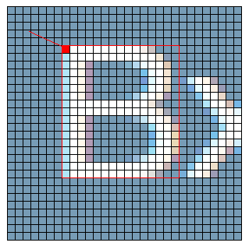

**earnControlPoint (earn)**

Size: 9 x 10

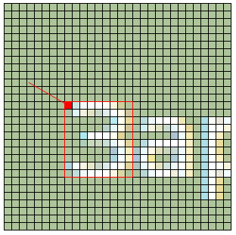

**toVisitsControlPoint (toVisits)**

Size: 19 x 10

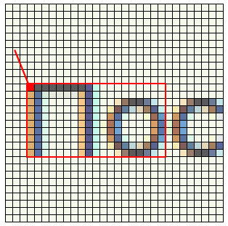

**hereVisitsControlPoint (hereVisits)**

Size: 11 x 10

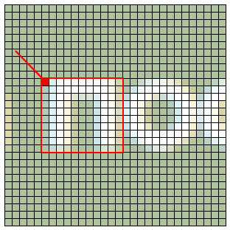

**visitsHereControlPoint (visitsHere)**

Size: 11 x 11

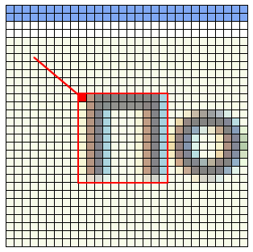

**roundLincControlPoint (round-linc)**

Size: 32 x 32

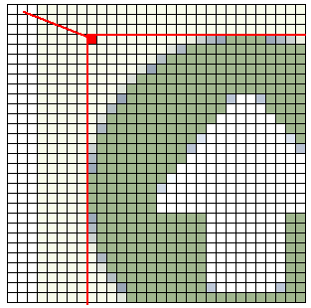

**idControlPoint (id)**

Size: 15 x 10

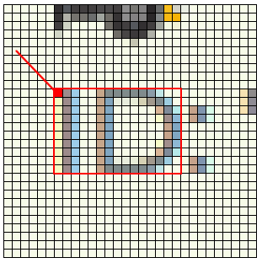

**visitControlPoint (to-visit)**

Size: 13 x 14

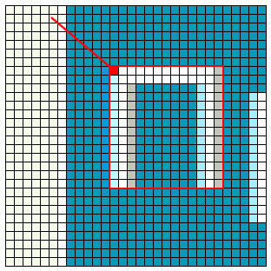

**closePassivePageControlPoint (close-passive-page)**

Size: 8 x 8

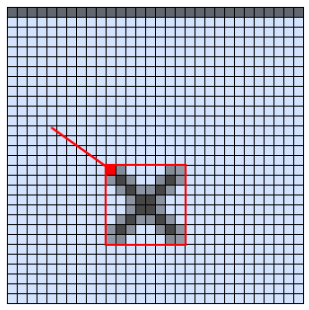

**closeActivePageControlPoint (close-active-page)**

Size: 8 x 8

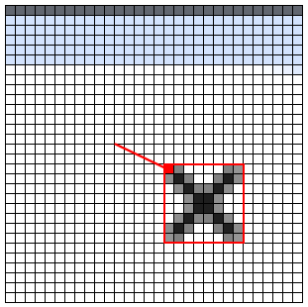

**confirmCompletedControlPoint (confirmCompleted)**

Size: 14 x 12

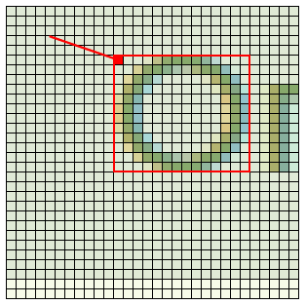

**completedControlPoint (completed)**

Size: 12 x 9

