|  |
| --- |
| EPAM Systems, RD Dep., RD Dep. |
| MTN.*NIX.02 Apache HTTP web server  MTN.*NIX."Applications support for *NIX " |

|  |  |  |  |  |  |
| --- | --- | --- | --- | --- | --- |
| REVISION HISTORY | | | | | |
| Ver. | Description of Change | Author | Date | Approved | |
| Name | Effective Date |
| <0.1> | New | Maksim Yaremka | <30-May-2011> |  |  |
|  |  |  |  |  |  |

**Reporting**

1. Task report that contains:
   1. Screenshots of test web pages being opened in browser
   2. Screenshots of output of web server checks, e.g. httpd -S

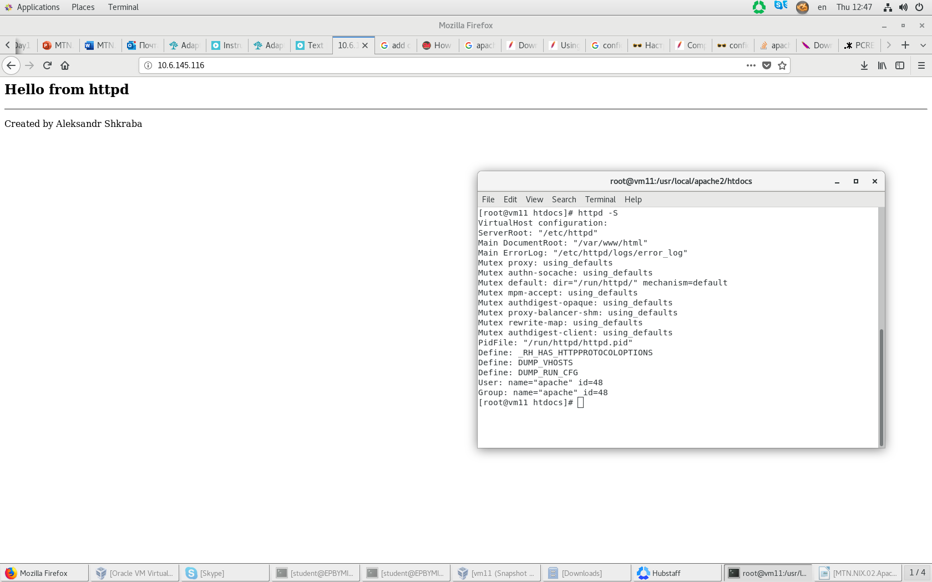

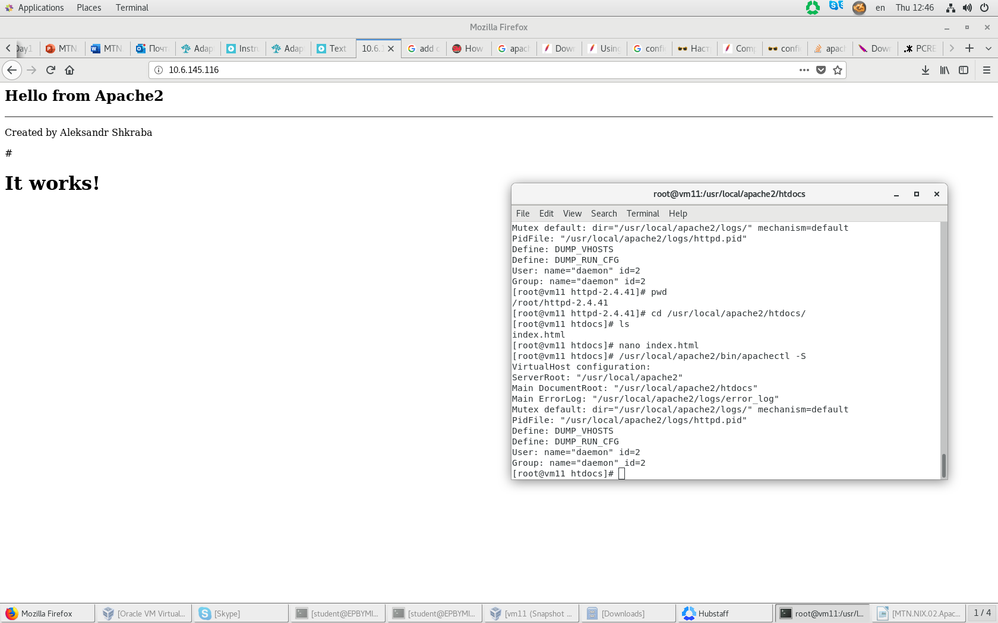

* 1. Screenshots of web server configurations used in tasks (virtual host, logging, etc.)

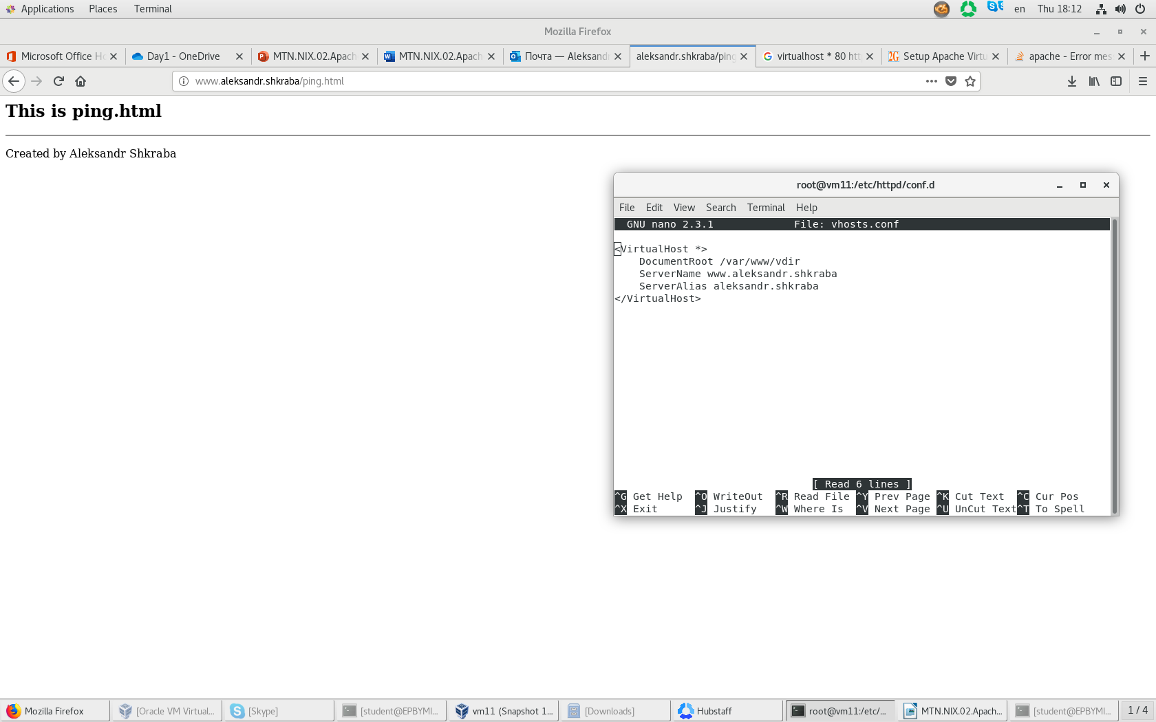

* 1. Screenshot of debug console to confirm mod_rewrite is working while opening /
  2. Screenshot of debug console to confirm mod_rewrite is working while opening /index.html
  3. Screenshot of debug console to confirm mod_rewrite is working while opening /none-existing-page

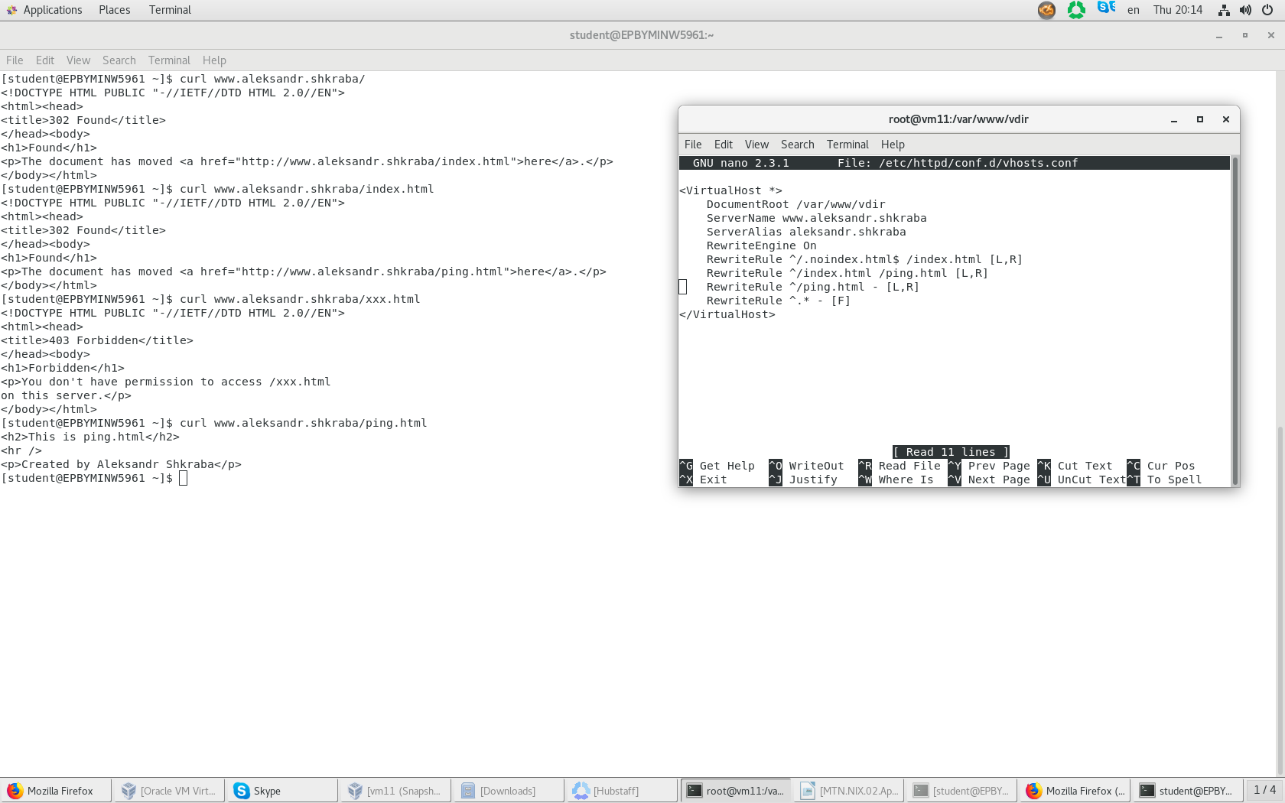

* 1. Screenshot of virtual host with cronolog configuration, output of *tree* command showing layout of log files created by cronolog

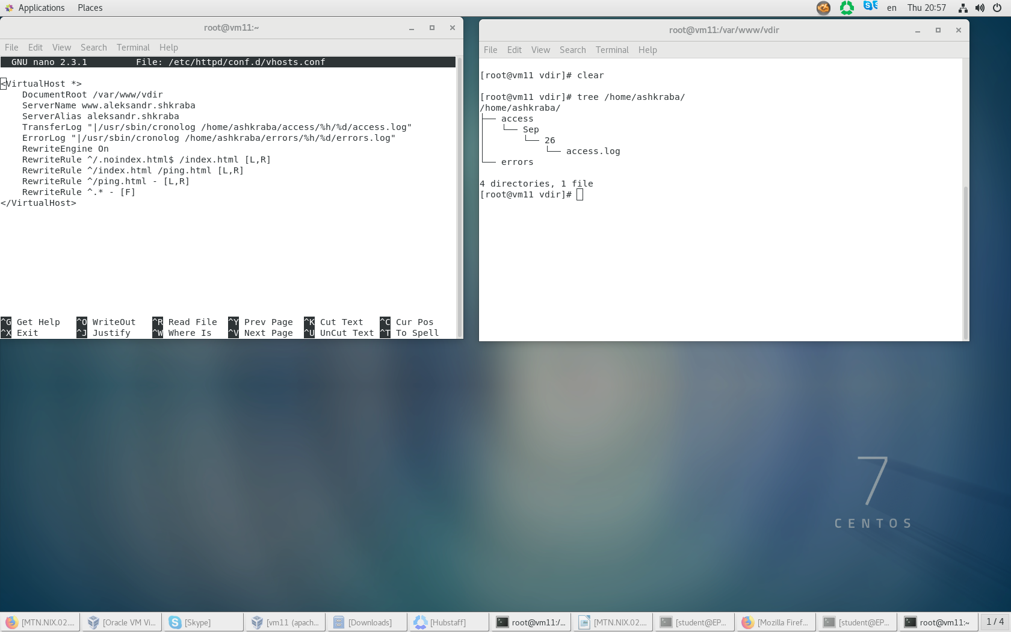

* 1. Screenshot of virtual host configuration with logging to syslog. Screenshots of syslog entries related to access/error web server logging.

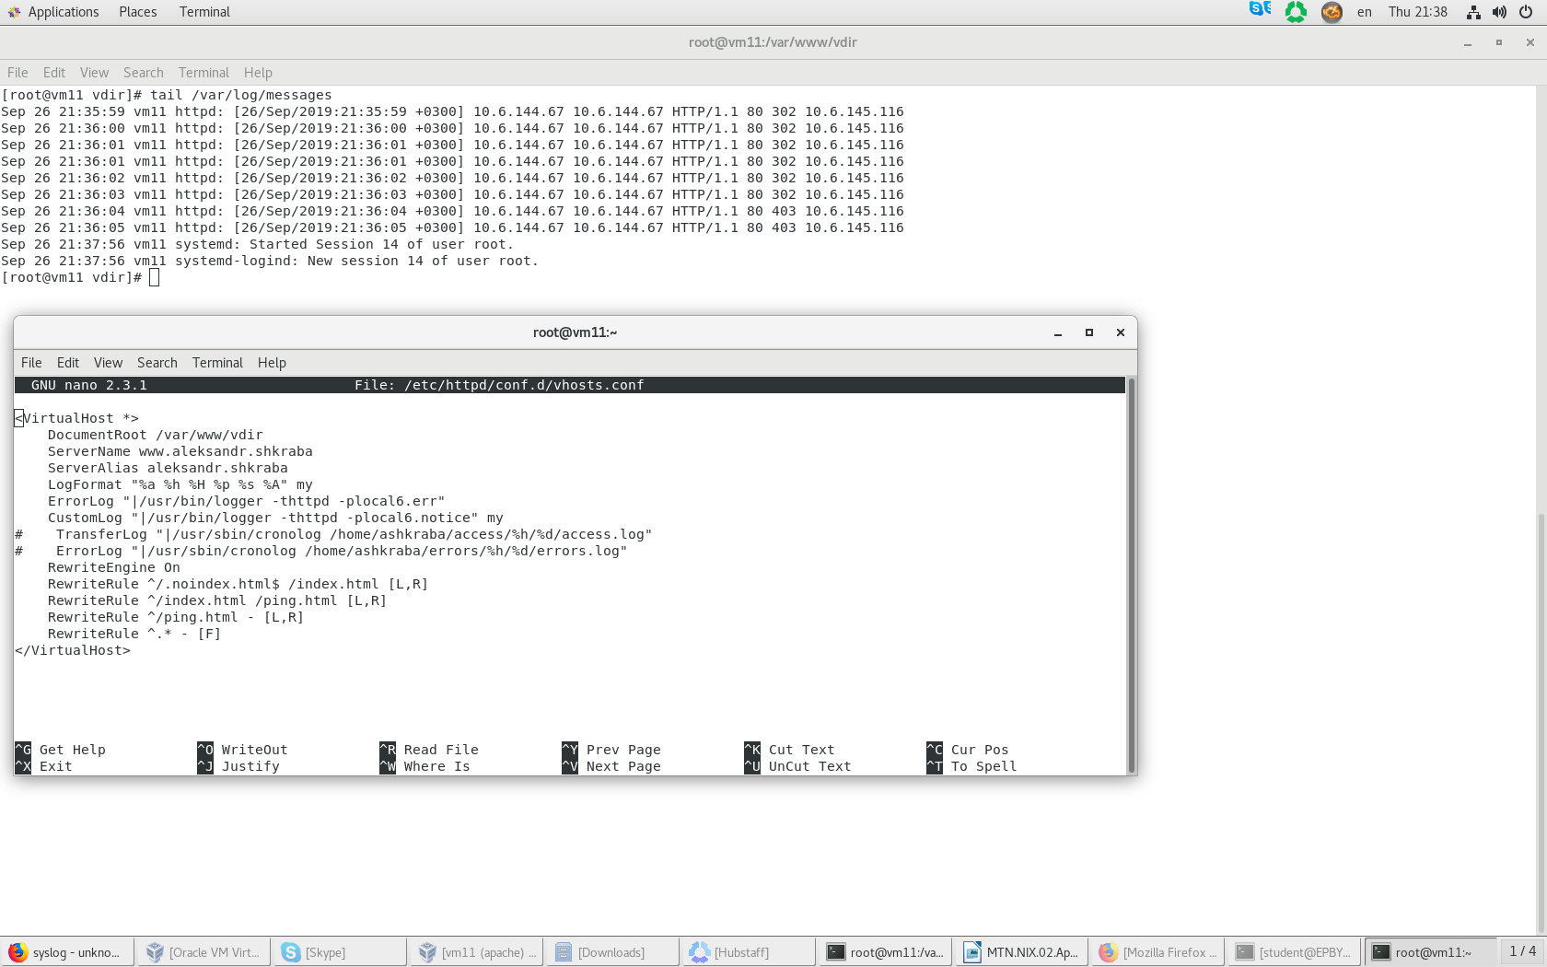

# What is apache graceful restart - выполнит рестарт веб-сервера после того, как будут обработаны все принятые запросы. Новые запросы при этом не принимаются.