|  |
| --- |
| EPAM Systems, RD Dep., RD Dep. |
| MTN.*NIX.02 Apache HTTP web server  MTN.*NIX."Applications support for *NIX " |

|  |  |  |  |  |  |
| --- | --- | --- | --- | --- | --- |
| REVISION HISTORY | | | | | |
| Ver. | Description of Change | Author | Date | Approved | |
| Name | Effective Date |
| <0.1> | New | Maksim Yaremka | <30-May-2011> |  |  |
|  |  |  |  |  |  |

**Task 4. Apache Tomcat**

**Review**

Show tomcat LoadBalancing with mod_jk

Show tomcat Clustering with mod_jk

**Task1**

1. Setup apache2 web server VM with mod_jk module.

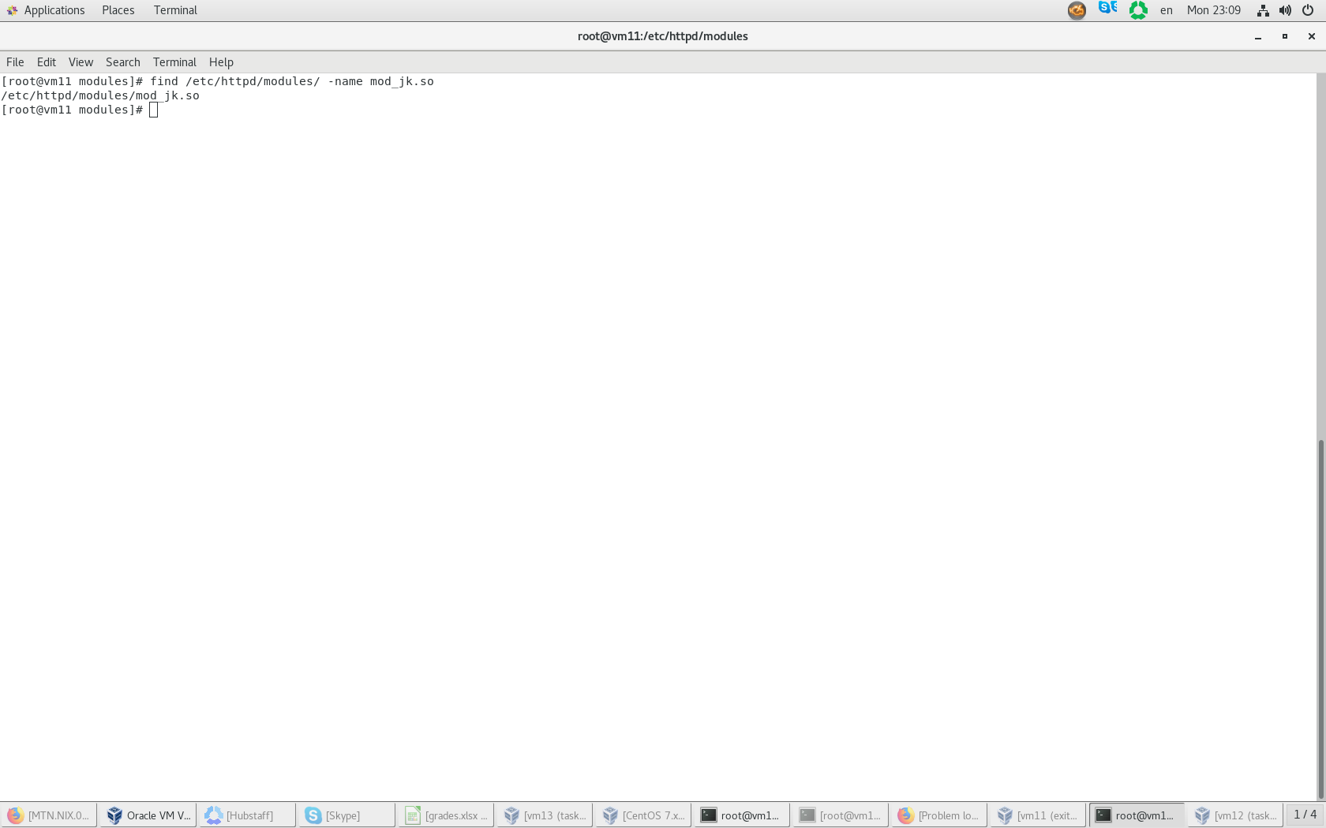

1. Setup 3 VMs with tomcat server and configure them. Tomcat instances surname-tomcat1, surname-tomcat2, surname-tomcat3

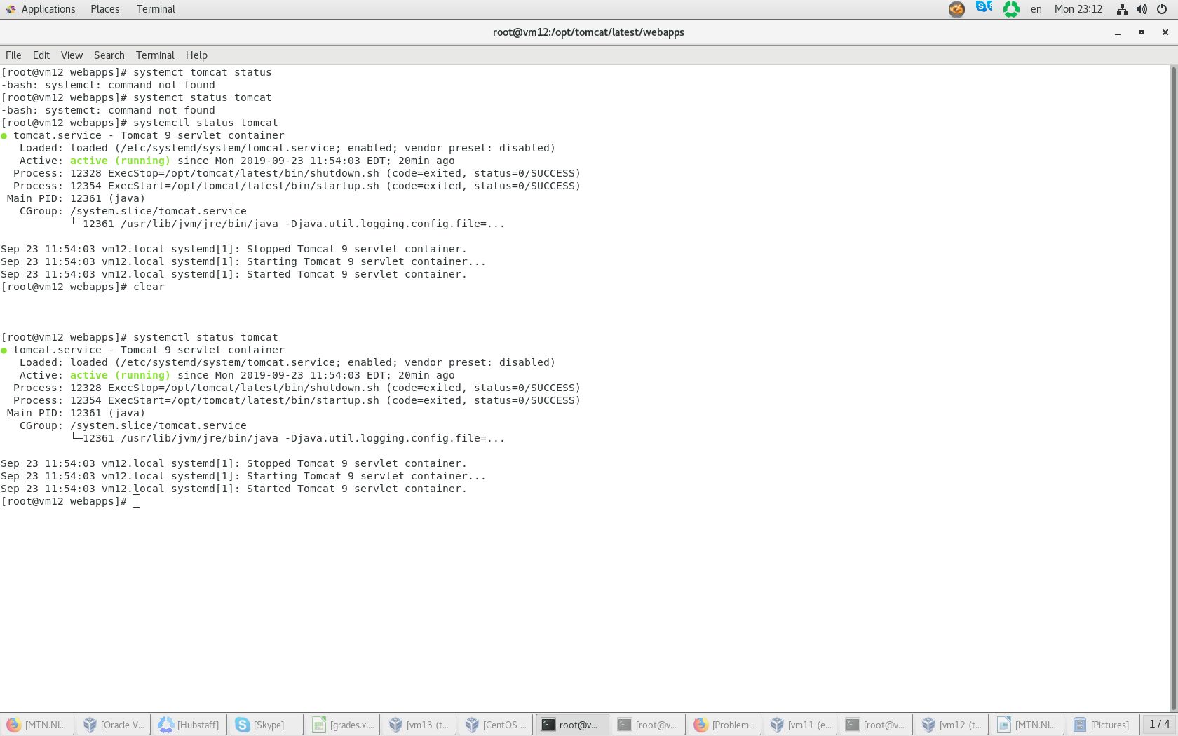

1. Add index.jsp from presentation to all tomcat servers.(тоже самое для двух других)

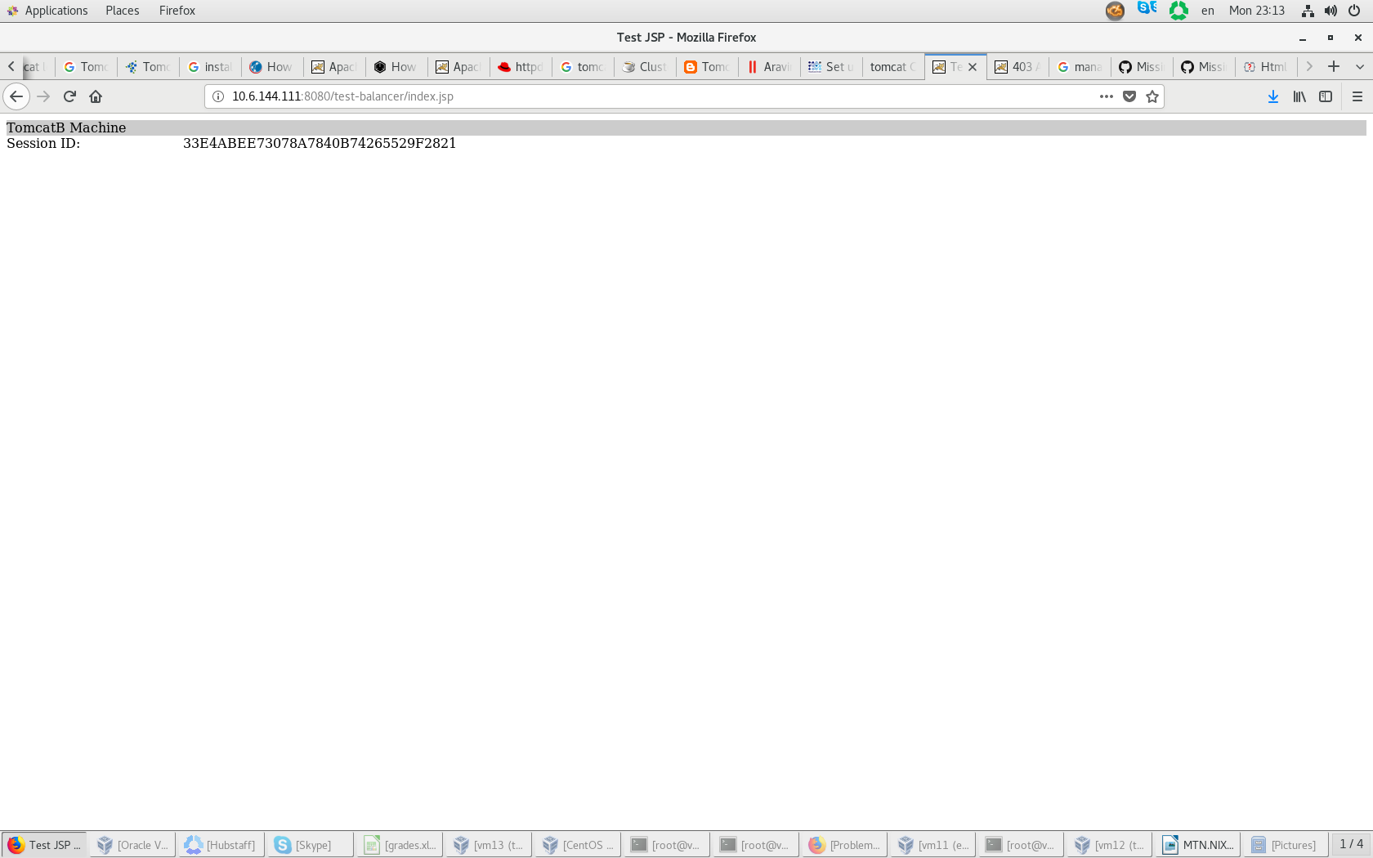

1. Deploy clusterjsp.war on each tomcat:

* Autodeploy on surname-tomcat1

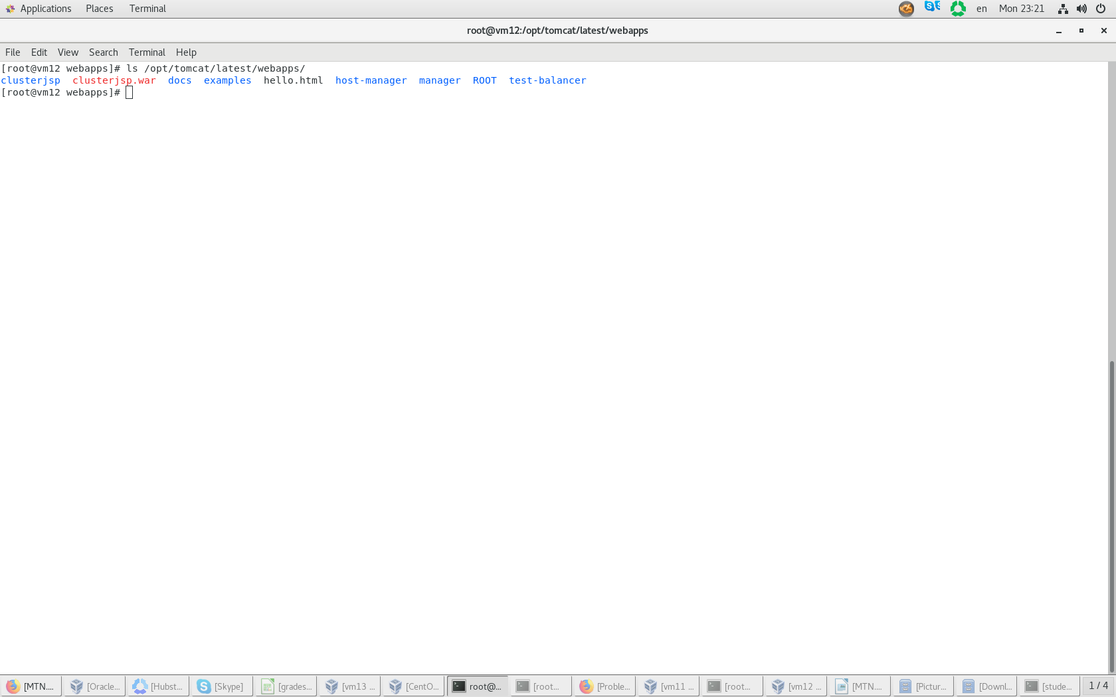

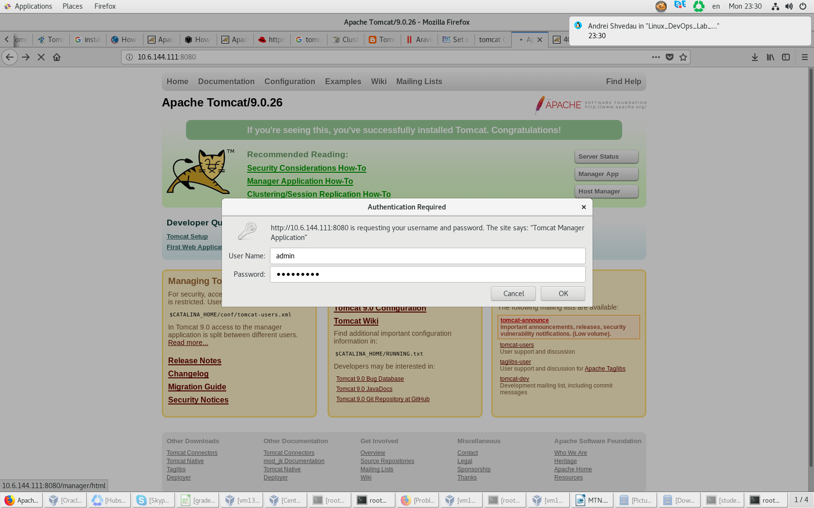

* Deploy via browse local host on surname-tomcat2

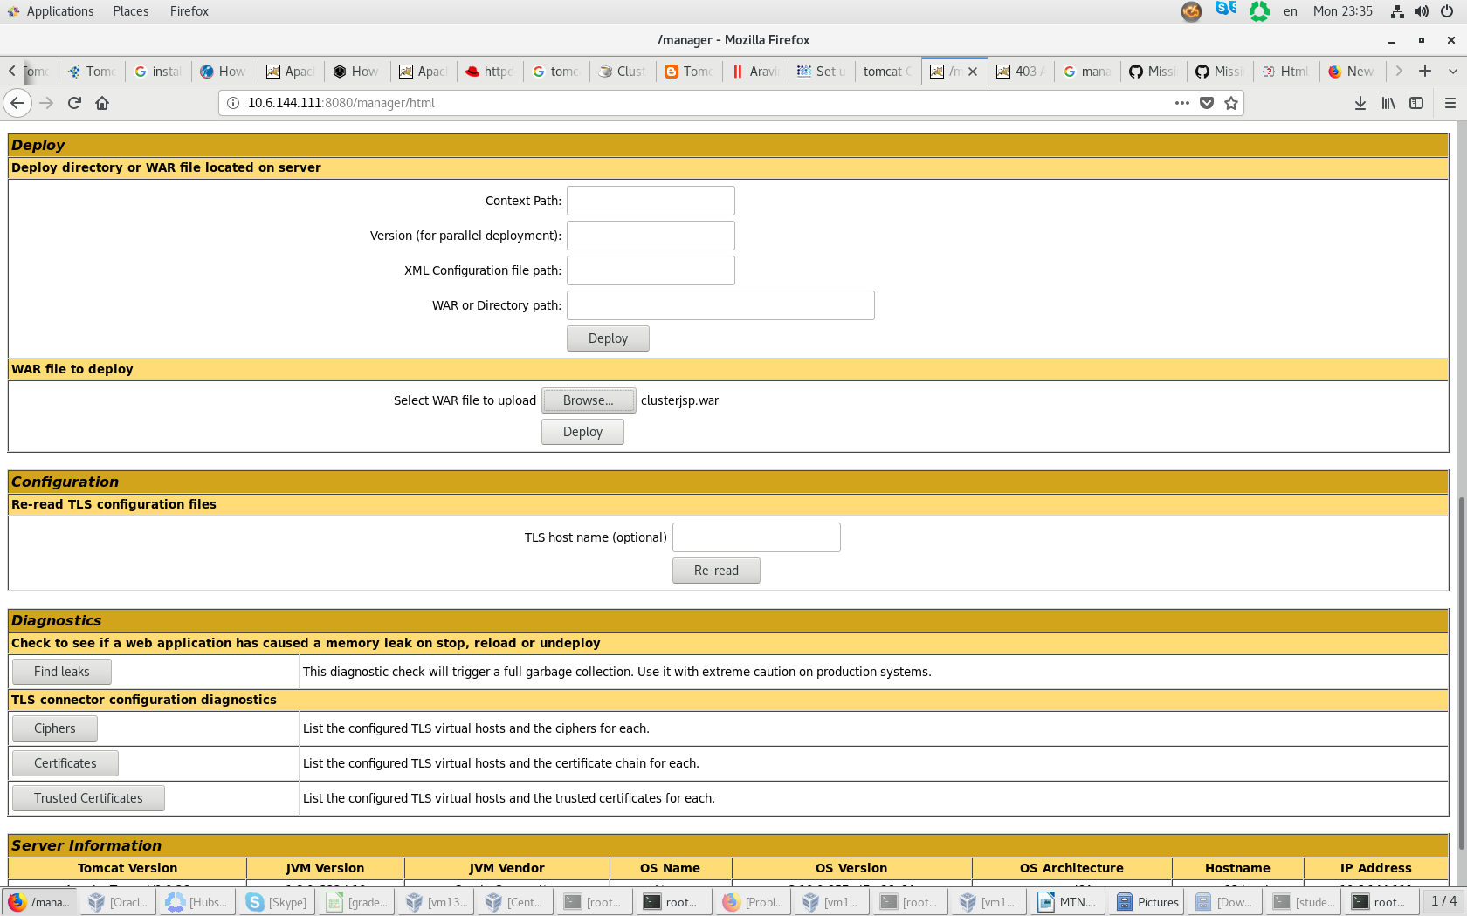

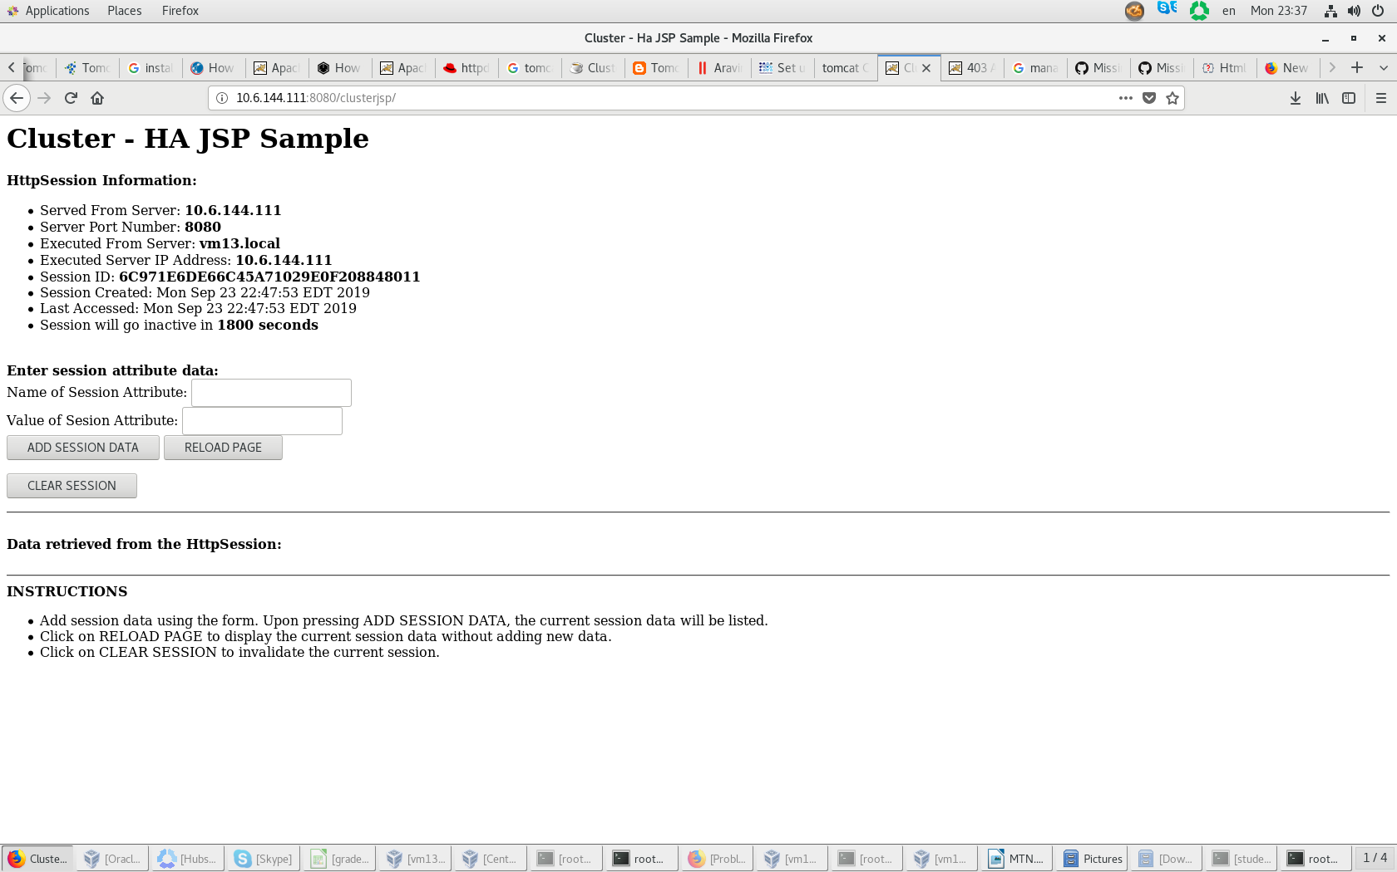

* Deploy via ContextPath on surname-tomcat3

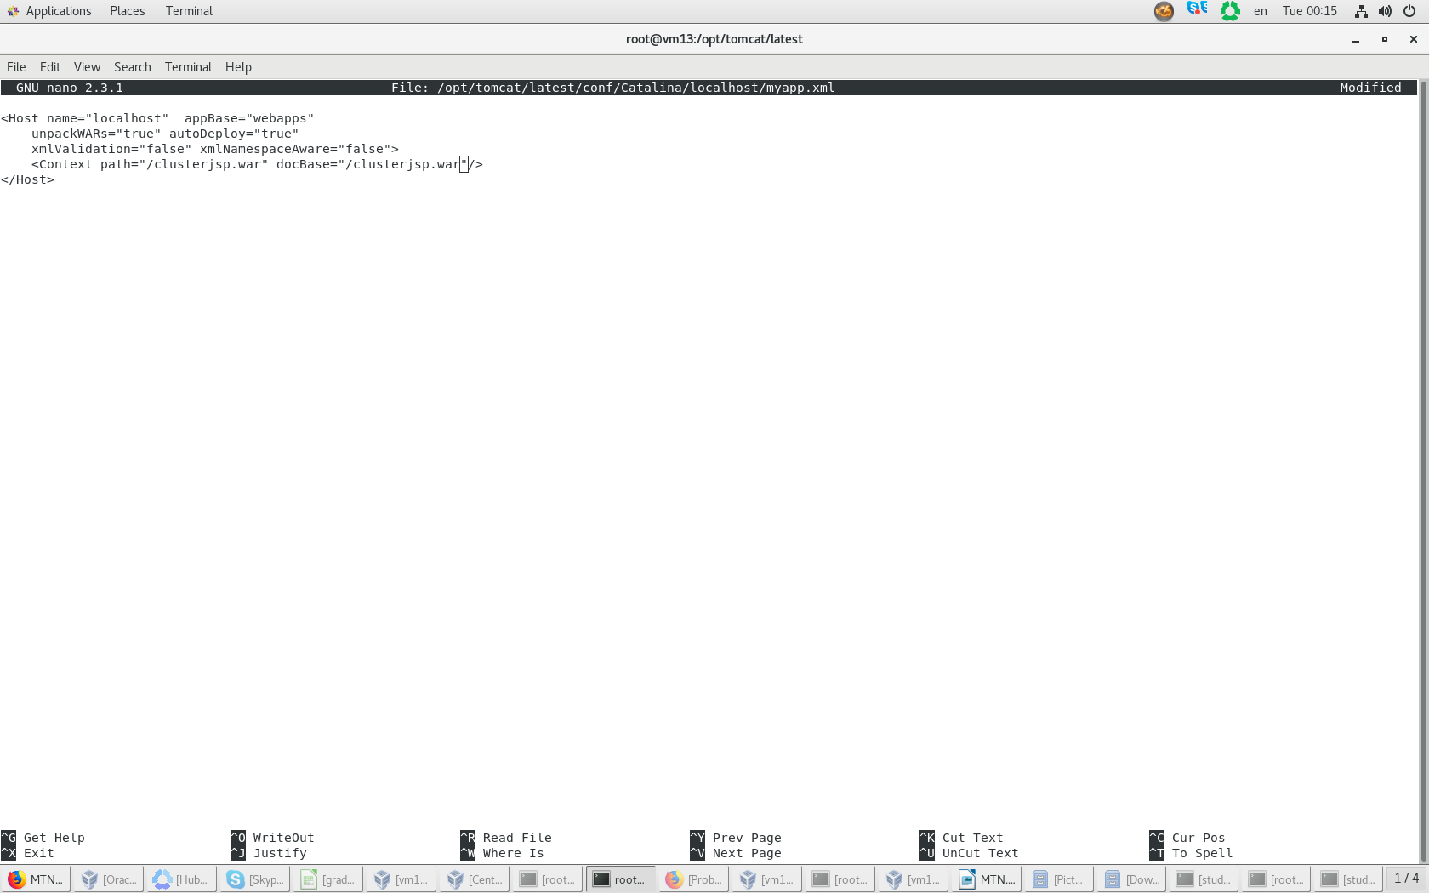

**Task2**

1. Using mod_jk configure Tomcat Cluster with session persistence (replication):
   1. Configure 4 separate Virtual hosts for surname-tomcat1.lab, surname-tomcat2.lab, surname-tomcat3.lab and Tomcat Cluster – surname-cluster.lab.

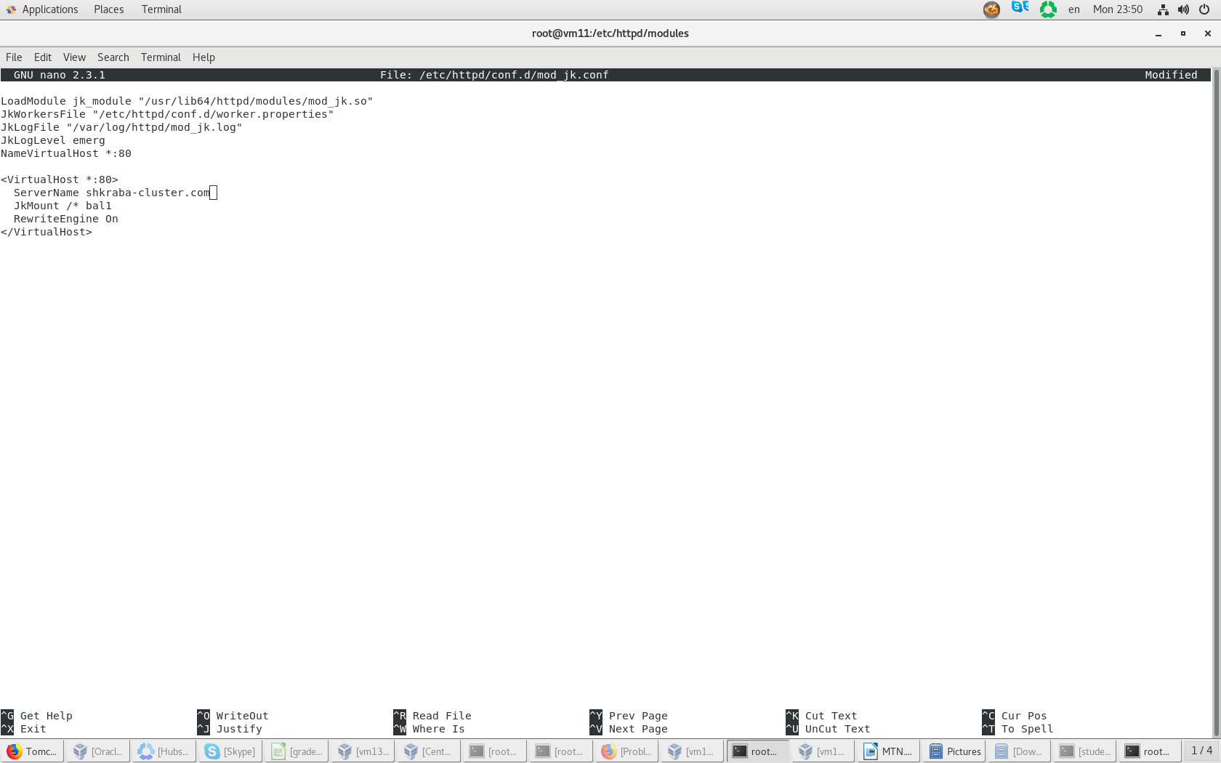

* 1. Configure mod_jk – worker.properties

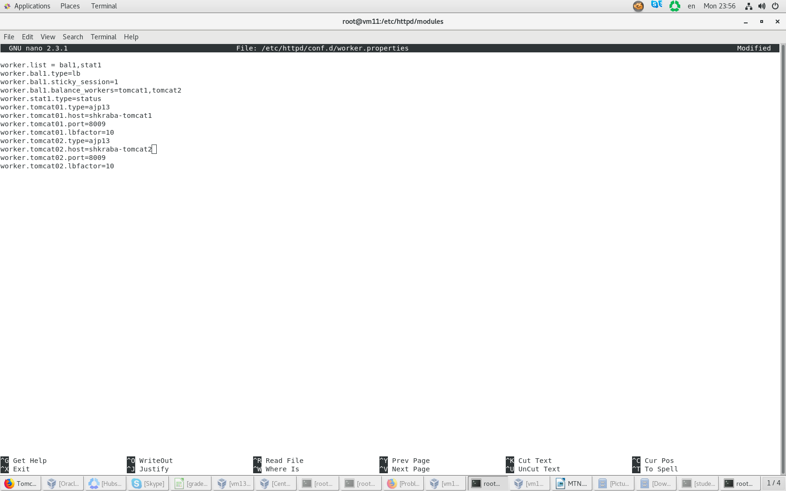

* 1. Setup cluster and check that you can reach clusterjsp app via surname-cluster.lab.
  2. 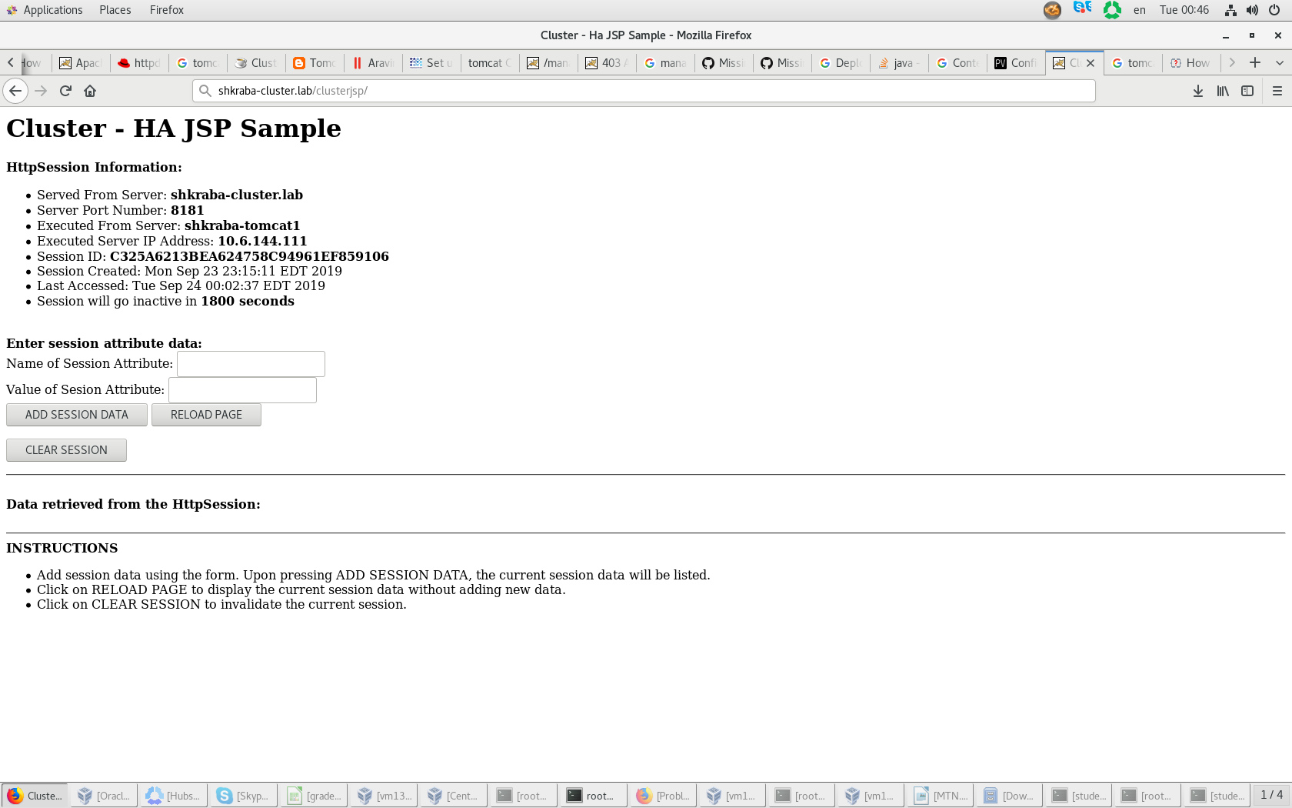Check session persistence by stopping active tomcat server.

